Brief title: Pre-hospital diagnosis of AMI with cMyC

Cardiac Myosin-Binding Protein C to diagnose Acute Myocardial Infarction in the pre-hospital setting
*Thomas E Kaier MD, MBA, PhDª; *Carsten Stengaard MD^{b}; Jack Marjot MBBS BScª; Jacob Thorsted Sørensen MD, PhD^{b}; Bashir Alaour MDª, Stavroula Stavropoulou-Tatla BScª; Christian Juhl Terkelsen MD, DrMSc^{b}; Luke Williams MBBS BScª; Kristian Thygesen MD, DrMSc^{b}; Ekkehard Weber PhD^{c}; Michael Marber MBBS, PhD^{a#}; Hans Erik Bøtker MD, PhD^{b#};
* Both authors have contributed equally and should be considered first author; # Both research groups have contributed equally
ª King’s College London BHF Centre, The Rayne Institute, St Thomas’ Hospital, London, UK
^{b} Department of Cardiology, Aarhus University Hospital, Aarhus, Denmark
^{c} Institute of Physiological Chemistry, Martin Luther University Halle-Wittenberg, Halle, Germany
Word count: 5,859 (including title page, abstract, text, references, tables, figures, and acknowledgments)

Corresponding author:
Professor Michael Marber, The Rayne Institute, 4th Floor Lambeth Wing, St Thomas’ Hospital, Westminster Bridge Road, London SE1 7EH, UK; Tel: +44-(0)20-7188 1008, Fax: +44-(0)20-7188 0970. email: mike.marber@kcl.ac.uk

Abstract (350 words max)
Background: Early triage is essential to improve outcome in patients with suspected Acute Myocardial Infarction (AMI). This study investigated whether cardiac myosin-binding protein C (cMyC), a novel biomarker of myocardial necrosis, can aid early diagnosis of AMI and risk stratification.
Methods and Results: cMyC and hs-cTnT were retrospectively quantified in blood samples obtained by ambulance-based paramedics in a prospective, diagnostic cohort study. Patients with ongoing or prolonged periods of chest discomfort, acute dyspnoea in the absence of known pulmonary disease, or clinical suspicion of AMI were recruited. Discrimination power was evaluated by calculating the Area under the Receiver-operating characteristics curve; diagnostic performance was assessed at pre-defined thresholds. Diagnostic nomograms were derived & validated using bootstrap resampling in logistic regression models.
776 patients with median age 68 [58;78] were recruited. AMI was the final adjudicated diagnosis in 22%. Median symptom to sampling time was 70 minutes. cMyC concentration in patients with AMI was significantly higher than with other diagnoses: 98 [43;855] vs 17 [9;42] ng/L. Discrimination power for AMI was better with cMyC than with hs-cTnT: AUC 0.839 vs 0.813 (p=0.005). At a previously published rule-out threshold (10 ng/L), cMyC reaches 100% sensitivity and NPV in patients after 2 hours of symptoms. In logistic regression analysis, cMyC is superior to hs-cTnT and was used to derive diagnostic and prognostic nomograms to evaluate risk of AMI and death.
Conclusions: In patients undergoing blood draws very early after symptom onset, cMyC demonstrates improved diagnostic discrimination of AMI and could significantly improve the early triage of patients with suspected AMI.

Keywords: Cardiac myosin-binding protein C; cMyC; Troponin T; myocardial infarction; pre-hospital triage

Clinical Perspective
What is new?
- In an observational, prospective diagnostic cohort study that included 776 individuals presenting with chest pain and suspected AMI, cMyC concentrations in blood draws obtained in the ambulance were significantly higher in patients with AMI than with other diagnoses.
- Discrimination power was significantly better for cMyC than for hs-cTnT, and cMyC at the previously published threshold of 10 ng/L for rule-out of AMI reached 100% sensitivity and NPV in patients with only 2 hours of symptoms.
What are the clinical implications?
- cMyC could significantly improve the early triage of patients with suspected AMI.
- We have developed a diagnostic nomogram, translating the combination of clinical risk factors and cMyC concentration into a personalised probability of AMI.

Introduction
Rapid triage to the appropriate treatment is the cornerstone of improving outcome for patients presenting with suspected Acute Myocardial Infarction (AMI).^{1–3} Pre- and early hospital triage is, however, fraught with difficulties: the former relies heavily on the recording of electrocardiograms and point-of-care measurement of biomarkers on devices that lack either cardiac specificity, or the sensitivity of laboratory platforms. Early hospital triage is restrained by the biology of cardiac Troponin, reflected in guidelines enabling direct rule-out of myocardial infarction only from at least 3 hours after symptom onset.¹ To streamline acute cardiac care, physicians at Aarhus University Hospital (Denmark) evaluate over 6,000 pre-hospital electrocardiograms (ECG) per year: transmitted from paramedics in the field. This system allows the team in the regional tertiary-care interventional centre to select the cases for priority transfer; bypassing the nearest secondary-care facility.⁴ However, ECG abnormalities identify only a minority of cases of AMI, do not allow risk-stratification⁵ and the interpretation is compounded by bundle branch block (BBB) and other longstanding abnormalities.⁴ A recent study investigating the precision with which emergency staff interpret ECGs (including ST-elevation) has demonstrated a mean accuracy of 81% across all study groups (such as paramedics, residents and cardiologists).⁶ For patients with high-risk non ST-elevation MI (NSTEMI), the inherent diagnostic challenges lead to delayed appropriate treatment and may be associated with worse outcomes.⁷ In a recent study, the endpoint committee re-adjudicated 9-14% of NSTEMI patients as STEMI, challenging the perception that ECG-based triage by a hospital physician is sufficient to identify all patients benefiting from urgent revascularisation.⁷
We have previously studied the performance of cardiac Troponin T (cTnT) and Copeptin point-of-care testing (POCT) devices to aid triage in the pre-hospital setting. Whilst cardiac-specific⁸, the cTnT POCT assay has a Limit of Quantification (LoQ) of 50 ng/L, with a 99th centile, defined by laboratory platforms, of 14 ng/L. Copeptin, on the other hand, is released early after acute illness, but low specificity limits its use in guiding patients towards regional interventional cardiology centres.⁹
We previously described cardiac myosin-binding protein C (cMyC) – a novel biomarker of myocardial necrosis and a more abundant analyte than cardiac Troponins (cTn).^{10,11} In smaller studies investigating patients early after chest pain onset or timed cardiac injury, cMyC rises more rapidly than cardiac Troponin I (cTnI)^{11,12} – at equal, absolute tissue-specificity. In a recently published study¹³, cMyC demonstrated favourable classification into rule-out and rule-in categories when compared to hs-cTn. Specifically, the reclassification improvement was more pronounced in patients presenting early after chest pain onset (≤3 hours). In combination, these features make cMyC an attractive biomarker for POCT. Recent correspondence demonstrated interest in the biomarker’s discrimination power in very early presenters, irrespective of ECG findings.^{14,15} Using conventional performance metrics as well as the development of diagnostic and prognostic nomograms, this study investigated whether cMyC – tested in a cohort of patients undergoing in ambulance blood-draws – could aid the early diagnosis of AMI.

Methods

Study design and population
In an observational, prospective, quality-control study, paramedics routinely performed point-of-care cTnT measurements in patients with suspected AMI.¹⁶ The point-of-care cTnT measurements were performed in 25 ambulances in the eastern part of the Central Denmark Region with a population of approximately 600,000 inhabitants from 26 May 2010 to 16 May 2011. Each patient in whom the standard operating procedure (SOP) instructed the recording of a prehospital ECG qualified for blood testing. The SOP criteria included ongoing or prolonged periods of chest discomfort within the past 12 hours, acute dyspnoea in the absence of known pulmonary disease, or clinical suspicion of AMI. The study was reviewed by the Regional Ethical Committee and accepted as a quality control study. Oral informed consent for participation in the study was obtained in the ambulance. The study was approved by the Danish Data Protection Agency and the Danish National Board of Health. The methods used in this analysis are available from the corresponding author.

Telemedicine Triage
The ECG was transmitted to the invasive cardiology centre at Aarhus University Hospital, Denmark, and interpreted by the cardiologist on call. Subsequently, a telephone interview was conducted with the patient. Thereafter, a tentative cardiac or a non-cardiac diagnosis was established and the patient underwent triage to either the PCI centre or a local hospital for further assessment.⁴
Following point-of-care cTnT analysis, the paramedics saved the remaining blood sample obtained in the ambulance. For details on sample storage & analysis, as well as data sources, please see supplement.

Cardiac biomarker analysis
cMyC was measured using the previously established high-sensitivity assay on the Erenna platform and was performed by Millipore Sigma (Hayward, California).¹⁷ The assay has a lower Limit of Detection (LoD) of 0.4 ng/L and a lower Limit of Quantification (LoQ) of 1.2 ng/L with a ≤20% coefficient of variation at LoQ, and ≤10% CV at 99th centile. Assay precision is not affected by freeze/thaw cycles, and results are closely correlated across different matrices (serum, lithium heparin, K2 EDTA).¹⁷ The estimated 99th percentile cut-off point (URL) determined previously is 87 ng/L.¹⁷ The precision profile is displayed in the supplement (figure S1, table S1) and remains ≤10% above 4.6 ng/L. We have recently contracted a POCT diagnostics device manufacturer to migrate cMyC onto their platform. As demonstrated in supplemental figure S2, our proposed threshold of 10 ng/L is attainable with a CV ≤10% on a pre-commercial device.¹³
For hs-cTnT, the samples were thawed and analysed as one batch in a "thaw-freeze" cycle at the central laboratory of Aarhus University Hospital, using the high-sensitivity cardiac Troponin T assay (Roche Diagnostics GmbH, Mannheim, Germany). The assay has a LoD of 5 ng/L, with a CV ≤10% at 13 ng/L and the 99th centile at 14 ng/L.¹⁸ Roche Diagnostics has previously released a technical bulletin regarding a calibration issue affecting all lots used in this study and for routine hs-cTnT measurements made during hospital admission.^{19,20} The manufacturer recommended a method for recalculating the reported values using combined calibration information, reagent lot number information and instrument details if the original signal data was not available.²¹ Where available, hs-cTnT samples below the 99th centile were subsequently re-analysed using reagent lots unaffected by the calibration issue to avoid ambiguities due to recalculation (n=287). A number of samples (n=202) have recalculated hs-cTnT concentrations – most of which affects samples with hs-cTnT values above the 99th centile. The hs-cTnT recovery rate and the 99th centile comply with those found in the original studies.^{18,19,21}

Adjudicated final diagnosis
As previously described, all admissions were reviewed by an endpoint committee for adjudication of the final diagnosis.¹⁶ This was performed according to the Universal Definition of MI.²² For the diagnosis of myocardial injury, the hs-cTnT URL was used. hs-cTnT values obtained from prehospital samples were not disclosed or used in clinical decision making. The endpoint committee had access to all patient file material including the discharge file, with the diagnoses determined by the clinicians. AMI patients were classified as ST-elevation Myocardial Infarction (STEMI) or Non-ST-elevation Myocardial Infarction (NSTEMI); unstable angina (UA) was diagnosed in patients with a significant episode of chest pain thought to be of ischemic origin who did not fulfil AMI criteria.
﻿The cardiologist on call recorded clinical and baseline data as well as the triage decision using a web- based telemedicine database. Prehospital data were obtained from the Central Denmark Region’s Prehospital Emergency Medical Services. ﻿Clinical details and baseline data were acquired from patient files in hard copies from the hospitals, and from The National Patient Registry. Survival data were obtained from The Danish Civil Registration System. Baseline health information was obtained from The National Patient Registry. At 30 days, 2 independent adjudicators evaluated all pre-, in-hospital and survival data. AMIs without cardiac death during 30-day follow-up was classified a non-fatal AMI.

Diagnostic proportions of hs-cTnT and cMyC
Classification power of both biomarkers was assessed by calculating sensitivity, negative predictive value (NPV), specificity and positive predictive value (PPV) for each cut-off threshold. The 99th centile of hs-cTnT is 14 ng/L, and the currently available POCT platform (Roche Cobas h323 handheld instrument) can detect a laboratory-equivalent value of 50 ng/L (POCT LoD, correct at date of submission) – about 3-fold the LoQ or 10-fold the LoD of the laboratory assay.²³ The result is reported as ‘negative’ <50 ng/L, ‘positive’ at 50-100 ng/L, and quantitatively positive with a numerical value >100 ng/L.
In line with results from a first foray into detection of cMyC concentrations on a POCT platform (see supplemental results and figure S1), 10 ng/L (the previously published threshold for rule-out of AMI¹³) seems feasible. We used 1,000 bootstrap replicates to determine the classification power of each biomarker with 95% confidence intervals (95% CI). Net Reclassification Improvement and Integrated Discrimination Improvement were calculated in line with Pencina’s recommendations.²⁴ A positive NRI indicates an improvement of classification from the initial model: Categorical NRI equal to x% means that compared with individuals without outcome, individuals with outcome were almost x% more likely to move up a category than down. IDI equal to x% means that the difference in average predicted risks between the individuals with and without the outcome increased by x% in the updated model.

Statistical analysis
All data are expressed as medians [1st quartile; 3rd quartile] or means (standard deviation) for continuous variables (compared with t-test or ANOVA for continuous normal distributed variables, and Kruskal-Wallis test if continuous non-normally distributed); categorical variables are expressed as absolute and relative frequencies (compared with Pearson chi-square). Hypothesis testing was two-tailed and p values <0.05 were considered statistically significant. Where bootstrap techniques were used, the calculations were performed using 1,000 stratified replicates.
Diagnostic accuracy was quantified by the area under the receiver-operating curve (AUC (95% confidence interval)) against adjudicated AMI. Bootstrapping was used to calculate Confidence Intervals (CI), compare the AUC between biomarkers and calculate the classification function. Youden’s Index was calculated to quote the concentration at which the sum of sensitivity and specificity is maximised.²⁵ Logistic regression was used to combine cMyC with hs-cTnT values for the assessment of an incremental value using the two biomarker concentrations at presentation. Correlation was assessed with Spearman’s rho (r_{s}) and adjusted R² by fitting a linear regression model.

Regression Models
Several regression models incorporating available biomarker concentrations (hs-cTnT and cMyC) and clinical variables (history of diabetes, hyperlipidaemia, hypertension, smoking, prior myocardial infarction; baseline variables sex, age, creatinine) were evaluated – 1) logistic regression models for the adjudicated diagnosis of AMI upon index presentation and 2) cox proportional hazard models to predict probability of a) death and b) non-fatal AMI or death during follow-up.
We used restricted cubic splines to model the distribution of cMyC, as the assay was able to detect a cMyC concentration in every enrolled participant tested and thus no individual was below the limit of detection (0.4 ng/L). For hs-cTnT, we modelled the distribution using linear splines – all concentrations below LoD (5 ng/L) were assigned the value 4.99 ng/L, and the knot locations were assigned at quantiles 5%, 25%, 50% and 75% above the LoD.
A short model for the probabilistic assessment of AMI likelihood was derived using a pragmatic approach informed by fast backward variable selection. To assess probability of AMI, this resulted in the inclusion of the following factors for the derivation of a nomogram displayed in an abbreviated model suitable to the development of a nomogram: cMyC, sex, hyperlipidaemia and smoking history. Log likelihoods were used to quantify and compare the predictive information contained in each subset of predictors.
Prognostic models
Follow-up was carried out for up to 2 years after enrolment to the study (recruitment period 26 May 2010 to 16 May 2011). Cox regression models to predict probability of i) death and ii) non-fatal AMI or death during follow-up were derived using fast backward variable selection from a model including all baseline variables. To assess probability of death during follow-up, this resulted in the inclusion of the following factors for the derivation of a nomogram: cMyC, creatinine, age, prior history of MI. The Cox models were tested for violation of the proportional hazards assumption by calculating correlation coefficients between transformed survival time (rank) and the scaled Schoenfeld residuals and testing the former with chi-square comparisons. All available variables were tested in a univariate regression model; significant variables (pre-defined as Wald test p<0.1) were selected for the final Cox multivariate regression model. The biomarkers were entered log-transformed.
All statistical analyses were performed using R, version 3.3.0 GUI 1.68 (The R Foundation for Statistical Computing), including packages ggplot2, RMarkdown, the tidyverse, survival, survminer and pROC.

Results

Baseline characteristics
Samples from a total of 776 patients were available for retrospective analysis. Median age was 68 years [58; 78], 303 patients (39%) were women, and 232 (30%) had a prior history of myocardial infarction (table 1, table S2). AMI was the adjudicated diagnosis in 173 patients (22%): Sixty-six patients (9%) had a final diagnosis of STEMI, 107 (14%) NSTEMI. Median time since onset of chest pain was 70 minutes [35; 173]. In 99% of cases, a telephone consultation was undertaken. There was considerable discrepancy between telemedicine-triage and final diagnosis: 107 patients (14%) presented with BBB on ECG; only 59% of patients with a final adjudicated diagnosis of STEMI had clear ST-elevation identified during telemedicine assessment. Sensitivity for NSTEMI during telemedicine assessment was 33%.

Distribution of biomarker concentrations
All blood samples were obtained in the ambulance but measured in a laboratory for hs-cTnT and cMyC. In-ambulance concentrations of cMyC were significantly higher in patients with AMI (median 98 ng/L [43; 855]) than in patients with other diagnoses (17 ng/L [9; 42], p<0.001). Median concentrations of cMyC were 88 ng/L [42; 253] for NSTEMI, 306 ng/L [49; 1706] for STEMI, 19 ng/L [11; 25] for unstable angina (UA). The corresponding concentrations for hs-cTnT were 33 ng/L [18; 72], 58 ng/L [15; 295] and 9 ng/L [7; 14], respectively (see Figure 1; table S3). In this cohort, there was a slight sex difference in cMyC concentration in patients without AMI: female 15 ng/L [8; 38] vs male 18 ng/L [10; 44], p=0.023; the difference does not reach significance in patients with AMI (female 121 ng/L [67; 1120] vs male 91 ng/L [38; 739], p=0.235). Correlation between hs-cTnT and cMyC is shown in the supplement (fig S3, table S4).
An overview of the distribution of cMyC is shown in Figures 2 (fig S4 for hs-cTnT). Overall, when comparing blood concentrations of biomarkers to assay-specifics (LoQ, LoD), cMyC concentrations were higher than those of hs-cTnT in all diagnostic categories.

Discrimination power for use of biomarkers alone
In blood draws performed in the ambulance, the discrimination power against ultimate diagnosis (AMI) as quantified by the AUC was higher for cMyC than for hs-cTnT: 0.839 (95% CI, 0.803-0.871) vs 0.813 (0.777-0.847; p=0.005 for direct comparison; figure 3; table 2). The discrimination power of cMyC for the individual diagnoses was: AUC 0.816 (0.761-0.866) for STEMI, AUC 0.787 (0.741-0.829) for NSTEMI, AUC 0.599 (0.531-0.67) for UA; Youden’s index was calculated at 50 ng/L.
The discrimination power for hs-cTnT for the individual diagnoses was: AUC 0.766 (0.701-0.828; p<0.001 for direct comparison to cMyC) for STEMI, AUC 0.781 (0.737-0.820; p=0.595) for NSTEMI, AUC 0.608 (0.529-0.692; p=0.711) for UA (figures S5+S6 for ROC curves). A stratified analysis based on time since symptom onset is shown in table S5.
The combination of both markers (cMyC and hs-cTnT) provided incremental value for STEMI (AUC 0.780; 0.719-0.84; p<0.001 for direct comparison) and NSTEMI (0.786; 0.745-0.824; p=0.037) compared to using hs-cTnT alone.

Logistic Regression models for AMI diagnosis
A model using all available biomarkers achieved a moderate model fit (R² 0.483), but a higher C index (C 0.875) and log likelihood ratio (LR $χ$²; 291.5) than using the respective biomarkers alone. Figure S7 depicts the odds ratio for AMI diagnosis at presentation stratified by sex, creatinine and cMyC concentrations, whilst holding other variables stable (table S6 for regression model, calibration plot figure S8). Models using only one (cardiac) biomarker yield lower discrimination indices than the model using both biomarkers (cMyC – R² 0.467, C 0.868, LR $χ$² 282.4; hs-cTnT – R² 0.431, C 0.853, LR $χ$² 256.9).
However, based on the comparison of log likelihoods, the model including cMyC explains a greater proportion of the complete model than hs-cTnT (difference in LR $χ$² = 25.5) and thus carries greater diagnostic information (table S7).

Development of a nomogram for prediction of AMI
Four variables remained in the final, short model used for the development of a nomogram (figure 4): cMyC, sex, hyperlipidaemia and smoking history. Model statistics are displayed in supplemental table S8 (S9 for validation) and, in short, achieved the following indices: R² 0.416, C 0.852.

Diagnostic proportions of cMyC and hs-cTnT
Performance characteristics for cMyC at previously published thresholds¹³ for rule-out (10 ng/L) and rule-in (120 ng/L) of myocardial infarction, as well as the 99th centile (87 ng/L) are displayed in table 3, stratified by symptom time (<60 mins, 60-120 mins, >120 mins of chest pain); for all patients across the cohort, see table S10. The performance characteristics of hs-cTnT were previously reported¹⁶, and are listed at 99th centile (14 ng/L), LoD of the hs-assay (5 ng/L) and POCT device (50 ng/L) and rule-in for myocardial infarction as per ESC guideline (52 ng/L) in the supplement (tables S11-12).¹ In short, the rule-out threshold for cMyC (10 ng/L) achieves sensitivity & NPV of 100% after 2 hours of chest pain. For all patients, specificity at the 99th centile (87 ng/L) was 90.2% (87.6-92.6%), PPV 61.4% (54-69.6%); at the rule-in threshold (120 ng/L), specificity was 92.2% (90-94.3%), PPV 62.7% (54.6-71.3%). A reclassification analysis is presented in table S13, indicating an improvement in classification (based on NRI +0.1067 and IDI +0.032) by using cMyC instead of hs-cTnT as the triage biomarker.

Prediction of death and first of non-fatal MI/death during follow-up
Patients were followed for up to 2 years after the index presentation: of the 173 patients with AMI, 28 (16%) died during follow-up; of the patients without AMI, 60 (10%) died. An abbreviated model to predict death during follow-up used the following factors for the derivation of a nomogram: cMyC, creatinine, age and prior myocardial infarction. Model statistics are displayed in supplemental table S14 and, in short, achieved the following indices: R² 0.179, C 0.798. For the model predicting non-fatal AMI or death during follow-up, factors cMyC and history of diabetes mellitus were included and achieved R² 0.317, C 0.828 (figures S9-S11; table S15 for hazard ratios; figure S12 for event curves).

Discussion
Cardiac myosin-binding protein C (cMyC) is a myocardial protein that is released into the circulation after injury in a similar manner to the cardiac troponins (cTn). A prior publication has suggested that the concentration of cMyC rises more rapidly than cTn based on an analysis of 26 patients with AMI, who presented to hospital within 180 mins of symptom onset.¹² This finding is in keeping with an in vitro analysis of human heart that shows cMyC is many times more abundant than cTn.¹⁰ A recent investigation has further shown superiority in early triage of >1,900 patients presenting with chest pain and suspected AMI – particularly in subjects presenting early after symptom onset.¹³ The median chest pain duration before first blood draw is typically 3-5 hours in large cohort studies undertaken in the secondary-care setting.^{26,27} In contrast, we studied patients with a median time of just 70 mins between symptom onset and blood draw in the ambulance – a population enriched for AMI, due to the circumstance of recruitment. The current study indicates superiority of the novel biomarker in the rule-out and diagnosis of AMI very early; based on an analysis of receiver operator characteristics, logistic regression modelling and log likelihood ratios. Our direct observations and hypothetical models suggest that cMyC may have distinct advantages as a point-of-care biomarker for AMI. This advantage of cMyC is evident despite the use of hs-cTnT in the final adjudication of AMI.
A biomarker result obtained in the pre-hospital setting or at first arrival to hospital could be interpreted with simple decision aids, such as a nomogram that translates the biomarker value plus cardiovascular risk factors into a probability of AMI. Alternatively, established risk stratification tools such as the GRACE risk score²⁸ can be used to identify patients with NSTEMI who benefit from early revascularisation – but the calculator requires an abnormal biomarker result obtained swiftly to classify high-risk ACS. In the data presented, even the diagnosis of STEMI was far from certain – thus it is intriguing that the AUC for the diagnosis of STEMI is higher for cMyC than it is for hs-cTnT, whilst not statistically different for NSTEMI in this cohort. Notably, cMyC provided incremental value to hs-cTnT measurement alone in all AMI categories. Patients identified earlier as high-risk could be transferred to the nearest PCI-capable facility, whereas low-risk patients – with a low likelihood of AMI - are admitted locally.
Currently, the way pre-hospital triage is performed is resource-intensive and yields imperfect results – ECGs have particularly low sensitivity in the context of (more common⁵) NSTEMI presentations, and the best commercially available POCT platforms for cardiac Troponin have limits of quantification that are well above the population 99th centile defined using a laboratory assay. This limitation is part-technology, part relative scarcity of the analyte – whilst a recent publication demonstrates a possible breakthrough with a portable hs-cTnI assay, regulatory approval and full disclosure on true assay performance are eagerly awaited.²⁹ Furthermore, the latest ESC guidelines¹ specifically warn against the use of high-sensitivity Troponin assays in early-presenters (<3 hours of chest pain). A protein which is much more abundant than cTn following myocardial injury would allow careful titration to individual requirements: whether the goalpost is maximum specificity/PPV, or maximum sensitivity/NPV, such as in rapid rule-in and rule-out pathways – the greater the ‘detectable’ spectrum of concentrations of an equally cardiac-specific marker, the greater the possibility to choose cut-offs to achieve local objectives. Our analysis has demonstrated that a cMyC concentration <10 ng/L might be sufficient after 2 hours of symptoms to reliably rule-out out AMI; notably, this concentration is about 25-fold the Limit of Detection of the current assay, which would allow for significant signal loss in the migration to POCT and still provide a useful tool for risk-stratification. Furthermore, previously published rule-in thresholds¹³ (120 ng/L) demonstrate a comparably high specificity (>90%) irrespective of symptom-onset.
This study has several limitations: 1) cMyC is currently only available on a high-sensitivity research platform and the migration onto POCT has not been completed. 2) Any cut-offs investigated are subject to cohort-specific calibration – hence, the current analysis employs additional, agnostic approaches such as the application and comparison of logistic regression models which are not dependent on assay-specific cut-offs. To allow a more clinically relevant interpretation, the information provided has been translated into diagnostic nomograms – to calculate probabilities of AMI or death based on an individual’s cMyC concentrations plus clinical variables. The ability to detect lower volumes of myocardial injury earlier might be of particular use in a cohort such as the one studied, where the median time since onset of chest pain is substantially lower than in other, diagnostic chest pain studies, and rule-in of high-risk cases is of much greater importance to both the clinician and the patient. The clinical utility of the nomograms, however, is uncertain until validated in external cohorts. Furthermore, implementation would require a sensitive cMyC assay on a point-of-care platform, such a platform is not currently available. 3) As in most studies of this type there is an inherent bias against the new biomarker since hs-TnT was measured during the in-hospital course and used in the clinical adjudication of AMI.
In summary, we have demonstrated that 1) cMyC achieves improved diagnostic discrimination at earlier time points compared to hs-cTnT; 2) the addition of cMyC to hs-cTnT would provide additional diagnostic information; 3) cMyC achieves high sensitivity and NPV at 10ng/L, a relatively high concentration that maybe measurable at point-of-care .

Acknowledgements:
Thanks to the Vanderbilt University Department of Biostatistics for hosting datamethods.org which provided a platform for fruitful discussions on this topic. We thank Prof Frank Harrell (Vanderbilt University School of Medicine, USA), A/Prof John Pickering (University of Otago, Christchurch, NZ) and Dr James Rooney PhD (Academic Unit of Neurology, Trinity Biomedical Sciences Institute, Trinity College Dublin, IE) for their thoughtful contributions and an inspiring exchange of ideas & methods.
We are grateful to Dr Jack Branch and Tim Dwyer of AgPlus Diagnostics Ltd. for supplying preliminary data regarding the feasibility of migrating the assay for cMyC on to a point of care diagnostic platform.

Funding:
C.S. has received lecture fees and research grants from Roche Diagnostics (Basel, Switzerland) Thermo Fisher Scientific (Waltham, USA) and The Medicines Company (Parsippany-Troy Hills, USA). J.T.S. has received research grants from Falck Emergency Medical Services (Copenhagen, Denmark) and lecture fees from Roche Diagnostics. H.E.B. has received grants from the Danish Research Council (Copenhagen, Denmark).
This work was further supported by grants from the Medical Research Council (London, UK) (G1000737), Guy's and St Thomas' Charity (London, UK; R060701, R100404), British Heart Foundation (Birmingham, London; TG/15/1/31518, FS/15/13/31320), and the UK Department of Health through the National Institute for Health Research Biomedical Research Centre award to Guy's & St Thomas' National Health Service Foundation Trust.
The remaining authors have no conflicts of interest.

Conflict of Interest Disclosures:
Millipore Sigma was contracted to undertake the analyses of cMyC on a fee-for-service basis and holds no commercial interest. Prof Marber is named as an inventor on a patent held by King’s College London for the detection of cardiac myosin–binding protein C as a biomarker of myocardial injury. The remaining authors have nothing to disclose.

Affiliations:
From King’s College London BHF Centre, The Rayne Institute, St Thomas’ Hospital, London, UK (T.E.K., J.M., B.A., S.S.-T., L.W., M.M.); Department of Cardiology, Aarhus University Hospital, Aarhus, Denmark (C.S., J.T.S., C.J.T., K.T., H.E.B.); Institute of Physiological Chemistry, Martin Luther University Halle-Wittenberg, Halle, Germany (E.W.)

References
1. Roffi M, Patrono C, Collet J-P, Mueller C, Valgimigli M, Andreotti F, Bax JJ, Borger MA, Brotons C, Chew DP, Gencer B, Hasenfuss G, Kjeldsen K, Lancellotti P, Landmesser U, Mehilli J, Mukherjee D, Storey RF, Windecker S. 2015 ESC Guidelines for the management of acute coronary syndromes in patients presenting without persistent ST-segment elevation. Eur Heart J. 2016;37:267–315.
2. Thygesen K, Alpert JS, Jaffe AS, Simoons ML, Chaitman BR, White HD, Katus HA, Apple FS, Lindahl B, Morrow DA, Clemmensen PM, Johanson P, Hod H, Underwood R, Bax JJ, Bonow RO, Pinto F, Gibbons RJ, Fox KA, Atar D, Newby LK, Galvani M, Hamm CW, Uretsky BF, Steg PG, Wijns W, Bassand JP, Menasché P, Ravkilde J, Ohman EM, Antman EM, Wallentin LC, Armstrong PW, Simoon ML, Januzzi JL, Nieminen MS, Gheorghiade M, Filippatos G, Luepker R V., Fortmann SP, Rosamond WD, Levy D, Wood D, Smith SC, Hu D, Lopez-Sendon JL, Robertson RM, Weaver D, Tendera M, Bove AA, Parkhomenko AN, Vasilieva EJ, Mendis S, Baumgartner H, Ceconi C, Dean V, Deaton C, Fagard R, Funck-Brentano C, Hasdai D, Hoes A, Kirchhof P, Knuuti J, Kolh P, McDonagh T, Moulin C, Popescu BA, Reiner Ž, Sechtem U, Sirnes PA, Torbicki A, Vahanian A, Windecker S, Morais J, Aguiar C, Almahmeed W, Arnar DO, Barili F, Bloch KD, Bolger AF, Bøtker HE, Bozkurt B, Bugiardini R, Cannon C, De Lemos J, Eberli FR, Escobar E, Hlatky M, James S, Kern KB, Moliterno DJ, Mueller C, Neskovic AN, Pieske BM, Schulman SP, Storey RF, Taubert KA, Vranckx P, et al. Third Universal Definition of Myocardial Infarction. Circulation. 2012;126:2020–2035.
3. Amsterdam EA, Wenger NK, Brindis RG, Casey DE, Ganiats TG, Holmes DR, Jaffe AS, Jneid H, Kelly RF, Kontos MC, Levine GN, Liebson PR, Mukherjee D, Peterson ED, Sabatine MS, Smalling RW, Zieman SJ. 2014 AHA/ACC Guideline for the Management of Patients With Non–ST-Elevation Acute Coronary Syndromes. Circulation. 2014;130:e139-228.
4. Terkelsen CJ, Jensen LO, Tilsted HH, Thaysen P, Ravkilde J, Johnsen SP, Trautner S, Andersen HR, Thuesen L, Lassen JF. Primary percutaneous coronary intervention as a national reperfusion strategy in patients with ST-segment elevation myocardial infarction. Circ Cardiovasc Interv. 2011;4:570–576.
5. McManus DD, Gore J, Yarzebski J, Spencer F, Lessard D, Goldberg RJ. Recent Trends in the Incidence, Treatment, and Outcomes of Patients with STEMI and NSTEMI. Am J Med. 2011;124:40–47.
6. Huitema AA, Zhu T, Alemayehu M, Lavi S. Diagnostic accuracy of ST-segment elevation myocardial infarction by various healthcare providers. Int J Cardiol. 2014;177:825–829.
7. Stengaard C, Sørensen JT, Rasmussen MB, Søndergaard HM, Dodt KK, Niemann T, Frost L, Jensen T, Hansen TM, Riddervold IS, Rasmussen C-H, Giebner M, Aarøe J, Maeng M, Christiansen EH, Kristensen SD, Bøtker HE, Terkelsen CJ. Acute versus subacute angiography in patients with non-ST-elevation myocardial infarction - the NONSTEMI trial phase I. Eur Heart J Acute Cardiovasc Care. 2017;6:490–499.
8. Thygesen K, Mair J, Giannitsis E, Mueller C, Lindahl B, Blankenberg S, Huber K, Plebani M, Biasucci LM, Tubaro M, Collinson P, Venge P, Hasin Y, Galvani M, Koenig W, Hamm C, Alpert JS, Katus H, Jaffe AS, Care SG on B in C of ESCWG on AC. How to use high-sensitivity cardiac troponins in acute cardiac care. Eur Heart J. 2012;33:2252–2257.
9. Stengaard C, Sørensen JT, Ladefoged SA, Lassen JF, Rasmussen MB, Pedersen CK, Ayer A, Bøtker HE, Terkelsen CJ, Thygesen K. The potential of optimizing prehospital triage of patients with suspected acute myocardial infarction using high-sensitivity cardiac troponin T and copeptin. Biomarkers. 2016;37:1–13.
10. Marjot J, Kaier TE, Martin ED, Reji SS, Copeland O, Iqbal M, Goodson B, Hamren S, Harding SE, Marber MS. Quantifying the Release of Biomarkers of Myocardial Necrosis from Cardiac Myocytes and Intact Myocardium. Clin Chem. 2017;63:990–996.
11. Baker JO, Tyther R, Liebetrau C, Clark J, Howarth R, Patterson T, Möllmann H, Nef H, Sicard P, Kailey B, Devaraj R, Redwood SR, Kunst G, Weber E, Marber MS. Cardiac myosin-binding protein C: a potential early biomarker of myocardial injury. Basic Res Cardiol. 2015;1–14.
12. Kaier TE, Anand A, Shah AS V, Mills NL, Marber M. Temporal Relationship between Cardiac Myosin-Binding Protein C and Cardiac Troponin I in Type 1 Myocardial Infarction. Clin Chem. 2016;62:1153–1155.
13. Kaier TE, Twerenbold R, Puelacher C, Marjot J, Imambaccus N, Boeddinghaus J, Nestelberger T, Badertscher P, Sabti Z, Gimenez MR, Wildi K, Hillinger P, Grimm K, Loeffel S, Shrestha S, Widmer DF, Cupa J, Kozhuharov N, Miró Ò, Martin-Sanchez FJ, Morawiec B, Rentsch K, Lohrmann J, Kloos W, Osswald S, Reichlin T, Weber E, Marber M, Mueller C. Direct Comparison of Cardiac Myosin-Binding Protein C With Cardiac Troponins for the Early Diagnosis of Acute Myocardial Infarction. Circulation. 2017;136:1495–1508.
14. Jiang X, Tian H, Qiao S. Letter by Jiang et al Regarding Article, “Direct Comparison of Cardiac Myosin-Binding Protein C With Cardiac Troponins for the Early Diagnosis of Acute Myocardial Infarction.” Circulation. 2018;138:543–543.
15. Kaier TE, Twerenbold R, Puelacher C, Marjot J, Imambaccus N, Boeddinghaus J, Nestelberger T, Badertscher P, Sabti Z, Giménez MR, Wildi K, Hillinger P, Grimm K, Loeffel S, Shrestha S, Widmer DF, Cupa J, Kozhuharov N, Miró Ò, Martín-Sánchez FJ, Morawiec B, Rentsch K, Lohrmann J, Kloos W, Osswald S, Reichlin T, Weber E, Marber M, Mueller C. Response by Kaier et al to Letter Regarding Article, “Direct Comparison of Cardiac Myosin-Binding Protein C With Cardiac Troponins for the Early Diagnosis of Acute Myocardial Infarction.” Circulation. 2018;138:544–545.
16. Stengaard C, Sørensen JT, Ladefoged SA, Christensen EF, Lassen JF, Bøtker HE, Terkelsen CJ, Thygesen K. Quantitative point-of-care troponin T measurement for diagnosis and prognosis in patients with a suspected acute myocardial infarction. Am J Cardiol. 2013;112:1361–1366.
17. Marjot J, Liebetrau C, Goodson RJ, Kaier T, Weber E, Heseltine P, Marber MS. The development and application of a high-sensitivity immunoassay for cardiac myosin-binding protein C. Transl Res. 2016;170:17–25.
18. Giannitsis E, Kurz K, Hallermayer K, Jarausch J, Jaffe AS, Katus HA. Analytical validation of a high-sensitivity cardiac troponin T assay. Clin Chem. 2010;56:254–261.
19. Kuster N, Dupuy A-M, Monnier K, Baptista G, Bargnoux A-S, Badiou S, Jeandel C, Cristol J-P, Kavsak PA, Hill SA, McQueen MJ, Devereaux PJ, Hallermayer K, Jarausch J, Menassanch-Volker S, Zaugg C, Ziegler A, Kavsak PA, Hill SA, McQueen MJ, Devereaux PJ. Implications of adjustment of high-sensitivity cardiac troponin T assay. Clin Chem. 2013;59:572–574.
20. Apple FS, Jaffe AS. Clinical implications of a recent adjustment to the high-sensitivity cardiac troponin T assay: user beware. Clin Chem. 2012;58:1599–1600.
21. Saenger AK, Beyrau R, Braun S, Cooray R, Dolci A, Freidank H, Giannitsis E, Gustafson S, Handy B, Katus H, Melanson SE, Panteghini M, Venge P, Zorn M, Jarolim P, Bruton D, Jarausch J, Jaffe AS. Multicenter analytical evaluation of a high-sensitivity troponin T assay. Clin Chim Acta. 2011;412:748–754.
22. Thygesen K, Alpert JS, White HD, Infarction JETF for the R of M. Universal definition of myocardial infarction. Eur Heart J. 2007;28:2525–2538.
23. Bertsch T, Chapelle J-P, Dempfle C-E, Giannitsis E, Schwabs M, Zerback R. Multicentre analytical evaluation of a new point-of-care system for the determination of cardiac and thromboembolic markers. Clin Lab. 2010;56:37–49.
24. Pencina MJ, D’Agostino RB, Steyerberg EW. Extensions of net reclassification improvement calculations to measure usefulness of new biomarkers. Stat Med. 2011;30:11–21.
25. Youden WJ. Index for rating diagnostic tests. Cancer. 1950;3:32–5.
26. Pickering JW, Greenslade JH, Cullen L, Flaws D, Parsonage W, Aldous S, George P, Worster A, Kavsak PA, Than MP. Assessment of the European Society of Cardiology 0 Hour/1 Hour Algorithm to Rule Out and Rule In Acute Myocardial Infarction. Circulation. 2016;134:1532–1541.
27. Rubini Giménez M, Hoeller R, Reichlin T, Zellweger C, Twerenbold R, Reiter M, Moehring B, Wildi K, Mosimann T, Mueller M, Meller B, Hochgruber T, Ziller R, Sou SM, Murray K, Sakarikos K, Ernst S, Gea J, Campodarve I, Vilaplana C, Haaf P, Steuer S, Minners J, Osswald S, Mueller C. Rapid rule out of acute myocardial infarction using undetectable levels of high-sensitivity cardiac troponin. Int J Cardiol. 2013;168:3896–3901.
28. Fox KAA, Dabbous OH, Goldberg RJ, Pieper KS, Eagle KA, Van De Werf F, Avezum Á, Goodman SG, Flather MD, Anderson FA, Granger CB. Prediction of risk of death and myocardial infarction in the six months after presentation with acute coronary syndrome: Prospective multinational observational study (GRACE). Br Med J. 2006;333:1091–1094.
29. Pickering JW, Young JM, George PM, Watson AS, Aldous SJ, Troughton RW, Pemberton CJ, Richards AM, Cullen LA, Than MP. Validity of a Novel Point-of-Care Troponin Assay for Single-Test Rule-Out of Acute Myocardial Infarction. JAMA Cardiol. 2018;3:1108–1112.

Figures:
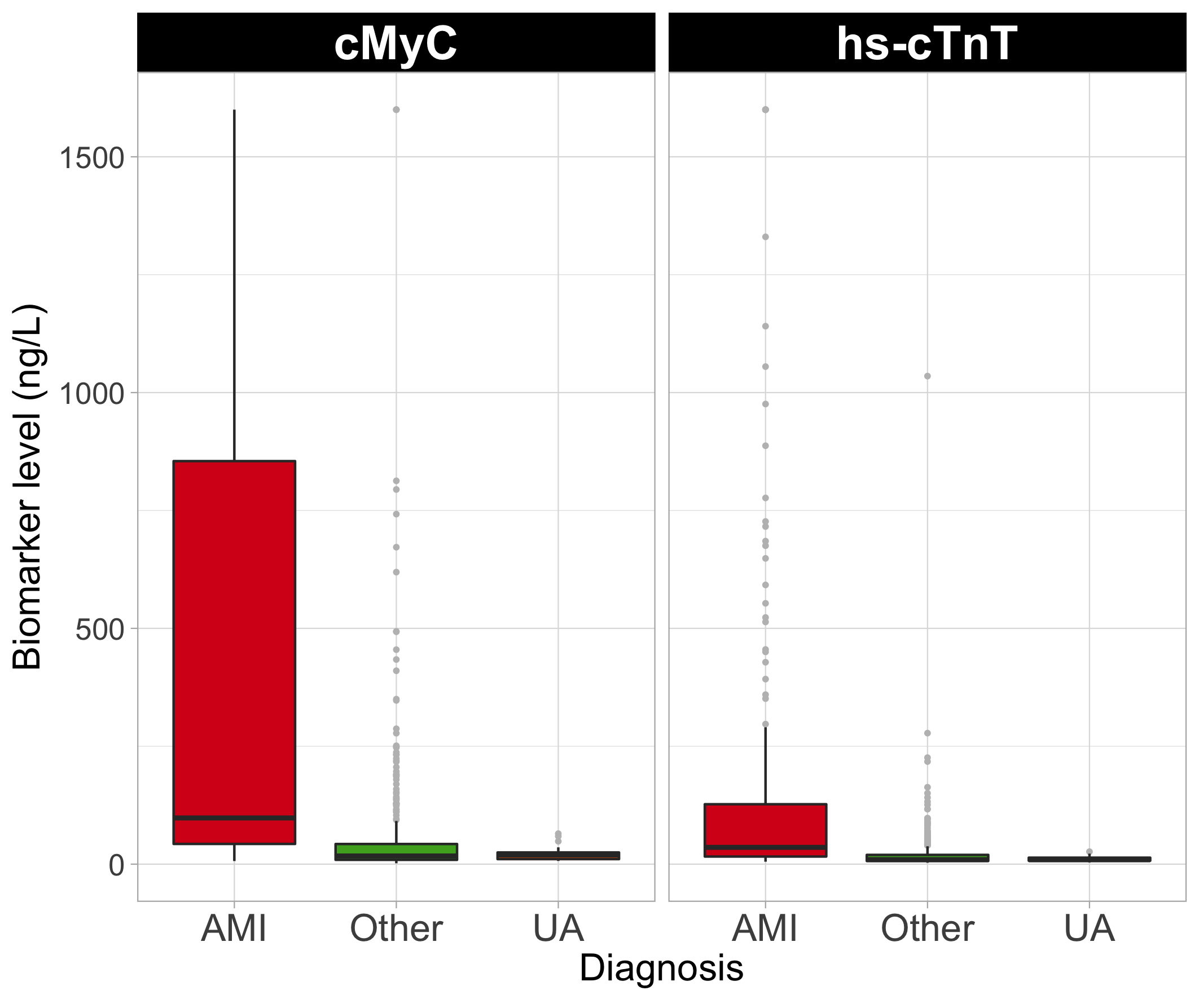
Figure 1 – Distribution of cMyC and hs-cTnT concentrations in samples obtained in the ambulance, based on adjudicated final diagnosis. Boxes represent interquartile ranges; whiskers extend to 1.5 * IQR from the hinges; light grey bullets are outliers. AMI = Acute Myocardial Infarction; UA = Unstable Angina

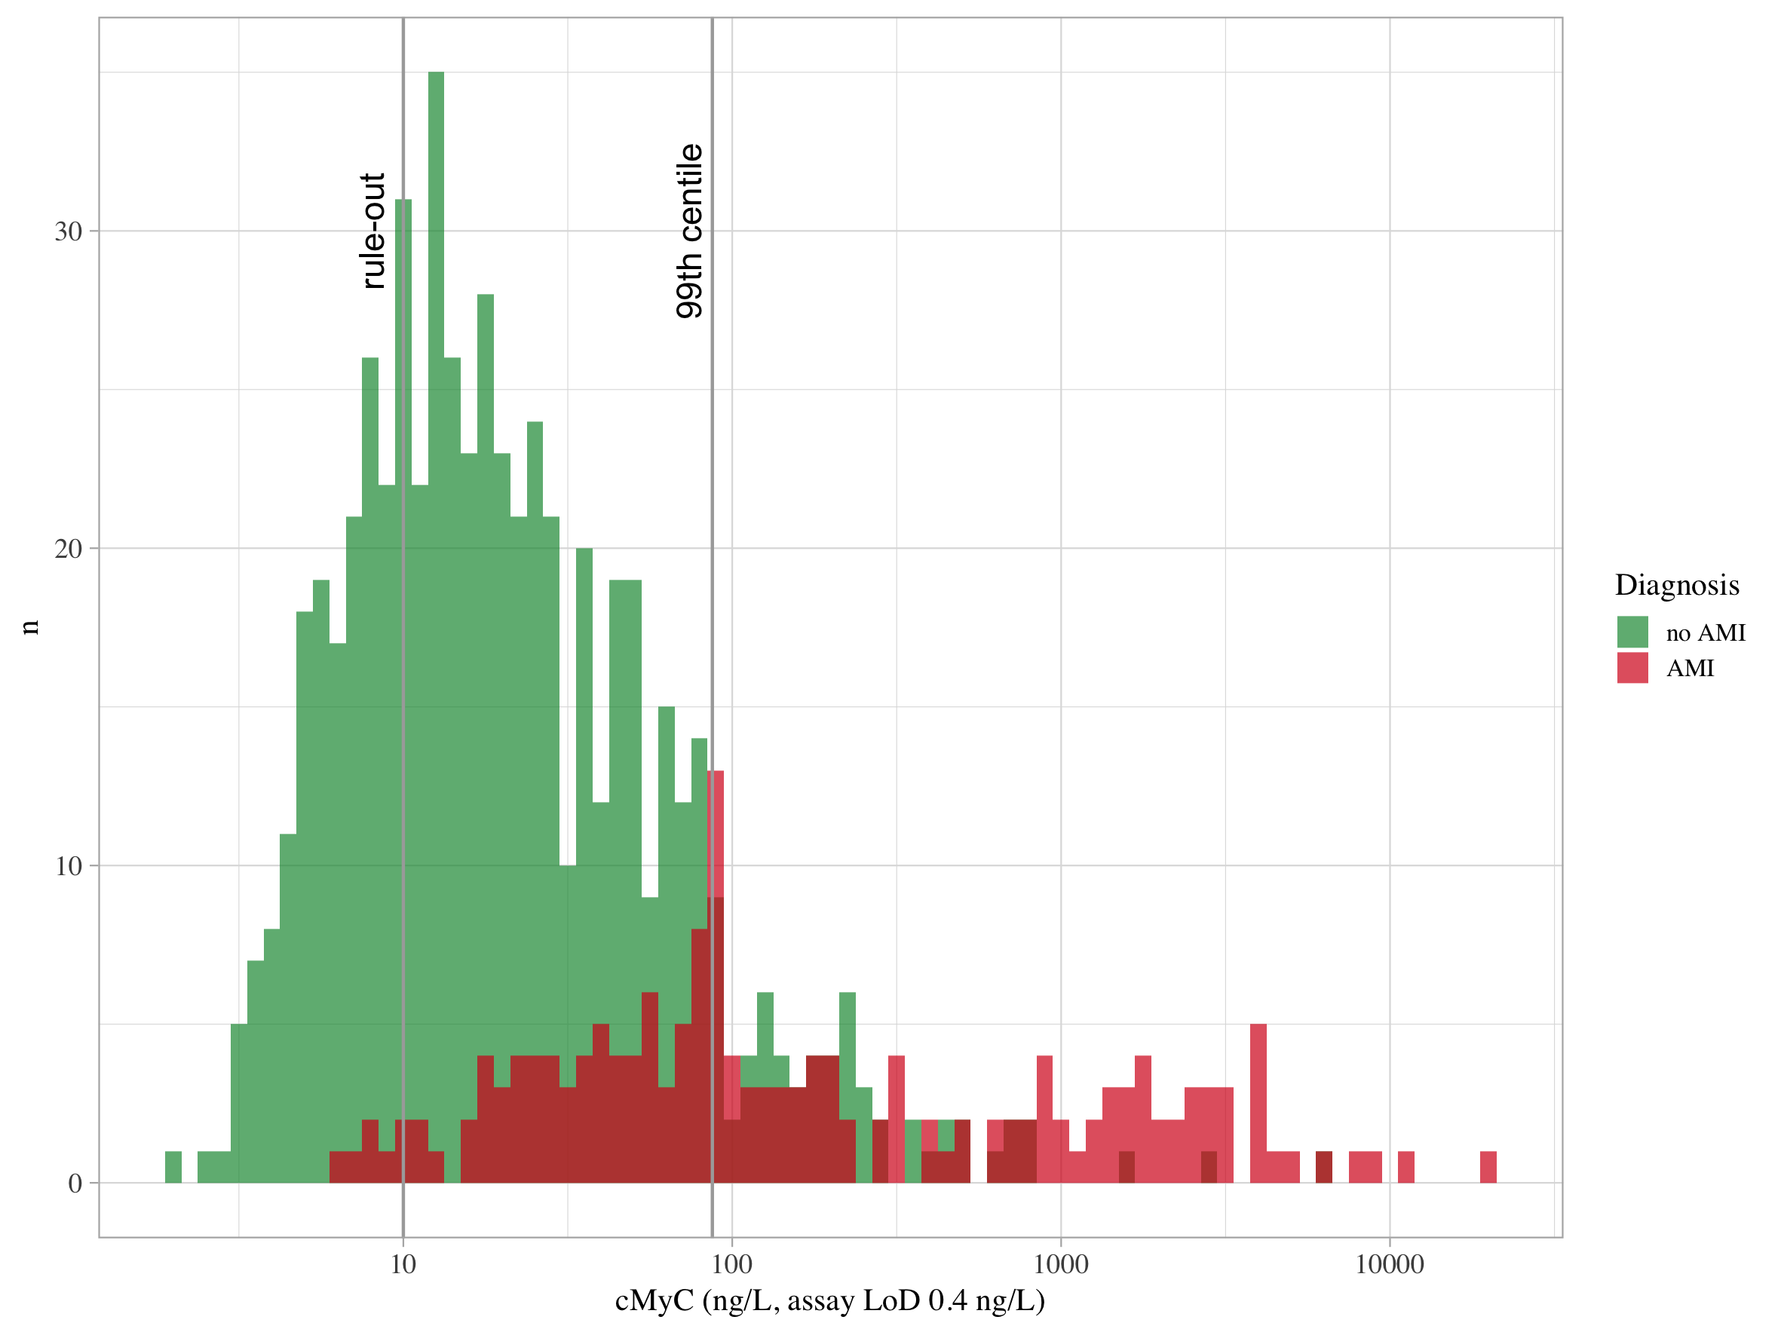
Figure 2 – Distribution of patients stratified by adjudicated diagnosis of AMI based on the pre-hospital cMyC concentration; x-axis log10-transformed

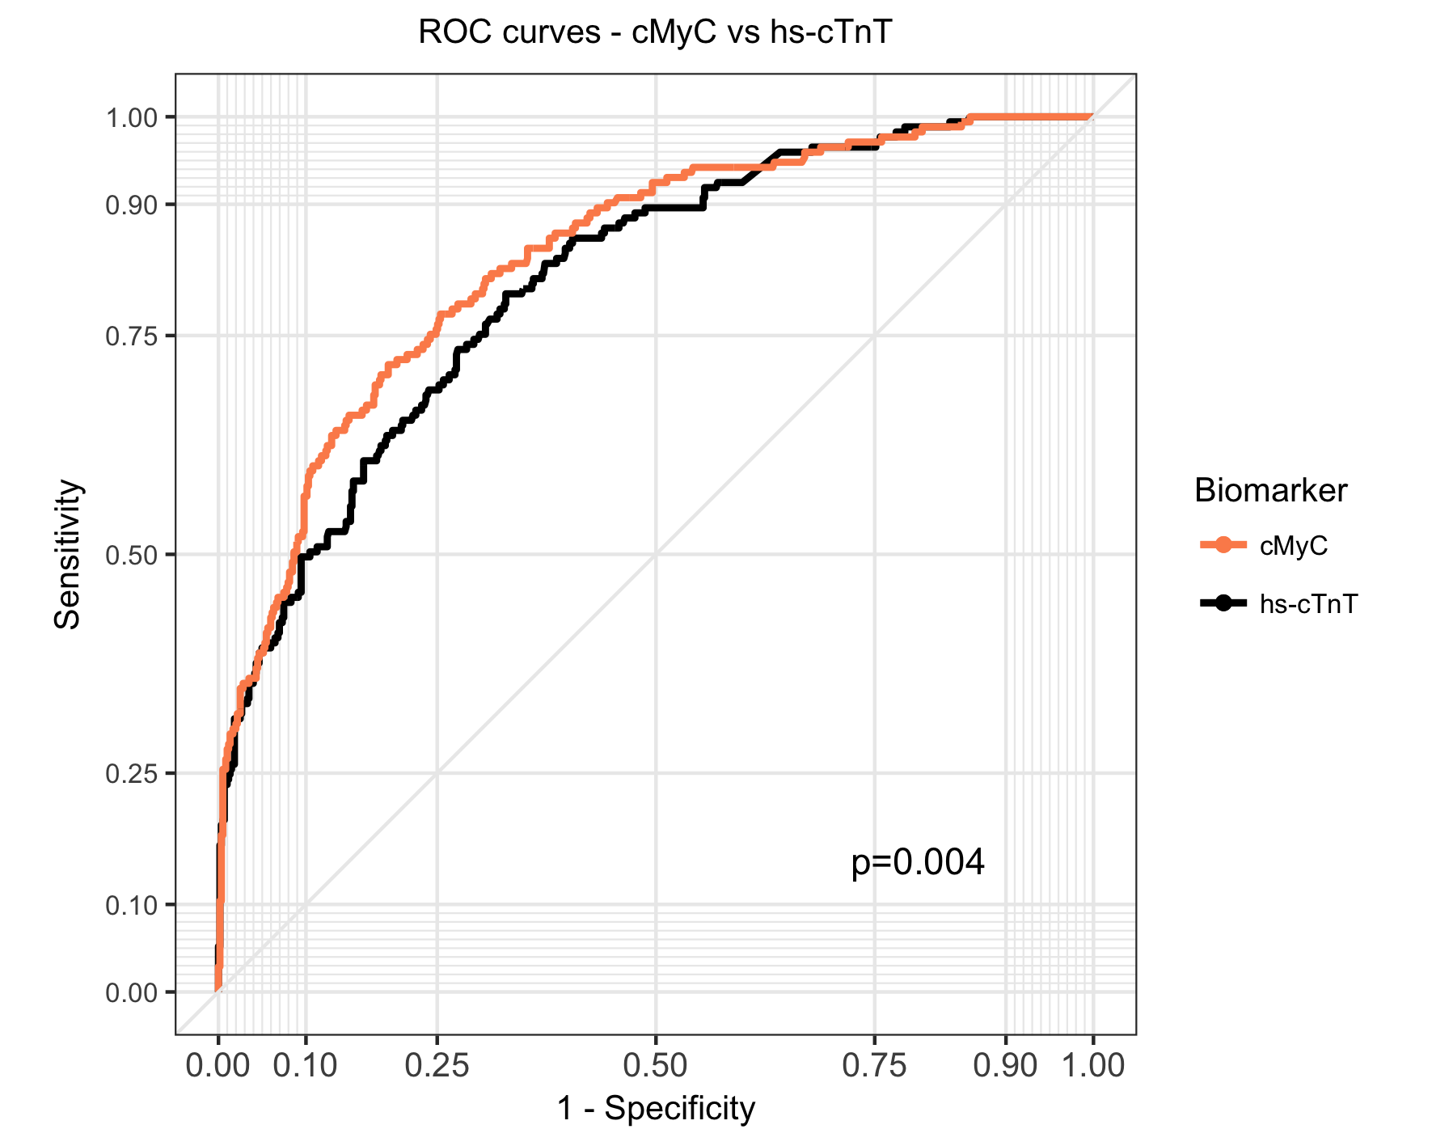
Figure 3 – Receiver-operating characteristics (ROC) curves for cMyC (ambulance) and hs-cTnT (ambulance) for the diagnosis of acute myocardial infarction. The AUC for cMyC was 0.839 (95% CI, 0.804-0.87), for hs-cTnT 0.813 (0.777-0.847). Youden’s index for cMyC in this cohort is 50 ng/L

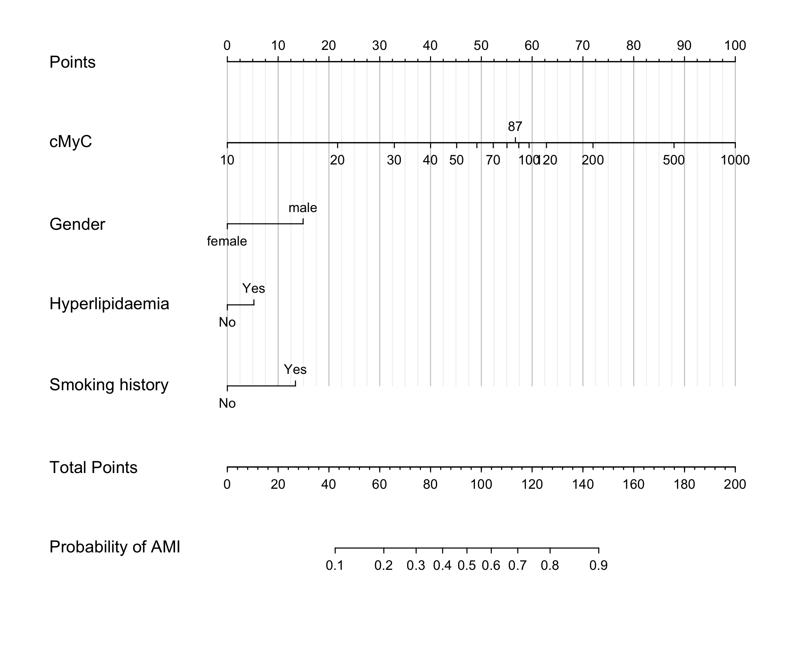
Figure 4 – Nomogram for the use of cMyC concentration, sex, hyperlipidaemia and smoking history to predict probability of AMI – e.g., a patient with cMyC concentration < 10 ng/L would score 0 points, or 100 points at a concentration of 1,000 ng/L; presence of hyperlipidaemia would add 5 points; all points are added for the total score, which can then provide a probability of AMI.

Tables:
 | No AMI | AMI | p-value* | N
 | N=603 | N=173
Sex: male | 344 (57%) | 129 (75%) | <0.001 | 776
Age (y) | 68 [56;78] | 70 [63;79] | 0.016 | 776
Hypertension | 337 (56%) | 102 (59%) | 0.528 | 776
Hyperlipidaemia | 480 (80%) | 142 (82%) | 0.540 | 776
Diabetes mellitus | 124 (21%) | 23 (13%) | 0.041 | 776
Current smoking | 165 (31%) | 65 (46%) | 0.001 | 674
Past smoking | 167 (31%) | 50 (35%) | 0.445 | 674
Previous MI | 174 (29%) | 58 (34%) | 0.276 | 776
Previous percutaneous intervention | 151 (25%) | 49 (28%) | 0.440 | 776
Systolic blood pressure, mmHg | 146 [130;165] | 149 [129;170] | 0.531 | 764
Diastolic blood pressure, mmHg | 87 [75;98] | 89 [73;105] | 0.154 | 764
Heart rate, beats/min | 84 [70;100] | 85 [70;100] | 0.790 | 765
Estimated glomerular filtration rate, ml/min/1.73m2* | 72 [56;87] | 68 [58;83] | 0.126 | 605
Time since chest pain onset, minutes | 66 [35;179] | 72 [35;150] | 0.872 | 726

Table 1 – Baseline characteristics stratified by AMI diagnosis; (A)MI = (acute) myocardial infarction; * p values for comparison AMI group versus all other diagnoses; data are expressed as medians [1st quartile, 3rd quartile], for categorical variables as numbers (percentages); eGFR = Estimated glomerular filtration rate, ml/min/1.73m², estimated using the Modification of Diet in Renal Disease (MDRD) formula); p value for comparison AMI vs non-AMI.

Outcome | AUC | 95% CI | AUC | 95% CI | Cases | Controls |  | p value
Biomarker | cMyC |  | hs-cTnT
AMI | 0.839 | 0.805-0.873 | 0.813 | 0.777-0.847 | 173 | 603 |  | 0.005
STEMI | 0.816 | 0.759-0.865 | 0.766 | 0.695-0.831 | 66 | 710 |  | <0.001
NSTEMI | 0.787 | 0.742-0.828 | 0.781 | 0.737-0.821 | 107 | 669 |  | 0.599
UA | 0.599 | 0.524-0.670 | 0.608 | 0.531-0.690 | 27 | 749 |  | 0.715
Biomarker | cMyC + hs-cTnT |  | hs-cTnT
AMI | 0.822 | 0.791-0.856 | 0.813 | 0.775-0.847 | 173 | 603 |  | <0.001
STEMI | 0.780 | 0.716-0.836 | 0.766 | 0.699-0.834 | 66 | 710 |  | <0.001
NSTEMI | 0.786 | 0.744-0.830 | 0.781 | 0.738-0.823 | 107 | 669 |  | 0.041
UA | 0.613 | 0.535-0.695 | 0.608 | 0.530-0.693 | 27 | 749 |  | 0.377

Table 2 – Area under the Receiver-operating Characteristics Curve for cMyC and hs-cTnT; AMI = Acute Myocardial Infarction; STEMI = ST-elevation Myocardial Infarction; NSTEMI = Non ST-elevation Myocardial Infarction; UA = Unstable Angina; AUC = Area under the Curve; CI = Confidence Interval

Patients with chest pain for <60 mins (n=321)
[cMyC] | 10 ng/L | 87 ng/L | 120 ng/L
Sensitivity | 94.3% (87-98.6%) | 40.7% (29.1-52.3%) | 33.3% (22.2-44.7%)
Specificity | 32.1% (26.8-37.9%) | 90.3% (86.6-93.8%) | 92.3% (88.8-95.3%)
NPV | 95.5% (90.7-98.9%) | 85.6% (81.1-89.6%) | 84.4% (79.7-88.5%)
PPV | 26.3% (21-32%) | 52.1% (37.8-65.4%) | 52.5% (37.5-67.5%)
Patients with chest pain for 60-120 mins (n=156)
Sensitivity | 98.1% (93.9-100%) | 54.7% (41.5-68.5%) | 46.5% (33.3-60.8%)
Specificity | 22.8% (15-31.3%) | 92.7% (86.9-96.9%) | 92.7% (86.9-96.9%)
NPV | 96.4% (87.1-100%) | 80.9% (73.6-87.2%) | 78.3% (70.6-84.9%)
PPV | 38% (30.3-46.3%) | 78% (63.9-89.8%) | 75% (58.6-88.5%)
Patients with chest pain for ≥120 mins (n=249)
Sensitivity | 100% (100-100%) | 73.5% (61.8-84.6%) | 61.2% (48.3-75%)
Specificity | 29.9% (23.8-36.6%) | 88.9% (84-93%) | 91.5% (87.3-95.1%)
NPV | 100% (100-100%) | 92.7% (88.6-96.2%) | 90% (85.5-93.8%)
PPV | 27.6% (21.1-33.7%) | 63.8% (51.2-75.5%) | 65.8% (52.2-78.4%)
Table 3 – Discriminatory power of cMyC at different thresholds; NPV = Negative Predictive Value; PPV = Positive Predictive Value

