Building a synthetic mechanosensitive signaling pathway in compartmentalized artificial cells

James W. Hindley1,2,3†, Daniela G. Zheleva1†, Yuval Elani1,2,3, Kalypso Charalmbous1, Laura M. C. Barter1,2, Paula J. Booth4 Charlotte L. Bevan5, Robert V. Law1,2 and Oscar Ces1,2,3*

**Affiliations**

1. Department of Chemistry, Imperial College London, Molecular Sciences Research Hub, Shepherd’s Bush, London, W12 0BZ, UK.
2. Institute of Chemical Biology, Imperial College London, Molecular Sciences Research Hub, Shepherd’s Bush, London, W12 0BZ, UK.
3. FABRICELL, Imperial College London, Molecular Sciences Research Hub, Shepherd’s Bush, London, W12 0BZ, UK
4. Department of Chemistry, King’s College London, Britannia House, 7 Trinity Street, London, SE1 1DB, UK.
5. Department of Surgery and Cancer, Imperial Centre for Translational & Experimental Medicine, Imperial College London, Shepherd’s Bush, London W12 0UQ, UK.

† These authors contributed equally. * Corresponding Author.

Email: o.ces@imperial.ac.uk

**Abstract**

To date reconstitution of one of the fundamental methods of cell communication, the signaling pathway, has been unaddressed in the bottom-up construction of artificial cells (ACs). Such developments are needed to increase the functionality and biomimicry of ACs, accelerating their translation and application in biotechnology. Here we report the construction of a *de novo* syntheticsignaling pathway in microscale nested vesicles. Vesicle cell models respond to external calcium signals through activation of an intracellular interaction between phospholipase A2 and a mechanosensitive channel present in the internal membranes, triggering content mixing between compartments and controlling cell fluorescence. Emulsion-based approaches to AC construction are therefore shown to be ideal for the quick design and testing of new signaling networks and can readily include synthetic molecules difficult to introduce to biological cells. This work represents a foundation for the engineering of multi-compartment-spanning designer pathways that can be utilised to control downstream events inside an artificial cell, leading to the assembly of micromachines capable of sensing and responding to changes in their local environment.

**Significance Statement**

In nature, an external input is translated by cellular machinery into a downstream effect through signaling pathways, enabling cells to respond to their environment. Bottom-up synthetic biology aims to re-create cellular organization and function through the creation of ‘artificial cells’ (ACs) through molecular self-assembly. Although the construction of new signaling pathways will enable increasingly responsive ACs, this area is undeveloped; here we show that multicompartment lipid vesicles are an ideal framework to build a pathway not found in nature. External calcium ions activate internal protein communication, leading to control of cell fluorescence. This highlights the potential of ACs for design and construction of synthetic pathways difficult to reconstitute in existing cells, leading to development of environment-responsive molecular machines in biotechnology.

\body

**Introduction**

In order to sense and respond to their external environment, biological cells have developed various means of communication(1–3). One of the most fundamental communication strategies in biological systems is to convert an external chemical input into a functional output, primarily through signal transduction. Here the controlled activation of protein machinery is often used to initiate gene transcription and translation of proteins that result in a functional change in cellular behaviour. One ubiquitous signaling molecule is the divalent calcium ion (Ca2+) which is utilised across biology(4), controlling both intra- and inter-cellular processes including transcription(5), mitochondrial energy production(6) and apoptosis(7). Calcium influx occurs across the plasma membrane as well as from intracellular stores in the endoplasmic reticulum, resulting in the activation of signaling cascades involving calcium-dependent enzymes(8, 9).

There is great interest in generating synthetic transduction pathways to control cell function as well as to increase fundamental understanding of cellular behaviour(10, 11). Many efforts have focused on the manipulation of existing pathways by creating chimeric proteins that combine the sensing domains of one protein with the signaling output of another(12–15). This strategy has been used to control protein activity through foreign autoinhibitory interactions(12), leading to the downstream control of cell morphology(13), organization(16) and migration(17). More recent work has focused on a generalized approach to controlling transduction, in which a modular extracellular sensor combined with a re-wired signaling pathway enables transgene expression(18).

These approaches have used genetic manipulation of existing eukaryotes or prokaryotes. An alternative method for engineering biology comes from the bottom-up construction of biological systems(19, 20). This nascent field aims to create soft matter structures with cellular functions and behaviours that are engineered to carry out specific tasks. Artificial cells (ACs) can be constructed from biological or synthetic molecules and have been used to reconstitute cellular behaviours such as protein expression(21), cell division(22) and minimal metabolism(23). They are also capable of communication; both AC-AC(24) and AC-biological cell(25) communication systems have been developed through the combination of sensing modules with cell-free expression outputs. This can enable ACs to behave as chemical translators, allowing non-natural bacterial communication to occur(25). Exogenous stimuli such as light have also been utilised to control gene expression in synthetic tissues(26), enzymatic microreactors(27, 28) and artificial photosynthetic organelles(29).

One challenge unaddressed to date involves the creation of *de novo* signaling pathways in bottom-up systems, which is particularly important given the difficulty in reconstituting native transduction pathways involving G-protein-coupled receptors (GPCRs)(30). Constructing new signaling pathways from the bottom up is needed to alleviate a bottleneck that has hindered the design of ACs with enhanced functionalities, for example that can dynamically respond to their surroundings through activation of internal processes. The relative simplicity of ACs make them an ideal foundation for pathway construction; recombinant proteins can be readily combined with non-natural sensing(31), structural(32) and processing(33) molecules found in chemistry and nanotechnology to create plug-and-play networks that are challenging to integrate into a living system. Here we make use of a previously reported interaction in which one protein (P1) can interact with a second (P2) using the membrane (M) as a communication pathway(34). This protein – membrane – membrane protein interaction (P1-M-P2) has been previously used to control triggered release from a population of mechanosensitive vesicles, where P1 and P2 are secretory phospholipase A2 (sPLA2) and the mechanosensitive channel of large conductance (MscL) respectively.

sPLA2 (P1) is a calcium-dependent enzyme that catalyses phosphatidylcholine lipids to lyso-phosphatidylcholine (LPC) and a concomitant fatty acid at the sn-2 position(35). Production of LPC in the external leaflet of vesicles results in an asymmetric change in the lateral pressure profile of the membrane (M)(36). This can be sensed by MscL (P2)(37), a homopentameric integral membrane protein that can respond to changes in membrane mechanics(38) by opening a large, non-specific pore ~2.5-3 nm in diameter(39), resulting in content release of molecules up to 10 kDa in size(40). The response of MscL to sPLA2 can be considered as a protein-protein interaction that occurs through the lipid bilayer itself and has the potential to be used as a network motif to couple chemical or mechanical changes within an AC to a functional output.

As the sPLA2-M-MscL network relies on active phospholipase enzymes as an input, in theory the full network can be activated by the controlled introduction of calcium into the AC. Here we demonstrate that P1-M-P2 networks can be used to trigger events in a compartmentalized AC, making use of the sPLA2-M-MscL network to control the concentration of the fluorescent molecule calcein in the vesicle lumen (Figure 1). To do this we employ a nested vesicle motif(28), where mechanosensitive inner vesicle compartments are encapsulated in a larger vesicle (Figure 1A). This is achieved by combining traditional detergent-mediated protein reconstitution strategies(41) with emulsion phase transfer(42). The phospholipase enzyme is also encapsulated in the larger vesicle but is rendered inactive through the inclusion of the calcium chelator ethylenediaminetetraacetic acid (EDTA). An EDTA-saturating calcium flux can be controllably introduced by permeabilizing the outer vesicle membrane with alpha hemolysin (αHL)(43). By increasing the availability of calcium within the artificial cell, the sPLA2-M-MscL network is activated (Figure 1B), and the fluorescence of the artificial cell is increased through calcein release into the main compartment of the vesicle (Figure 1C).

To our knowledge this is the first time that a synthetic signaling pathway has been created in a bottom-up synthetic biological system and represents a foundation for the engineering of multi-compartment-spanning designer pathways that can be utilised to control downstream events inside an artificial cell.

**Results**

**Using nested vesicle systems to build synthetic communication pathways**

We have recently shown that functional nested vesicles (otherwise known as vesosomes (44)) can be created using emulsion phase transfer and lend themselves well to a modular-based construction approach(28). By loading giant vesicles with a mechanosensitive vesicle ‘module’, we can readily test the feasibility of pathway creation in bottom-up systems.

Making use of the size-independent encapsulation of water-soluble molecular species intrinsic to emulsion phase transfer(45) (Figure S1), we assembled the nested vesicle system containing an outer lipid membrane composed of 1-palmitoyl-2-oleoyl-sn-glycero-3-phosphocholine (POPC), which contained 1,2-dioleoyl-sn-glycero-3-phophocholine (DOPC) and 1,2-dioleoyl-sn-glycero-3-phophoglycerol (DOPG) large unilamellar vesicles (LUVs) at a 1:1 molar ratio containing reconstituted G22C F93W MscL and a self-quenching concentration of calcein. The bee venom phospholipase A2 enzyme and EDTA were also encapsulated. Nested vesicle composition is shown and discussed further in Figure S2 and Table S1; the stability and functionality of this composition was determined from initial experiments with mechanosensitive vesicles as detailed below and in the supplementary information. Gel electrophoresis data of purified G22C F93W Mutant of MscL (*E. coli*) is additionally shown in figure S3.

In order to activate the nested system, permeabilization of the outer membrane is necessary due to the low permeability of Ca2+ across lipid bilayers. We achieved this through the addition of αHL, a water-soluble protein toxin that can self-assemble in the membrane to form oligomeric pores that are permanently open(43). Previous work(46) has shown that αHL will readily self-assemble in GUV membranes, enabling permeation of small molecules. To confirm successful encapsulation of the nested structure of MscL-vesicles in the GUV, inner compartments were labelled with Rhodamine-PE lipid to fluorescently visualise the full system. Using bright-field and fluorescence microscopy the outer membrane, inner membranes and calcein cargo can be visualised (Figure S4A, B and C respectively), confirming that the nested structure was successfully produced.

Although the experiments in figure S4 confirmed successful formation of nested vesicles, quantification of LUV encapsulation efficiency is essential to evaluate vesicle composition and enable analysis of encapsulated component functionality. To address this, confocal fluorescence microscopy was used to quantify the encapsulation of rhodamine PE-labelled LUVs in nested systems. The fine spatial resolution of confocal microscopy leads to reduced error in measurements compared to widefield microscopy, improving the accuracy of encapsulation efficiency estimation(47). The average encapsulation efficiency of PC:PG vesicles at millimolar concentration in POPC GUVs was estimated to be 67.59 ± 1.94 %, (Table S2) as estimated using the linear relationship in PC:PG lipid concentration and Rhodamine-PE fluorescence obtained between 0.0225 – 6.35 mM (r2 = 0.992, figure S5A). This loss is attributed to the rupture of encapsulated vesicles to stabilise the water/oil interface during emulsion generation. When lipids are present in both phases, competition occurs between vesicles rupturing from the aqueous phase and inverse micelles rupturing the oil phases during monolayer formation, leading to the disruption of a percentage of the encapsulated vesicle population(48). These efficiencies may therefore be increased above ~70% if greater lipid concentrations are encapsulated in the oil and/or water phases during emulsion generation.

It can therefore be assumed that successful production of a nested vesicle with millimolar internal lipid content occurs with ~30% loss of LUV content during the emulsion phase transfer process. This is acceptable for the proof-of-principle work undertaken here and compares favourably to previous studies of nested vesicle encapsulation efficiency. Previous hydration-based methods of nested vesicle (or vesosome) production have yielded encapsulation efficiency averages of ~50-60%(49–51), indicating that emulsion methods out-perform the production of nested vesicles through sequential extrusion(51) and perform at least equally as well as nested vesicles produced through the encapsulation of LUVs during cochleate cylinder to giant vesicle transition(49, 52).

To confirm network activation, fluorescence spectroscopy and microscopy was used to assess calcein fluorescence changes in the full vesicle population as well as monitor changes in individual vesicles. As can be seen in Figure 1D and Figure S6, nested vesicles containing MscL in their inner compartment membranes can successfully respond to a calcium concentration of 10 mM, showing ~10-fold increase in calcein fluorescence 100 minutes after Ca­2+ addition compared to nested vesicles lacking the channel. Lower (2.5 mM) and higher (15, 30 mM) calcium concentrations resulted in either negligible or MscL-independent release of calcein respectively; negligible release occurs at low Ca2+ concentrations due to insufficient Ca2+ present to saturate the EDTA in the vesicle, whilst at high Ca2+ concentrations MscL-vesicle aggregation within the GUV leads to uncontrolled calcein flux, as shown by dynamic light scattering (Figure S7). This uncontrolled flux could occur due to the high local concentrations of lysophosphatidylcholine and oleic acid produced upon phospholipase activity of aggregated vesicles, which are known to act as membrane permeability enhancers(53). Oleic acid is also known to mediate membrane fusion between calcium-aggregated phosphatidylserine vesicles where content leakage to the environment occurs alongside fusion(54). Stability of inactivated nested vesicles was additionally monitored (Figure S8); without permeabilisation of the outer membranes with αHL a slow decrease in fluorescence occurs over 14 hours, indicating that negligible calcein leakage is occurring from the inner, mechanosensitive vesicles due to enzyme activation or passive leakage and the full system is stable.



Whilst fluorescence spectroscopy of the full system indicated that the mechanosensitive pathway could be controlled inside nested vesicles, spectroscopy captures solution fluorescence and so can only give information on the whole vesicle population. As nested vesicles exist on the microscale, fluorescence microscopy can be employed to monitor the fluorescence of individual vesicles (Figure 1E). To confirm that the positive result observed in spectroscopy measurements was due to the controlled activation of the mechanosensitive pathway *within* the giant vesicle and not caused by the destruction of the nested structure, αHL was added to a population of nested vesicles before adding 10 mM Ca2+ and monitoring the fluorescence of individual vesicles over 90 minutes. As can be seen in Figure 1E, if MscL is present in the internal membranes a fluorescence intensity increase can be observed in the vesicles (red squares). If, however either MscL is absent from the internal membranes (blue circles) or αHL from the external membrane (yellow triangles) no increase in fluorescence occurs. The gradual overall decrease over time for control experiments is attributed to photobleaching of the calcein in the inactivated systems.

Statistical testing confirms that the fluorescence increases for vesicles containing the full pathway is significant compared to both the –MscL and - αHL controls (p< 0.005; unpaired t-test, n=15/14/13 for full system, -MscL and – αHL respectively). Interestingly, we note that the release behaviour observed in nested vesicles is comparable to calcein release from unencapsulated mechanosensitive vesicles activated with sPLA2 (Figure 2A below). As the time constants from the fitted exponential functions are within error (t1nested =19.61 ± 1.36 min, t1free=18.83 ± 0.58 min) we conclude that the release rate of calcein in the nested system is equivalent to calcein release profiles from free vesicles (Supplementary note 1 and Figure S9). This confirms that the pathway is functional, both proteins are necessary for pathway activity, and that bulk release behaviour has been successfully compartmentalized. Additionally, the lack of activity in the absence of MscL confirms that nested vesicle fluorescence increase is not due to permeabilisation of inner membranes by αHL, indicating that these results are a true reflection of pathway functionality. We can therefore attribute the increase in fluorescence observed in spectroscopy experiments to a controlled activation of the pathway inside the microcompartment of the nested vesicle.

**Controlling sPLA2-M-MscL network activity via calcium chelation**

Before encapsulation of the full system was attempted, it was critical to confirm that sPLA2-M-MscL network function could be controlled through calcium chelation. Large unilamellar DOPC:DOPG vesicles were produced through thin-film rehydration, extrusion and detergent-mediated reconstitution of recombinant G22C F93W MscL. After removing octyl β-D-glucopyranoside detergent from vesicles using hydrophobic adsorption chromatography, unencapsulated calcein was removed through size-exclusion chromatography (Figure S10) to yield calcein-loaded MscL-vesicles ~100 nm in diameter (Figure S11).

Network function was demonstrated through the sPLA2-dependent release of calcein from MscL-containing vesicles (Figure 2). Here, concentration dependence is observed over three orders of magnitude from 0.05 nM to 5.00 nM (0.3 – 30 U/ml) for vesicles containing MscL. If the channel is removed from the membrane, negligible release is observed over 100 minutes, indicating that MscL is key to triggering calcein flux from DOPC:DOPG vesicles at the low concentrations of sPLA2 used here.

After confirming network function, the next step was to successfully inactivate sPLA2. EDTA is a hexadentate ligand which chelates divalent cations and removes them from solution, and as such increasing concentrations of the calcium chelator EDTA was added to MscL-vesicles (Figure 3A). The observed calcein flux 1 hour after the addition of 0.5 nM sPLA2 was then used as a measure to estimate the fraction of Ca2+ chelation in solution. An EDTA-dependent reduction in calcein flux was observed with increasing EDTA concentration, with leakage significantly reduced upon addition of 0.25 mM EDTA before being reduced to background levels from 0.5 mM EDTA and upwards. It can therefore be inferred that 2.5 to 5-fold greater EDTA is necessary to fully chelate 0.1 mM Ca2+. This is likely due to competition for calcium association by the strongly negatively charged MscL-vesicles(55) as well as the pentachelating state of EDTA at pH 7.4, which reduces the affinity of the molecule for Ca2+(56).

Once network inhibition was successfully shown, re-activation of the network through addition of Ca2+ to systems inhibited with 2.5 mM EDTA was undertaken. Here, calcein flux of the system was measured for 45 minutes to confirm that complete inhibition was occurring (shown in Figure S12). Different concentrations of Ca2+ (0.5 – 10.0 mM) were then introduced into solution, and fluorescence was monitored for a further 90 minutes as shown in Figure 3B. As expected, addition of upwards of 2.5 mM Ca2+ caused re-activation of the network, resulting in Ca2+ concentration-dependent calcein flux from vesicles 60 minutes after Ca2+ addition (Figure 3C). Again, if the MscL channel is removed from vesicles concentration-dependent flux is lost, indicating that the channel is essential for triggered release.

**Discussion**

In this work we demonstrate the creation of a nested vesicle-in-vesicle artificial cell that can respond to an external Ca2+ stimulus by initiating a mechanosensitive sPLA2-M-MscL network, which results in controlled calcein release from nanoscale MscL-vesicles into the main compartment of the artificial cell (AC). Similarities between the engineered pathway and that of biological transduction processes include: the use of a Ca2+ as a key messenger in the process; the ~20,000-fold increase in calcium concentration (nM to mM) in the AC lumen upon pathway activation(5); the controlled activation of protein machinery in the pathway and a resultant change in the cell (in our case simply in its temporal fluorescent behaviour).

This pathway acts as a foundation that can be extended in two main ways:

1. Integrating the use of a primary messenger to gate calcium flux into the artificial cell (resulting in signal amplification).
2. Enabling a biochemical output for the pathway.

The first point can be addressed through reconstitution of receptor proteins, for example glutamate receptors from the excitatory neurotransmitter pathway which respond to a glutamate primary messenger by triggering calcium influx(57). However, one of the major advantages when designing bottom-up synthetic biology structures is that elements of extant biological machinery can be combined with non-native molecular systems. This enables a streamlining of pathway design that can result in the construction of synthetic pathways with equivalent functional output, but that are simpler in design to transduction pathways created by nature.

In this proof-of-principle study we have utilised αHL to solve the problem of controlled calcium introduction to the artificial cell. This paves the way for the development of second-generation systems, utilising rational design of the cell structure to modulate membrane permeability. Although only fluorescence changes within the artificial cell have been produced as the output in this work, more complex molecular processes can be controlled through triggered-release strategies. As MscL has a large pore diameter of ~2.5-3 nm when open, small molecules, biopolymers and even small proteins can pass through the channel(58). This, coupled with the use of emulsion phase transfer to create the nested vesicles gives versatility when considering pathway design, as size-independent content encapsulation can be achieved alongside the system developed here. As such, further complexity can be readily built into the designed system, opening up the possibility for the creation of multi-responsive ACs. Future work will focus on extending the pathway as well as building reversibility into the sPLA2-M-MscL interaction utilised here.

In conclusion, we have designed a multi-compartment, synthetic communication pathway that utilises protein communication through inner lipid membranes to control the fluorescence behaviour of an artificial cell. The framework designed here is modular and can be readily integrated with the increasingly large tool-kit offered by bottom-up synthetic biology to create a new generation of artificial cells. These structures can be quickly designed and tested compared to the genetic editing of extant biological systems, persist for shorter lengths of time in the environment, and can be rationally designed to utilise all available resources to accomplish their primary function. Such soft matter systems could be utilized across biotechnology, functioning as responsive biochemical factories that could be applied in areas from environmental remediation to the long-term monitoring of disease development *in vivo*.

**Materials and Methods**

1,2-dioleoyl-sn-glycero-3-phophocholine (DOPC), 1,2-dioleoyl-sn-glycero-3-phophoglycerol (DOPG) and 1-palmitoyl-2-oleoyl-sn-glycero-3-phosphocholine (POPC) were obtained from Avanti Polar Lipids™ (USA). Detergent Octyl-b-D-Glucopyranoside (OG) was purchased from Affymetrix (USA). SM-2 Adsorbant BioBeads were purchased from BioRad (USA). All other reagents were purchased from Sigma Aldrich (UK).

**Expression and purification of recombinant G22C F93W MscL**

*E. coli* BL21 (DE3) cells carrying the pET28a (Novagen) vector with chemically gated MscL gene (G22C and F93W mutations) were grown overnight in Luria broth (LB) (30μg/ml kanamycin) at 370C and 250 rpm. The overnight culture was then reseeded 1:100 into 1L fresh LB (30μg/ml kanamycin) and incubated at 37°C and 250 rpm to the maximum of the exponential phase (OD600 = 1). Note that all subsequent volumes are for expression and purification from 6L fresh LB. Protein production then induced for 90 min in the presence of isopropyl β-D-thiogalactopyranoside (IPTG) (0.5 mM). MscL was purified using a modified protocol of Perozo et al., (2001)49. Briefly, cells were collected by centrifugation at 16,000g (45 minutes, 4°C) and resuspended in 50ml of 20mM HEPES, 100mM KCl and 0.1mM phenylmethanesulfonylfluoride (PMSF) solution. Cells were then lyzed by two passages through a cell disruptor (Constant Systems Cell Disruptor Model T5) at 25 kpsi. Membrane fractions were isolated through centrifugation (100,000g, 1hr, 4°C) and solubilised in solubilisation buffer (20 mM HEPES pH 7.2, 100 mM KCl, 2% (w/v) DDM, EDTA-free cOMPLETE protease inhibitor) overnight with rotation. Insoluble material removed by centrifugation (100,000g, 30 min, 4°C). Supernatant diluted 2-fold in 20 mM HEPES pH 7.2, 100 mM KCl and DDM-solubilised protein batch-bound to 4ml TALON cobalt metal affinity resin with rotation for 90 min at 4°C. Centrifugation at 1000g until resin pelleted (5-10mins) and supernatant removed, avoiding disturbing the pellet.

Non-specific protein binding was removed by washing the resin with 40 ml wash buffer (20 mM HEPES pH 7.2, 100 mM KCl, 0.13% DDM, 0.1mM PMSF and 6 mM imidazole), incubating the suspension for 10 min at 4°C with rotation. The resuspended resin was pelleted again via centrifugation (1000g, 5-10 min), supernatant removed and pellet resuspended in 10 ml wash buffer and transferred to a gravity-flow column where the resin was allowed to settle out of suspension. MscL was eluted in 15 ml elution buffer (20 mM HEPES pH 7.2, 100 mM KCl, 0.13% DDM, 0.1 mM PMSF, 150 mM imidazole) and concentrated to ~2 ml using an Amicon Ultra 100,000 MWCO centrifugal concentrator (Millipore). Imidazole removed using a PD-10 desalting column (GE Healthcare) and concentrated again using an Amicon Ultra 100,100 MWCO centrifugal concentrator before being snap frozen in liquid nitrogen and stored at -80°C until reconstitution. The concentration of purified MscL was then quantified using a NanoDrop 2000 UV-vis Spectrophotometer (Thermo Scientific), measuring the absorbance at 280 nm. Average MscL concentrations varied between 0.15- 1.5 mM.

**Preparation of 1:1 DOPC:DOPG large unilamellar vesicles containing reconstituted MscL**

To prepare 12.5 mM (5mg) of 1:1 DOPC:DOPG (mol/mol) lipid films, 2.5 mg of DOPC and 2.53 mg DOPG were weighed out and dissolved in chloroform. This lipid solution was then gently mixed for 2 min before evaporating the chloroform under a stream of N2(g) and storing the resultant film under vacuum overnight at room temperature. Films were rehydrated with 40 mM octyl-beta-D-glucopyranoside (OG), 50 mM calcein, 20 mM HEPES, 100 mM KCl at pH 7.4 to a concentration of 10 mg/ml and freeze-thawed 3 times, flash-freezing the suspension in N2(l) each time before heating to 50°C and vortexing for 1 minute at a time. Vesicles were extruded through 0.1 μm polycarbonate filters 11 times to produce a suspension of large unilamellar vesicles ~ 100 nm in diameter. Vesicles were then added to G22C F93W MscL at a 50,000:1 lipid:protein molar ratio, and left on rotator bars for 45 minutes at 4°C. OG was then removed through the addition of 300 mg of SM-2 Bio-Beads (mesh size 25-50, Bio Rad (USA)) in 3 x 100 mg batches, leaving the lipid-MscL-OG suspension on rotator bars for 1 hour with each batch of beads at 4°C**.** Unencapsulated calcein was then removed by size-exclusion chromatography using a Sephadex G-50 column, loading a maximum of 10 µmol MscL-vesicles, eluting the sample with sucrose buffer (500 mM sucrose, 100 mM KCl, 20 mM HEPES, pH 7.4) in fractions of 300μl. Control samples (-MscL) were prepared identically except with the addition of 0.13 % DDM.

**Formation of nested vesicles via emulsion phase transfer**

2.63 mM (4 mg) POPC was suspended in mineral oil (2 ml), vortexed for 60 seconds and sonicated at 37 Hz for 45 minutes to give a lipid-in-oil solution. The aqueous phase was created by mixing calcein loaded MscL-vesicles 1:1 (v/v) with a phospholipase solution (1 nM b.v. sPLA2, 5 mM EDTA, 500 mM sucrose, 20 mM HEPES, 100 mM KCl pH 7.4). The sPLA2/EDTA solution was mixed for 10+ minutes before combination with vesicles to ensure inactivation of sPLA2 due to calcium chelation.

Emulsions were then generated at 10:1 (v/v) of POPC in mineral oil: aqueous phase containing MscL-vesicles, sPLA2 and EDTA in sucrose buffer by combining both phases and pipetting 5-10 times until a homogeneous emulsion was formed. The emulsion was then layered on top of a glucose buffer (500mM glucose, 20 mM HEPES, 100 mM KCl pH 7.4) before centrifuging the sample for 15 minutes at 9000 x g at room temperature to form a nested vesicle pellet. The oil and glucose was removed before resuspending the nested vesicles in fresh glucose buffer, and any free calcein/MscL vesicles/sPLA2 was removed by re-pelleting the vesicles through centrifugation for 10 minutes at 6000 x g, removing the glucose supernatant and re-suspending the nested vesicles again. This process was carried out twice before further experiments. For spectroscopy based experiments, sucrose buffer was used for the final vesicle re-suspension to ensure that the vesicles did not settle due to density differences in the spectrometer well-plate. LUV-free GUVs were prepared following the same protocol, the only difference being the use of calcein buffer (0.5mM calcein, 500 mM sucrose, 20 mM HEPES, 100 mM KCl, pH 7.4) as the aqueous phase.

**Fluorescence Spectroscopy of Vesicles**

The fluorescence of all vesicle samples was recorded in 96-well plates, with calcein fluorescence emission recorded at λex/em = 494/514 nm. Large unilamellar DOPC:DOPG vesicles +/-MscL were diluted in sucrose buffer at a 1:50 (v/v) ratio, whilst nested vesicles +/-MscL were diluted in sucrose buffer at a 1:8 (v/v) ratio. Baseline recordings (F0) were collected for 10+ minutes prior to reagent addition in all experiments. Triton X-100 (3 v/v%) was added at the end of each assay, left for 15 minutes to enable complete vesicle lysis and then the samples were imaged for a further 10 minutes (complete lysis was established by negligible change in fluorescence during final imaging, as well as upon the addition of further Triton X-100). Measurement of lysed vesicles provides the maximum fluorescence value for each well (FEND), allowing for normalization of results. Since the amount of vesicles in each well remains constant, the percentage and rate of fluorescence increase can be directly related to the release of dye through open MscL pores(34, 59). Normalised fluorescence data was obtained using equation 1, where Ft is the fluorescence value at a given time.

$Calcein Flux \left(\%\right)=\frac{F_{t}-F_{0}}{F_{END}-F_{0}}*100$ (1)

**Triggering MscL opening using sPLA2**

sPLA2 was added at concentrations ranging from 0.05 nM to 5 nM (final concentration) to wells containing LUVs +/-MscL. Sample fluorescence was recorded every 5 minutes for two hours before lysis.

**Inactivating sPLA2 in LUV experiments**

EDTA was added at concentrations from 0.25 mM to 2.5 mM (final concentration) to wells containing LUVs +/- MscL mixed and incubated for 1 hour. sPLA2 (0.5 nM) was then added to each well and sample fluorescence was recorded every 2 minutes for a further hour.

**Reactivating mechanosensitive networks through Ca2+ addition**

EDTA (2.5 mM) was added to wells containing LUVs +/-MscL and imaged for 1 hour. sPLA2 (0.5 nM) was added and the fluorescence was measured for 45 minutes to ensure network inactivation. CaCl2 was then added at 0.25 mM – 10 mM (final concentration) before recording sample fluorescence every 5 minutes for a further 100 minutes.

**Activating the mechanosensitive pathway in nested vesicles**

αHL was added to nested vesicle-containing wells at a 1:10 ratio. After 45 minutes of imaging, CaCl2 was added at 2.5 mM – 30 mM. The sample fluorescence was recorded every 10 minutes for a further 3 hours. When testing the stability of nested vesicles, samples were diluted in sucrose buffer at a 1:8 (v/v) ratio as above without adding CaCl2, and sample fluorescence was recorded every 10 minutes for 15 hours.

**Optical and Fluorescence Microscopy of Vesicles**

GUVs were imaged on a Nickon Eclipse TE 2000-E Inverted Microscope connected to a QICAM camera (QImaging, Surrey, Canada) illuminated by a mercury arc lamp. The TRITC filter (Ex. 535 nm, Em. 590nm, dichroic 575 nm) and the FITC filter (Ex. 489 nm, Em. 535 nm, dichoric 505 nm) were used to capture rhodamine and calcein fluorescence respectively. Phase contrast and fluorescence images were taken of all samples. All images were analyzed and manipulated using ImageJ/FIJI 1.46 software (National Institute of Health, USA). Fluorescence intensity was extracted using the Mean Grey Value option.

Samples were imaged on 1% BSA-coated glass imaging slides to prevent wetting and rupture of the nested vesicles to the glass surface. Slides produced by depositing a 50 µL of 1% BSA in DI on the glass slide, followed by evaporation of the solution overnight in a 60°C oven to leave a protein film. Slides then rinsed under a stream of DI water and dried with N2(g) to leave behind a dry protein monolayer.

Nested vesicles were imaged in wells containing the following: 4:4:1:1 nested vesicles:glucose buffer:CaCl2 (100mM; final concentration = 10 mM)) in glucose buffer, αHL (0.5 mg/ml; final concentration = 0.05 mg/ml in citrate buffer as provided by Sigma Aldrich). For control experiments without αHL an equal volume of glucose buffer was added, and for controls without MscL nested vesicles were created with 1:1 DOPC:DOPG vesicles lacking the channel. The solution was mixed to ensure αHL insertion into nested vesicle membranes. When monitoring activation of the mechanosensitive pathway in single vesicles, images were taken on a 20x magnification every two minutes in both bright-field and fluorescence (FITC) channels. A 100 ms exposure time was used for bright-field and 500 ms exposure time was used for fluorescence measurements. To minimise photobleaching the lamp was turned off immediately after each sample acquisition. Fluorescence was normalised with respect to vesicle volume and the fluorescence increase was recorded as a % increase from the vesicle fluorescence at t=0.

**Confocal Fluorescence Microscopy of Vesicles**

A Leica TCS SP5 confocal fluorescent microscope was used with a 20× objective set with a 113.2 µm pinhole. The field of view was set to 775 × 775 µm (512 × 512 pixels) and the samples were acquired at a frequency of 400 Hz with three line averages. The excitation was achieved with a wavelength of 543 nm (HeNe 543 laser) and absorbance was set at between 560 and 600 nm. DOPC:DOPG:Rhod-PE (50:49:1 molar ratio) LUVs prepared at 12.7 mM in sucrose buffer (0.5M sucrose, 20 mM HEPES, 100 mM KCl pH 7.4) were freeze-thawed 4 times and extruded 21 times through a 100 nm filter before diluting to the relevant concentration. Slides and nested vesicles were prepared as above and nested vesicles diluted 2-fold in glucose buffer before imaging. Extracted grey scale fluorescence values were converted into a lipid concentration through use of a Rhod-PE-labelled PC:PG (1:1 molar ratio) LUV calibration curve (Figure S5). Encapsulation efficiencies were then estimated using the following equation:

$Encapsulation Efficiency \left(\%\right)=\left(\frac{C_{encap}}{C_{initial}}\right)*100$ (2)

Where cencap and cinitial are the encapsulated and initial lipid concentration respectively.

**Dynamic Light Scattering of Large Unilamellar Vesicles**

DLS data was obtained on a Delsa™ Nano C Particle Analyser (Beckman Coulter, USA) with an argon ion laser light source using a 514.5 wavelength beam. Scattered light was detected at an angle of 163 °C from the transmitted beam to minimize the effects of reflection. Samples were diluted in sucrose buffer (500 mM sucrose, 100 mM KCl, 20 mM HEPES, pH 7.4) at a 1:10 ratio and imaged in a quartz cuvette. 30 mM CaCl2 was added when monitoring calcium induced size changes. The sample was gently pipetted each time to ensure complete suspension and imaged at 0, 60 and 180 minutes after CaCl2 addition.

References

1. Lai EC (2004) Notch signaling: control of cell communication and cell fate. *Development* 131(5):965–973.

2. Waters CM, Bassler BL (2005) Quorum Sensing: Cell-to-Cell Communication in Bacteria. *Annu Rev Cell Dev Biol* 21(1):319–346.

3. Ratajczak J, Wysoczynski M, Hayek F, Janowska-Wieczorek A, Ratajczak MZ (2006) Membrane-derived microvesicles: Important and underappreciated mediators of cell-to-cell communication. *Leukemia* 20(9):1487–1495.

4. Rasmussen H (1970) Cell communication, calcium ion, and cyclic adenosine monophosphate. *Science* 170(3956):404–412.

5. Clapham DE (2007) Calcium Signaling. *Cell* 131(6):1047–1058.

6. Tarasov AI, Griffiths EJ, Rutter GA (2012) Regulation of ATP production by mitochondrial Ca2+. *Cell Calcium* 52(1):28–35.

7. Rasola A, Bernardi P (2011) Mitochondrial permeability transition in Ca2+-dependent apoptosis and necrosis. *Cell Calcium* 50(3):222–233.

8. Grewal SS, et al. (2000) Calcium and cAMP signals differentially regulate cAMP-responsive element-binding protein function via a Rap-1-extracellular signal-regulated kinase pathway. *J Biol Chem* 275(44):34433–34441.

9. Putney JW, Tomita T (2012) Phospholipase C signaling and calcium influx. *Adv Biol Regul* 52(1):152–164.

10. Pryciak PM (2009) Designing New Cellular Signaling Pathways. *Chem Biol* 16(3):249–254.

11. Kiel C, Yus E, Serrano L (2010) Engineering Signal Transduction Pathways. *Cell* 140(1):33–47.

12. Dueber JE, Yeh BJ, Chak K, Lim WA (2003) Reprogramming control of an allosteric signaling switch through modular recombination. *Science* 301(5641):1904–1908.

13. Yeh BJ, Rutigliano RJ, Deb A, Bar-Sagi D, Lim WA (2007) Rewiring cellular morphology pathways with synthetic guanine nucleotide exchange factors. *Nature* 447(7144):596–600.

14. Peisajovich SG, Garbarino JE, Wei P, Lim WA (2010) Rapid Diversification of Cell Signaling Phenotypes by Modular Domain Recombination. *Science* 328(April):368–372.

15. Engelowski E, et al. (2018) Synthetic cytokine receptors transmit biological signals using artificial ligands. *Nat Commun* 9(1). doi:10.1038/s41467-018-04454-8.

16. Toda S, Blauch LR, Tang SKY, Morsut L, Lim WA (2018) Programming self-organizing multicellular structures with synthetic cell-cell signaling. *Science* 361(6398):156–162.

17. Wu YI, et al. (2009) A genetically encoded photoactivatable Rac controls the motility of living cells. *Nature* 461(7260):104–108.

18. Scheller L, Strittmatter T, Fuchs D, Bojar D, Fussenegger M (2018) Generalized extracellular molecule sensor platform for programming cellular behavior article. *Nat Chem Biol* 14(7):723–729.

19. Szostak J, Bartel D, Luisi P (2001) Synthesizing life. *Nature* 409:387–390.

20. Schwille P (2015) Jump-starting life? Fundamental aspects of synthetic biology. *J Cell Biol* 210(5):687–690.

21. Noireaux V, Libchaber A (2004) A vesicle bioreactor as a step toward an artificial cell assembly. *Proc Natl Acad Sci U S A* 101(51):17669–17674.

22. Kurihara K, et al. (2011) Self-reproduction of supramolecular giant vesicles combined with the amplification of encapsulated DNA. *Nat Chem* 3(10):775–781.

23. Gardner PM, Winzer K, Davis BG (2009) Sugar synthesis in a protocellular model leads to a cell signalling response in bacteria. *Nat Chem* 1(5):377–383.

24. Ding Y, Contreras-Llano LE, Morris E, Mao M, Tan C (2018) Minimizing Context Dependency of Gene Networks Using Artificial Cells. *ACS Appl Mater Interfaces* 10(36):30137–30146.

25. Lentini R, et al. (2017) Two-Way Chemical Communication between Artificial and Natural Cells. *ACS Cent Sci* 3(2):117–123.

26. Booth MJ, Schild VR, Graham AD, Olof SN, Bayley H (2016) Light-activated communication in synthetic tissues. *Sci Adv* 2(4):e1600056.

27. Peters RJRW, et al. (2014) Multicompartment Cascade Reactions Cascade Reactions in Multicompartmentalized Polymersomes. *Angew Chem Int Ed* 53:146–150.

28. Hindley JW, et al. (2018) Light-triggered enzymatic reactions in nested vesicle reactors. *Nat Commun* 9(1):1093.

29. Altamura E, et al. (2017) Highly oriented photosynthetic reaction centers generate a proton gradient in synthetic protocells. *Proc Natl Acad Sci* 114(15):3837–3842.

30. Brea RJ, et al. (2017) In Situ Reconstitution of the Adenosine A2AReceptor in Spontaneously Formed Synthetic Liposomes. *J Am Chem Soc* 139(10):3607–3610.

31. Bernitzki K, Schrader T (2009) Entirely artificial signal transduction with a primary messenger. *Angew Chemie - Int Ed* 48(43):8001–8005.

32. Pinheiro A V, Han D, Shih WM, Yan H (2011) Challenges and opportunities for structural DNA nanotechnology. *Nat Nanotechnol* 6(12):763–772.

33. Amir Y, et al. (2014) Universal computing by DNA origami robots in a living animal. *Nat Nanotechnol* 9(5):353–357.

34. Charalambous K, et al. (2012) Engineering de novo membrane-mediated protein-protein communication networks. *J Am Chem Soc* 134(13):5746–5749.

35. Dennis EA, Cao J, Hsu YH, Magrioti V, Kokotos G (2011) Phospholipase A2 Enzymes: Physical Structure, Biological Function, Disease Implication, Chemical Inhibition, and Therapeutic Intervention. *Chem Rev* 111(10):6130–6185.

36. Gullingsrud J, Schulten K (2004) Lipid bilayer pressure profiles and mechanosensitive channel gating. *Biophys J* 86(6):3496–3509.

37. Mukherjee N, et al. (2014) The activation mode of the mechanosensitive ion channel, MscL, by lysophosphatidylcholine differs from tension-induced gating. *FASEB J*:1–11.

38. Perozo E, Cortes DM, Sompornpisut P, Kloda A, Martinac B (2002) Open channel structure of MscL and the gating mechanism of mechanosensitive channels. *Nature* 418(6901):942–948.

39. Corry B, et al. (2010) An improved open-channel structure of MscL determined from FRET confocal microscopy and simulation. *J Gen Physiol* 136:483–494.

40. Doerner JF, Febvay S, Clapham DE (2012) Controlled delivery of bioactive molecules into live cells using the bacterial mechanosensitive channel MscL. *Nat Commun* 3:990.

41. Rigaud JL, Pitard B, Levy D (1995) Reconstitution of membrane proteins into liposomes: application to energy-transducing membrane proteins. *BBA - Bioenerg* 1231(3):223–246.

42. Pautot S, Frisken BJ, Weitz DA (2003) Production of unilamellar vesicles using an inverted emulsion. *Langmuir* 19(10):2870–2879.

43. Song L, et al. (1996) Structure of staphylococcal alpha-hemolysin, a heptameric transmembrane pore. *Science* 274(1995):1859–1866.

44. Paleos CM, Tsiourvas D, Sideratou Z, Pantos A (2013) Formation of artificial multicompartment vesosome and dendrosome as prospected drug and gene delivery carriers. *J Control Release* 170(1):141–152.

45. Elani Y, et al. (2018) Constructing vesicle-based artificial cells with embedded living cells as organelle-like modules. *Sci Rep* 8(1):1–8.

46. Fujii S, Matsuura T, Sunami T, Kazuta Y, Yomo T (2013) In vitro evolution of α-hemolysin using a liposome display. *Proc Natl Acad Sci U S A* 110(42):16796–16801.

47. St. Croix CM, Shand SH, Watkins SC (2005) Confocal microscopy: comparisons, applications, and problems. *Biotechniques* 39(6S):S2–S5.

48. Venkatesan GA, et al. (2015) Adsorption Kinetics Dictate Monolayer Self-Assembly for Both Lipid-In and Lipid-Out Approaches to Droplet Interface Bilayer Formation. *Langmuir* 31(47):12883–12893.

49. Kisak E, Coldren B, Evans C, Boyer C, Zasadzinski J (2004) The Vesosome - A Multicompartment Drug Delivery Vehicle. *Curr Med Chem* 11(2):1241–1253.

50. Boyer C, Zasadzinski J a. (2007) Multiple lipid compartments slow vesicle contents release in lipases and serum. *ACS Nano* 1(3):176–182.

51. Zhang X, et al. (2019) Multicompartmentalized vesosomes containing DOX loaded liposomes and 5FU loaded liposomes for synergistic tumor treatment. *New J Chem* 43:4895.

52. Walker SA, Kennedy MT, Zasadzinski JA (1997) Encapsulation of bilayer vesicles by self-assembly. *Nature* 387(6628):61–64.

53. Mouritsen OG, et al. (2006) Activation of interfacial enzymes at membrane surfaces. *J Phys Condens Matter* 18(28):S1293–S1304.

54. Meers P, Hong K, Papahadjopoulos D (1988) Free fatty acid enhancement of cation-induced fusion of liposomes: synergism with synexin and other promoters of vesicle aggregation. *Biochemistry* 27(18):6784–6794.

55. Melcrová A, et al. (2016) The complex nature of calcium cation interactions with phospholipid bilayers. *Sci Rep* 6(1):38035.

56. Griko Y V. (1999) Energetics of Ca2+–EDTA interactions: calorimetric study. *Biophys Chem* 79(2):117–127.

57. Bading H, Ginty DD, Greenberg ME (1993) Regulation of gene expression in hippocampal neurons by distinct calcium signaling pathways. *Science* 260(5105):181–186.

58. van den Bogaart G, Krasnikov V, Poolman B (2007) Dual-color fluorescence-burst analysis to probe protein efflux through the mechanosensitive channel MscL. *Biophys J* 92(4):1233–1240.

59. Powl AM, East JM, Lee AG (2008) Anionic phospholipids affect the rate and extent of flux through the mechanosensitive channel of large conductance MscL. *Biochemistry* 47(14):4317–4328.

**Acknowledgments**

This work was supported by an EPSRC Centre for Doctoral Training Studentship from the Institute of Chemical Biology (Imperial College London) awarded to JWH, EPSRC grants EP/J017566/1 and EP/K038648/1 awarded to OC, and by EPSRC fellowship EP/N016998/1 awarded to YE.

**Author contributions**

JWH and KC expressed and purified recombinant MscL G22C F93W. PJB supplied the BL21 (DE3) cells containing the pET-28a vector with MscL G22C F93W gene. DGZ, JWH and YE performed the vesicle experiments and the data analysis. JWH, DGZ, YE, CLB and OC contributed to designing the experiments, discussion and writing the manuscript, and LMCB, CLB and RVL checked and revised the manuscript.

**Competing interests**

The authors declare they have no competing interests.

**Data and materials availability**

All relevant data are available from the authors upon reasonable request.

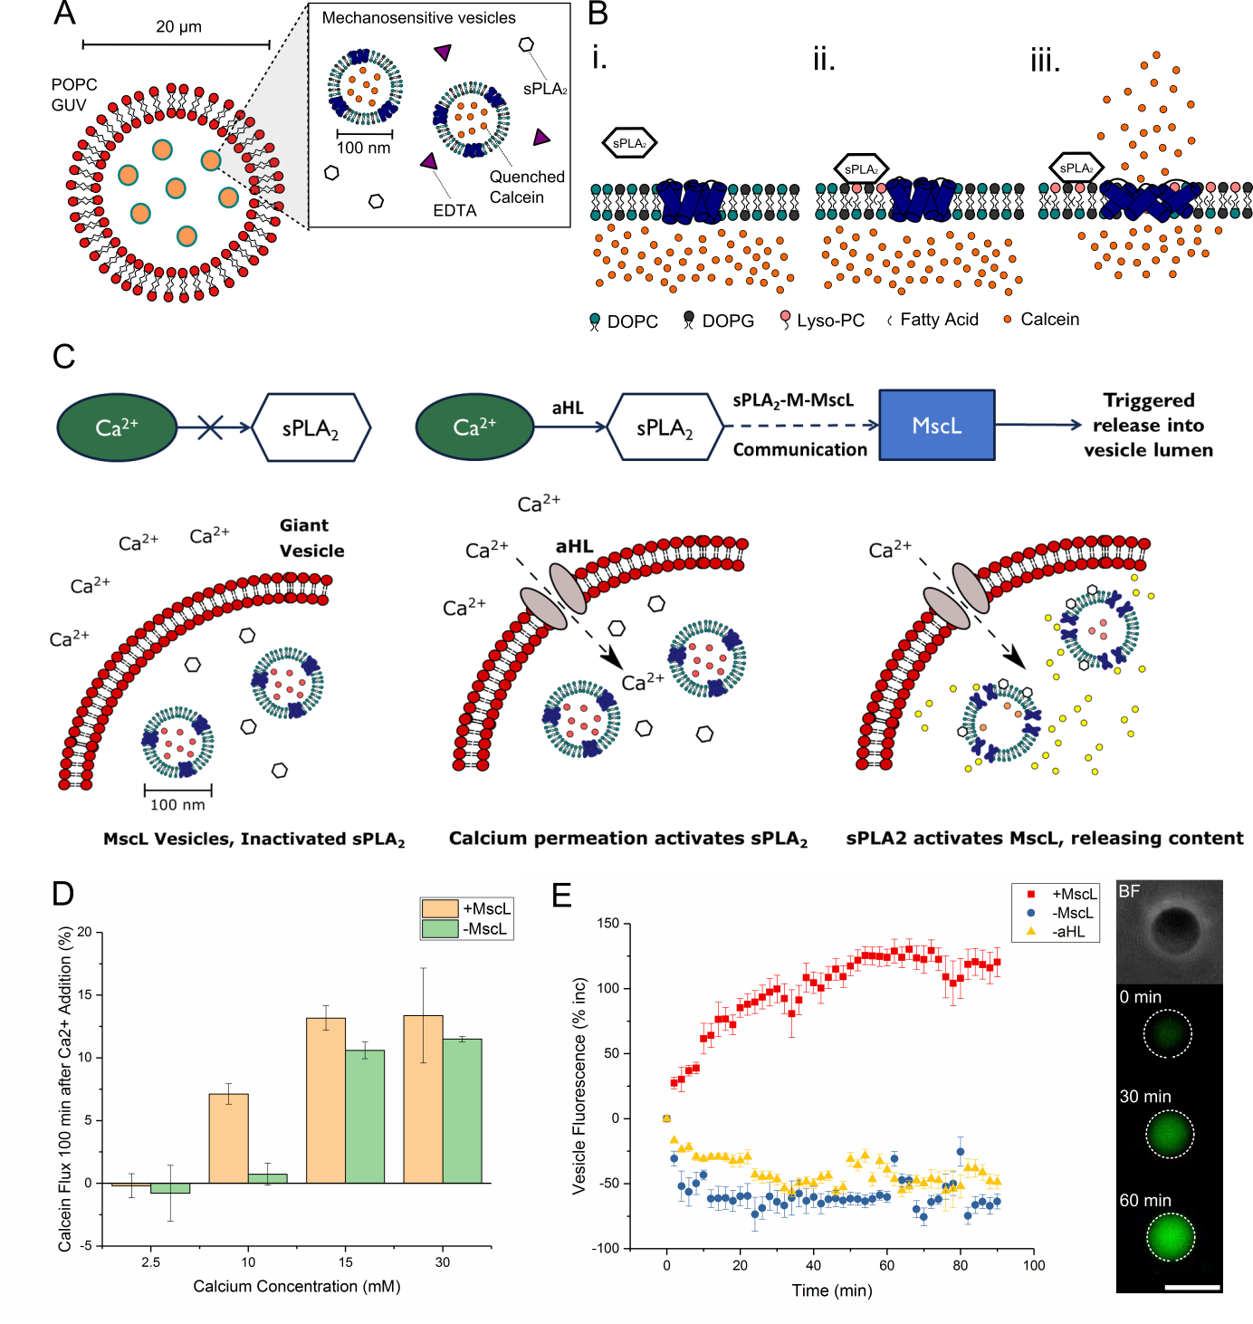**Figures Legends**

**Fig 1. Using the sPLA2-M-MscL network to build a syntheticmechanosensitive signaling pathway inside an artificial cell. A.** Composition of the nested artificial cell: a microscale POPC membrane encloses 1:1 DOPC:DOPG vesicles containing reconstituted mechanosensitive channel of large conductance (MscL), secretory phospholipase A2 (sPLA2) enzyme and EDTA to chelate trace calcium present in the artificial cell. **B.** Function of the sPLA2-M-MscL network. i. MscL is reconstituted into a DOPC:DOPG membrane and is closed in the absence of tension or asymmetry in the membrane. sPLA2 is added to the solution. ii. sPLA2 binds to the membrane and begins to catalyse the production of lyso-PC and a concomitant fatty acid. The asymmetric generation of lyso-PC begins to asymmetrically change the pressure profile of the lipid bilayer. iii. Once a critical amount of lyso-PC has been produced, MscL responds to the lateral pressure change by opening to form a 3-4 nm diameter pore in the lipid bilayer. Encapsulated cargo is then released across the membrane. **C.** The proposed functioning of the synthetic mechanosensitive signaling pathway. Ca2+ is prevented from entering the nested vesicle due to the presence of the outer POPC membrane. Permeabilization of the outer membrane (here accomplished with αHL) then results in a calcium influx, activating latent sPLA2 in the vesicle lumen. This activates the sPLA2-M-MscL network, resulting in content release (and potentially the control of downstream events) within the artificial cell. **D.** Monitoring activation of the mechanosensitive pathway with fluorescence spectroscopy. Successful activation is triggered by addition of ~10 mM Ca2+. Error bars represent 1 S.D. (n=3). **E.** Confirming activation of the pathway through fluorescence microscopy of individual nested vesicles. Both MscL and αHL are necessary to increase vesicle fluorescence (red squares), whilst absence of MscL (blue circles) or αHL (yellow triangles) prevents network activation. Error bars represent 1 S.E.M. (n=15/14/13 respectively). Inset highlights micrographs of a nested vesicle in bright field and 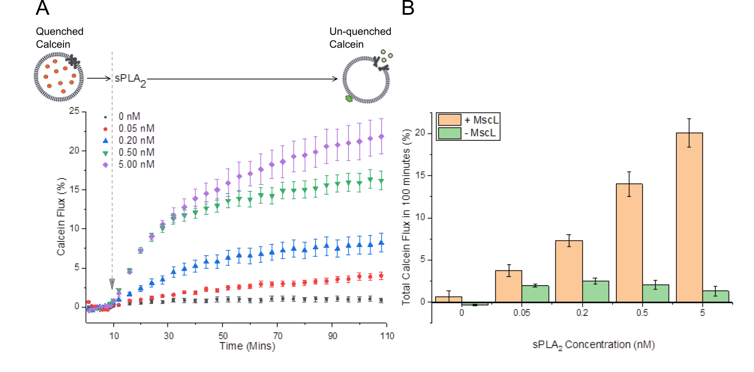fluorescence microscopy of pathway activation within the nested vesicle at t = 0, 30 and 60 minutes respectively. Scale bar = 10 μm for all images.

**Fig 2. MscL is essential for sPLA2-M-MscL Communication. A.** The release of calcein from 1:1 DOPC:DOPG vesicles can be monitored spectroscopically over time. sPLA2 is added at 10 minutes, before monitoring calcein fluorescence for 100 minutes. Release of calcein from vesicles results in a fluorescence increase as the dye dilutes in external solution and self-quenching becomes inefficient. Error bars show propagated error of 1 S.D. (n=3). **B.** Total calcein flux at 100 minutes for vesicles +/-MscL. sPLA2-concentration dependent calcein flux is only observed for vesicles containing MscL. Error bars show 1 S.D. (n=3).

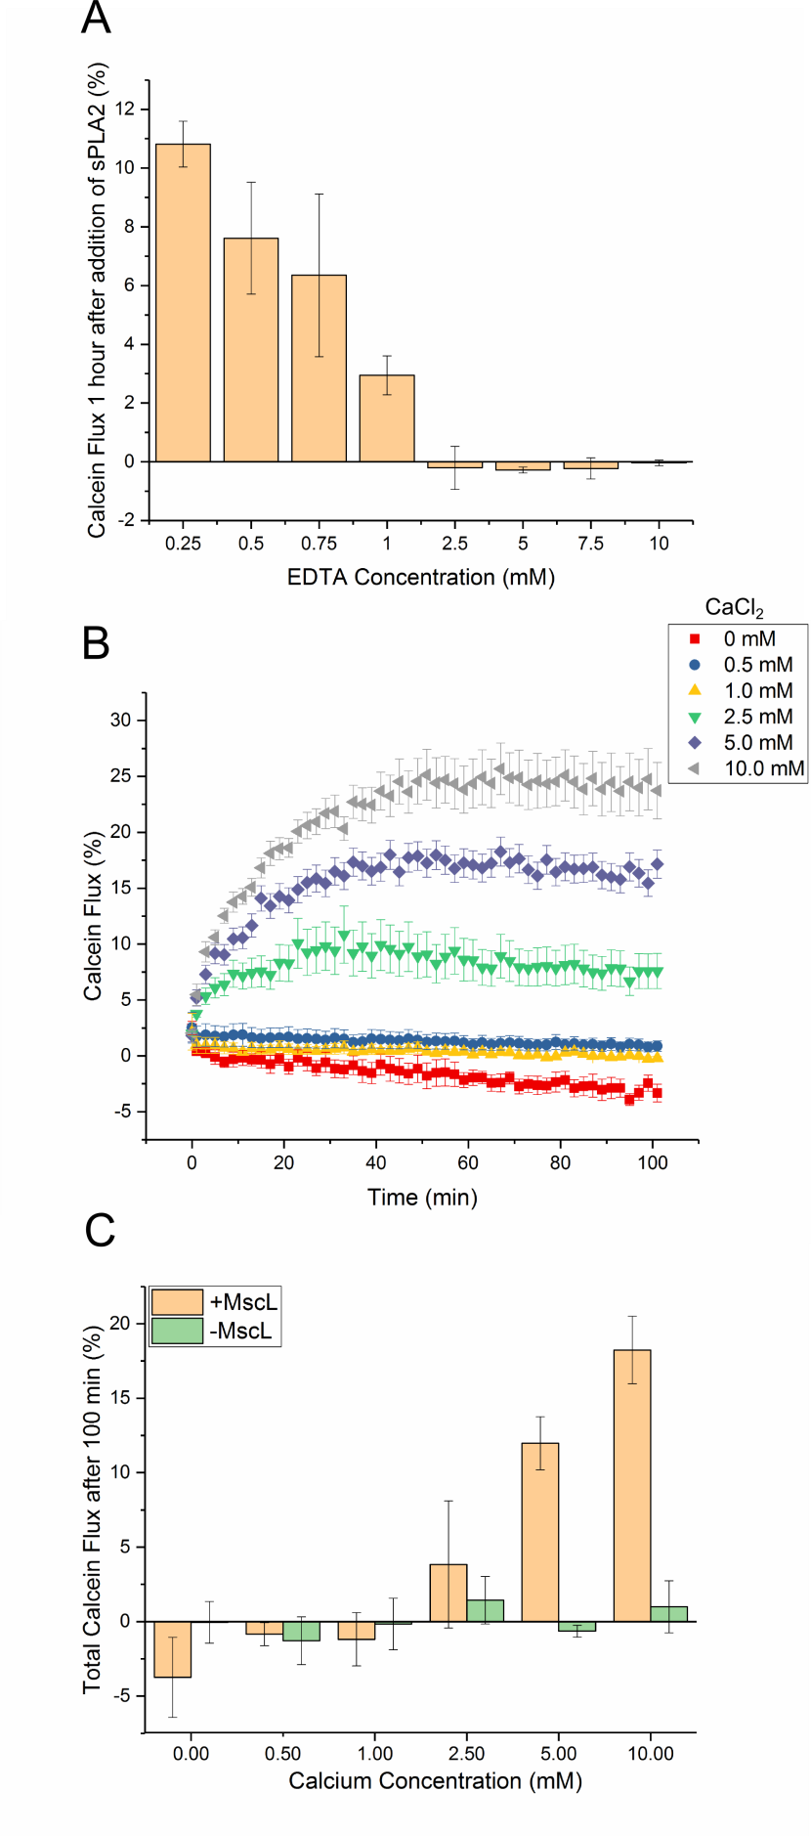

**Fig 3. The sPLA2-M-MscL network can be controlled through calcium chelation. A.** sPLA2 inactivation, and hence network activation can be achieved through addition of increasing concentrations of the Ca2+ chelator EDTA. Error bars = 1 S.D. (n=3). **B.** Monitoring reactivation of the network using calcein flux after addition of Ca2+ (0-10.0 mM) to solutions containing the network and 2.5 mM EDTA. Error bars show 1 S.D. (n=3). **C.** Total calcein flux after 60 minutes for 1:1 DOPC:DOPG vesicles +/- MscL showing that the MscL channel is necessary for network re-activation with Ca2+. Error bars show 1 S.D. (n=3).