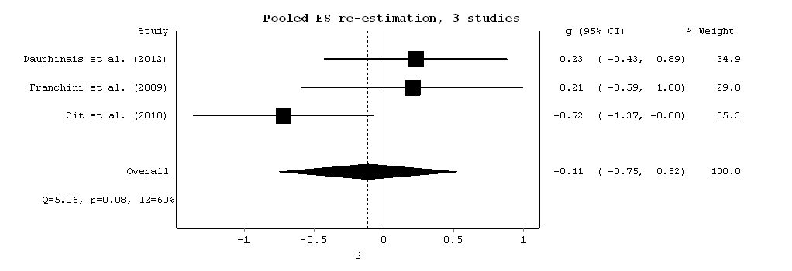

Favours [BLT] Favours [control]

Figure 1 Forest plot of post-intervention treatment effect sizes for scores of depressive symptoms. BLT, bright light therapy; CI, confidence interval.