**Nopal fiber (*Opuntia ficus-indica*) improves symptoms in irritable bowel syndrome in the short term: a randomized-controlled trial**

**Short running title:** Nopal fiber and irritable bowel syndrome

Jose M. Remes-Troche 1, Héctor Taboada-Liceaga1, Samantha Gill2, Mercedes Amieva-Balmori1, Megan Rossi 2, Gildardo Hernández-Ramírez1, José F García-Mazcorro 1, Kevin Whelan.2

1 Instituto de Investigaciones Médico-Biológicas, Universidad Veracruzana, Veracruz. Av. Iturbide s/n Entre Carmen Serdán y 20 de Nov. Col. Centro, C.P. 91700 Veracruz, Ver. Mexico.

2 King’s College London, Department of Nutritional Sciences, London, UK, SE1 9NH.

Corresponding author: Dr José María Remes-Troche. Instituto de Investigaciones Médico-Biológicas, Universidad Veracruzana, Veracruz. Av. Iturbide s/n Entre Carmen Serdán y 20 de Nov. Col. Centro, C.P. 91700 Veracruz, Ver. México.

**Email:** jose.remes.troche@gmail.com

**Authorship:** José M Remes-Troche is the guarantor of the article. Héctor Taboada-Liceaga, Mercedes Amieva-Balmori and Gildardo Hernández-Ramírez performed the research, collected and analyzed the data. Samantha Gill analyzed the data and contribute to write the paper. José F García-Mazcorro collected and analyzed the data. Megan Rossi and Kevin Whelan analyzed the data, designed the research study and contribute to write the paper. All authors approved the final version of the manuscript.

**Abstract**

**Background:** Clinical guidelines provide limited and conflicting recommendations regarding dietary fiber supplementation in irritable bowel syndrome (IBS). Nopal (*Opuntia ficus-indica*) is a cactus plant fiber containing both insoluble and soluble fibers that may have therapeutic potential in IBS. Our aim was to evaluate the dose-response effect of extracted nopal fiber powder on symptoms in IBS.

**Methods:** We performed a 4-arm, double-blind, parallel, randomized controlled trial in 60 patients fulfilling Rome IV criteria for IBS. Patients were randomized and blindly allocated to receive either nopal fiber (10g/d, 20g/d, or 30g/d) or placebo (30g/d dextrose) for one week and to keep their usual diet. Symptom severity (Global Symptom Question, IBS-SSS, Gastrointestinal Symptom Rating Scale), stool frequency and consistency (Bristol Stool Form Scale), breath hydrogen response and stool short-chain fatty acids (SCFA) were measured at baseline and follow-up.

**Key results:** Significantly more patients reported adequate relief of symptoms after 20 g/d (87%, p=0.008) and 30 g/d (80%, p=0.025) of nopal fiber compared to placebo (33%). More patients receiving 20 g/d nopal fiber (67%) had a >50% reduction in IBS-SSS compared to placebo (20%, p=0.027), whereas the 30 g/d dose induced more loose stools (p=0.027). Response rates were similar among IBS subtypes. There were no differences in breath hydrogen or stool SCFA between groups.

**Conclusions & inferences:** Nopal fiber supplementation at doses of 20 g/d and 30 g/d was associated with short-term improvement in IBS symptoms, warranting a fully powered clinical trial of longer duration with symptomatic, physiological and microbiological endpoints.

**Keywords:** irritable bowel syndrome, abdominal pain, nopal, prickly pear, fiber

**Introduction**

Dietary fiber plays a key role in optimizing gut function, exerting varying physiological effects in the gastrointestinal tract depending upon type and source.1 Fibers can differ in their chemical composition (e.g., distribution of different fiber fractions within a plant) and physical structure (e.g. degree of polymerization, molecular weight, carbon-carbon bonds), which can have a profound effect on its solubility, viscosity and fermentability.

The proposed mechanisms underpinning the therapeutic potential of dietary fiber in irritable bowel syndrome (IBS) include modulation of the microbiota and their metabolites, including short-chain fatty acids (SCFA) 2,3,4 in addition to regulating regional gut transit time and impacting stool form (e.g. stool bulking, stool softening).5,6Although numerous trials and systematic reviews of fiber in IBS have been performed the evidence for effectiveness are often conflicting,7,8,9 likely reflecting differences in dose and duration of the intervention, the limited understanding of the different types of dietary fibers investigated, and variations in their functions in different IBS sub-types.10 Previous studies have shown that dietary fibers could both improve and worsen symptoms of IBS patients.8,9,11 The largest problem with fiber intake is the formation of gas, which may lead to bloating, abdominal distension and flatulence, but this problem seems to be less prominent with soluble than with insoluble fibers.11,12 It is important to highlight that both soluble and insoluble fibers frequently co-exist in intact cell-walls of plants, and the physiological responses of the gut can differ independent of solubility.

Recently, focus has turned to the untapped potential of novel plant fibers in optimizing gastrointestinal health. Nopal is a crop native to Mexico, which, despite limited scientific review has been consumed for its health-promoting properties for thousands of years in rural communities.12 Nopal is approximately 50% dietary fiber, of which 26% is soluble (e.g. pectins, gums) and 74% insoluble (e.g. cellulose, lignin).13 There are potential functionalities including *in vitro* evidence of prebiotic effects similar to that observed with inulin (increasing *Bifidobacterium spp*. and decreasing *Enterobacteriacea*)14 and stool forming benefits similar to psyllium.15 Yet to date, the potential therapeutic effects of nopal in the management of IBS is absent. With this in mind, the aim of the present study was to evaluate the dose-response effect of extracted nopal fiber powder on symptoms in IBS.

**Material and methods**

***Subjects and recruitment***

Subjects were recruited to the Functional Digestive Disorders Clinic and Motility Laboratory at the University of Veracruz between January and May 2017. Inclusion criteriawere: a diagnosis of IBS fulfilling Rome IV criteria, in the absence of alarm signs such as anemia, weight loss, fever or bloody stools and only patients who did not have adequate relief of their IBS symptoms. The exclusion criteria included: co-morbidities (including diabetes mellitus, cardiovascular disease) and surgical history (except appendectomy), the use of prebiotics, probiotics, other dietary interventions (low FODMAP diet, gluten-free diet) and medications (including antibiotics such as rifaximin, laxatives, antidiarrheals or antispasmodics) in the preceding4 weeks. This trial was approved by the University of Veracruz Research Ethics Committee (registration number CEI-UV 2017-0013) and performed in accordance with the Declaration of Helsinki. Participants provided written informed consent before the collection of any research data.

***Study design and protocol***

This was a 4-arm, double-blinded, parallel, randomized controlled trial designed (Figure 1) to compare the effects of nopal fiber at different doses (10g/d, 20g/d, 30g/d) with placebo (30g/d dextrose). One week before the intervention, demographic and anthropometric (weight, height, BMI) data were recorded. At baseline, one day prior to intervention, gastrointestinal symptoms were reported using the Global Symptom Question (‘do you have adequate relief of your IBS symptoms?’), IBS Symptom Scoring System (IBS-SSS, recalled over the previous 10 days)16 and the Gastrointestinal Symptom Rating Scale (GSRS, recalled over the previous 7 days)17 and stool consistency and frequency were reported using the Bristol Stool Form Scale (BSFS, average recalled over the previous 14 days).18

Baseline breath hydrogen (H2) and methane (CH4) were also recorded (Gastro CH4ECK, Bedfont® Scientific Ltd, UK) and a stool sample was collected to measure short-chain fatty acid (SCFA) concentrations.

After recording all baseline values, eligible patients were randomly allocated to one of four groups: 10 g/d nopal fiber (mixed with 100 ml water); 20 g nopal fiber (mixed with 200 ml water); and 30 g nopal fiber (mixed with 300 ml water), or placebo (30 g dextrose mixed with 300 ml water). Randomization was stratified by sex and IBS-D (as IBS-D is the least prevalent IBS subtype in the Mexican population).19 Allocation to the four groups occurred using a 1:1:1:1 ratio. A random allocation sequence was prepared using a random number generator undertaken by a researcher not involved in participant recruitment. Allocation was sealed in an opaque envelope and allocation was not revealed until all data had been analyzed.

The nopal fiber was provided by Nopal Export (Morelos, Mexico) in powdered, dehydrated form in individual sealed bags of 10g, 20g and 30g doses. The nopal fiber is obtained from healthy and mature leaves (cladiodes) of the *Opuntia ficus Indica* plant. In the process the leaves are rinsed, washed manually and sanitized with hydrogen peroxide. Then, the leaves are sun dried until an optimal humidity is reached and finally, using a mill, a fine and uniform powder is obtained and packaged. The nopal powder is a greenish brown powder with a light musky smell and a strong cactus flavor. The strong hydrophilic and gelling properties of the nopal fiber have been related with a slimy mouth feeling. The chemical composition of the nopal powder was analyzed by Medallion Labs (Minneapolis, MN, USA), and contained 37.6% insoluble fiber, 13.2% soluble fiber, <2% starch, 4.7% fructose, 3.6% glucose and 1.8% fructans, though nutritional composition will vary depending on the maturity of the cactus plant (Medallion Labs, Minneapolis, MN, USA).20

To ensure adequate blinding, the placebo (dextrose) was mixed with a natural green colorant and added to individual sealed opaque bags identical to those containing nopal. Patients were asked to dissolve each bag in a specified amount of water using a black plastic shaker bottle (10 g/d nopal fiber mixed with 100 ml water; 20 g nopal fiber mixed with 200 ml water; 30 g nopal fiber mixed with 300 ml water; and 30 g dextrose mixed with 300 ml water). Patients were then instructed to consume the nopal or placebo before breakfast for the subsequent 6 days using the same method and to adhere to their habitual dietary intake.

During the 7-day intervention period, patients were asked to complete a daily symptom and stool diary. Symptoms were measured daily using the GSRS for 15 different symptoms, rated using a 4-point Likert scale (0 absent, 1 mild, 2 moderate, 3 severe). Stool consistency and frequency were assessed daily using the Bristol Stool Form Scale (BSFS), a 7-point scale used to determine normal or altered bowel habits by classifying stool form ranging from type 1 (hard stool) to type 7 (watery stool).18 Patients were also asked to report any side-effects of the supplement.

Patients returned to the laboratory on day 8 and Global Symptom Question (‘do you have adequate relief of your IBS symptoms?’, recalled over the previous 7 days), IBS Symptom Scoring System (IBS-SSS, recalled over the previous 7 days), Gastrointestinal Symptom Rating Scale (GSRS, recalled over the previous 7 days) were repeated. Also, a repeat breath hydrogen (H2) and methane (CH4) were also recorded and a repeat stool sample was collected. Supplement acceptability was assessed at the end of the trial, using a 5 item (taste, aroma, texture, appearance and overall) visual analogue scale from 0 (not at all tolerable) to 10 (extremely tolerable).

***Short-chain fatty acids***

Homogenized fresh stools were frozen at −80 °C until analysis and were analyzed for SCFA using gas liquid chromatography at King’s College London. SCFA were extracted from defrosted stool in a stomacher using extraction buffer containing an internal standard (2,2-dimethylbutyric acid), as previously described.21 Extracted SCFA (0.2 μl) were separated in duplicate on a 7890A Aligent Technology gas–liquid chromatography system equipped with a 220 μm internal diameter, 25 m fused silica capillary column with a film thickness of 0.25 μm (ID-BP21, SGE, Australia). The initial oven temperature was 80 °C, increasing to 145 °C at 10°C/min and then increasing to 200°C at 100°C/min until full elution. All chromatograms were automatically integrated using the Agilent Chromatogram database (Agilent Technologies, US). The identities of the individual SCFA were established through retention time matching with authentic reference standards included in each analytical batch. Quantitation was achieved using the method of internal standardization across a four-level calibration for each SCFA.

***Sample size calculation***

The sample size estimation was calculated for the primary outcome (adequate relief of IBS symptoms using the GSQ). There was no published data on the effectiveness of nopal in IBS, therefore the sample size was calculated assuming the response to placebo would be 35% and to exposure to any dose of nopal fiber would be at least 70% exposure. To detect this effect size at a power of 0.95 and a 0.01 level of significance (to account for multiple comparisons), we anticipated this pilot study would require 17 patients in each arm (68 patients in total). Patients were recruited consecutively until the study was completed. As a pilot study to investigate the optimal dosage and sample size required to inform a fully powered randomized controlled trial, this study was not pre-registered on a clinical trial database.

***Statistical analysis***

The primary outcome was the proportion of patients reporting adequate relief of IBS following nopal compared with placebo at the end of the treatment. Secondary outcomes included IBS symptoms (IBS-SSS, GSRS), and stool output (BSFS) compared between groups. Change in stool consistency was defined as an increase or a decrease of at least 1 point in the final BSFS compared to the baseline. In the case of constipation improvement means a reduction in consistency and in diarrhea an increase. The primary outcome (adequate relief) and other categorical variables (e.g. sex, IBS subtype, number of patients with >50% improvement in IBS-SSS) were compared between groups using the chi-squared test. Continuous variables (e.g. GSRS scores, IBS-SSS, number of days with pain, breath H2 and CH4 concentrations, SCFA, pH) were compared using ANOVA with Bonferroni post hoc correction to detect differences between individual groups. Differences were considered significant when p<0.05. All statistical analyses were performed using SPSS v15 (IBM, Chicago, Illinois, US)

**Results**

***Demographic characteristics***

A total of 68 patients (51 females, 17 males; mean age 34.2 ± SD 13.5, range 24-68) were screened for eligibility. Eight patients were excluded of whom six did not meet eligibility criteria (four started new IBS medications, two had major organ disorders) and two were uncontactable after the baseline visit. Therefore, data for 60 patients who completed their intervention were analyzed (15 patients in each arm) (**Figure 2**). Each arm included 7 IBS-C, 5 IBS-M, and 3 IBS-D. Twenty patients (33%) were methane producers on breath testing. Baseline demographic characteristics are provided in **Table 1**.

***Gastrointestinal symptoms and stool output***

Forty of the 60 patients (66%) reported adequate relief of gastrointestinal symptoms at the end of trial. Response rates were similar among IBS subtypes (61% IBS-C, 75% IBS-D, 65% IBS-M, p=0.686). There were no significant differences in adequate relief between sex (p=0.545) or age (p=0.394).

Compared with placebo, a significantly higher proportion of patients reported adequate relief after consuming 20g/d and 30 g/d of nopal, but not after consuming 10 g/d (**Figure 3a**). Compared with placebo a significantly greater proportion of patients experienced >50% reduction in IBS-SSS after consuming 20g/d of nopal but not with 10 g/d or 30 g/d (**Figure 3b**).

There were significant reductions in total GSRS and IBS-SSS scores between baseline and end of trial for all groups, however, the end of trial values were significantly lower in all of the fiber groups compared with placebo, with the largest reduction observed in those consuming the 20g/d dose (**Table 2**). In addition, for all doses of fiber seven symptoms were significantly reduced between baseline and end of trial (abdominal pain, borborygmi, bloating, constipation, urgency, incomplete evacuation, tiredness). All domains of the IBS-SSS significantly reduced between baseline and end of trial for both 20 g/d and 30 g/d groups, as did the total IBS-SSS score (**Table 2**). A significant reduction in the number of days with pain was observed in the group consuming 20g/d of nopal compared to other groups (p=0.05) (**Table 2**). Stool consistency significantly improved in patients consuming 30g/d nopal compared to placebo (p=0.027), but not between other groups and placebo. No differences in stool frequency were observed between baseline and end of trial or between groups (**Table 2**).

The percentage of subjects that report a change in stool consistency among IBS-subtypes after each intervention is shown in **Figure 4**. Nopal fibre at the 10 g, 20 g and 30 g improve consistency in patients with IBS-C. In IBS-D, the 20 g dose improves consistency in all cases. In IBS-M, the 10 g dose in general did not produce any changes in the BSFS, whereas the 20 g and 30 g dosages reduced or increased the patients’ stool in similar proportions. We found a statistically significant improvement for incomplete evacuation sensation in IBS-C subjects whom received either with 20 g (p=0.004) or 30 g (p=0.003) of nopal fiber (**Table 3).** No differences in urgency were observed between baseline and end of trial or between groups.

***Tolerability and side-effects***

Supplement acceptability is shown in **Table 4.** There were no differences among the four interventions, but nopal 20 g had the highest overall acceptability. However, four patients (27%) in the 10 g/d, five patients (33%) in the 20 g/d and four patients (27%) in the 30 g/d group reported that the nopal supplement had an unpleasant taste. One patient (7%) in the 20 g/d and two patients (13%) in the 30 g/d group reported an episode of diarrhea, though all continued the intervention. There was no difference in mild-moderate bloating at the end of the trial between groups.

***Breath gases and stool short-chain fatty acids***

There were no significant differences in breath hydrogen or breath methane values between groups at baseline nor were there differences after intervention (**Table 5**). There were also no significant differences in SCFA between groups at baseline nor were there differences after intervention (**Table 5**).

**Discussion**

In this 7-day randomized controlled trial we found that a novel fiber supplement from the Mexican nopal cactus improved adequate relief in patients with IBS, irrespective of IBS subtype, sex or age, compared to placebo. Notably, a dose of 20 g/d and 30 g/d resulted in the most favorable effects, suggesting that these doses may have potential clinical effectiveness in IBS management.

Previous studies have demonstrated that high intake of insoluble fibers increases water content and fecal bulking, resulting in accelerated GI transit time. This is a likely explanation of the benefit of high dietary fiber intake in IBS-C patients. However, the largest problem with fiber intake is the formation of gas, which may worsen symptoms of IBS patients. Our results are consistent with previous systematic reviews and meta-analysis showing improvements in IBS symptoms with fiber supplementation, particularly with soluble fibres.6,7 The recommendation of solely soluble fibers has its limitations, since the distinction of fibers in terms of insoluble and soluble has been proposed to be partly outdated. Both soluble and insoluble fibers frequently co-exist in intact cell-walls of plants, and the physiological responses of the gut can differ independent of solubility.22

Nopal contains a characteristically diverse group of soluble and insoluble fibers that have different physiological functions in the gastrointestinal tract. It is plausible that this combination of functionalities may in part explain the underlying mechanisms behind its effectiveness in alleviating symptoms of IBS in the current study. Insoluble fibers (e.g. cellulose) are resistant to fermentation by the gut microbiota and remain intact throughout the large intestine, while soluble fibers (e.g. some hemicelluloses and gums) have a high water-holding capacity, thereby inducing intraluminal water retention. Both therefore contributing to stool bulking, which stimulates peristalsis and normalizes gut transit time, although these were not measured in the current study. Meanwhile soluble fibers contribute to stool softening and therefore improves stool consistency in those with hard stools. According to our results, nopal appeared to normalize stool consistency, suggesting nopal elicits a regulatory effect starting at 10 g dose.

Evidence suggests that the therapeutic effect of fiber is greater when more than 15 g/d are consumed, which can be easily obtained with a 30 g/d dose of nopal (15.2 g/d total fiber). Fresh nopal stems contain a high amount of water (approximately 90%). However, used in its dehydrated form, the nopal supplement used in this study equated to 50.8% fiber (i.e. 10 g nopal = 5.1 g fiber, 20 g nopal = 10.2 g fiber, 30 g nopal = 15.2 g fiber). These fiber doses are reflective of those used in previous studies of fiber including bran, linseeds and other fiber supplements in the range of 3.5 to 15 g/d.11,23

Regarding the improvement in all IBS subtypes is important to mention that our results are like those reported by others using psyllium. Bijkerk et al 11 found that fiber supplementation with psyllium decrease abdominal pain in IBS patients, irrespectively of the subtypes. The mechanism of action across all IBS subtypes of nopal fiber is uncertain. It is likely that in addition to the effect on increased stool volume as well as changes in the microbiota, nopal exerts anti-inflammatory effects mediated by other metabolites. It has been described that nopal has a higher concentration of calcium, β-carotene and lutein than other vegetables.24,25

Fibers, and in particular prebiotic fibers, are well-known for their impact on the gut microbiome and in particular increasing bifidobacterial.26 However, in IBS these rapidly fermentable prebiotic fibers can be problematic, contributing to gas production and symptoms including bloating and abdominal pain,27-29and thus trials specifically of prebiotic fibers have failed to show significant beneficial improvement in IBS symptoms.30 Compositional analysis revealed that nopal contains small amounts of fructans (<2%) and so as a partially fermented fiber, may be better tolerated in those with IBS. The absence of changes in breath hydrogen and methane levels across all groups supports this premise, but also may be related to an adaptation of the microbiota as has been shown with other prebiotic fibers. Emerging evidence suggests that pectins and gums which may be better tolerated in those with IBS, have bifidogenic properties.31,32 With this in mind, it’s possible nopal may have provided a modulatory effect on the gut microbiota, though no microbial sequencing was undertaken in this study to confirm this. The need for a larger adequately controlled RCT is warranted to elucidate these potential underpinning mechanisms.

SCFAs, particularly butyrate, propionate and acetate are well-known for their health-promoting effects in the large intestine. In the current study, despite an acute dose of nopal fiber for 7 days, no differences in individual or total SCFAs were observed between any of the groups. To date, research reporting SCFA production after fiber interventions shows widely varying responses. Most recently, a meta-analysis of 25 RCTs (870 participants) reported that fiber had no effect on total stool SCFAs concentrations, nor acetate or propionate concentrations in healthy populations, although overall it increased butyrate concentrations compared with placebo or a low fiber comparator, though considerable heterogeneity was present.26 Finally, stool SCFA concentrations are not an accurate measure of colonic SCFA production, as at least 95% of SCFA are absorbed in the colon and stool concentrations are therefore affected by changes in colonic transit time.33

There were significant reductions in IBS-SSS scores following intervention in all groups (data not shown), including the placebo group (glucose), which reflects the findings of previous clinical trials in IBS showing a significant placebo effect;34,35 though the largest differences were observed across all nopal groups.

This study is not without its limitations. Firstly, this study only investigated the acute effects of nopal on gastrointestinal symptoms. Studies that investigate the impact of nopal on IBS symptoms over several months and combine this with studies on gut transit time and microbiome are warranted. Secondly, while ‘adequate relief’ as an outcome measure is commonly used in IBS trials, it is limited in that it provides no detail regarding individual symptoms that are likely to vary from person to person, and it is not possible to quantify the level of symptom improvement reported. Also, we recognize that patients could guess if they received either placebo (sweet taste) or nopal fiber (bad taste) but we need to emphasize that with natural products it is not easy to blind. It is difficult to makeup a placebo of natural products (including fiber or herbal medicine) because of special color, taste and smell, etc. Currently, there is no specific requirements and standards for the creation of a natural fibre-placebo.36 Although we recommend to patients to kept in their regular diet, we did not record habitual dietary intake and potential for consumption of other dietary triggers including fiber and FODMAPs.37 Finally, for sample size calculation we assume that placebo solution will have a response of at least 35% , as reported by Ford et al.38 (95% IC 34.4-40.6%), while nopal fiber will have a response at least twice than placebo.

In conclusion, nopal fiber supplementation at doses of 20 g and 30 g was well tolerated and associated with an adequate relief in IBS. IBS-SSS symptom scores were significantly lower compared to placebo, with the largest reduction observed in those who consumed 20 g/d of nopal. The 20 g dosage seems to be the most appropriate dose for all subtypes of IBS, warranting a longer-term larger adequately controlled RCT of longer duration and with symptomatic, physiological and microbiological outcomes.

**Conflict of interest:** JRT is memberof Takeda’s Advisory Board Pharmaceuticals, Alfa-Wasserman and Almirall, speaker for Takeda, Asofarma, Alfa-Wassermnan, Almirall and Astra-Zeneca. MABis a speaker for Takeda and Sanfer. KWhas served as a consultant for Danone, has received research funding from Clasado Biosciences, Nestec Ltd, Almond Board of California and the International Nut and Dried Fruit Council, and is co-inventor of a mobile application to assist patients following the low FODMAP diet.The remaining authors have no conflicts of interest to report.

**Funding:** This research was financed by the Medical Research Council (UK) -CONACYT (FONCYCIT, 1000-830-2016, Mexico), 2015.

**References**

1.- Scientific Advisory Committee on Nutrition. Carbohydrates and Health. England, London, 2015. <https://www.gov.uk/government/publications/sacn-carbohydrates-and-health-report>

2.- Dimidi E, Whelan K. Food supplements and diet as treatment options in irritable bowel syndrome. Neurogastroenterol Motil. 2020;32(8):e13951. doi:10.1111/nmo.13951

3.- Martinez I, Kim J, Duffy PR, et al. Resistant starches types 2 and 4 have differential effects on the composition of the fecal microbiota in human subjects. PLoS One. 2010;5: e15046.

4.- Mayer, EA, Savidge, T, Shulman, RJ. Brain-gut microbiome interactions and functional bowel disorders. Gastroenterology 2014; 146: 1500-12.

5.- Major G, Murray K, Singh G, et al. Demonstration of differences in colonic volumes, transit, chyme consistency, and response to psyllium between healthy and constipated subjects using magnetic resonance imaging. Neurogastroenterol Motil. 2018;30(9):e13400.

6.- Mehmood MH, Aziz N, Ghayur MN, et al. Pharmacological basis for the medicinal use of psyllium husk (Ispaghula) in constipation and diarrhea. Dig Dis Sci 2011; 56: 1460-71.

7.- Suares NC, Ford AC. Systematic review: the effects of fiber in the management of chronic idiopathic constipation. Aliment Pharmacol Ther 2011;33:895-901.

8.- Moayyedi P, Quigley EM, Lacy BE, et al. The effect of fiber supplementation on irritable bowel syndrome: a systematic review and meta-analysis. Am J Gastroenterol 2014 ;109:1367-74.

9.- Rao SS, Yu S, Fedewa A. Systematic review: dietary fiber and FODMAP-restricted diet in the management of constipation and irritable bowel syndrome. Aliment Pharmacol Ther. 2015;41:1256-70.

10.- Bijkerk CJ, Muris JWM, Erus JAK, Hoes AW. De Wit NJ. Systematic review: The role of different types of fibre in the treatment of irritable bowel syndrome. Aliment. Pharmacol. Ther. 2004;19:245–251. d

11.- Bijkerk CJ, de Wit NJ, Muris JW, Whorwell PJ, Knottnerus JA, Hoes AW. Soluble or insoluble fiber in irritable bowel syndrome in primary care? Randomised placebo-controlled trial. BMJ. 2009;339:b3154.

12.- Ríos-Hoyo A, Romo-Araiza A, Meneses-Mayo M, Guttiérrez-Salmeán G. Prehispanic Functional Foods and Nutraceuticals in the Treatment of Dyslipidemia Associated to Cardiovascular Disease: a Mini-Review. Int J VitamNutr Res. 2017; 87;58-98.

13.- Saenz, C, Sepulveda, E, Pak, N, et al. Chemical and Physical Characterization of Cactus Cladode (Opuntia Ficus Indica) Powder. Italian J Food Sci 2010, 22: 416-22.

14.- Guevara-Arauza, JC, Ornelas-Paz, JD, Pimentel-Gonzalez, DJ, et al.: Prebiotic effect of mucilage and pectic-derived oligosaccharides from nopal (Opuntia ficus-indica). Food Sci and Biotech 2012, 21: 997-1003.

15.- Stintzing FC, Carle R. Cactus stems (Opuntia spp.): a review on their chemistry, technology, and uses. Mol Nutr Food Res 2005, 49: 175-94.

16.- Francis CY, Morris J, Whorwell PJ. The irritable bowel severity scoring system: a simple method of monitoring irritable bowel syndrome and its progress. Aliment Pharmacol Ther. 1997;11(2):395-402.

17.- Kulich KR, Madisch A, Pacini F, et al. Reliability and validity of the Gastrointestinal Symptom Rating Scale (GSRS) and Quality of Life in Reflux and Dyspepsia (QOLRAD) questionnaire in dyspepsia: a six-country study. Health Qual Life Outcomes 2008; 6:12.

18.- Blake MR, Raker JM, Whelan K. Validity and reliability of the Bristol Stool Form Scale in healthy adults and patients with diarrhoea-predominant irritable bowel syndrome. Aliment Pharmacol Ther 2016;44:693-703.

19.- Amieva-Balmori M, Meixueiro A, Canton P, Remes-Troche JM. Su2059 Prevalence of Irritable Bowel Syndrome in Mexico. A Nationwide Population Based Study Using the ROME III Questionnaire. Gastroenterology 2014;146 (Suppl 1): 535.

20.- Rodriguez-Garcia ME, de Lira C, Hernández-Becerra E, et al 2007. Physicochemical characterization of nopal pads (Opuntia ficus indica) and dry vacuum nopal powders as a function of the maturation. Plant Foods Hum Nutr 2007;62:107-12.

21.- Whelan K, Judd PA, Preedy VR, Simmering R, Jann A, Taylor MA. Fructooligosaccharides and fiber partially prevent the alterations in fecal microbiota and short-chain fatty acid concentrations caused by standard enteral formula in healthy humans. J Nutr 2005; 135: 1896–1902.

22.- McCleary BV, De Vries J, Rader J, Cohen G, Prosky L, Mugford DC, Champ M, Okuma K. Determination of Insoluble, Soluble, and Total Dietary Fiber (CODEX Definition) by Enzymatic-Gravimetric Method and Liquid Chromatography: Collaborative Study. J AOAC Int. 2010;93:221–233.

23.- Cockerell KM, Watkins AS, Reeves LB, Goddard L, Lomer MC. Effects of linseeds on the symptoms of irritable bowel syndrome: a pilot randomized controlled trial. J Hum Nutr Diet 2012;25:435-43.

24.-Betancourt-Domínguez MA, Hernández-Pérez T, García-Saucedo P, Cruz-Hernández A, Paredes-López O (2006) Physico-chemical changes in cladodes (nopalitos) from cultivated and wild cacti (Opuntia spp.). Plant Foods Hum Nutr 61:115–119.

25.- Contreras-Padilla M, Gutiérrez-Cortez E, Valderrama-Bravo Mdel C, et al. Effects of drying process on the physicochemical properties of nopal cladodes at different maturity stages. Plant Foods Hum Nutr. 2012;67(1):44-49.

26.-So D, Whelan K, Rossi M, et al. Dietary fiber intervention on gut microbiota composition in healthy adults: a systematic review and meta-analysis.Am J ClinNutr 2018 ;107:965-983.

27.- Major G, Pritchard S, Murray K, et al. Colon hypersensitivity to distension, rather than excessive gas production, produces carbohydrate-related symptoms in individuals with irritable bowel syndrome. Gastroenterology 2017;152:124-133.

28.-McIntosh K, Reed DE, Schenider T, et al 2017. FODMAPs alter symptoms and the metabolome of patients with IBS: a randomized controlled trial. Gut 2017;66:1241-1251.

29.- Staudacher HM, Whelan K. The low FODMAP diet: recent advances in understanding its mechanisms and efficacy in IBS.Gut 2017;66:1517-1527.

30.- Wilson B, Rossi M, Dimidi E, Whelan K. Prebiotics in irritable bowel syndrome and other functional bowel disorders in adults: a systematic review and meta-analysis of randomized controlled trials. Am J ClinNutr 2019;109(4):1098-1111.

31- Hotchkiss AT, Olano-Martin E, Grace WE, Gibson GR, Rastall RA. Pectic Oligosaccharides as Prebiotics. in ACS Symposium Series 2003; 849:54-62

32.- Russo L, Andreozzi P, Zito FP, et al. Partially hydrolyzed guar gum in the treatment of irritable bowel syndrome with constipation: effects of gender, age, and body mass index. Saudi J Gastroenterol 2015;21:104-10.

33.- Lewis SJ, Heaton KW. Increasing butyrate concentration in the distal colon by accelerating intestinal transit.Gut 1997;41:245-51.

34.- Staudacher HM, Lomer MCE, Farquharson FM,et al . A Diet Low in FODMAPs Reduces Symptoms in Patients With Irritable Bowel Syndrome and A Probiotic Restores Bifidobacterium Species: A Randomized Controlled Trial. Gastroenterology 2017 ;153:936-947.

35.- Patel SM, Stason WB, Legedza A, et al. The placebo effect in irritable bowel syndrome trials: a meta-analysis. Neurogastroenterol Motil 2005;17:332-40.

36.- Zhang X, Tian R, Zhao C, Tang X, Lu A, Bian Z. Placebo design in WHO-registered trials of Chinese herbal medicine need improvements. BMC Complement Altern Med. 2019;19(1):299.

37.- O'Keeffe M, Jansen C, Martin L, et al. Long-term impact of the low-FODMAP diet on gastrointestinal symptoms, dietary intake, patient acceptability, and healthcare utilization in irritable bowel syndrome. Neurogastroenterol Motil. 2018;30(1):10.1111/nmo.13154.

38.- Ford AC, Moayyedi P. Meta-analysis: factors affecting placebo response rate in the irritable bowel syndrome. Aliment Pharmacol Ther. 2010;32(2):144-58.

**Table 1.- Demographic characteristics and clinical characteristics of 60 patients with IBS in the four groups**

|  |  |  |  |  |  |
| --- | --- | --- | --- | --- | --- |
|  | **Placebo**  **(n=15)** | **Nopal 10g/d (n=15)** | **Nopal 20g/d (n=15)** | **Nopal 30g/d (n=15)** | **P value** |
| Sex, n (%) |  |  |  |  | 0.515 |
| Female | 13 (87%) | 10 (67%) | 12 (80%) | 12 (80%) |  |
| Male | 2 (13%) | 5 (33%) | 3 (21%) | 3 (20%) |  |
| Age, years, mean (SD) | 34 (16) | 30.6 (12) | 38.8 (17) | 34.6 (13.9) | 0.400 |
| BMI, kg/m2, mean (SD) | 27 (5) | 25.4 (4) | 26.9 (3) | 28.2 (3) | 0.367 |
| IBS subtype, n (%) |  |  |  |  | 1.000 |
| Constipation | 7 (47%) | 7 (47%) | 7 (47%) | 7 (47%) |  |
| Diarrhoea | 3 (20%) | 3 (20%) | 3 (20%) | 3 (20%) |  |
| Mixed | 5 (33%) | 5 (33%) | 5 (33%) | 5 (33%) |  |

P values compare categorical data using a chi squared test and compare continuous data using ANOVA

**Table 2.-Symptoms and stool output before and after treatment in the four groups**

|  |  |  |  |  |  |  |  |  |  |  |  |  |
| --- | --- | --- | --- | --- | --- | --- | --- | --- | --- | --- | --- | --- |
|  | **Placebo (n=15)** | | | **Nopal 10 g/d (n=15)** | | | **Nopal 20 g/d (n=15)** | | | **Nopal 30 g/d (n=15)** | | |
|  | **Baseline** | **Final** | **P value** | **Baseline** | **Final** | **P value** | **Baseline** | **Final** | **P value** | **Baseline** | **Final** | **P value** |
| **GI symptom rating scale**  Abdominal pain  Heartburn  Acid reflux  Nausea  Borborygmi  Bloating  Belching  Flatulence  Constipation  Diarrhea  Loose stool  Hard stool  Urgency  Incomplete evacuation  Tiredness  Total score | 1.1 (0.8)  1.2 (0.7)  0.8 (0.5)  0.8 (0.8)  1.4 (0.6)  1.8 (0.6)  0.9 (0.4)  1.2 (0.5)  1 (1)  0.2 (0.5)  0.8 (0.7)  0.9 (0.4)  0.4 (0.6)  1.4 (0.9)  0.8 (0.6)  17.1 (5) | 0.7 (0.5)  1 (0.8)  0.7 (0.7)  0.5 (0.6)  1.6 (0.7)  1.4 (0.9)  0.8 (0.6)  1.2 (0.7)  0.4 (0.7)  0.3 (0.5)  0.6 (0.9)  0.4 (0.3)  0.5 (0.6)  1.2 (1)  0.5 (0.6)  12.9 (6) | **0.028**  0.433  0.774  0.104  0.054  **0.029**  0.582  1.000  0.057  1.000  0.150  0.378  0.670  0.271  **0.041**  **0.001** | 1.1 (0.3)  1.2 (0.8)  0.6 (0.6)  0.5 (0.5)  1.5 (0.6)  1.9 (1)  1 (0.8)  1.5 (0.6)  1.1 (0.5)  0.6 (0.3)  0.6 (0.5)  0.8 (0.5)  0.5 (0.7)  1.5 (1)  1 (0.7)  15.9 (5) | 0.3 (0.3)  1.1 (0.3)  0.5 (0.6)  0.7 (0.2)  0.6 (0.6)  0.5 (0.5)  0.7 (0.6)  0.9 (0.4)  0.6 (0.3)  0.2 (0.5)  0.7 (0.4)  0.7 (0.3)  0.1 (0.3)  0.4 (0.6)  0.4 (0.5)  5 (4.7) | **0.003**  0.813  0.654  0.745  **0.012**  **<0.001**  0.523  **0.013**  **0.008**  **0.019**  0.063  0.654  **0.028**  **0.008**  **0.040**  **<0.001** | 1.2 (0.8)  1 (0.9)  0.7 (0.5)  0.6 (0.5)  1.3 (0.4)  1.4 (1)  1 (0.9)  1.2 (0.4)  1.2 (0.6)  0.6 (0.6)  0.8 (0.5)  0.8 (0.5)  0.6 (0.6)  1.2 (0.7)  0.8 (0.7)  16.5 (6) | 0.7 (0.2)  1.1 (0.7)  0.7 (0.6)  0.6 (0.4)  0.5 (0.6)  0.5 (0.5)  0.9 (.6)  0.5 (0.5)  0.7 (0.4)  0.4 (0.4)  0.6 (0.5)  0.4 (0.3)  0.1 (0.3)  0.1 (0.4)  0.3 (0.2)  4.2(3) | **<0.001**  0.370  0.278  0.096  **0.003**  **0.006**  0.542  **0.002**  **0.012**  **0.350**  0.216  **0.019**  **0.027**  **<0.001**  **0.006**  **<0.001** | 1 (0.6)  1 (0.8)  0.7 (0.8)  0.6 (0.6)  1.5 (0.6)  2 (0.9)  0.8 (0.6)  1.2 (0.4)  0.8 (0.9)  0.4 (0.8)  0.6 (0.5)  1 (0.6)  0.4 (0.6)  1.2 (1.1)  0.6 (0.5)  16.4 (5) | 0.2 (0.4)  0.9 (1)  0.7 (0.6)  0.5 (0.6)  0.7 (0.6)  0.8 (0.6)  0.7 (0.7)  0.9 (0.8)  0.1 (0.5)  0.7 (0.7)  0.9 (0.6)  0.4 (0.3)  0.1 (0.3)  0.2 (0.4)  0.2 (04)  6.7 (4) | **<0.001**  0.753  0.827  0.732  **0.005**  **<0.001**  0.458  0.104  **0.012**  0.165  0.140  **<0.001**  **0.012**  **0.002**  **0.009**  **<0.001** |
| **IBS-SSS**  Pain severity  Days of pain  Distension severity  Satisfaction with bowels  Affecting life  Total score | 54 (26)  50 (37)  58 (23)  56 (15)  30 (129)  254 (90) | **40 (32)**  35 (25)  48 (34)  49 (21)  25 (11)  **202 (112)** | **0.036**  0.160  0.104  0.173  0.104  **0.013** | 51 (26)  37 (13)  64 (27)  57 (11)  31 (12)  246 (77) | 24 (21)  27 (23)  30 (24)  40 (17)  18 (12)  128 (72) | **0.017**  0.193  **0.002**  **0.015**  **0.002**  **<0.001** | 51 (29)  32 (20)  45 (36)  52 (18)  25 (16)  228 (86) | 17 (20)  12 (13)  17 (15)  32 (18)  8 (10)  87 (70) | **0.001**  **0.005**  **0.007**  **0.005**  **<0.001**  **<0.001** | 50 (20)  46 (28)  58 (27)  57 (17)  35 (16)  250 (80) | 28 (25)  26 (26)  38 (29)  35 (13)  18 812)  140 (91) | **0.010**  **0.046**  **0.010**  **0.006**  **0.001**  **<0.001** |
| Days with pain | 5 (3) | 3.5 (2.5) | 0.160 | 3.7 (1.3) | 2.7 (2.3) | 0.115 | 3.1 (20) | **1.3 (1.3)** | **<0.001** | 4.6 (2.8) | **2.6 (2.6)** | **0.030** |
| **Stool output**  Stool consistency, BSFS  Stool frequency, per day | 2.9 (1.2)  1.8 (1) | 3.6 (1.1)  1.7 (0.9) | **0.027**  0.720 | 3.6 (1.3)  1.8 (0.9) | 4.1 (0.9)  1.7 (0.9) | 0.187  0.517 | 4 (1.1)  1.9 (0.8) | 4.2 (1.2)  2 (1.1) | 0.757  0.732 | 2.6 (1.4)  2.3 (1.6) | **3.7 (1.1)**  1.8 (0.8) | **0.023**  0.311 |

Data are expressed as mean and standard error.

**Table 3.- Urgency and incomplete evacuation before and after treatment according to IBS subtypes**

|  |  |  |  |  |  |  |
| --- | --- | --- | --- | --- | --- | --- |
|  | Urgency | | | Incomplete evacuation | | |
|  | Basal | Final | p value | Basal | Final | p value |
| IBS-C |  |  |  |  |  |  |
| * Placebo | 0.37 (.18) | 0.5 (.26) | 0.59 | 1.6 (.32) | 1.3 (.37) | 0.35 |
| * Nopal 10 g | 0.66 (.66) | 0.33 (.33) | 0.42 | 2 (1) | 0 (0) | 0.18 |
| * Nopal 20 g | 0.40 (.24) | 0.20 (.20) | 0.37 | 1.4 (.24) | 0.20 (.2) | **0.004\*** |
| * Nopal 30 g | 0.50 (.18) | 0.50 (.26) | 1 | 1.6 (.37) | 0.12 (.12) | **0.003\*** |
| IBS-D |  |  |  |  |  |  |
| * Placebo | 1 | 1 | 1 | 0 | 0 | 1 |
| * Nopal 10 g | 1 (.40) | 0 (0) | 0.09 | 0.75 (.25) | 0.25 (.25) | 0.18 |
| * Nopal 20 g | 0.50 (.28) | 0 (0) | 0.18 | 1 (.40) | 0 (0) | 0.09 |
| * Nopal 30 g | 0.40 (0.6) | 0.55 (.6) | 0.67 | 0.60 (.4) | 0.60 (.5) | 0.96 |
| IBS-M |  |  |  |  |  |  |
| * Placebo | 0.66 (.33) | 0.66 (.21) | 1 | 1.33 (.33) | 1.16 (.40) | 0.61 |
| * Nopal 10 g | 0.28 (.18) | 0.14 (.14) | 0.35 | 1.71 (.35) | 0.71 (.28) | 0.08 |
| * Nopal 20 g | 1 (.40) | 0.25 (.25) | 0.21 | 1.25 (.47) | 0.25 (.25) | 0.09 |
| * Nopal 30 g | 0.20 (.20) | 0.60 (.24) | 0.17 | 0.80 (.48) | 0.40 (.24) | 0.17 |

Data are expressed as mean and standard error

**Table 4. Supplement acceptability**

|  |  |  |  |  |  |
| --- | --- | --- | --- | --- | --- |
|  | Placebo | Nopal 10 g | Nopal 20 g | Nopal 30 g | p value |
| * Taste | 4.2 (1.2) | 4.9 (0.8) | 5.6 (0.9) | 5.2 (0.8) | 0.77 |
| * Aroma | 6.6 (0.8) | 6.3 (0.7) | 6.8 (0.7) | 6.5 (0.7) | 0.96 |
| * Texture | 7 (0.7) | 7.0 (0.7) | 6.6 (0.8) | 6.0 (0.7) | 0.76 |
| * Appearance | 6.2 (0.7) | 7.1 (0.5) | 7.8 (0.6) | 7.0 (0.5) | 0.31 |
| * Overall | 6.6 (0.8) | 7.0 (0.6) | 8.0 (0.5) | 7.2 (0.7) | 0.50 |

**Data are expressed as mean and standard deviation**

**Table 5.- Markers of fermentation: breath hydrogen and methane production and short-chain fatty acid concentrations at baseline and after intervention in the four groups**

|  |  |  |  |  |  |  |  |  |  |
| --- | --- | --- | --- | --- | --- | --- | --- | --- | --- |
| **Mean (SD)** | **Placebo (n=15)** | | **Nopal 10 g/d (n=15)** | | **Nopal 20 g/d (n=15)** | | **Nopal 30 g/d (n=15)** | | **P value1** |
|  | Baseline | Final | Baseline | Final | Baseline | Final | Baseline | Final |  |
| Breath hydrogen, ppm | 3.0(2.8) | 4.0 (2.6) | 3.6 (2.7) | 4.2 (3.7) | 2.6 (2.7) | 4.0 (2.7) | 4.3 (3.7) | 4.4 (3.4) | 0.464 |
| Breath methane, ppm | 11.2 (9.2) | 15.1 (14.2) | 10.7 (8.3) | 13.4 (9.2) | 14.0 (7.8) | 12.8 (16.1) | 13.9 (9.0) | 17.1 (12.2) | 0.463 |
| Total SCFA, µmol/g | 133.6 (81.9) | 119.8 (77.9) | 235.3 (237.9) | 394.7 (478.1) | 327.5 (378.2) | 349.8 (337.1) | 305.5 (486.9) | 176.8 (166.8) | 0.647 |
| Acetate | 72.8 (46.1) | 47.5 (50.7) | 129.8 (127.8) | 158.3 (256.3) | 201.7 (227.1) | 155.2 (173.9) | 148.3 (214.2) | 71.6 (107.6) | 0.713 |
| Propionate | 26.7 (18.2) | 23.3 (18.0) | 47.5 (50.6) | 68.9 (76.1) | 52.3 (63.5) | 69.5 (69.5) | 68.5 (119.7) | 29.9 (22.5) | 0.417 |
| Butyrate | 22.6 (15.1) | 15.4 (10.2) | 38.1 (38.1) | 62.7 (88.0) | 49.7 (64.4) | 56.0 (69.5) | 63.4 (105.4) | 28.6 (30.2) | 0.682 |
| Iso-butyrate | 3.4 (2.2) | 2.8 (1.3) | 5.9 (8.0) | 6.5 (7.7) | 7.2 (9.8) | 8.4 (9.4) | 6.6 (11.5) | 3.2 (1.3) | 0.253 |
| Valerate | 3.6 (2.7) | 3.3 (2.2) | 6.1 (7.2) | 11.4 (16.8) | 7.4 (9.1) | 11.5 (16.4) | 10.3 (23.5) | 3.6 (2.0) | 0.495 |
| Iso-valerate | 4.5 (3.1) | 3.8 (1.9) | 7.8 (9.7) | 7.8 (9.3) | 9.2 (12.1) | 10.4 (13.1) | 8.5 (15.0) | 4.2 (1.8) | 0.362 |

**Figure 1.- Trial design**

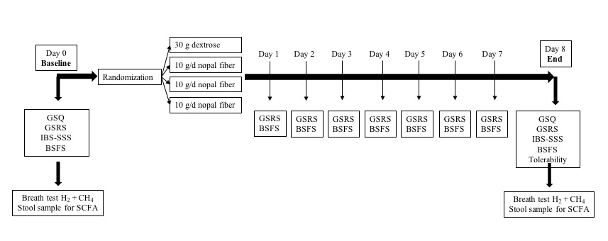

**Figure legend.** GSQ: Global Symptom, GSRS: Gastrointestinal Symptom Rating Scale; IBS-SSS: IBS Symptom Scoring System; BSFS: Bristol Stool Form Scale; H2: Hydrogen; CH4: methane; SCFA: short chain fatty acids.

**Figure2.- CONSORT diagram for patients in the trial**

Analysed (15)

Lost to follow-up(0)

Analysed (15)

Lost to follow-up(0)

Analysed (15)

Lost to follow-up(0)

Analysed (15)

Lost to follow-up(0)

Randomised (60)

Assessed for eligibility (68)

Enrolment

**Excluded (8)**

Started new IBS medication (4)

Serious comorbidities (2)

Declined to participate (2)

**Allocated nopal 30 g/d (15)**

Received intervention (15)

**Allocated nopal 20 g/d (15)**

Received intervention (15)

Allocation

Follow-Up

Analysis

**Allocated nopal 10 g/d (15)**

Received intervention (15)

**Allocated placebo (15)**

Received intervention (15)

**Figure 3 Clinical response at the end of treatment in the four groups**

(a)Percentage of patients with adequate relief (primary outcome), responding positively to the global symptom question (‘do you have adequate relief of your IBS symptoms’). (b) Percentage of patients with >50% improvement in total IBS-SSS score.

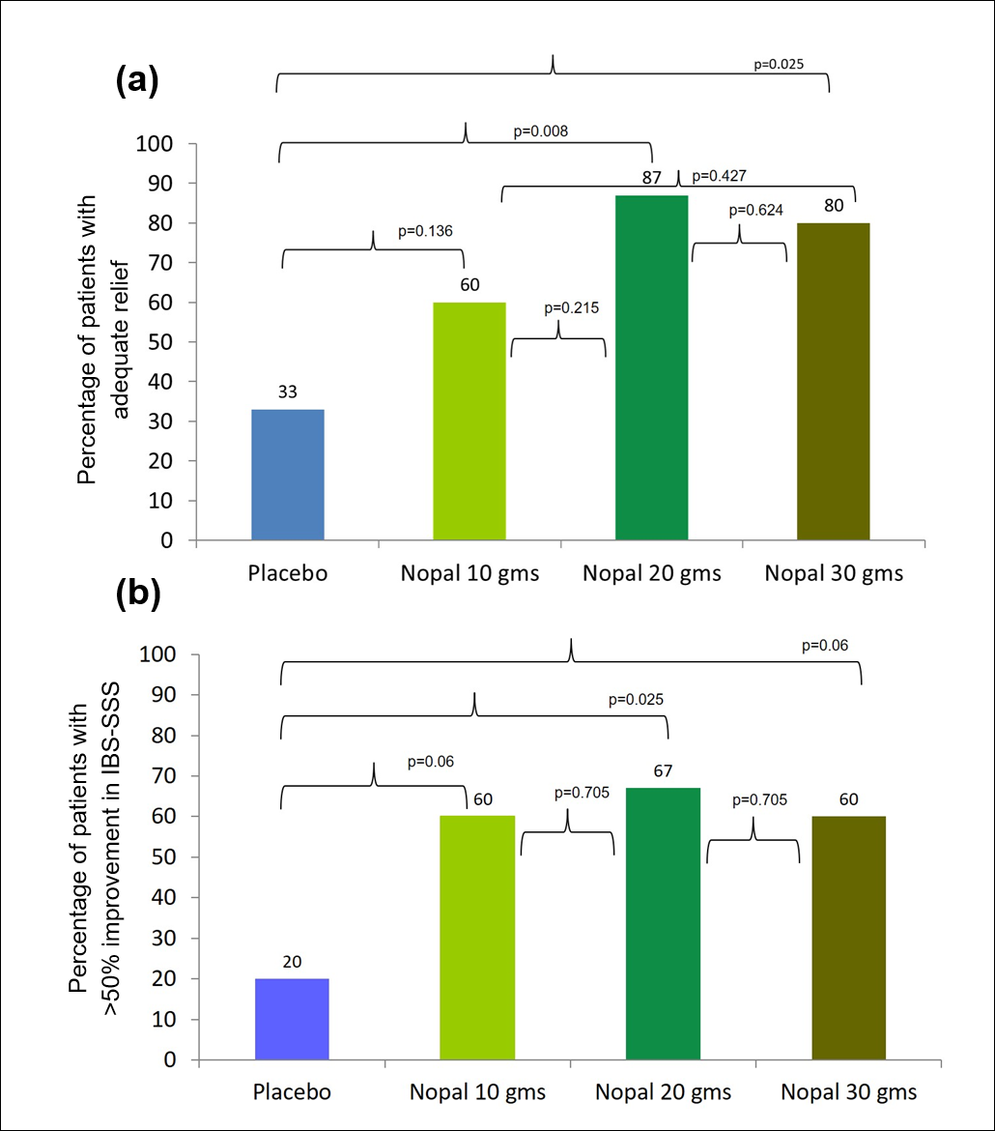

**Figure 4. Changes in stool consistency among IBS subtypes at the end of treatment**

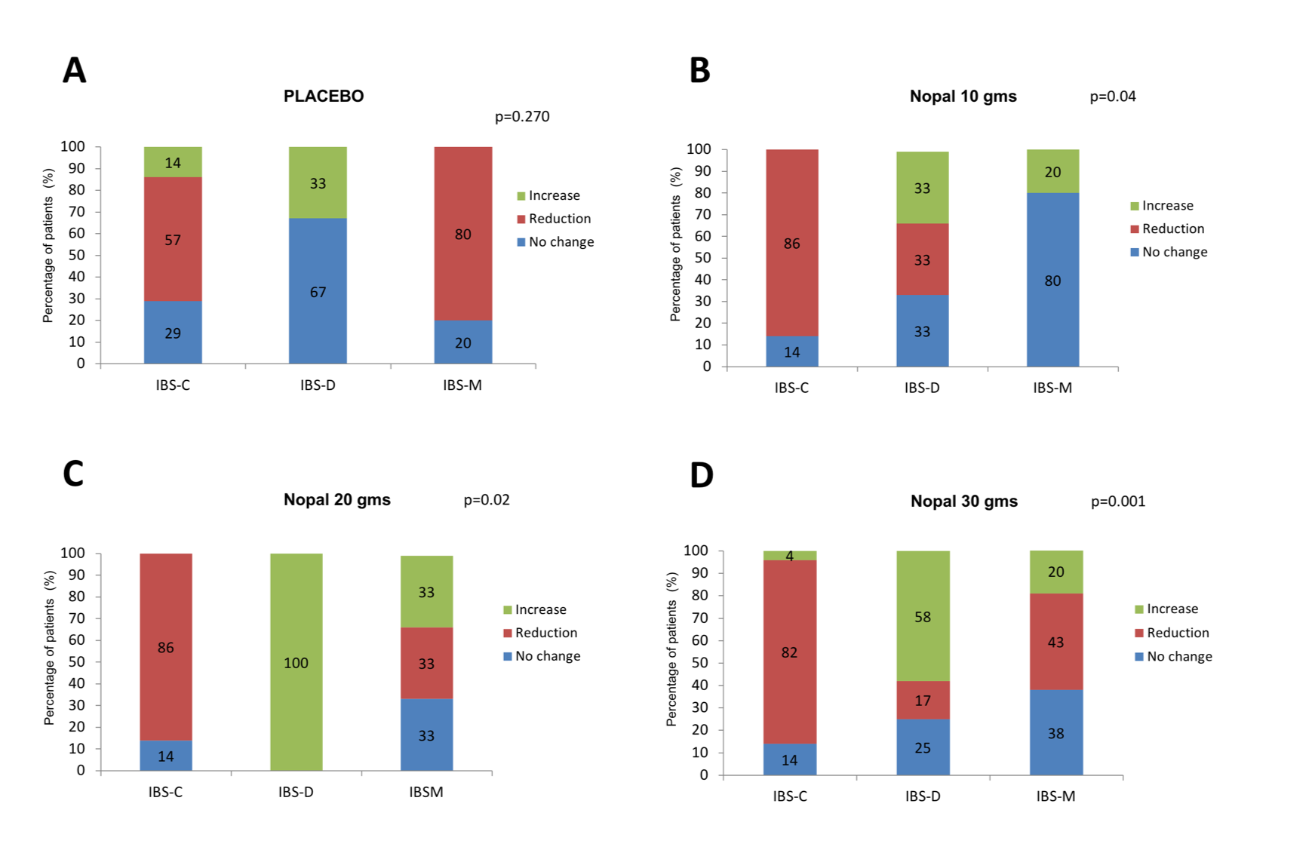

**Figure 4 Legend.** Change in stool consistency was defined as an increase or a decrease of at least 1 point in the final Bristol stool form scale compared to the baseline. In the case of constipation improvement means a reduction in consistency and in diarrhea an increase.