Supplementary information
Complementary techniques to analyse pericellular matrix formation by human MSC within hyaluronic acid hydrogels

Christoph Salzlechner¹†, Anders Runge Walther^{1,2}†, Sophie Schell^{1,3}, Nicholas Groth Merrild¹, Tabasom Haghighi¹, Isabella Huebscher¹, Gerhard Undt⁴, Kathleen Fan⁵, Mads Bergholt¹, Martin Hedegaard², and Eileen Gentleman¹*

¹ Centre for Craniofacial and Regenerative Biology, King’s College London, London SE1 9RT, United Kingdom
² Department of Chemical Engineering, Biotechnology and Environmental Technology, University of Southern Denmark, DK-5230 Odense, Denmark
³ Department of Conservative Dentistry, Centre of Dentistry, Oral Medicine and Maxillofacial Surgery, University Hospital Tübingen, 72076 Tübingen, Germany
⁴ University Clinic of Dentistry, Department of Oral Surgery, Medical University of Vienna, Sensengasse 2a, 1090 Vienna, Austria
⁵ Department of Oral and Maxillofacial Surgery, King's College Hospital, London, SE5 9RS, United Kingdom

†These authors contributed equally
*To whom correspondence should be addressed: eileen.gentleman@kcl.ac.uk

Highest academic title: Dr Christoph Salzlechner, Prof Gerhard Undt, Dr Sophie Schell, Dr Mads Bergholt, Dr Martin Hedegaard, Dr Kathleen Fan, Dr Eileen Gentleman

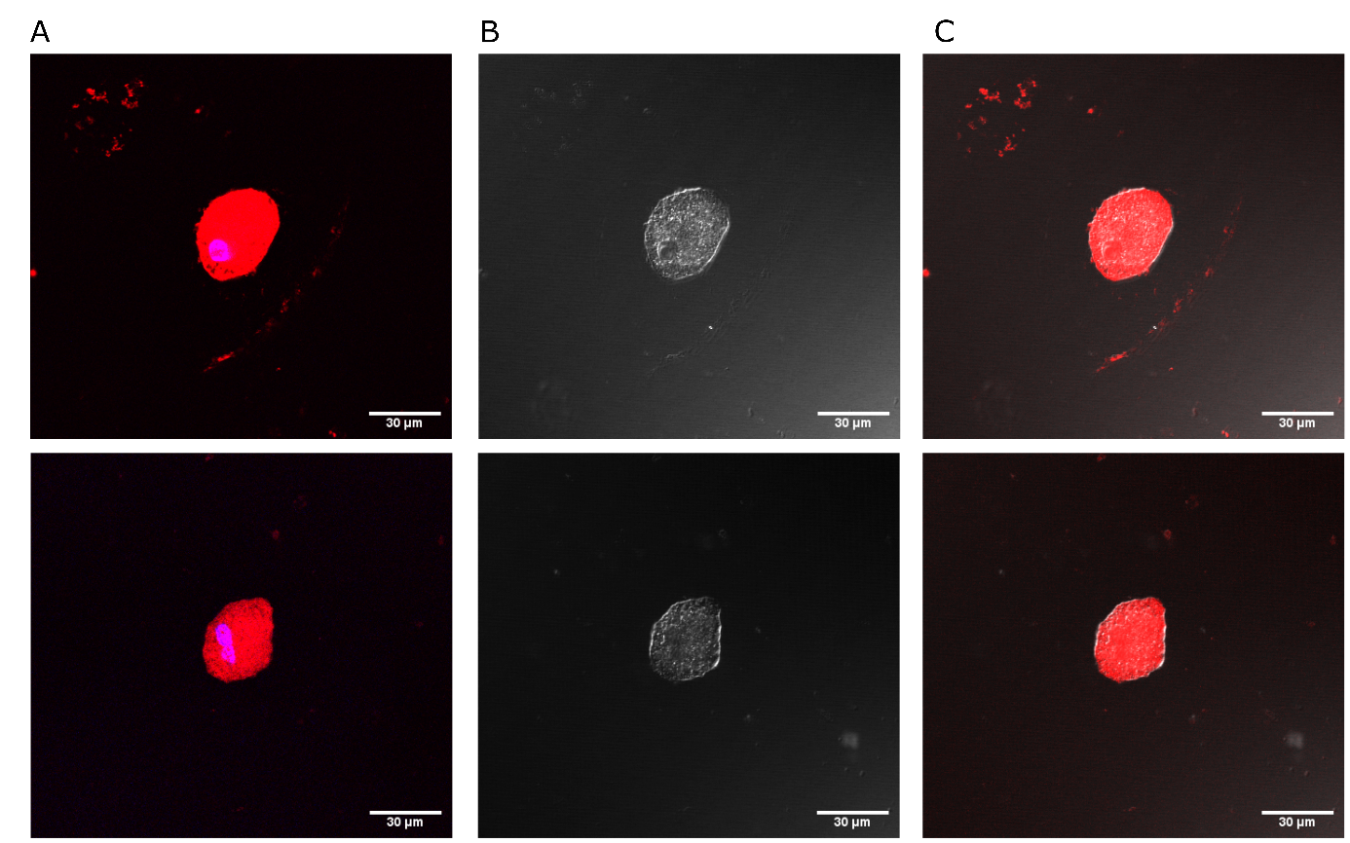
Figure S1 Representative confocal images of hydrogel encapsulated MSCs. (A) Fluorescent non-canonical amino acid tagging (red) and nucleus (blue). (B) Differential interference contrast (DIC) images of the cells shown in A for visualization of cell outline and (C) merged view of red and DIC channels.

