**Prognostic Impact of Late Gadolinium Enhancement by CMR in Myocarditis: A Systematic Review and Meta-analysis**

**Running title:** Prognostic Impact of LGE in Myocarditis

Georgios Georgiopoulosa,b*, MD, Stefano Figliozzia*, MD, Francesca Sanguinetic, MD, Giovanni Donato Aquarod, MD, Gianluca di Bellae, MD, Kimon Stamatelopoulosb, MD, Amedeo Chiribiria, MD, Jerome Garotc, MD, Pier Giorgio Mascia†, MD, Tevfik F Ismail a†, PhD, FACC.

* These authors contributed equally as first authors.

† These authors contributed equally as senior authors.

aSchool of Biomedical Engineering & Imaging Sciences, King's College London, UK.

bDepartment of Clinical Therapeutics, National and Kapodistrian University of Athens, Greece.

cCardiovascular MR Lab, ICPS, Hôpital Privé Jacques Cartier- Ramsay Santé, Massy, France.

dFondazione Toscana G. Monasterio, Pisa, Italy.

eClinical and Experimental Department of Medicine and Pharmacology, University of Messina, Messina, Italy.

**Address for Correspondence:**

Dr Georgios Georgiopoulos, MD, PhD

School of Biomedical Engineering & Imaging Sciences

King’s College London

St Thomas’ Hospital

Westminster Bridge Road

London SE1 7EH

United Kingdom

Email: georgios.georgiopoulos@kcl.ac.uk

Phone: +44 747 1551780

**Authors email address:**

Georgios Georgiopoulos: georgiopoulosgeorgios@gmail.com

Stefano Figliozzi: stefanofigliozzi@hotmail.it

Francesca Sanguineti: f.sanguineti@angio-icps.com

Giovanni Donato Aquaro: aquaro@ftgm.it

Gianluca di Bella: gianluca.dibella@unime.it

Kimon Stamatelopoulos: stamatelopoulosk@yahoo.gr

Amedeo Chiribiri: amedeo.chiribiri@kcl.ac.uk

Jerome Garot: jgarot@angio-icps.com

Pier Giorgio Masci: pgmasci@gmail.com

Tevfik F Ismail: tevfik.ismail@kcl.ac.uk

**Word count: 6,322**

**Subject terms:** meta-analysis; systematic review; myocarditis; inflammatory heart disease; Magnetic Resonance Imaging (MRI); prognosis.

**ABSTRACT**

**Background:** Patientswithacute myocarditis (AM) are at increased risk of adverse cardiac events after the index episode. Late gadolinium enhancement (LGE) detected by cardiovascular magnetic resonance (CMR) in patients with AM plays an important diagnostic role but its prognostic significance remains unresolved.This systematic review and meta-analysis sought to assess the prognostic implications of CMR-derived LGE in patients with AM.

**Methods:** Data search was conducted from inception through February 28, 2020, using the following Medical Subject Heading terms:*Myocarditis, CMR, MRI, Magnetic Resonance*. From 2,422 articles retrieved, we selected 11 studies reporting baseline CMR assessment and long-term clinical follow-up in AM patients. Hazard ratios (HR) and confidence intervals (CIs) for a combined clinical endpoint were recorded for LGE presence, extent (>2 segments or >10% of left ventricular [LV] mass or >17g) and location (anteroseptal [AS] vs. non-AS). A combined endpoint comprised all-cause mortality, cardiac mortality, and MACE. Hartung and Knapp (HK) correction improved robustness of the results. Pre-specified sensitivity analyses explored potential sources of heterogeneity. The meta-analysis was conducted according to the Meta-analysis of Observational Studies in Epidemiology (MOOSE) guidelines and registered in the PROSPERO database (CRD42019146619).

**Results:** LGE presence (pooled-HR=3.28, 95% CIs 1.69-6.39, P<0.001; 95% CIs 1.33-8.11 after HK correction) and AS LGE (pooled-HR=2.58, 95% CIs 1.87-3.55, P<0.001; 95% CIs 1.64-4.06 after HK correction) were associated with an increased risk of the combined endpoint. Extensive LGE was associated with worse outcomes (pooled-HR=1.96, 95% CIs 1.08-3.56, P=0.027) but this association was not confirmed after HK correction (95% CIs =0.843-4.57).

**Conclusion:** LGE presence and anteroseptal location at baseline CMR are important independent prognostic markers that herald an increased risk of adverse cardiac outcomes in patients with AM.

**Clinical Perspective**

Acute myocarditis is an inflammatory myocardial disease which can be complicated by adverse cardiac events, including sudden cardiac death and heart failure. Hitherto, endomyocardial biopsy has been the cornerstone of diagnosis, however, most patients are now being diagnosed non-invasively with cardiovascular magnetic resonance (CMR). The latter may reveal areas of late gadolinium enhancement (LGE) typically in an epicardial to mid-wall (non-ischemic) distribution denoting tissue inflammation and early fibrosis. In addition to being of diagnostic importance, there is growing evidence that the presence, extent, and regional location of LGE assume prognostic significance. However, due to the low incidence of the condition and relatively low event rates, observational studies addressing this have been limited by small sample sizes, short follow-up durations, and the use of broad composite endpoints. We therefore undertook a systematic review and meta-analysis of the available literature. To account for the small number of studies available, the Hartung and Knapp correction was used to improve the robustness of confidence interval estimates. Based on data from 2,328 patients derived from 11 independent cohorts, we showed that the presence of LGE conferred a significant adjusted 3-fold increased risk of the combined endpoint of all-cause mortality and major adverse cardiac events. Anteroseptal location but not LGE extent was also associated with the clinical outcome when the stringent Hartung and Knapp correction was applied. Our meta-analysis demonstrates that the presence and location of LGE may identify a subgroup of patients with acute myocarditis who warrant more intensive clinical surveillance for adverse cardiac events.

**INTRODUCTION**

Acute myocarditis (AM) is an inflammatory disease of the myocardium with a heterogeneous etiology and natural history.1,2 While the majority of patients appear to have a benign clinical course, a significant number experience adverse events including sudden cardiac death (SCD) or heart failure (HF).2-5 Endomyocardial biopsy (EMB) has traditionally played a vital role in the diagnosis of myocarditis, however, it is an imperfect tool with a yield as low as 35% due to the patchy nature of inflammation in some cases, and inability to readily access the epicardial and mid-wall layers where inflammation predominates.2 In this context, cardiovascular magnetic resonance (CMR) with T2-weighted imaging, contemporary parametric mapping techniques, and late gadolinium enhancement (LGE) imaging, are assuming greater importance in non-invasive diagnosis.6,7 The presence of LGE denotes tissue inflammation, necrosis and early fibrosis.8,9 The latter is known to play a key role in generating arrhythmogenic substrates and has been shown to be a harbinger of SCD as well as HF in a variety of non-ischemic cardiomyopathies.10,11

There is emerging evidence that the presence, location, and extent of LGE may also carry important prognostic information in AM.4,12-16 However, due to a combination of the low incidence of the condition, and relatively low event rates, studies addressing the prognostic significance of LGE in this context have been limited by small sample sizes, short follow-up durations, and a reliance on broad composite endpoints.15-18 These observational data therefore do not permit granular risk stratification. We sought to address this by undertaking a systematic review and meta-analysis of the available observational studies to derive adjusted estimates of the prognostic significance of LGE.

**METHODS**

The authors declare that all supporting data are available within the article and its online supplementary files.

**Systematic review**

*Search strategy*

We performed a systematic review of the English and non-English literature using PubMed, Cochrane Library, Medline, Embase, Web of Science, Cinahl, ClinicalTrials.gov and grey literature databases (OpenGrey and The Grey Literature Report by the New York Academy of medicine) from inception through February 28, 2020. Full-length publications in peer-reviewed journals or abstracts in international congresses that assessed the association of CMR-LGE and the risk of future clinical events in patients with clinically suspected13 or confirmed12,14-17,19-23 AM were retrieved. CMR variables of interest were the presence,12,13,16,19-21 extent,14-16, 19, 22 location15-17,19,23, pattern15,19 and distribution15,19 of LGE. The extent of LGE was evaluated either as left ventricular (LV) segments involved,15,16,22,24 grams,14 or as a percentage of LV mass.15,16,19 For LGE location, we searched for risk estimates for anteroseptal (AS) versus non-AS and inferolateral (IL) versus non-IL location of LGE. For LGE pattern and distribution, we searched for mid-wall vs. subepicardial and patchy vs. linear, respectively. Data sources were also identified through a manual search of the retrieved articles’ references. All abstracts from large international cardiovascular conventions were also sought and screened. Further details on the search strategy are provided in the **Supplementary File**.

*Study eligibility*

Studies were deemed eligible if they analyzed data in patients with AM (interval time between symptom-onset and CMR ≤2 weeks); reported details of LGE (presence and/or location and/or extent); and evaluation of at least one of the following outcomes: all-cause or cardiac mortality and major adverse cardiovascular events (MACE). We defined the combined endpoint as the combination of any cause of death and MACE. The latter comprised of new heart failure; sustained ventricular tachycardia (VT); aborted SCD or appropriate implantable cardioverter defibrillator (ICD) discharge; implantation of an ICD or pacemaker; cardiac transplantation or ventricular assist device implantation; VT ablation; or recurrence of myocarditis. Criteria used for study inclusion were: estimates of the risk related to LGE presence, extent or location; survival models adjusted for confounders; otherwise, unadjusted (crude) estimates of the combined endpoint incidence were used. No restrictions were imposed with regard to the type AM diagnosis (clinical plus EMB-based versus clinical plus CMR-based diagnosis); patient treatment (beta-blockers and/or ACEi/ARB versus medical monitoring); or study sample size. Studies with mean follow-up <9-months, in pediatric subjects (<18 years), or in patients affected by significant comorbidities or other cardiac diseases, were excluded. Comprehensive details of the included studies are provided in the **Supplementary File**.

*Identification of eligible studies*

The literature search, selection of studies, and extraction of data were performed by two independent authors (GG and SF) who followed pre-specified forms (see the **Supplementary File**). Where the required data were not available, we contacted the study authors.12,13,15,16, Disagreements were reviewed by a third investigator (PGM) and finally resolved by consensus.

**Meta-analysis**

The meta-analysis was conducted according to the framework of the Meta-analysis of Observational Studies in Epidemiology25 and registered in the PROSPERO database (CRD42019146619). Missing data were obtained from original study investigators whenever possible (see **Supplementary File**). No imputation methods were used.

*Quality Assessment and Grading of Evidence*

Two reviewers (GG and SF) independently assessed the quality of the included studies using the validated Newcastle-Ottawa Quality Assessment Scale (NOS) for case-control, cross-sectional, and cohort studies.26 Potential selection bias, comparability, and outcome assessment adequacy were evaluated. Quality assessment through the Newcastle Ottawa Scale (NOS) indicated that 7 studies could be classified as good quality studies; 3 studies as fair quality studies; and 1 study as a poor-quality study. The criteria for converting NOS results (expressed as stars, **Supplementary Table 1S**) to quality category were a) good quality if NOS was ≥7 stars; b) fair quality for studies with 5-6 stars; and c) poor quality for studies ≤4 stars. The certainty of evidence for the association between LGE and the occurrence of adverse cardiac events in AM was evaluated by implementing The Grades of Recommendation, Assessment, Development and Evaluation Working Group (GRADE) system.27,28 In brief, we took into account the five GRADE considerations (*i.e.*, risk of bias, consistency of effect, imprecision, indirectness and publication bias) and adjudicated the certainty of the body of evidence separately for LGE presence, extent and location and the incidence of the combined endpoint.

*Data extraction*

Data were screened and extracted independently by 2 investigators (SF and GG). We recorded hazard ratios (HRs) and corresponding 95% confidence intervals as indices of effect size for: a) LGE presence; b) LGE extent (*i.e.*, more than 2 involved myocardial segments or more than 10% of the total myocardial mass or more than 17g of LGE); c) AS vs non-AS and IL vs non-IL location. We could not perform any analysis on the prognostic impact of LGE pattern and distribution since only two studies were eligible.15,19 When possible, multi-adjusted HRs were used (**Supplementary Table 2S**).12,13,15,16,19,21,23 For two studies,15,16 additional data were obtained after contacting the authors. For two studies,12,13 95% Confidence Intervals (CIs) around the mean estimate were calculated as previously suggested.29 In one study,17 HR was calculated from the corresponding log-rank test as previously shown.30 For two studies,17,22 ORs and 95% CIs were calculated from available data as approximation of HRs in light of the small probability of the event of interest.31,32 For one study,16 a zero-cell correction was applied during OR calculation. One study was excluded from estimates of effect for the presence of LGE as study participants without LGE on CMR were excluded from the final study cohort.15

*Data synthesis and analysis*

We performed a meta-analysis of all eligible studies and obtained the pooled estimate separately for the association between LGE presence; extent; and LGE location and the combined endpoint comprising all-cause mortality, cardiac mortality, and MACE. We evaluated combined clinical endpoints since data for individual outcomes were available only in few eligible studies (**Supplementary Table 3S**).

We evaluated heterogeneity using the I2-statistic. Usually, when moderate to significant heterogeneity (p<0.1) exists among studies, a random-effects model is implemented.33 In our case, given that the power of such heterogeneity identification tests is low due to the small number of included studies, visual checks through forest plots were also performed to identify heterogeneity. Subsequently, to avoid false positive findings, we directly implemented a random-effects model. We utilized the inverse variance method with the Sidik-Jonkman two-step heterogeneity estimator as a reference method, instead of the popular DerSimonian and Laird method, since the latter is known to underestimate heterogeneity in meta-analyses with a low number of individual studies.34 To tackle the small number of studies and provide more robust results, we applied the more conservative Hartung and Knapp (HK) correction to the overall estimate of confidence intervals.35 The mean effect size and CIs of individual studies were illustrated with forest plots. We conducted pre-specified sensitivity analyses where applicable to evaluate whether the estimates of the association of LGE findings on the combined endpoint differed within certain populations and to further explore potential sources of heterogeneity. Briefly, we excluded: a) studies with <50 participants;20-22 b) studies of lower quality according to NOS evaluation;13,21-23 and/or studies with less likely AM (potential bias in AM diagnosis13 and delayed CMR19). We did not implement the HK correction in sensitivity analyses since the number of studies was low (≤4) and the underlying distribution of the treatment effect with 3 or less degrees of freedom could substantially deviate from both the t- and the normal distribution, rendering the calculation of corrected 95% confidence intervals problematic.36 In addition, random-effects meta-regression was performed to estimate the contribution of study moderators to the overall heterogeneity for the combined endpoint throughout the selected individual studies. Due to the small number of included studies, dedicated sub-group analysis was not performed.37

The presence of publication bias was investigated graphically by funnel plots of precision, and statistically by regression tests for asymmetry. The Egger test and the Begg and Mazumdar test were implemented. We also performed a linear regression of the intervention effect estimates on their standard errors weighting by 1/(variance of the intervention effect estimate). Statistical analysis was performed with STATA V12.1 (StataCorp, College Station, Texas, USA). The module "admetan" was used for meta-analysis in STATA. Two-tailed values of P<0.05 were deemed significant.

**RESULTS**

**Literature Search**

The results of the literature search are depicted in **Figure 1**. We retrieved 2,422 articles and after discarding duplicates (n=1,051), the title and abstract of the remaining 1,371 articles were screened and 1,298 records were excluded. Full-text articles of the remaining 73 records were retrieved and examined. Ultimately, 62 studies were deemed not eligible (see **Supplementary File**)and the remaining 11 studies were selected for quantitative analysis.12-17, 19-23

**Study characteristics**

The meta-analysis included 11 papers with 11 independent cohorts and a total of 2,328 patients (**Table 1; Supplementary Table 4S**). A total of 6 papers reported data on LGE presence; 5 on LGE extent; and 5 on LGE location. Information on all-cause mortality and cardiac death was available in 7 and 6 studies, respectively. MACE were analyzed by 10 studies. Arrhythmic complications or development of heart failure were reported in 9 studies, whereas AM recurrence was assessed in 5 studies. Further information on the association between LGE features and the risk of developing adverse clinical outcomes for each study is provided in the **Supplementary File**.

**Presence of LGE and the risk of the combined endpoint**

The association between LGE presence and the development of the combined endpoint was assessed in 6 studies.12,13,16,19-21 Adjustment for potential confounders was used in 412,13,19,21 out of 6 studies. The pooled HR for LGE was 3.28 (95% CIs 1.69-6.39, P<0.001) for the combined endpoint. After applying the HK correction, this association retained significance (95% CIs 1.33-8.11, P=0.02) (**Figure 2A**). Moderate heterogeneity was observed across the studies (I2=36.5%, P=0.107). When small (<50 participants)20,21 or lower quality studies13,21 were excluded, presence of LGE at baseline CMR scan was still related to the combined endpoint (pooled HR=2.19, 95% CIs 1.47-3.25, P<0.001 and pooled HR=2.10, 95% CIs 1.36-3.24, P=0.001, respectively)(**Supplementary Table 5S**). Accordingly, when the studies from Gräni *et al.19* and Schumm *et al.13* were excluded, the pooled result of the meta-analysis was not attenuated (pooled HR=8.13, 95% CIs 2.87-23.00).

**Extent of LGE and the risk of the combined endpoint**

Five studies14-16,19,22 provided information on the incidence of the combined endpoint and LGE extent at baseline CMR. Two studies compared patients with >2 LGE segments to subjects with LGE ≤2 myocardial segments.15,16 One study used a semi-quantitative approach based on the number of positive LGE segments according to a 17-segment AHA model;22 two assessed LGE extent as a percentage of LV mass;15,19 and one as absolute LGE in grams14. The pooled HR of LGE extent for the combined endpoint was 1.96 (95% CIs 1.08-3.56, P=0.027). The more conservative meta-analysis after the HK correction confirmed a trend towards increased risk for the combined endpoint (pooled HR=1.96, 95% CIs 0.843-4.57) (**Figure 2B**). Moderate to significant heterogeneity was observed across the studies (I2=75.6%, P=0.1). In sensitivity analyses, the exclusion of studies with sample size <50,22 did not change the pooled risk estimate (pooled HR=1.68, 95% CIs 1.114-2.52). Nevertheless, this association was attenuated when studies of lower quality22 or less likely diagnosis of AM19 were not considered (pooled HR=1.66, 95% CIs 0.896-3.09) (**Supplementary Table 5S**).

**Location of LGE and risk of the combined endpoint**

The relationship between the combined endpoint and LGE location was reported in 5 studies.15-17,19,23 **Table 1** displays the demographic and clinical characteristics of the participants. AS location of LGE was associated with a 2.6-fold increased risk of the combined endpoint (pooled HR=2.58, 95% CIs 1.87-3.55, P<0.001 for the reference analysis). The HK method showed a similar trend (pooled HR=2.58, 95% CIs 1.64-4.06, P=0.004) (**Figure 2C**). No significant heterogeneity was observed across the 5 studies of LGE localization (I2=0%, P=0.535). All studies in this analysis had more than 50 participants. When studies of lower quality23 or uncertain diagnosis of AM19 were removed, AS location of LGE still conferred increased risk for the combined endpoint (pooled HR=2.17, 95% CIs 1.14-4.12, P=0.018). Inferolateral location of LGE trended towards a decreased incidence of MACE versus non-IL distribution (HR=0.50, 95% CIs 0.21-1.20, P=0.122, I2=69.2%, P=0.002) but this non-significant trend was even further attenuated after the HK correction (HR=0.50, 95% CIs 0.15-1.73, P=0.197)(**Figure 1S**).

**Meta-regression analysis**

In view of the moderate to significant heterogeneity in two main analyses (*i.e.*, presence, and extent of LGE), we performed meta-regression analyses on the association of LGE pattern with the primary endpoint. We also applied meta-regression analyses for LGE location on an exploratory basis. Among age, prevalence of male gender, traditional cardiovascular risk factors, and symptoms at presentation, we did not find variables that affected the magnitude of the association between LGE presence, location or extent and the combined endpoint. Accordingly, ECG abnormalities, pericardial effusion, LV ejection-fraction or LV end-diastolic volume, sustained VT, and troponin levels did not modify the association between LGE features and the combined endpoint occurrence (P>0.1 for all). Importantly, the association of AS location of LGE with increased risk of the primary endpoint was not influenced by the LGE extent (P=0.352).

**Publication bias and grading of evidence**

The funnel plot for the association between LGE presence and the primary endpoint was asymmetrical at its bottom left, suggesting either possible publication bias or a true non-existence of negative studies (**Figure 3A**). Regression tests for funnel plot asymmetry only partially supported a small-study effect (Egger's test: P=0.025 and Begg and Mazumdar test: P=0.260). Asymmetry was also evident in funnel plots for LGE extent (**Figure 3B**) but not for localization (AS versus non-AS) (**Figure 3C**). While publication bias cannot be excluded for these variables, regression diagnostic tests showed a non-significant effect (Egger's test: P=0.221 and P=0.957; Begg and Mazumdar test: P=0.264 and P=0.806 for LGE extent and distribution, respectively).

According to the GRADE system,28 the level of certainty for the association between LGE presence and location with the risk of MACE was moderate; a low level of certainty was adjudicated for the association between LGE extent with the combined endpoint (**Supplementary Table 6S**).

**DISCUSSION**

In this meta-analysis, we provide for the first time, pooled adjusted CMR-derived estimates from 2,328 patients with AM showing that LGE presence and anteroseptal location are associated with a significantly increased risk of an adverse clinical outcome. Overall, AM patients with LGE at the CMR conducted early after clinical presentation (within 2 weeks from symptom onset) had a 3-fold increased risk of dying or developing MACE during a mean 2-years follow-up as compared to their counterparts without LGE. Patients with AM and high LGE burden trended towards having a higher likelihood of experiencing the combined endpoint as compared to those with no or low LGE burden. Overall, these results were shown to be consistent in a number of sensitivity analyses and were not affected by baseline patient characteristics including age, cardiovascular risk factors, troponin level, and LV function.

**LGE presence and outcomes**

The clinical trajectory of patients with AM and LGE at the baseline CMR was more often complicated by the combined endpoint when compared with patients with a normal CMR scan. This finding is in accord with four out of six original studies. Of note, one study20 with discrepant results was adjudicated as of lower quality by the NOS scale due to the small number of patients enrolled (<50) and the very short follow-up.

Several different mechanisms may underlie the deleterious impact of LGE. First, LGE signifies edema and fibrosis, and may play a key role in the genesis of ventricular arrhythmias by favoring re-entrant circuits.10 Second, AM patients with LGE are more likely to have had a more extensive myocardial damage as compared to AM patients without LGE, promoting progressive LV remodeling and dysfunction eventually culminating in HF.38

To our knowledge, only one previous meta-analysis has attempted to address the prognostic significance of LGE in AM. Yang *et al* similarly found that LGE was an important predictor of outcome.39 However, their search strategy only identified 8 out of 1,021 studies including 1,319 patients versus 11 studies out of 2,422 in the present study which included 2,328 patients. In addition, where possible, we used pooled adjusted hazard ratios derived from Cox regression techniques that are more appropriate for looking at data that is subject to censoring, while simultaneously also accounting for potential confounders. Furthermore, we used the HK correction to ensure a more robust estimate of confidence intervals given the relatively small number of included papers. Finally, our meta-analysis also addresses the potential importance of LGE amount and location, topics not addressed by Yang *et al*.

**LGE extent and outcomes**

The risk of experiencing the combined endpoint was doubled in patients with more extensive LGE (*i.e.*, >2 LV segments with LGE or LGE>10% of LV mass or LGE>17 grams) as compared to those with small or no LGE burden. As expected, the two studies15,16 in which LGE presence was not associated with worse outcome did not show association between LGE burden and the combined endpoint (**Table 1**). However, the interpretation of this finding was hindered by 1) the heterogeneity in defining the LGE burden; and 2) the diversity in methodology applied for quantifying LGE including different post-processing algorithms. Moreover, when the more restrictive HK correction was applied, the LGE burden did not remain associated with the composite endpoint. Overall, this finding indicates that there is a trend towards LGE extent being associated with clinical outcome but larger studies using a standardized methodology for gauging LGE are needed to confirm this.

**LGE location and outcomes**

Anteroseptal location of LGE portended a two-fold increased risk of dying or experiencing MACE as compared to non-AS LGE. Of note, LGE extent was comparable between AS and non-AS subgroups supporting the concept that LGE location may hold prognostic value *per se*. A previous study found higher troponin release, LV volumes, and greater LGE extent in the AS as compared to non-AS group. However, meta-regression analysis in our study showed an independent prognostic value of AS location of LGE in AM patients irrespective of LGE extent and indices of LV remodeling, including LV ejection-fraction and volumes. In contradistinction, an IL location trended towards a reduced incidence of the primary outcome. Previous studies in AM patients undergoing LGE-CMR guided endocardial biopsy indicated that AS myocarditis patients are more likely to harbor human herpes virus 6 (HHV6) and parvovirus B19 (PVB19) co-infection than those with non-AS involvement.40 The natural history of HHV6 infection is featured by a long-lasting latent infection after the first exposure in early childhood and may be associated with worse outcomes, particularly as the cardiac conduction system resides in the septum.41

**Clinical implications**

Contrary to the conventional knowledge of good long-term prognosis in patients affected by AM,42 our systematic review revealed an overall incidence of mortality, life-threatening ventricular arrhythmias, heart failure recurrence rate of the disease equating to 11.5% over a mean follow up of 2 years. On the other hand, in contrast to Yang *et al*, who examined LVEF as a dichotomized covariate in exploratory subgroup analysis, we found that impaired LVEF was not an independent predictor of the combined endpoint.39 Risk stratification of AM patients is clinically challenging, and no reliable tools are currently available. Based on our pooled analysis, presence and AS location of LGE conferred an independent increased risk for all cause of death and MACE. However, confirmatory multicenter studies are needed to investigate whether high LGE burden and AS location LGE are independent predictors of clinical outcome and whether the adoption of these markers improves risk stratification beyond the current standard of care in AM patients.

**Limitations**

Our meta-analysis has a number of limitations. First, EMB-based diagnosis of AM was obtained in only a few patients of the total sample. Nevertheless, given the good diagnostic yield of CMR in inflammatory cardiomyopathy and excellent agreement between CMR and EMB in patients with suspected AM,43 we believe that the studies included in the meta-analysis correctly included AM patients. Second, we included only observational studies, which have an intrinsic risk for selection bias and can detect associations but not ascibe causality. Third, the studies included in the meta-analysis presented significant heterogeneity with respect to the patient populations. However, meta-regression analyses did not suggest significant modification of our estimates by baseline characteristics, including age, gender, cardiovascular risk factors, clinical presentation or laboratory parameters. Fourth, it is important to bear in mind that the presence and the AS location of LGE were associated with the occurrence of the combined endpoint even after the restrictive HK correction was applied. However, when sensitivity analysis was performed, although the findings remained significant, given the residual small number of studies available, the HK-correction could not be validly applied on the resulting confidence intervals, risking the residual possibility of a type 1 error. This emphasizes the need for further prospective studies to evaluate the mechanisms and significance of LGE presence and location. Finally, novel CMR markers such as parametric imaging and myocardial strain were not adjudicated eligible for meta-analysis in view of the scarcity of data available so far. Native T1 and extracellular volume mapping techniques are increasingly being used for diagnosis and have been incorporated into the revised Lake Louise criteria.6 However, while there is growing evidence for their diagnostic utility in AM,7 and for their prognostic significance in many other disease settings,44,45 the studies in our meta-analysis pre-dated their widespread use for this purpose. Further work is required to prospectively assess the prognostic utility of this nascent technology in patients with AM.

**Conclusion**

The presence of LGE and anteroseptal location on baseline CMR in AM are important independent prognostic markers that portend an increased risk of major adverse cardiac events.

**Acknowledgements:** none.

**Funding:** Dr Georgiopoulos was supported by a research fellowship from the European Association of Cardiovascular Imaging and a postdoctoral research grant from the Alexander S. Onassis Foundation.

**Disclosures:**

Georgios Georgiopoulos: none related.

Stefano Figliozzi: none related.

Francesca Sanguineti: none related

Giovanni Donato Aquaro: none related.

Gianluca di Bella: none related.

Kimon Stamatelopoulos: none related.

Amedeo Chiribiri: none related.

Jerome Garot: none related.

Pier Giorgio Masci: none related.

Tevfik F Ismail: none related.

**References**

**1.** Richardson P, McKenna W, Bristow M, et al. Report of the 1995 World Health Organization/International Society and Federation of Cardiology Task Force on the Definition and Classification of cardiomyopathies. *Circulation.* 1996;93(5):841–842.

**2.** Caforio AL, Pankuweit S, Arbustini E, et al. Current state of knowledge on aetiology, diagnosis, management, and therapy of myocarditis: a position statement of the European Society of Cardiology Working Group on Myocardial and Pericardial Diseases. *Eur Heart J.* 2013;34(33):2636–48,2648a–d.

**3.** Caforio AL, Calabrese F, Angelini A, et al. A prospective study of biopsy-proven myocarditis: prognostic relevance of clinical and aetiopathogenetic features at diagnosis. *Eur Heart J.* 2007;28(11):1326–1333.

**4.** Felker GM, Hu W, Hare JW, Hruban RH, Baughman KL, Kasper EK. The spectrum of dilated cardiomyopathy. The Johns Hopkins experience with 1,278 patients. *Medicine.* 1999;78(4):270–283.

**5.** Basso C, Calabrese F, Corrado D, Thiene G. Postmortem diagnosis of sudden cardiac death victims. *Cardiovasc Res.* 2001;50(2):290-300.

**6.** Ferreira VM, Schulz-Menger J, Holmvang G, et al. Cardiovascular Magnetic Resonance in Nonischemic Myocardial Inflammation: Expert Recommendations. *J Am Coll Cardiol*. 2018;72(24):3158-3176.

**7.** Kotanidis CP, Bazmpani MA, Haidich AB, Karvounis C, Antoniades C, Karamitsos TD. Diagnostic Accuracy of Cardiovascular Magnetic Resonance in Acute Myocarditis: A Systematic Review and Meta-Analysis. *JACC Cardiovasc Imaging*. 2018;11(11):1583-1590.

**8.** Friedrich MG, Sechtem U, Schulz-Menger J, et al. International Consensus Group on Cardiovascular Magnetic Resonance in Myocarditis. Cardiovascular magnetic resonance in myocarditis: A JACC White Paper. *J Am Coll Cardiol.* 2009;53(17):1475-87.

**9.** Mahrholdt H, Goedecke C, Wagner A, et al. Cardiovascular magnetic resonance assessment of human myocarditis: a comparison to histology and molecular pathology. *Circulation.* 2004;109(10):1250–8.

**10.** Gulati A, Jabbour A, Ismail TF et al. Association of fibrosis with mortality and sudden cardiac death in patients with nonischemic dilated cardiomyopathy. *JAMA.* 2013;309(9):896-908.

**11.** Ismail TF, Jabbour A, Gulati A et al. Role of late gadolinium enhancement cardiovascular magnetic resonance in the risk stratification of hypertrophic cardiomyopathy. *Heart.* 2014;100(23):1851-8.

**12.** Grün S, Schumm J, Greulich S, et al. Long-term follow-up of biopsy-proven viral myocarditis: predictors of mortality and incomplete recovery. *J Am Coll Cardiol*. 2012;59(18):1604–15.

**13.** Schumm J, Greulich S, Wagner A, et al. Cardiovascular magnetic resonance risk stratification in patients with clinically suspected myocarditis. *J Cardiovasc Magn Reson*. 2014;16(1):14.

**14.** Chopra H, Arangalage D, Bouleti C, et al. Prognostic value of the infarct- and non-infarct like patterns and cardiovascular magnetic resonance parameters on long-term outcome of patients after acute myocarditis. *Int J Cardiol*. 2016;212:63-9.

**15.** Sanguineti F, Garot P, Mana M, et al. Cardiovascular magnetic resonance predictors of clinical outcome in patients with suspected acute myocarditis. *J Cardiovasc Magn Reson*. 2015;17(1):78.

**16.** Aquaro GD, Perfetti M, Camastra G, et al. Cardiac MR With Late Gadolinium Enhancement in Acute Myocarditis With Preserved Systolic Function: ITAMY Study. *J Am Coll Cardiol*. 2017;70(16):1977-1987.

**17.** Imazio M, Angelico G, Andriani M, et al. Prevalence and Prognostic Impact of Septal Late Gadolinium Enhancement in Acute Myocarditis With or Without Preserved Left Ventricular Function. *Am J Cardiol*. 2018;122(11):1955-1958.

**18.** Mahrholdt H, Greulich S. Prognosis in Myocarditis: Better Late Than (N)ever! *J Am Coll Cardiol*. 2017;70(16):1988-1990.

**19.** Gräni C, Eichhorn C, Bière L, et al. Prognostic Value of Cardiac Magnetic Resonance Tissue Characterization in Risk Stratifying Patients With Suspected Myocarditis. *J Am Coll Cardiol*. 2017;70(16):1964-1976.

**20.** Spieker M, Haberkorn S, Gastl M, et al. Abnormal T2 mapping cardiovascular magnetic resonance correlates with adverse clinical outcome in patients with suspected acute myocarditis. *J Cardiovasc Magn Reson*. 2017;19(1):38.

**21.** Lee WJ, Jeong YJ, Lee G, et al. Predictive Value of Cardiac Magnetic Resonance Imaging-Derived Myocardial Strain for Poor Outcomes in Patients with Acute Myocarditis. *Korean J Radiol*. 2017;18(4):643-654.

**22.** Barone-Rochette G, Augier C, Rodière M, et al. Potentially simple score of late gadolinium enhancement cardiac MR in acute myocarditis outcome. *J Magn Reson Imaging*. 2014;40(6):1347-54.

**23.** Filippetti L, Mandry D, Venner C, et al. Long-Term Outcome of Patients With Low/Intermediate Risk Myocarditis Is Related to the Presence of Left Ventricular Remodeling in Addition to the MRI Pattern of Delayed Gadolinium Enhancement. *JACC Cardiovasc Imaging*. 2018;11(9):1367-1369.

**24.** Cerqueira MD, Weissman NJ, Dilsizian V, et al. Standardized myocardial segmentation and nomenclature for tomographic imaging of the heart. A statement for healthcare professionals from the Cardiac Imaging Committee of the Council on Clinical Cardiology of the American Heart Association. *Circulation*. 2002;18(1):539-42

**25.** Stroup DF, Berlin JA, Morton SC, et al. Meta-analysis of observational studies in epidemiology: a proposal for reporting. Meta-analysis Of Observational Studies in Epidemiology (MOOSE) group. *JAMA*. 2000;283(15):2008-12.

**26.** Stang A. Critical evaluation of the Newcastle-Ottawa scale for the assessment of the quality of nonrandomized studies in meta-analyses. *Eur J Epidemiol*. 2010;25(9):603-5.

**27.** Guyatt GH, Oxman AD, Vist GE, et al. GRADE: an emerging consensus on rating quality of evidence and strength of recommendations. *BMJ.* 2008 Apr 26;336(7650):924-6. doi: 10.1136/bmj.39489.470347.AD. PMID: 18436948; PMCID: PMC2335261.

**28.** Guyatt GH, Oxman AD, Kunz R, et al. GRADE guidelines 6. Rating the quality of evidence--imprecision. *J Clin Epidemiol.* 2011;64(12):1283-93. doi: 10.1016/j.jclinepi.2011.01.012. Epub 2011 Aug 11. PMID: 21839614.

**29.** Altman DG, Bland JM. How to obtain the confidence interval from a P value. *BMJ.* 2011; 343 :d2090.

**30.** Tierney JF, Stewart LA, Ghersi D, Burdett S, Sydes MR. Practical methods for incorporating summary time-to-event data into meta-analysis. *Trials.* 2007 Jun 7;8:16. doi: 10.1186/1745-6215-8-16. PMID: 17555582; PMCID: PMC1920534.

**31.** Nurminen, M. To use or not to use the odds ratio in epidemiologic analyses?. *Eur J Epidemiol.* 11, 365–371 (1995). <https://doi.org/10.1007/BF01721219>**.**

**32.** Figliozzi S, Masci PG, Ahmadi N, et al. Predictors of adverse prognosis in COVID-19: A systematic review and meta-analysis. *Eur J Clin Invest*. 2020 Jul 29:e13362. doi: 10.1111/eci.13362. Epub ahead of print. PMID: 32726868.

**33.** Riley RD, Higgins JP, Deeks JJ. Interpretation of random effects meta-analyses. *BMJ*. 2011;342:d549.

**34.** Mehlum MH, Liestøl K, Kjeldsen SE, et al. Blood pressure variability and risk of cardiovascular events and death in patients with hypertension and different baseline risks. *Eur Heart* *J*. 2018;39(24):2243-2251.

**35.** Chiriacò M, Pateras K, Virdis A, et al. Association between blood pressure variability, cardiovascular disease and mortality in type 2 diabetes: A systematic review and meta-analysis. *Diabetes Obes Metab*. 2019;21(12):2587-2598.

**36.** IntHout J, Ioannidis JP, Borm GF. The Hartung-Knapp-Sidik-Jonkman method for random effects meta-analysis is straightforward and considerably outperforms the standard DerSimonian-Laird method. *BMC Med Res Methodol.* 2014 Feb 18;14:25. doi: 10.1186/1471-2288-14-25. PMID: 24548571; PMCID: PMC4015721.

**37.** Pateras K, Nikolakopoulos S, Roes K. Data-generating models of dichotomous outcomes: Heterogeneity in simulation studies for a random-effects meta-analysis. *Stat Med*. 2018;37(7):1115-1124. doi: 10.1002/sim.7569. Epub 2017 Dec 11. PMID: 29230852.

**38.** Heusch G, Libby P, Gersh B, et al. Cardiovascular remodelling in coronary artery disease and heart failure. *Lancet*. 2014;383(9932):1933-43.

**39**. Yang F, Wang J, Li W, et al. The prognostic value of late gadolinium enhancement in myocarditis and clinically suspected myocarditis: systematic review and meta-analysis. *Eur Radiol*. 2020;30(5):2616-2626.

**40.** Mahrholdt H, Wagner A, Deluigi CC, et al. Presentation, patterns of myocardial damage, and clinical course of viral myocarditis. *Circulation*. 2006;114(15):1581-90. doi: 10.1161/CIRCULATIONAHA.105.606509. Epub 2006 Oct 2. PMID: 17015795.

**41**. De Bolle L, Van Loon J, De Clercq E, Naesens L. Quantitative analysis of HHV6 cell tropism. J Med Virol 2005;75(1):76–85.

**42.** McCarthy RE, Boehmer JP, Hruban RH, et al. Long-Term Outcome of Fulminant Myocarditis as Compared with Acute (Nonfulminant) Myocarditis. *N Engl J Med*. 2000 9;342(10):690-5.

**43.** Lurz P, Eitel I, Adam J, et al. Diagnostic Performance of CMR Imaging Compared With EMB in Patients With Suspected Myocarditis. *JACC Cardiovasc Imaging*. 2012;5(5):513-24.

**44**. Banypersad SM, Fontana M, Maestrini V, et al. T1 mapping and survival in systemic light-chain amyloidosis. *Eur Heart J*. 2015;36(4):244-251. doi:10.1093/eurheartj/ehu444

**45**. Schelbert EB, Piehler KM, Zareba KM, et al. Myocardial Fibrosis Quantified by Extracellular Volume Is Associated With Subsequent Hospitalization for Heart Failure, Death, or Both Across the Spectrum of Ejection Fraction and Heart Failure Stage. *J Am Heart Assoc*. 2015;4(12):e002613. doi: 10.1161/JAHA.115.002613. PMID: 26683218; PMCID: PMC4845263.

**Table 1.** Main characteristics of the included studies

|  |  |  |  |  |  |  |  |  |  |  |  |  |  |
| --- | --- | --- | --- | --- | --- | --- | --- | --- | --- | --- | --- | --- | --- |
| **Author,**  **Year** | **Mean**  **Age** | **Males,**  **N (%)** | **Abnormal**  **ECG,**  **N (%)** | **Abnormal**  **Troponin**  **N (%)** | **EMB**  **N (%)** | **Number of patients with LGE (N,%)** | **Number of segments with LGE, N** | **Myocardial extent of LGE**  **(% myocardial surface area)** | **Inferolateral LGE**  **(N,%)** | **Anteroseptal**  **LGE**  **(N,%)** | **LGE presence impact on clinical outcomes (HR/OR)** | **LGE extension impact on clinical outcomes (HR/OR)** | **LGE localization impact on clinical outcomes (HR/OR)** |
| Grün  et al., 2012 (12) | 52 (40–54) | 63 (31.0) | - | 46  (22.7) | 203 (100) | 108 (53.2) | - | 4.2 (2.3–9.3) | - | - | HR 8.40  (95% CIs 1.98–35.72) | - | - |
| Barone-Rochette  et al., 2014 (22) | 33 ± 10 (16-57) | 19 (68) | 28  (100) | 28  (100) | - | 28 (100) | - | - | - | - | - | OR: 8,17 (95% CIs 1.42 – 47.02) | - |
| Schumm  et al., 2014  (13) | 47.9 (36.9-60.8) | 228 (56) | 131 (32.3) | 38  (9.4) | 78 (19) | 114 (28.3) | - | - | - | - | OR 2.91 (95% CIs 1.18-7.21) | - | - |
| Sanguineti  et al., 2015 (15) | 42.7 ± 16.5 | 155 (76) | - | 165  (81) | - | 203 (100) | 3.8 ± 2.2 | 11.4 ± 7.0 | 182 (90) | 77 (37.9) | - | HR 1.23 (95% CIs 0.74-2.04) | HR 1.16 (95% CIs 0.33-4.05) |
| Chopra et al., 2016 (14) | 39.2 ± 16.4 | 70 (80) | 75 (85%) | 48  (54) | - | - | 4.20 ± 2.6 | 21.5 ± 13.1 | - | - | - | HR 3.40 (95% CIs 1.46-8.10) | - |
| Aquaro et al., 2017 (16) | 35±15 | 299 (73) | 371 (96) | 386  (100) | 18 (5) | 348 (93) | 2 (1–4) | - | 154 (41) | 135 (36) | OR: 7.12 (95% CIs 0.42 – 120) | HR1.35 (95% CIs 0.70-2.6) | OR: 2.73 (95% CIs 1.2-5.9) |
| Gräni et al., 2017 (19) | 47.8 ± 16.0 | 392 (59) | 278 (42) | 170  (63) | 57 (9) | 294 (44) | - | 2.2±4.4 | 314 (46.9) | 241 (40) | HR 1.72 (95% CIs 1.08-2.76) | HR 1.79 (95% CIs 1.25-2.57) | HR 2.55 (95% CIs 1.77–3.83) |
| Spieker et al., 2017 (20) | 41±16 | 33 (72) | 32 (70) | 38  (83) | 40(87) | 37 (80) | - | - | - | - | OR: 4.2 (95% CIs 0.62–49.34) | - | - |
| Lee et al., 2017 (21) | 41.5 ± 17.5 | 22 (59) | 31 (83.8) | - | 7 (18.9) | 23 (62.2) | - | - | - | - | HR 42.88  (95% CIs 2.15-855) | - | - |
| Filippetti et al., 2018 (23) | 34.9 ± 14.6 | 154 (76) | - | - | - | - | - | - | (79) | (6.3) | - | - | HR 5.88 (95% CIs 1.61-21.49) |
| Imazio et al., 2018 (17) | 47 (42 - 51) | 53 (75) | - | - | - | 66 (93) | 3.5 | - | - | 21 (30) | - | - | OR: 2.53 (95% CIs 0.33 – 19.25) |

CIs: Confidence Intervals; EMB: endomyocardial biopsy; HR: Hazard Ratio; LGE: Late gadolinium enhancement; N: Numbers; OR: odds ratio.

**Figure titles and legends**

**Figure 1**. Study screening flow diagram.

**Figure 2**. Pooled estimates for A) presence, B) extent, and C) anteroseptal location of LGE and the incidence of the combined endpoint.

The diamonds and their width represent the pooled HRs and the 95% CIs, respectively. Pooled estimates are derived from a random-effects model with the HK correction to address the small number of studies. CIs: Confidence Intervals; HK: Hartung and Knapp; HR: hazard ratio; LGE: Late gadolinium enhancement.

**Figure 3.** Publication bias for A) presence; B) extent and C) location of LGE and incidence of the combined endpoint in patients with acute myocarditis.

Circles represent individual studies in the meta-analysis and the vertical line the pooled estimate of the logarithmic hazard ratio for each outcome.

**Figure 1**.

Screening

Included

Eligibility

Identification

Records identified through database searching  
(n = 2,422)

Records screened  
(n = 1,371)

Records excluded  
(n = 1,298)

Studies assessed for eligibility  
(n = 73)

Studies excluded (n =62):  
Insufficient data (n= 23)

Not relevant (n= 39)

Duplicates  
(n = 1,051)

Studies included in quantitative synthesis  
(n =11)

**Figure 2**.

**A)**

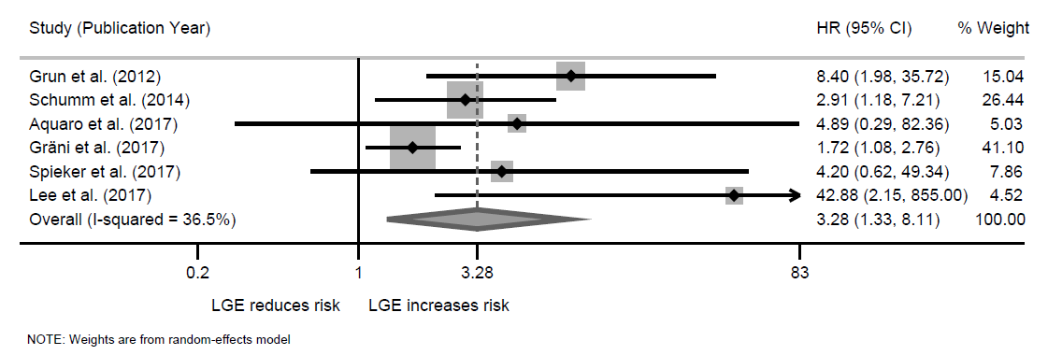

**B)**

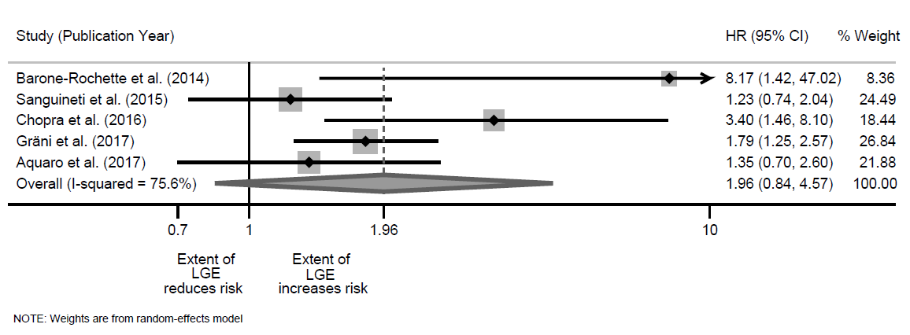

**C)** 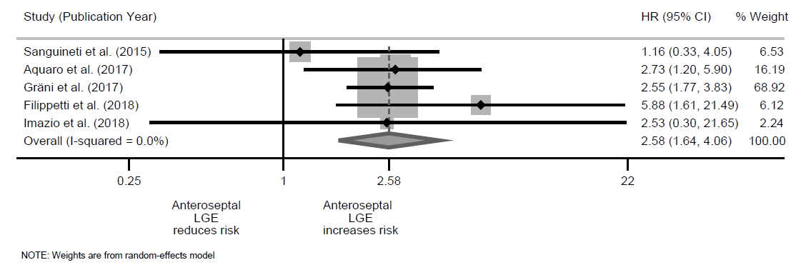

**Figure 3**.

**A)**

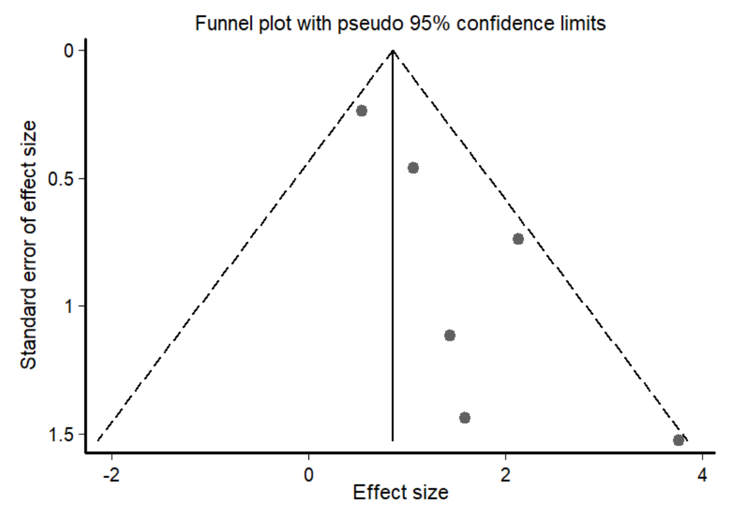

**B)**

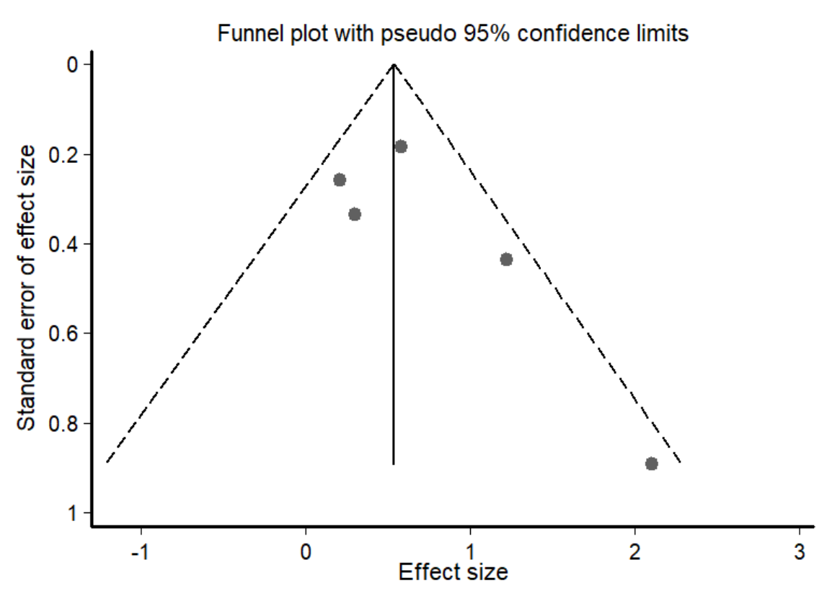

**C)**

