Supplementary – Figure 1

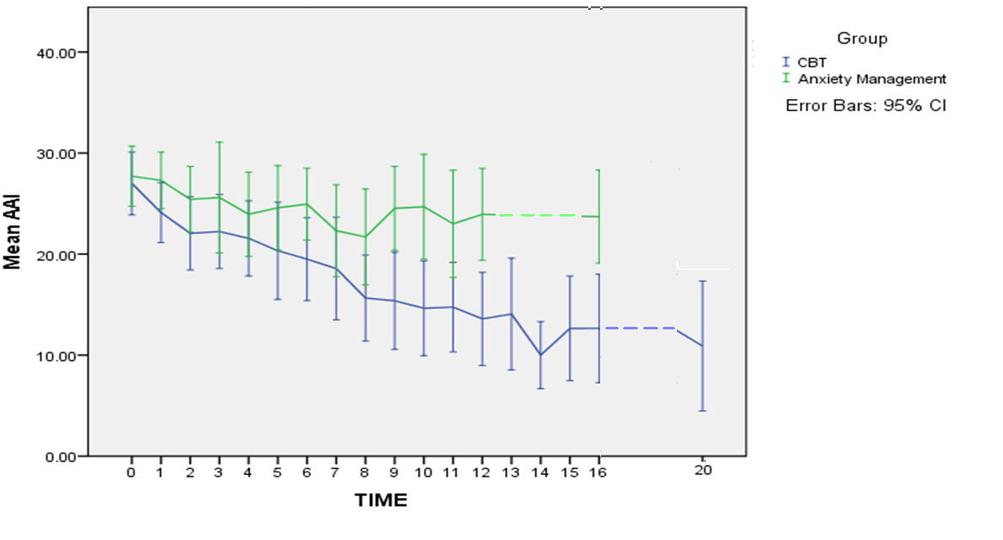

Figure 1. Appearance Anxiety Inventory (AAI) self-report scores over time