# Social norms as a predictor of smoking uptake among youth: a systematic review, meta-analysis and meta-regression of prospective cohort studies

**Katherine East*1,2,3, Ann McNeill1,2, James F Thrasher4,5, Sara C Hitchman1**

* Corresponding author

*katherine.east@uwaterloo.ca, ann.mcneill@kcl.ac.uk, thrasher@mailbox.sc.edu, sara.hitchman@kcl.ac.uk*

1 National Addiction Centre, Institute of Psychiatry, Psychology and Neuroscience, King’s College London, UK

2 Shaping Public hEalth poliCies To Reduce ineqUalities and harM (SPECTRUM) Consortium, UK

3 School of Public Health & Health Systems, Faculty of Applied Health Sciences, University of Waterloo, Waterloo, Ontario, Canada

4 Department of Health Promotion, Education, and Behavior, Arnold School of Public Health, University of South Carolina, USA

5 Department of Tobacco Research, Center for Population Health Research, National Institute of Public Health, Mexico

**Running Head:** **A review of norms and youth smoking uptake**

**Word Count:** 3,986

**Declarations of competing interests:** JFT has served on behalf of governments in response to legal challenges from the tobacco industry. All other authors have no competing interests to declare.

**Funding:** This work was funded by a PhD studentship from the UK Centre of Tobacco and Alcohol Studies (UKCTAS; MR/K023195/1). AM is a National Institute for Health Research (NIHR) Senior Investigator. The views expressed in this article are those of the authors and not necessarily those of UKCTAS or NIHR.

**Date re-submitted to Addiction:** 13th January 2020

# Abstract

*Background and aims.* Social norms towards smoking are a key concept in tobacco control policy and research; however, the influence and strength of different types of social norms on youth smoking uptake is unclear. This study aimed to examine, quantify, and compare evidence of the longitudinal associations between different types of social norms towards smoking and youth smoking uptake (initiation and escalation).

*Methods.* Systematic review searching four databases (MEDLINE/EMBASE/PsycINFO/CINAHL) from January 1998 to October 2020. Evidence synthesis via narrative review, meta-analysis pooling unadjusted associations (initiation only, due to heterogeneity in escalation outcomes), and meta-regression comparing effect-sizes by norm type and study characteristics. Studies included observational prospective cohort studies using survey methodology with youthaged ≤24 years. Measurements included longitudinal associations between descriptive norms (perceived smoking behaviour) and injunctive norms (perceived approval/disapproval of smoking) among social network(s) and subsequent smoking initiation or escalation.

*Results.* Thirty articles were identified. In the narrative review, smoking initiation (but not escalation) was consistently predicted by two norms: parent and close friend smoking. Associations between smoking uptake and other descriptive norms (smoking among: siblings, family/household, partner, peers, adults) and all injunctive norms (perceived approval of smoking among: parents, siblings, close friends/peers, partner, teachers, people important to you, the public) were less consistent/inconclusive. In the meta-analysis pooling unadjusted associations, 17 articles were included (N=27,767). Smoking initiation was predicted by the following descriptive norms: smoking among parents (OR=1.88[95%CI=1.56-2.28]), close friends (OR=2.53[1.99-3.23]), siblings (OR=2.44[1.93-3.08]), family/household (OR=1.55[1.36-1.76]), and adults (OR=1.34[1.02-1.75]), but not peers (OR=1.14[0.92-1.42]). Smoking initiation was also predicted by two injunctive norms, perceived approval of smoking among parents (OR=1.74[1.27-2.38]) and the public (OR=4.57[3.21-6.49]), but not close friends/peers (OR=2.36[0.86-6.53]) or people important to the individual (OR=1.24[0.98-1.58]).

*Conclusions.* In this systematic review (narrative and meta-analysis), descriptive norms of parents’ and close friends’ smoking behaviour appeared to be consistent predictors of youth smoking initiation, more so than the descriptive norms of more distal social networks and injunctive norms.

# Key words

1. Smoking
2. Tobacco use
3. Social norms
4. Social behaviour
5. Health behaviour
6. Adolescent
7. Observation
8. Systematic review
9. Meta-analysis

# Introduction

Smoking is the leading preventable cause of premature death and disease worldwide [1]. Smoking is highly addictive [2-4] and over two-thirds of people who try a cigarette (initiate smoking) escalate to daily smoking [5]. Smoking is largely initiated before age 18 [6,7]. Youth smoking initiation therefore puts individuals at risk for developing a lifetime addiction to smoking, and smoking-related diseases [4,5]. Clarifying the predictors of youth smoking uptake (initiation and escalation) is crucial for the theoretical understanding of smoking addiction and developing interventions to reduce youth smoking.

Social norms influence behaviour [8-15] and are central to several behavioural theories [9,14-18]. Social norms consist of *descriptive* and *injunctive* norms, which can be measured in relation to different social networks [10]. Descriptive norms are perceptions of the behaviour of a social network (e.g., family, close friends, peers, adults) [10]. Injunctive norms are perceptions of what a social network believes people should or should not do [10]. Descriptive and injunctive norms associated with different social networks are distinct and have unique influences on behaviour [18-21], although they can interact [21]. Social norms may influence behaviour by providing cues or opportunities for that behaviour to take place and via innate desires to conform with others’ behaviours and attitudes [10,13-15]. Most theories focus on the norms of close social network members [9,14-18] and less so on the normative influence of more distal social networks.

The influence of close network members’ descriptive norms on youth smoking uptake are well-documented. For example, systematic reviews and meta-analyses have found that youth with parents and siblings [22] and close friends [23] who smoke are more likely to take up smoking. However, the influence of close network members’ *injunctive* norms on youth smoking uptake is less clear: while one meta-analysis found a positive indirect association via intention to smoke, the direct effect was not assessed [24]. Moreover, in a broad systematic review exploring the predictors of youth smoking initiation [25], the injunctive norm of parent disapproval of smoking was not a consistent predictor, while few studies or none at all measured descriptive or injunctive norms among more distal social networks, such as peers, adults, and the public. In sum, while the descriptive norms of close network members consistently predict smoking uptake, other normative influences are less clear.

Social norms are often used to explain how tobacco control policies change smoking behaviour [18,26-29]. For example, smoke-free legislation is said to denormalise smoking, and reduce smoking prevalence [30]. Some smoking prevention programmes also target social norms to reduce youth smoking [31-33]. For example, the A Stop Smoking in Schools Trial (ASSIST), which promoted anti-smoking norms at school, reduced the odds of being a smoker two years later [32]. Other programmes focussing on resisting pro-smoking injunctive norms, such as perceived peer pressure to smoke, have also been effective in reducing smoking uptake in schools [33,34]. Changing social norms may thus help to reduce youth smoking uptake.

The centrality of social norms in tobacco research and some policies [18,26-29] makes it imperative to understand their impact on youth smoking uptake. We therefore conducted a systematic review with evidence synthesis via a narrative review, meta-analysis, and meta-regression to: (i) examine the longitudinal associations between descriptive and injunctive norms towards smoking among different social networks and youth smoking uptake (initiation and escalation); (ii) quantify and compare the strength of these associations. We also examined risk of bias.

# Methods

## Protocol

This review adhered to the Preferred Reporting Items for Systematic Reviews and Meta-Analyses (PRISMA) statement (Table S1; Supporting Information). The protocol was registered online (PROSPERO ID:CRD42016033416) [35].

## Search strategy

MEDLINE, EMBASE, PsycINFO, CINAHL were searched from 1st January 1998 to 13th October 2020. The search strategy is available in the Supporting Information, and was informed by previous work [36].

## Article selection

### Inclusion criteria

*Population.* Youth age ≤24 years [37] at baseline.

*Exposure (norm type).* Self-reported descriptive norm of distal social networks (e.g., peers, adults, public) or any injunctive norm towards smoking. Descriptive norms were defined as an individual’s perceptions of the smoking behaviour of a social network (e.g., parents, siblings, close friends, peers, adults) [10]. Injunctive norms were defined as an individual’s perceptions of what a social network believe people should or should not do [10], including perceived approval/disapproval of smoking, acceptability/unacceptability of smoking, and also perceived pressure to smoke/not smoke. In this review, perceived pressure was included as a unique norm type because it was measured separately from injunctive norms in all articles included. Articles were excluded if they only assessed the descriptive norms of close social network members (e.g., family, close friends) because reviews have already been published on their association with youth smoking uptake [22,23] and many articles (N=140) only assessed these norm types.

The centrality of social norms in tobacco research and some policies [18,26-29] makes it imperative to understand their impact on youth smoking uptake. We therefore conducted a systematic review with evidence synthesis via a narrative review, meta-analysis, and meta-regression to: (i) examine the longitudinal associations between descriptive and injunctive norms towards smoking among different social networks and youth smoking uptake (initiation and escalation); (ii) quantify and compare the strength of these associations. We also examined risk of bias.

*Outcome.* Smoking uptake, defined as initiation (any smoking at follow-up from baseline never smoking, including puffing on a cigarette) or escalation (any increase in smoking between baseline and follow-up among those that had already initiated, e.g., experimental to regular smoking).

*Date.* Data collected in/after 1998 (chosen for significance as the year of the first comprehensive smoking ban, in California, US, because smoking bans may change smoking norms [38,39]).

*Design.* Observational prospective cohort surveys, assessed the longitudinal association(s) between norms at baseline and smoking at follow-up.

*Language.* English.

*Multiplicity of samples.* Some samples were present in more than one article (Table S2). Criteria were applied in the following order to select which article to include:(1) peer-reviewed, (2) smoking initiation as primary outcome, (3) most norms measures, (4) most injunctive norms measures, (5) longest follow-up, (6) most respondents.

*Data for meta-analysis (initiation only).* Odds ratios (ORs) and 95% confidence intervals (CIs) for the longitudinal association(s) between norms at baseline and smoking initiation at follow-up, either from articles directly, calculated/converted using data from articles (via Campbell Collaboration Effect Size Calculator [40]), or from article’s authors following request. Unadjusted associations were prioritised to minimise heterogeneity. Heterogeneity in smoking escalation measures (e.g., continuous/binary/ordinal; Table S3) precluded a meta-analysis for this outcome. However, articles assessing escalation were included in the meta-analysis if article’s authors subsequently provided data to calculate unadjusted associations between norms and smoking *initiation* at follow-up. Where necessary, up to three emails were sent to the article’s authors requesting data.

### Screening process

Articles were imported into EndNote-X9 [41] and duplicates removed. One reviewer (KE) screened articles in three stages (titles/abstracts/full-texts). Reasons for exclusion were documented at abstract and full-text level. Where information necessary to determine eligibility was missing, article’s authors were contacted. Articles were excluded where authors did not provide this information. AM, SH, and ES (see acknowledgements) checked screening, each checking 50 articles per stage. Agreement was moderate overall (kappa=0.58) and 100% at full-text level (kappa=1.0). Disagreements were resolved through discussion.

## Data extraction

Data extraction was completed in SPSS v22 [42] by KE and independently checked by AM. Two data extraction sheets were constructed (Supporting Information):(1) narrative review, containing information from articles and (2) meta-analysis, containing unadjusted associations between norms and smoking initiation.

When extracting data, norms were categorised into norm type (descriptive/injunctive/pressure, for each social network). For the meta-analysis, the primary summary statistic was the unadjusted OR and 95%CIs for the associations between each norm type and smoking initiation (see inclusion criteria). Several articles grouped perceived close friend with peer approval; a combined measure of “perceived close friend/peer approval” was therefore used. Similarly, “perceived approval from important people” was used where articles grouped perceived approval from multiple close social networks. Where articles measured perceived *disapproval* (rather than approval) of smoking or pressure *not to smoke* (rather than to smoke), associations were inversed (1/(OR[95%CI])).

## Risk of bias within studies

Risk of bias was assessed using the adapted 5-star Newcastle-Ottawa Quality Assessment Scale for Cohort Studies (adapted from Taylor et al. [43], Supporting Information). Scores range from 0-5 stars; ≤3 stars indicate high risk of bias [43].

## Analyses

Due to the heterogeneity in smoking escalation measures (Table S3), findings were first synthesised using a narrative review (additional to protocol [35]). We created a database, organised by norm type and outcome (initiation/escalation), listing each relevant article and unadjusted and adjusted association(s) reported (Tables S5-S7). We coded associations according to strength of evidence: some (p<.05/95%CI excludes null); mixed (some p<.05/95%CI excludes null, some p≥.05/95%CI includes null, e.g., p<.05 in unadjusted but not adjusted models); little (p≥.05/95%CI includes null); unclassifiable (associations not reported). Direction of association (positive/negative) was coded where there was some/mixed evidence. We tabulated and discussed the findings per norm type and outcome, including covariates (to explore confounding) and interactions.

Second, we ran a meta-analysis of the unadjusted associations between smoking norms and smoking initiation only. The meta-analysis data extraction sheet was exported to Stata v15 [44]. A variable was created indicating norm type. The natural logarithm of the OR and 95%CIs for each association were calculated, and pooled using a random-effects meta-analysis with Stata’s *metan* command [45]: first overall (to obtain overall effect-size), second by (1) descriptive, (2) injunctive, (3) pressure, and third by social network within (1)-(3).

Third, we ran a random-effects meta-regression because of anticipated heterogeneity to explore whether effect-sizes varied by study characteristics and norm type. Univariable and multivariable (adjusting for study characteristics significant (p<.05) in univariable analyses) meta-regressions were run with norm type and study characteristics as predictors, using Stata’s *metareg* command [46]. Study characteristics were: region (Asia/Europe/US), risk of bias (high/low), setting (school/other), data collection year (1998-2000/2001-2018 [modal split]), outcome (puffing on a cigarette/other), sample mean age (or, if unavailable, median), sample % female, follow-up length.

Publication bias was assessed using Funnel plots and Egger’s test [47-50] and corrected for using a non-parametric trim-and-fill method [51,52].

# Results

The search identified 11,831 articles, of which 30 were included in the narrative review [53-82] and 17 in the meta-analysis [53-69] (Fig.1). Reasons for exclusion from the meta-analysis are listed in Table S3.

[Insert Figure 1 here]

## Narrative review

### Description of articles

Table S3 details the characteristics of all 30 articles. All except one PhD thesis [73] were peer-reviewed journal publications. Articles were from the US (13 articles), Europe (13), and Asia (4). Sample sizes ranged from N=193-11,583, and age ranged from 8-23 years. Most (21) used school-based surveys. Follow-up ranged from 6 months to 5 years, with the majority (23) running for 1+ years.

Most (19) articles had high risk of bias (Table S4). The most common sources of bias were lack of bio-verified smoking outcomes (26 articles) and lack of a standardised, valid, or reliable assessment of smoking norms (16).

Descriptive norms were assessed in 24 articles. Injunctive norms were assessed in 23 articles. Three articles assessed perceived pressure to smoke/not smoke. There was considerable variation in the measurement of social norms (Table S3). Half (16) assessed smoking initiation, defined as progressing from never smoking to: any smoking (even a puff; 15 articles), at-least-monthly smoking (1 article). Half (17) assessed smoking escalation using several different measures (Table S3). Three assessed both initiation and escalation. All except one included covariates in analyses, and there was considerable variation in covariates (Table S3).

### Longitudinal associations between social norms and smoking uptake

Table 1 summarises the associations between each norm type and smoking uptake (initiation and escalation). Tables S5-S7 show the associations in detail.

#### Descriptive norms

Despite eliminating articles solely assessing the descriptive norms of close social networks, parent and close friend smoking were the most frequently assessed norm, appearing in 13 and 21 articles, respectively (Table 1). Parent smoking was positively associated with smoking initiation in most articles (5 out of(/)7 articles) but only with escalation in 2/6 articles. Findings were similar for close friend smoking (initiation:6/11; escalation:3/10) although close friend smoking was negatively associated with smoking escalation in one article [73]. For all other descriptive norms, evidence of associations with smoking initiation/escalation was less consistent or inconclusive because of predominantly mixed findings and/or too few articles.

Most articles adjusted for several covariates including other measures of social norms (Table S5). Mixed evidence of associations was largely attributable to differences between unadjusted and adjusted results (Table S5). For example, in 2/21 articles assessing close friend smoking, and 2/3 articles assessing sibling smoking, associations with initiation/escalation were found in unadjusted but not adjusted analyses.

#### Injunctive norms

Perceived parent and close friend/peer approval of smoking were the most frequently assessed injunctive norms; however, there was little consistent evidence of associations with smoking initiation/escalation (Table 1). For all other injunctive norms, evidence was less consistent or inconclusive because of predominantly mixed findings and/or too few articles.

Similar to descriptive norms, most articles adjusted for several covariates including other measures of social norms (Table S6). Mixed evidence was largely attributable to differences between unadjusted and adjusted results or interactions with other social norms (Table S6). For example, in 2/11 articles assessing parent approval of smoking, associations with initiation/escalation were found in unadjusted but not adjusted analyses. An additional 2/11 articles found associations were dependent on parent smoking, such that parent disapproval of smoking protected against smoking among youth with non-smoking, but not smoking, parents (Table S6).

#### Pressure

Too few articles assessed associations between perceived pressure to smoke/not smoke from parents, siblings, and friends/peers and smoking initiation/escalation to enable conclusive evidence (Table 1).

[Insert Table 1 here]

## Meta-analysis

### Description of articles

Seventeen articles were included in the meta-analysis. Unadjusted associations between norms and smoking initiation were available directly from 11 articles [53,55-57,59,60,62,63,66,67,69]. Authors provided data for 6 articles [54,58,61,64,65,68]. Eighteen unique samples, with total N=27,767, were included. Figs.2-4 show the sample characteristics for each association. Briefly, follow-up ranged from 6 months to 5 years and samples ranged from N=298-4,351.

### Longitudinal associations between social norms and smoking initiation

The pooled effect-size for the association between all social norms and smoking initiation was OR=1.80[95%CI=1.62-1.99]). Heterogeneity (variation in associations between studies) was considerable (I2=92.8) [83].

#### Descriptive norms

Fig.2shows the meta-analysis of associations between descriptive norms from different social networks (e.g., parents, close friends) and smoking initiation. Thirty-six associations were assessed across 15 articles. Overall, descriptive norms were positively associated with smoking initiation (OR=1.88[1.65-2.13]). When stratified by network, parent, sibling, close friend, and family/household smoking were associated with smoking initiation. Sibling and close friend smoking had the largest effect-sizes. Perceived adult smoking prevalence had a small but consistent effect. Perceived peer smoking prevalence had no consistent effect. Heterogeneity was considerable overall and separately for parent, close friend, peer, and adult smoking (all I2>75) [83].

[Insert Figure 2 here]

#### Injunctive norms

Fig.3 shows the meta-analysis of associations between injunctive norms from different social networks and smoking initiation. Nineteen associations were assessed across 14 articles. Overall, injunctive norms were positively associated with smoking initiation (OR=1.78, 95%CI=1.43-2.21). When stratified by social network, only perceived parent and public approval of smoking were consistently associated with smoking initiation. Perceived public approval had the largest effect-size, although CIs were wide indicating low precision. Perceived approval from close friends/peers and people important to you had no consistent effect. Again, heterogeneity was considerable overall and for parent and close friend/peer approval (both I2>75) [83].

[Insert Figure 3 here]

#### Perceived pressure

Fig.4 shows the meta-analysis of associations between perceived pressure to smoke/not smoke from different social networks and smoking initiation. Three associations were assessed across two articles. Overall, perceived pressure was not consistently associated with smoking initiation (OR=1.15[0.91-1.46]). When stratified by social network, perceived pressure from friends/peers, but not parents, had a consistent effect; however, few associations were explored. Heterogeneity was considerable (I2=82.1) [83].

[Insert Figure 4 here]

### Meta-regression

Table 2 shows the meta-regression results. In univariable analyses, country and risk of bias influenced the magnitude of effect-size between norms and smoking initiation, and hence were included in multivariable analyses together with norm type. Effect-size was larger among samples from Asia than Europe or the US, and, in univariable analyses only, larger among studies with low risk of bias.

Norm type also influenced the magnitude of effect-size, such that, compared to perceived peer smoking prevalence, effects were greater for parent, sibling, and close friend smoking, and approval of smoking from friends/peers and the public (unadjusted analyses only) (Table 2).

[Insert Table 2 here]

### Publication bias

Asymmetry in the funnel plots indicated few smaller-sized studies with negative effects and thus some publication bias for descriptive norms, injunctive norms, and pressure (Fig.S1) [47]. Egger’s test indicated strong evidence of publication bias for descriptive norms (p<.001) but not injunctive norms (p=.167) or pressure (p=.909). Correcting for publication bias did not change the interpretation of results (effect-sizes after trim-and-fill: descriptive OR=1.60[1.42-1.82], injunctive OR=1.78[1.43-2.21], pressure OR=1.10[0.87-1.38]).

# Discussion

This study examined, quantified, and compared evidence of the longitudinal associations between social norms towards smoking and youth smoking uptake (initiation and escalation). Overall, when pooling unadjusted associations via a meta-analysis, perceiving that others smoke (descriptive norms) and approve of smoking (injunctive norms) predicted youth smoking initiation, although the strength and consistency of associations varied across social networks. In the narrative review, injunctive norms had a less consistent effect on smoking initiation and escalation when adjusting for covariates, including other social norms.

Descriptive norms towards smoking from close network members, specifically parents and close friends, had relatively consistent effects on youth smoking initiation, similar to previous reviews and meta-analyses [22,23,25]. For example, close friend smoking more than doubled the odds of smoking initiation. This contrasts with findings for more distal social networks: perceived adult smoking prevalence had a small effect on youth smoking initiation, while perceived peer prevalence of smoking had no consistent effect. Taken together, these findings suggest that the descriptive norms of close network members are consistent predictors of youth smoking initiation, more so than the descriptive norms of more distal social networks.

The injunctive norm of perceived parent approval of smoking strongly predicted youth smoking initiation in the meta-analysis. However, the findings from the narrative review suggest this association may be confounded by, or be dependent upon, covariates including but not limited to parent smoking. Any influence of parent attitudes may thus be redundant to parents’ actual smoking behaviour. Perceiving that close friends/peers approve of smoking also did not consistently predict youth smoking initiation. Overall, injunctive norms may therefore not be as predictive of youth smoking initiation as the descriptive norms of close network members, consistent with previous research [20]. Few articles assessed perceived public approval of smoking and perceived pressure to smoke/not smoke; studies should continue to assess these norms to advance knowledge in this area.

In the narrative review, parent, and close friend smoking were consistently associated with smoking initiation among never smoking youth, but not escalation among youth who had initiated smoking, although the findings for other social norms were broadly similar for initiation and escalation. However, there was heterogeneity across outcomes of smoking escalation. More studies using similar standardized outcomes of escalation to regular smoking are required to synthesise evidence via meta-analyses and obtain effect estimates.

In the meta-regression, perceived peer smoking prevalence had a smaller effect on youth smoking initiation than parent smoking, consistent with the findings from the meta-analysis. There was little variation in effect-sizes across all other types of social norm. However, meta-regressions are often limited by low statistical power, resulting in failure to detect associations, and associations were few for some norms (e.g., two associations for perceived public approval of smoking). Additional studies assessing smoking norms, particularly of more distal social networks and perceived pressure, are required to allow stronger conclusions to be drawn.

There was high risk of bias within and between studies. Two thirds of articles were low quality, and, to address this, future studies could consider bio-verifying smoking uptake and use validated/reliable norms measures [36]. However, surprisingly, low quality was associated with smaller effect-size, suggesting little cause for concern when interpreting findings. There was also publication bias, although its’ correction did not influence the results.

The association between smoking norms and smoking initiation was stronger among studies from Asia than the US and Europe. Some Asian countries are at earlier stages of the tobacco epidemic than the US and Europe [84] and associations between smoking norms and behaviours differ across countries with different policies and smoking rates [19,85]. The understanding of norms may also differ by culture and language [86]. Future research should consider cross-country differences in associations between smoking norms and youth smoking uptake specifically, particularly because policies recommended by the World Health Organization’s Framework Convention on Tobacco Control are presumed to reduce smoking through changing social norms [26,27].

Our findings have important theoretical implications. They are broadly consistent with a seminal study finding that smoking behaviour spreads through interconnected social networks [87] and with Social Cognitive Theory and PRIME Theory of Addiction, which both state that the behaviours of those closest to you predict that same behaviour, more so than the behaviours of distal social networks [14,15,18]. Specifically, social norms may influence behaviour by providing cues or opportunities to engage in that behaviour [10,88]; this is likely particularly true of parent and close friend smoking.

The findings are inconsistent with theories, such as the Theory of Planned Behaviour (TPB), which posit that injunctive norms from “people important to you” predict behaviour [9]. More recent versions of the TPB that also include close network members’ descriptive norms may better predict youth smoking initiation [16,20]. Theories may also benefit from distinguishing between the descriptive and injunctive norms of different social networks to enhance their predictive utility.

This study also has implications for interventions and policies to reduce smoking prevalence. Smoking norms are modifiable, and theorised to be on the causal pathway between tobacco control policies and changes in smoking behaviour [18,26-29]. Our findings suggest that interventions should continue to focus on reducing smoking prevalence, particularly encouraging parents who smoke to quit, and reducing youth exposure to smoking in the home and among close friends. Similarly, collective smoking prevention programmes involving close network members may be more successful and cost-effective than individual programmes [87]. Interventions that focus on reducing how common smoking is perceived to be among peers or the public, or the perceived acceptability of smoking, may be less effective in reducing youth smoking. They are also broadly consistent with other findings that smoking norms (particularly injunctive) do not always correspond with population smoking prevalence, and also with tobacco control policies [39,85,89].

Declines in youth perceptions of the proportion of peers who smoke have previously been used to indicate the denormalisation of smoking and reductions in youth smoking prevalence [90]. However, our findings suggest that perceived peer smoking prevalence may not consistently predict youth smoking uptake. Instead, perceptions of close friends’ smoking among could be used to predict reductions in youth smoking.

## Limitations

First, we excluded articles that only measured close network members’ descriptive norms. Despite this, the effect-size for family smoking was similar to previous meta-analyses [22], enhancing confidence in our findings for this norm type. This criterion would also not have influenced findings for more distal social networks or injunctive norms. Second, social norms are not always independent and some theories and empirical evidence support their interactive effects [21,58,66]. Thus, the meta-analysis pooling *unadjusted* associations may not have captured independent effects of social norms on smoking initiation. However, in the narrative review we examined unadjusted and adjusted associations, including interactions, and discussed differences and implications. Third, perceived approval from close friends and peers were grouped for analyses, possibly concealing individual effects. However, there was little difference in the results of articles assessing only close friend approval and those that combined it with peers’ approval. Fourth, only English language articles were searched, and associations differ across countries [19,85] and may differ by culture and language [96].

## Strengths

The search was not limited to peer-reviewed publications to minimise publication bias. Where articles/data were unavailable, we requested them from articles’ authors. Only longitudinal studies were included, with most running for one year or more, and consisting of >1,000 respondents, enhancing statistical power. We used random-effects meta-analysis and meta-regression to account for and explore heterogeneity, and only pooled data with similar outcomes of smoking initiation to reduce heterogeneity.

## Conclusions

The descriptive norms (perceived smoking behaviour) of parents and close friends were consistent predictors of youth smoking initiation, more so than the descriptive norms of more distal social networks (peers, adults) and injunctive norms (perceived approval of smoking).

# Acknowledgements

Erikas Simonavicius (ES) for performing screening checks.

Abigail ter Kuile for assisting with screening and data extraction.

# References (*included in narrative review, *†included in meta-analysis)

[1] World Health Organisation. Tobacco fact sheet 2019 [Available from: www.who.int/news-room/fact-sheets/detail/tobacco.

[2] Tobacco Advisory Group of the Royal College of Physicians. Nicotine without smoke: Tobacco harm reduction. 2016.

[3] Benowitz NL. Nicotine addiction. N Engl J Med. 2010;362(24):2295-2303. 10.1056/NEJMra0809890.

[4] Attwood A, Aveyard P, Bauld L, Britton J, Hajek P, Hastings G, et al. Tobacco. In: Miller PM, editor. Principles of Addiction. 12013. p. 767-776.

[5] Birge M, Duffy S, Miler JA, Hajek P. What proportion of people who try one cigarette become daily smokers? A meta-analysis of representative surveys. Nicotine Tob Res. 2018;20(12):1427-1433. 10.1093/ntr/ntx243.

[6] U.S. Department of Health and Human Services. The health consequences of smoking - 50 years of progress: A report of the Surgeon General. Atlanta, GA: U.S. Department of Health and Human Services, Centers for Disease Control and Prevention, National Center for Chronic Disease Prevention and Health Promotion, Office on Smoking and Health; 2014.

[7] Office for National Statistics. General Lifestyle Survey 2008: Smoking and drinking among adults. 2010.

[8] Lapinski MK, Rimal RN. An explication of social norms. Communication Theory. 2005;15(2):127–147. 10.1111/j.1468-2885.2005.tb00329.x.

[9] Ajzen I. The theory of planned behavior. Organ Behav Hum Decis Process. 1991;50(2):179-211. 10.1016/0749-5978(91)90020-T.

[10] Cialdini RB, Kallgren CA, Reno RR. A focus theory of normative conduct: A theoretical refinement and reevaluation of the role of norms in human behavior. Adv Exp Soc Psychol. 1991;24:201-234. 10.1016/S0065-2601(08)60330-5.

[11] Park HS, Smith SW. Distinctiveness and influence of subjective norms, personal descriptive and injunctive norms, and societal descriptive and injunctive norms on behavioral intent: A case of two behaviors critical to organ donation. Hum Commun Res. 2007;33(2):194-218. 10.1111/j.1468-2958.2007.00296.x.

[12] Sherif M. The Psychology of Social Norms. Oxford, England: Harper; 1936.

[13] Hechter M, Opp KD. Social Norms. New York: Russell Sage Foundation; 2005.

[14] Bandura A. Social Foundations of Thought and Action: A Social Cognitive Theory. Englewood Cliffs, NJ, US: Prentice-Hall, Inc.; 1986.

[15] Bandura A. Social Learning Theory. New York: General Learning Press; 1971.

[16] Rivis A, Sheeran P. Descriptive norms as an additional predictor in the theory of planned behaviour: A meta-analysis. Current Psychology: Developmental, Learning, Personality, Social. 2003;22(3):218-233. 10.1007/s12144-003-1018-2.

[17] Conner M, Norman P. Predicting and Changing Health Behaviour: Research and Practice with Social Cognition Models. Maidenhead, Berkshire: McGraw-Hill Education; 2015.

[18] West R, Brown J. Theory of Addiction: John Wiley & Sons, Ltd.; 2013.

[19] Hosking W, Borland R, Yong HH, Fong G, Zanna M, Laux F, et al. The effects of smoking norms and attitudes on quitting intentions in Malaysia, Thailand and four Western nations: A cross-cultural comparison. Psychology and Health. 2009;24(1):95-107. 10.1080/08870440802385854.

[20] Manning M. The effects of subjective norms on behaviour in the theory of planned behaviour: A meta-analysis. British Journal of Social Psychology. 2009;48(Pt 4):649-705. 10.1348/014466608X393136.

[21] Rimal RN, Real K. Understanding the Influence of Perceived Norms on Behaviors. Communication Theory. 2006;13(2):184-203. 10.1111/j.1468-2885.2003.tb00288.x.

[22] Leonardi-Bee J, Jere ML, Britton J. Exposure to parental and sibling smoking and the risk of smoking uptake in childhood and adolescence: A systematic review and meta-analysis. Thorax. 2011;66(10):847-855. 10.1136/thx.2010.153379.

[23] Simons-Morton BG, Farhat T. Recent findings on peer group influences on adolescent smoking. J Prim Prev. 2010;31(4):191-208. 10.1007/s10935-010-0220-x.

[24] Topa G, Moriano JA. Theory of planned behavior and smoking: Meta-analysis and SEM model. Subst Abuse Rehabil. 2010;1:23-33. 10.2147/SAR.S15168.

[25] Wellman RJ, Dugas EN, Dutczak H, O'Loughlin EK, Datta GD, Lauzon B, et al. Predictors of the onset of cigarette smoking: A systematic review of longitudinal population-based studies in youth. Am J Prev Med. 2016;51(5):767-778. 10.1016/j.amepre.2016.04.003.

[26] Fong GT, Thompson M, Boudreau C, Bécuwe N, Driezen P, Agar T, et al. The conceptual model and methods of Wave 1 ( 2016 ) of the EUREST-PLUS ITC 6 European Countries Survey. Tob Induc Dis. 2018;16(2):A3. 10.18332/tid/99881.

[27] Fong GT, Cummings KM, Borland R, Hastings G, Hyland A, Giovino GA, et al. The conceptual framework of the International Tobacco Control (ITC) Policy Evaluation Project. ‎Tob Control. 2006;15:iii3-iii11. 10.1136/tc.2005.015438.

[28] Cummings KM, Fong GT, Borland R. Environmental influences on tobacco use: Evidence from societal and community influences on tobacco use and dependence. Annu Rev Clin Psychol. 2009;5:433-458. 10.1146/annurev.clinpsy.032408.153607.

[29] Michie S, van Stralen MM, West R. The behaviour change wheel: A new method for characterising and designing behaviour change interventions. Implementation Science. 2011;6(1):42. 10.1186/1748-5908-6-42.

[30] Sargent JD, Gibson J, Heatherton TF. Comparing the effects of entertainment media and tobacco marketing on youth smoking. ‎Tob Control. 2008;18(1):47-53. 10.1136/tc.2008.026153.

[31] Starkey F, Moore L, Campbell R, Sidaway M, Bloor M. Rationale, design and conduct of a comprehensive evaluation of a school-based peer-led anti-smoking intervention in the UK: the ASSIST cluster randomised trial. BMC public health. 2005;5:43. 10.1186/1471-2458-5-43.

[32] Campbell R, Starkey F, Holliday J, Audrey S, Bloor M, Parry-Langdon N, et al. An informal school-based peer-led intervention for smoking prevention in adolescence (ASSIST): A cluster randomised trial. The Lancet. 2008;371(9624):1595-1602. 10.1016/s0140-6736(08)60692-3.

[33] Coe RM, Crouse E, Cohen JD, Fisher Jr. EB. Patterns of change in adolescent smoking behavior and results of a one year follow-up of a smoking prevention program. Journal of School Health. 1982;52(6):348-353. 10.1111/j.1746-1561.1982.tb07133.x.

[34] Thomas RE, McLellan J, Perera R. Effectiveness of school-based smoking prevention curricula: systematic review and meta-analysis. BMJ Open. 2015;5(3):e006976. 10.1136/bmjopen-2014-006976.

[35] East K, Hitchman SC, Thrasher JF, McNeill A. Social norms as a predictor of transitions to smoking uptake among youth: A systematic review and meta-regression (CRD42016033416): PROSPERO; 2016 [Available from: www.crd.york.ac.uk/PROSPERO/display_record.php?ID=CRD42016033416.

[36] East K, Hitchman SC, Stead M, Mackintosh AM, McNeill A. The development of tools to measure norms towards smoking, nicotine use, and the tobacco industry. 2017.

[37] United Nations. Definition of youth. 2013.

[38] Chapman S, Freeman B. Markers of the denormalisation of smoking and the tobacco industry. ‎Tob Control. 2008;17(1):25-31. 10.1136/tc.2007.021386.

[39] East K, Hitchman S, McNeill A, Ferguson S, Yong HH, Cummings MK, et al. Trends in social norms towards smoking between 2002 and 2015 among daily smokers: Findings from the International Tobacco Control Four Country Survey (ITC 4C). Nicotine Tob Res. 2019. 10.1093/ntr/ntz179.

[40] Wilson DB. Practical meta-analysis effect size calculator n.d. [Available from: www.campbellcollaboration.org/research-resources/research-for-resources/effect-size-calculator.html.

[41] Clarivate Analytics. EndNote X9. Philadelphia: Clarivate Analytics2019.

[42] IBM Corp. IBM SPSS Statistics for Windows, Version 22.0. Armonk, New York: IBM Corp2013.

[43] Taylor G, McNeill A, Girling A, Farley A, Lindson-Hawley N, Aveyard P. Change in mental health after smoking cessation: Systematic review and meta-analysis. BMJ. 2014;348:g1151. 10.1136/bmj.g1151.

[44] StataCorp. Stata Statistical Software, Version 15.0. College Station, TX: Stata Corporation2017.

[45] Harris R, Bradburn M, Deeks J, Harbord R, Altman D, Sterne J. metan: Fixed- and random-effects meta-analysis. Stata Journal. 2008;8(1):3-28.

[46] Harbord RM, Higgins JPT. Meta-regression in Stata. Stata Journal. 2008;8(4):493-519.

[47] Sterne JAC, Sutton AJ, Ioannidis JP, Terrin N, Jones DR, Lau J, et al. Recommendations for examining and interpreting funnel plot asymmetry in meta-analyses of randomised controlled trials. BMJ. 2011;343:d4002. 10.1136/bmj.d4002.

[48] Egger M, Smith GD, Schneider M, Minder C. Bias in meta-analysis detected by a simple, graphical test. BMJ. 1997;315(7109):629. 10.1136/bmj.315.7109.629.

[49] Sterne JAC. METAFUNNEL: Stata module to produce funnel plots for meta-analysis. Stata Journal: Statistical Software Components S434101, Boston College Department of Economics; 2003.

[50] Harbord RM, Harris RJ, Sterne JAC. Updated tests for small-study effects in meta-analyses. Stata Journal. 2009;9(2):197–210.

[51] Steichen T. METATRIM: Stata module to perform nonparametric analysis of publication bias. Stata Journal: Statistical Software Components S410501, Boston College Department of Economics; 2000.

[52] Duval S, Tweedie R. Trim and fill: A simple funnel-plot-based method of testing and adjusting for publication bias in meta-analysis. Biometrics. 2000;56(2):455-463. 10.1111/j.0006-341X.2000.00455.x.

[53] *†Barrington-Trimis JL, Urman R, Berhane K, Unger JB, Cruz TB, Pentz MA, et al. E-cigarettes and future cigarette use. Pediatrics. 2016;138(1). 10.1542/peds.2016-0379.

[54] *†Bernat DH, Erickson DJ, Widome R, Perry CL, Forster JL. Adolescent smoking trajectories: Results from a population-based cohort study. J Adolesc Health. 2008;43(4):334-340. 10.1016/j.jadohealth.2008.02.014.

[55] *†Bernat DH, Klein E, Forster JL. Smoking initiation during young adulthood: A longitudinal study of a population-based cohort. J Adolesc Health. 2012;51(5):497-502. 10.1016/j.jadohealth.2012.02.017.

[56] *†Bidstrup PE, Frederiksen K, Siersma V, Mortensen EL, Ross L, Vinther-Larsen M, et al. Social-cognitive and school factors in initiation of smoking among adolescents: a prospective cohort study. Cancer Epidemiol Biomarkers Prev. 2009;18(2):384-392. 10.1158/1055-9965.EPI-08-0584.

[57] *†Chang FC, Lee CM, Lai HR, Chiang JT, Lee PH, Chen WJ. Social influences and self-efficacy as predictors of youth smoking initiation and cessation: A 3-year longitudinal study of vocational high school students in Taiwan. Addiction. 2006;101(11):1645-1655. 10.1111/j.1360-0443.2006.01607.x.

[58] *†Chassin L, Presson CC, Rose J, Sherman SJ, Davis MJ, Gonzalez JL. Parenting style and smoking-specific parenting practices as predictors of adolescent smoking onset. J Pediatr Psychol. 2005;30(4):333-344. 10.1093/jpepsy/jsi028.

[59] *†Conner M, Grogan S, Simms-Ellis R, Flett K, Sykes-Muskett B, Cowap L, et al. Do electronic cigarettes increase cigarette smoking in UK adolescents? Evidence from a 12-month prospective study. ‎Tob Control. 2017;27:365-372. 10.1136/tobaccocontrol-2016-053539.

[60] *†Dalton MA, Sargent JD, Beach ML, Titus-Ernstoff L, Gibson JJ, Ahrens MB, et al. Effect of viewing smoking in movies on adolescent smoking initiation: A cohort study. The Lancet. 2003;362(9380):281-285. 10.1016/s0140-6736(03)13970-0.

[61] *†Doubeni CA, Li W, Fouayzi H, Difranza JR. Perceived accessibility as a predictor of youth smoking. Ann Fam Med. 2008;6(4):323-330. 10.1370/afm.841.

[62] *†East K, Hitchman SC, Bakolis I, Williams S, Cheeseman H, Arnott D, et al. The association between smoking and electronic cigarette use in a cohort of young people. J Adolesc Health. 2018;62(5):539-547. 10.1016/j.jadohealth.2017.11.301.

[63] *†Grogan S, Conner M, Fry G, Gough B, Higgins A. Gender differences in smoking: A longitudinal study of beliefs predicting smoking in 11-15 year olds. Psychology and Health. 2009;24(3):301-316. 10.1080/08870440701746586.

[64] *†Hoving C, Reubsaet A, de Vries H. Predictors of smoking stage transitions for adolescent boys and girls. Prev Med. 2007;44(6):485-489. 10.1016/j.ypmed.2007.02.011.

[65] *†Hukkelberg SS, Dykstra JL. Using the prototype/willingness model to predict smoking behaviour among Norwegian adolescents. Addict Behav. 2009;34(3):270-276. 10.1016/j.addbeh.2008.10.024.

[66] *†Otten R, Engels RCME, Van Den Eijnden RJJM. General parenting, anti-smoking socialization and smoking onset. Health Educ Res. 2008;23(5):859-869. 10.1093/her/cym073.

[67] *†Shete SS, Wilkinson AV. Identifying demographic and psychosocial factors related to the escalation of smoking behavior among Mexican American adolescents. Prev Med. 2017;99:146-151. 10.1016/j.ypmed.2017.02.018.

[68] *†Valente TW, Fujimoto K, Soto D, Ritt-Olson A, Unger JB. A comparison of peer influence measures as predictors of smoking among predominately Hispanic/Latino high school adolescents. J Adolesc Health. 2013;52(3):358-364. 10.1016/j.jadohealth.2012.06.014.

[69] *†Wang MP, Ho SY, Lo WS. Overestimation of peer smoking prevalence predicts smoking initiation among primary school students in Hong Kong. J Adolesc Health. 2011;48(4):418-420. 10.1016/j.jadohealth.2010.07.017.

[70] *Carvajal SC, Granillo TM. A prospective test of distal and proximal determinants of smoking initiation in early adolescents. Addict Behav. 2006;31(4):649-660. 10.1016/j.addbeh.2005.05.047.

[71] *Colder CR, Flay BR, Segawa E, Hedeker D, Abrams DB. Trajectories of smoking among freshmen college students with prior smoking history and risk for future smoking: Data from the University Project Tobacco Etiology Research Network (UpTERN) study. Addiction. 2008;103(9):1534-1543. 10.1111/j.1360-0443.2008.02280.x.

[72] *Etcheverry PE, Agnew CR. Romantic partner and friend influences on young adult cigarette smoking: Comparing close others' smoking and injunctive norms over time. Psychol Addict Behav. 2008;22(3):313-325. 10.1037/0893-164X.22.3.313.

[73] *Glass K. Adhd symptoms and risk for alcohol use and cigarette smoking among college students: What role do social-cognitive factors play? US: University of South Carolina; 2012.

[74] *Grenard JL, Guo Q, Jasuja GK, Unger JB, Chou C, Gallaher PE, et al. Influences affecting adolescent smoking behavior in China. Nicotine Tob Res. 2006;8(2):245-255. 10.1080/14622200600576610.

[75] *Harakeh Z, Scholte RHJ, Vermulst AA, de Vries H, Engels RCME. Parental factors and adolescents' smoking behavior: An extension of the theory of planned behavior. Prev Med. 2004;39(5):951-961. 10.1016/j.ypmed.2004.03.036.

[76] *Lotrean LM, Mesters I, de Vries H. Why do Romanian junior high school students start to smoke? Child Care Health Dev. 2013;39(6):851-855. 10.1111/j.1365-2214.2012.01428.x.

[77] *O'Brien F, Simons-Morton B, Chaurasia A, Luk J, Haynie D, Liu D. Post-high school changes in tobacco and cannabis use in the United States. Substance Use and Misuse. 2018;53(1):26-35. 10.1080/10826084.2017.1322983.

[78] *Otten R, Engels RCME, Prinstein MJ. A prospective study of perception in adolescent smoking. J Adolesc Health. 2009;44(5):478-484. 10.1016/j.jadohealth.2008.09.004.

[79] *Otten R, Harakeh Z, Vermulst AA, Van den Eijnden RJ, Engels RC. Frequency and quality of parental communication as antecedents of adolescent smoking cognitions and smoking onset. Psychol Addict Behav. 2007;21(1):1-12. 10.1037/0893-164X.21.1.1.

[80] *Van Den Eijnden RJJM, Spijkerman R, Engels RCME. Relative contribution of smoker prototypes in predicting smoking among adolescents: A comparison with factors from the Theory of Planned Behavior. Eur Addict Res. 2006;12(3):113-120. 10.1159/000092112.

[81] *Van Zundert RMP, Engels RCME, Van den Eijnden RJJM. Adolescent smoking continuation: Reduction and progression in smoking after experimentation and recent onset. J Behav Med. 2006;29(5):435-447. 10.1007/s10865-006-9065-4.

[82] *Xie B, Palmer P, Li Y, Lin C, Johnson CA. Developmental trajectories of cigarette use and associations with multilayered risk factors among Chinese adolescents. Nicotine Tob Res. 2013;15(10):1673-1681. 10.1093/ntr/ntt035.

[83] The Cochrane Collaboration. Cochrane handbook for systematic reviews of interventions: Version 5.1.0. Higgins, J. P. T., & Green, S. (editors). 2011.

[84] World Health Organisation. WHO report on the global tobacco epidemic. Geneva; 2019.

[85] East K, Hitchman S, McNeill A, Thrasher JF, Hammond D. Social norms towards smoking and vaping and associations with product use among youth in England, Canada, and the US. Drug Alcohol Depend. 2019;205:107635. 10.1016/j.drugalcdep.2019.107635.

[86] Thrasher JF, Quah ACK, Dominick G, Borland R, Driezen P, Awang R, et al. Using cognitive interviewing and behavioral coding to determine measurement equivalence across linguistic and cultural groups. Field Methods. 2011;23(4):439-460. 10.1177/1525822x11418176.

[87] Christakis NA, Fowler JH. The collective dynamics of smoking in a large social network. N Engl J Med. 2008;358(21):2249-2258. 10.1056/NEJMsa0706154.

[88] Hitchman S, Fong GT, Zanna MP, Thrasher JF, Laux F. The relation between number of smoking friends, and quit intentions, attempts, and success: Findings from the International Tobacco Control (ITC) Four Country Survey. Psychol Addict Behav. 2014;28(4):1144–1152. 10.1037/a0036483.

[89] East K, Hitchman SC, McDermott M, McNeill A, Herbeć A, Tountas Y, et al. Social norms towards smoking and electronic cigarettes among adult smokers in seven European countries: Findings from the EUREST-PLUS ITC Europe Surveys. Tob Induc Dis. 2019;16(2):A15. 10.18332/tid/104417.

[90] McNeill A, Lewis S, Quinn C, Mulcahy M, Clancy L, Hastings G, et al. Evaluation of the removal of point-of-sale tobacco displays in Ireland. ‎Tob Control. 2011;20(2):137-143. 10.1136/tc.2010.038141.

# Figures and Tables

Table 1. Summary of associations between smoking norms and smoking uptake (initiation and escalation) among youth (30 articles). All associations for which there are some or mixed evidence are positive unless otherwise indicated (*).

|  |  |  |  |  |  |  |  |  |
| --- | --- | --- | --- | --- | --- | --- | --- | --- |
| **Norm and outcome** | **Number** | |  | **Evidence of associations**  **(n articles (%))** | | | | |
| **Articles** | **Respondents** |  | **Some (p<.05)** | **Mixed** | | **Little (p≥.05)** | |
| **DESCRIPTIVE NORMS** | |  |  |  |  | |  | |
| **Parent smoking** | |  |  |  |  | |  | |
| Initiation | 7 | 15,098 |  | 5 (71.4) | 1 (14.3) | | 1 (14.3) | |
| Escalation | 6 | 15,592 |  | 2 (33.3) | 2 (33.3) | | 2 (33.3) | |
| Total | 13 | 30,690 |  | 7 (53.8) | 3 (23.1) | | 3 (23.1) | |
| **Sibling smoking** | |  |  |  |  | |  | |
| Initiation | 2 | 3,526 |  | 1 (50.0) | 1 (50.0) | | 0 (0.0) | |
| Escalation | 1 | 504 |  | 0 (0.0) | 1 (100.0) | | 0 (0.0) | |
| Total | 3 | 4,030 |  | 1 (33.3) | 2 (66.7) | | 0 (0.0) | |
| **Family/household smoking** | | |  |  |  | |  | |
| Initiation | 4 | 5,031 |  | 0 (0.0) | 3 (75.0) | | 1 (25.0) | |
| Escalation | 2 | 511 |  | 1 (50.0) | 0 (0.0) | | 1 (50.0) | |
| Total | 6 | 5,542 |  | 1 (16.7) | 3 (50.0) | | 2 (33.3) | |
| **Close friend smoking** | |  |  |  |  | |  | |
| Initiation | 11 | 17,685 |  | 6 (54.5) | 2 (18.2) | | 3 (27.3) | |
| Escalation | 10 | 28,086 |  | *4 (40.0) | 6 (60.0) | | 0 (0.0) | |
| Total | 21 | 45,771 |  | 10 (47.6) | 8 (38.1) | | 3 (14.3) | |
| **Romantic partner smoking** | | |  |  |  | |  | |
| Initiation | 0 | 0 |  | NA | NA | | NA | |
| Escalation | 1 | 779 |  | 1 (100.0) | 0 (0.0) | | 0 (0.0) | |
| Total | 1 | 779 |  | 1 (100.0) | 0 (0.0) | | 0 (0.0) | |
| **Perceived prevalence of peer smoking** | |  |  |  |  | |  | |
| Initiation | 4 | 7,809 |  | 1 (25.0) | 1 (25.0) | | 2 (50.0) | |
| Escalation | 7 | 14,376 |  | 4 (57.1) | 2 (28.6) | | 1 (14.3) | |
| Total | 11 | 22,185 |  | 5 (45.5) | 3 (27.3) | | 3 (27.3) | |
| **Perceived prevalence of adult smoking** | |  |  |  |  | |  | |
| Initiation | 2 | 3,007 |  | 1 (50.0) | 0 (0.0) | | 1 (50.0) | |
| Escalation | 1 | 3,637 |  | 1 (100.0) | 0 (0.0) | | 0 (0.0) | |
| Total | 3 | 6,644 |  | 2 (66.7) | 0 (0.0) | | 1 (33.3) | |
| **INJUNCTIVE NORMS** | |  |  |  |  | |  | |
| **Parent approval** | |  |  |  |  | |  | |
| Initiation | 6 | 15,834 |  | 1 (16.7) | 3 (50.0) | | 2 (33.3) | |
| Escalation | 5 | 7,380 |  | 1 (20.0) | 3 (60.0) | | 1 (20.0) | |
| Total | 11 | 23,214 |  | 2 (18.2) | 6 (54.5) | | 3 (27.3) | |
| **Sibling approval** | |  |  |  |  |  | |
| Initiation | 0 | 0 |  | NA | NA | NA | |
| Escalation | 1 | 504 |  | 0 (0.0) | 1 (100.0) | 0 (0.0) | |
| Total | 1 | 504 |  | 0 (0.0) | 1 (100.0) | 0 (0.0) | |
| *Table 1 continued below.* | | | | | | | | |

| Table 1 (continued). Summary of associations between smoking norms and smoking uptake (initiation and escalation) among youth (30 articles) | | | | | | | | | | | | |
| --- | --- | --- | --- | --- | --- | --- | --- | --- | --- | --- | --- | --- |
| **Norm and outcome** | | **Number** | | | |  | | **Evidence of associations**  **(n articles (%))** | | | | |
| **Articles** | | **Respondents** | |  | | **Some (p<.05)** | | **Mixed** | | **Little (p≥.05)** | |
| **Close friend/peer approval** | | | |  | |  | |  | |  | |  | |
| Initiation | | 5 | | 8,214 | |  | | 0 (0.0) | | 3 (60.0) | | 2 (40.0) | |
| Escalation | | 7 | | 5,923 | |  | | 3 (42.9) | | 2 (28.6) | | 2 (28.6) | |
| Total | | 12 | | 14,137 | |  | | 3 (25.0) | | 5 (41.7) | | 4 (33.3) | |
| **Romantic partner approval** | | | |  | |  | |  | |  | |  | |
| Initiation | | 0 | | 0 | |  | | NA | | NA | | NA | |
| Escalation | | 1 | | 779 | |  | | 1 (100.0) | | 0 (0.0) | | 0 (0.0) | |
| Total | | 1 | | 779 | |  | | 1 (100.0) | | 0 (0.0) | | 0 (0.0) | |
| **Teacher approval** | | | |  | |  | |  | |  | |  | |
| Initiation | | 0 | | 0 | |  | | NA | | NA | | NA | |
| Escalation | | 1 | | 3,521 | |  | | 0 (0.0) | | 1 (100.0) | | 0 (0.0) | |
| Total | | 1 | | 3,521 | |  | | 0 (0.0) | | 1 (100.0) | | 0 (0.0) | |
| **Important people approval** | | | |  | |  | |  | |  | |  | |
| Initiation | | 3 | | 2,665 | |  | | 0 (0.0) | | 1 (33.3) | | 2 (66.7) | |
| Escalation | | 2 | | 1,078 | |  | | 1 (50.0) | | 0 (0.0) | | 1 (50.0) | |
| Total | | 5 | | 3,743 | |  | | 1 (20.0) | | 1 (20.0) | | 3 (60.0) | |
| **Public approval** | | | |  | |  | |  | |  | |  | |
| Initiation | | 2 | | 2,577 | |  | | 0 (0.0) | | 1 (50.0) | | 1 (50.0) | |
| Escalation | | 0 | | 0 | |  | | NA | | NA | | NA | |
| Total | | 2 | | 2,577 | |  | | 0 (0.0) | | 1 (50.0) | | 1 (50.0) | |
| **PRESSURE** | | | | | | | | | | | | |
| **Pressure to smoke from parents** | | | |  | |  | |  | |  |  | | |
| Initiation | | 1 | | 4,055 | |  | | 0 (0.0) | | 0 (0.0) | 1 (100.0) | | |
| Escalation | | 1 | | 504 | |  | | 0 (0.0) | | 1 (100.0) | 0 (0.0) | | |
| Total | | 2 | | 4,559 | |  | | 0 (0.0) | | 1 (50.0) | 1 (50.0) | | |
| **Pressure to smoke from siblings** | | | |  | |  | |  | |  |  | | |
| Initiation | | 0 | | 0 | |  | | NA | | NA | NA | | |
| Escalation | | 1 | | 504 | |  | | 0 (0.0) | | 1 (100.0) | 0 (0.0) | | |
| Total | | 1 | | 504 | |  | | 0 (0.0) | | 1 (100.0) | 0 (0.0) | | |
| **Pressure to smoke from friends/peers** | | | |  | |  | |  | |  |  | | |
| Initiation | | 2 | | 4,497 | |  | | 0 (0.0) | | 2 (100.0) | 0 (0.0) | | |
| Escalation | | 1 | | 4,497 | |  | | 1 (100.0) | | 0 (0.0) | 0 (0.0) | | |
| Total | | 3 | | 504 | |  | | 1 (33.3) | | 2 (66.7) | 0 (0.0) | | |

NA=Not Applicable

* In one [73] of these four articles, close friend smoking was negatively associated with smoking escalation (see Table S5, supporting information, for further details).

Table 2. Random-effects meta-regression of norm type and study characteristics on pooled effect-size of youth smoking initiation (k=58 associations)

|  |  |  |  |  |  |  |  |  |
| --- | --- | --- | --- | --- | --- | --- | --- | --- |
| **Variable (univariable I2 / Adj R2)** |  | **Univariable**  **associations** | |  | | **Multivariable associations1** | | |
| **k** | **OR (95% CI)** | **p** | |  | | **OR (95% CI)** | **p** | |
| **Norm type** (89.3/28.2) |  |  |  | |  | |  |  | |
| Peer smoking prevalence (ref) | 4 | 1.00 |  | |  | | 1.00 |  | |
| Parent smoking | 9 | 1.59 (0.97-2.61) | .063 | |  | | **1.62 (1.07-2.45)** | **.024** | |
| Sibling smoking | 2 | **2.09 (1.03-4.22)** | **.040** | |  | | **2.28 (1.26-4.11)** | **.006** | |
| Family/household smoking | 5 | 1.23 (0.71-2.13) | .451 | |  | | 1.39 (0.89-2.19) | .150 | |
| Close friend smoking | 13 | **2.12 (1.32-3.39)** | **.002** | |  | | **2.05 (1.38-3.03)** | **<.001** | |
| Adult smoking prevalence | 3 | 1.12 (0.60-2.06) | .726 | |  | | 1.23 (0.74-2.02) | .426 | |
| Parent approval | 8 | 1.45 (0.88-2.40) | .146 | |  | | 1.47 (0.97-2.23) | .072 | |
| Close friend/peer approval | 4 | **1.93 (1.06-3.52)** | **.031** | |  | | **1.75 (1.05-2.91)** | **.032** | |
| Important people approval | 5 | 1.03 (0.59-1.78) | .924 | |  | | 1.12 (0.67-1.87) | .660 | |
| Public approval | 2 | **3.45 (1.48-8.04)** | **.004** | |  | | 2.07 (0.97-4.41) | .061 | |
| Pressure from parents | 1 | 0.80 (0.33-1.90) | .606 | |  | | 0.92 (0.44-1.94) | .836 | |
| Pressure from friends/peers | 2 | 1.15 (0.56-2.35) | .702 | |  | | 1.32 (0.70-2.50) | .388 | |
| **Study characteristics** |  |  |  | |  | |  |  | |
| ***Region*** (90.2/40.1) |  |  |  | |  | |  |  | |
| Asia (ref) | 7 | 1.00 |  | |  | | 1.00 |  | |
| Europe | 22 | **0.40 (0.28-0.56)** | **<.001** | |  | | **0.50 (0.34-0.72)** | **<.001** | |
| US | 29 | **0.42 (0.30-0.58)** | **<.001** | |  | | **0.50 (0.35-0.72)** | **<.001** | |
| ***Risk of Bias*** (91.4/12.4) |  |  |  | |  | |  |  | |
| Low (NOS >3) (ref) | 22 | 1.00 |  | |  | | 1.00 |  | |
| High (NOS ≤3) | 36 | **0.71 (0.56-0.91)** | **.007** | |  | | 0.89 (0.72-1.11) | .305 | |
| ***Follow-up length2*** (92.0/-2.0) | 58 | 1.00 (0.99-1.01) | .913 | |  | |  |  | |
| ***Mean age of sample2*** (92.9/-1.9) | 58 | 0.99 (0.93-1.06) | .788 | |  | |  |  | |
| ***% female in sample 2*** (92.9/4.2) | 58 | 0.99 (0.98-1.00) | .095 | |  | |  |  | |
| ***School setting*** (92.8/-0.3) |  |  |  | |  | |  |  | |
| Yes (ref) | 39 | 1.00 |  | |  | |  |  | |
| No | 19 | 0.89 (0.68-1.16) | .388 | |  | |  |  | |
| ***Data collection year*** (92.8/0.8) |  |  |  | |  | |  |  | |
| 1998-2000 (ref) | 26 | 1.00 |  | |  | |  |  | |
| 2001-2018 | 32 | 0.87 (0.67-1.12) | .277 | |  | |  |  | |
| ***Outcome*** (92.9/3.1) |  |  |  | |  | |  |  | |
| Any smoking (even a puff) | 41 | 1.00 |  | |  | |  |  | |
| Other | 17 | 1.25 (0.95-1.64) | .106 | |  | |  |  | |

Multivariate model I2=83.6, Adj. R2=54.9.

1 Multivariable analyses only include norm type and the study characteristics significant (at p<.05) in univariable analyses. 2 Continuous variables. k=number of associations. I2=the percentage of residual heterogeneity that is attributable to between-study heterogeneity. Adjusted R2=the percentage of between-study heterogeneity explained by the norm type/study characteristic. NOS=Newcastle-Ottawa Scale score.

Figure 1. Preferred Reporting Items for Systematic Reviews and Meta-Analyses (PRISMA) flow diagram describing article selection

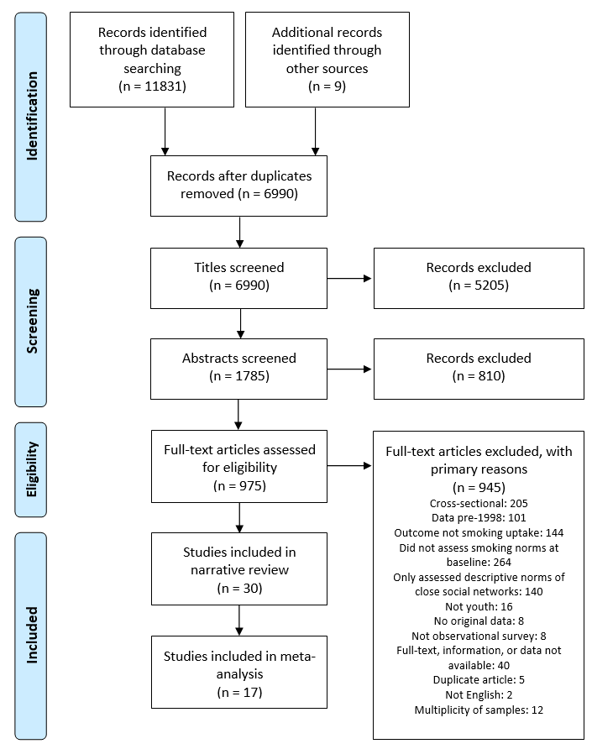

Primary reasons for exclusion are shown because some articles had more than one reason for exclusion. The reasons for exclusion are presented in terms of what exclusion criteria became apparent first during screening. See Supporting Information Table S2 for details on articles that were excluded due to multiplicity of samples, and Table S3 for details on articles that were included in the narrative review but excluded from the meta-analysis.

Figure 2. Random-effects meta-analysis of the pooled associations between descriptive norms and youth smoking initiation, grouped by social network and sorted by sample size

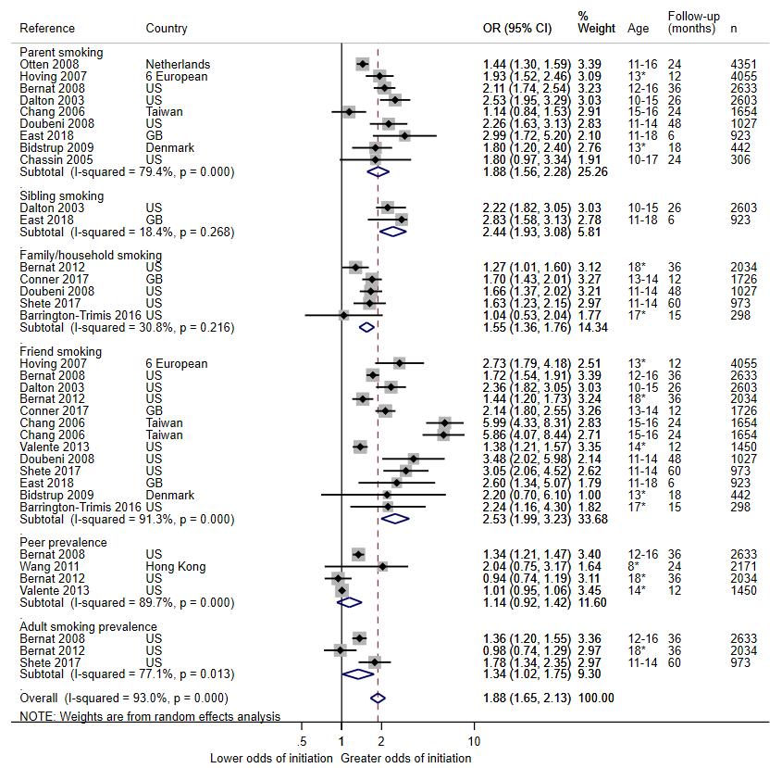

Country: US=United States; GB=Great Britain; 6 European=Finland, Denmark, the United Kingdom, the Netherlands, Spain, and Portugal. Age: Presented as range or mean (SD) depending on availability in source. *Mean presented (SD not available).

Figure 3. Random-effects meta-analysis forest plot of the pooled associations between injunctive norms and youth smoking initiation, grouped by social network and sorted by sample size

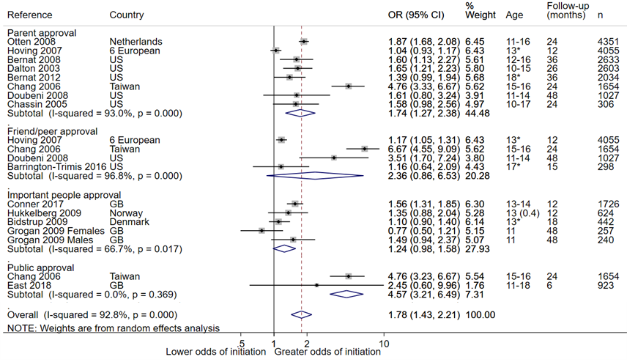

Country: US=United States; GB=Great Britain; 6 European=Finland, Denmark, the United Kingdom, the Netherlands, Spain, and Portugal. Age: Presented as range or mean (SD) depending on availability in source. *Mean presented (SD not available).

Figure 4. Random-effects meta-analysis forest plot of the pooled associations between perceived pressure to smoke and youth smoking initiation, grouped by social network and sorted by sample size

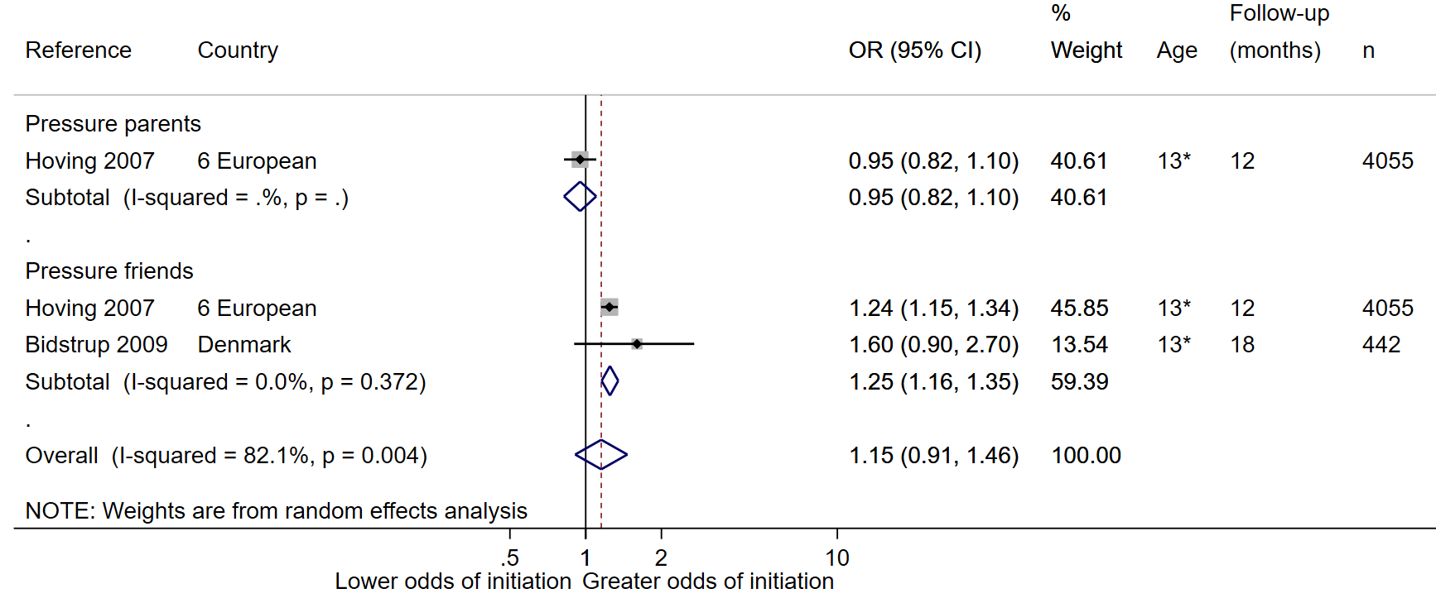

Country: 6 European=Finland, Denmark, the United Kingdom, the Netherlands, Spain, and Portugal. Age: Presented as range or mean (SD) depending on availability in source. *Mean presented (SD not available).