## Anosmia/ageusia and other COVID-like symptoms in association with SARS-CoV-2 positive test, across six national, digital surveillance platforms as the COVID-19 pandemic and response unfolded: an observation study

Carole H. Sudre PhD*1,2,3, Ayya Keshet MSc*4,5, Mark S. Graham PhD1, Amit D. Joshi PhD6,7, Smadar Shilo MD4,5,8, Hagai Rossman MSc4,5, Benjamin Murray MSc1, Erika Molten PhDi1, Kerstin Klaser MSc1, Liane D Canas PhD1, Michela Antonelli PhD1, Long H. Nguyen MD6,7, David A. Drew PhD6,7, Marc Modat PhD1, Joan Capdevila Pujol PhD9, Sajaysurya Ganesh9, Jonathan Wolf PhD9, Tomer Meir PhD4,5, Prof Andrew T. Chan MD6,7, Claire J. Steves PhD9, Prof Tim D. Spector PhD9,10, Prof John S. Brownstein PhD11, Prof Eran Segal PhD4,5, Prof Sebastien Ourselin PhD1,14, Christina M. Astley MD11,12,13

* These authors contributed equally to this work.

1. School of Biomedical Engineering & Imaging Sciences, King’s College London, London, UK

2. MRC Unit for Lifelong health and Ageing at UCL, Department of Population Science and Experimental Medicine, University College London, London, UK

3. Centre for Medical Image Computing, Department of Computer Science, University College London, London, UK

4. Department of Computer Science and Applied Mathematics, Weizmann Institute of Science, Rehovot, Israel

5. Department of Molecular Cell Biology, Weizmann Institute of Science, Rehovot, Israel

6. Clinical and Translational Epidemiology Unit, Massachusetts General Hospital and Harvard Medical School. Boston, Massachusetts, USA

7. Division of Gastroenterology, Massachusetts General Hospital and Harvard Medical School. Boston, Massachusetts, USA

8. Pediatric Diabetes Unit, Ruth Rappaport Children’s Hospital, Rambam Healthcare Campus, Haifa, Israel

9. Department of Twin Research and Genetic Epidemiology, King’s College London, UK

10. Zoe Global Limited

11. Computational Epidemiology Lab, Boston Children’s Hospital, Boston, MA, USA

12. Division of Endocrinology, Boston Children’s Hospital, Boston, MA, USA

13. Broad Institute of Harvard and MIT, Cambridge, MA, USA

14. AI Institute "3IA Côte d'Azur", Université Côte d’Azur, Nice, France

## **Corresponding author**

Carole H. Sudre – c.sudre@ucl.ac.uk

MRC Unit for Lifelong Health and Ageing at UCL, University College London, London, UK

**Research in context**

**Evidence before this study:** As the COVID-19 pandemic has evolved, testing capacity expanded and governmental guidelines adapted, generally encouraging testing with a broader set of symptoms beyond fever with canonical respiratory symptoms. In parallel, multiple large-scale citizen science digital surveillance platforms launched to complement knowledge from laboratory and somewhat smaller clinical studies. Symptoms such as loss of smell have been identified as strongly predictive of COVID-19 infection in both clinical and syndromic surveillance analyses and have therefore been used to inform these testing policy changes and access expansion.

**Added value of this study:** This study identifies symptoms that are or are not consistently associated with SARS-CoV-2 test positivity across various testing conditions using six data sets from 3 COVID-19 surveillance platforms in the United States, United Kingdom and Israel. These platforms are web- and smartphone-based, as well as cross-sectional and longitudinal. The study period of 4 months covers varying COVID-19 prevalence during the fall of the first wave and, in some areas, rise of the second wave. Importantly, these collaborative analyses use large-scale surveillance data to track and highlight the value of individual symptoms, specifically anosmia, fever and respiratory symptoms, to predict SARS-CoV-2 test positivity by region, platform, demographic factors, calendar time, timing of testing, illness duration, and exposure- and outcome-ascertainment, and illness.

**Implications of all the available evidence:** Despite differences in syndromic surveillance methodology, access to and timing of SARS-CoV-2 testing, and disease prevalence, loss of smell or taste was consistently the strongest predictor of COVID-19 infection across all platforms over time. The odds of COVID-19 test positivity was nearly 17 times higher among those with anosmia/ageusia compared to those without this symptom. Fever and respiratory symptoms of shortness of breath and cough also ranked highly in their association with test positivity. This large, collaborative analysis demonstrates anosmia/ageusia, fever, shortness of breath and cough are suitable empiric signals of ongoing COVID-19 transmission in regions where testing data are sparse or delayed. A prospective, iterative, surveillance-data based approach, leveraging multiple data sets such as was done here, is likely to play an important role in other epidemiological contexts.

# 

**Abstract**

**Background:** Multiple voluntary surveillance platforms were developed across the world in response to the COVID-19 pandemic, providing a real-time understanding of population-based COVID-19 epidemiology. During this time, testing criteria broadened and healthcare policies matured. We sought to test whether there were consistent associations of symptoms with SARS-CoV-2 test status across three national surveillance platforms, during periods of testing and policy changes.

**Methods:** Four months (April 1, 2020 to July 31, 2020) of observation through three volunteer COVID-19 digital surveillance platforms targeting communities in three countries (Israel, United Kingdom, and United States). Logistic regression of self-reported symptom on self-reported SARS-CoV-2 test status, adjusted for age and sex, in each of the study cohorts. Odds ratios were compared across platforms, countries and meta-analyzed. We also evaluated testing policy changes, COVID-19 incidence, and time scales of duration of symptoms and symptom-to-test.

**Findings:** Anosmia/ageusia was the strongest, most consistent symptom associated with a positive COVID-19 test (robust aggregated rank=1, random effects meta-analyzed OR 16.96 95%CI [13.13, 21.92]), based on 514,459 tests from over 10 million respondents in six datasets from three digital surveillance platforms across three different countries (2 platforms per country). Fever and respiratory symptoms also ranked highly as associated with test positivity. The association of symptoms with test status varied by duration of illness, timing of test, and broader test criteria, as well as over time, by country and platform.

**Interpretation:** The strong association of anosmia/ageusia with self-reported SARS-CoV-2 test positivity is consistently observed, supporting its validity as a reliable COVID-19 signal, regardless of the participatory surveillance platform, country, phase of illness or testing policy. These findings show that COVID-19 symptom-test positivity associations rank similarly in a wide range of scenarios. Anosmia, fever and respiratory symptoms consistently have the strongest effect estimates, and are the most appropriate empiric signals for symptom-based public health surveillance in areas with limited testing or benchmarking capacity. Collaborative syndromic surveillance will enhance real-time epidemiologic investigation and public health utility globally.

**Funding:** NIH, NIHR, Alzheimer’s Society, Wellcome Trust, Massachusetts Consortium on Pathogen Readiness (MassCPR)

## **Introduction**

Participatory syndromic surveillance has informed public health for nearly a decade(1,2)[1,2](https://paperpile.com/c/sPSRLZ/AlEAt+U3v8p), though it was the COVID-19 pandemic that spurred the rapid development of multiple digital monitoring platforms(3–9) to accelerate our understanding of and response to SARS-CoV-2 globally(10). These population science initiatives encompass a range of participant interfaces including website(3,5,9), phone(5), text message(9) and smartphone applications(4,6), using cross-sectional and longitudinal study designs, and implementing varying degrees of wide-scale sampling or engagement.

Real-time, community-based data from these platforms are strongly complementary to the so-called “hard outcomes” — i.e., COVID-19 cases, hospitalizations and deaths(11) — particularly in the setting of inadequate testing, delayed or absent reporting, or when ascertained outcomes only capture the most severe cases (e.g. clinical features of hospitalized COVID-19)(12,13). As an example of the utility of such platforms, prediction of COVID-19 infection using symptom-based scores was pioneered using data from these platforms in response to the limited testing capacity early during the pandemic, and highlighted early the potential importance of smell and taste disorders(8,14).

COVID-19 participatory surveillance platforms function in regions that have been variably impacted by the pandemic, though there has been no direct comparison of these data. Testing policies(15), test access(16), and Covid-Like-Illness (CLI) definitions have also varied substantially from country-to-country and over time. In many regions, testing was primarily targeted at those whose symptoms (or exposures) met strict criteria (e.g. fever and respiratory symptoms)(17), and then later CLI symptoms were broadened to acknowledge the spectrum of COVID-19 presentations(18), and to include other, sometimes highly specific features (e.g. anosmia)(19).

With all of these spatio-temporal changes in policies and access, as well as platform-specific study design features and inherent participation biases, we sought to identify which symptoms were consistently associated with SARS-CoV-2 test positivity — and thus might represent the most clinically and epidemiologically relevant COVID-19 signals despite possible changes over time and across assessment types of their absolute effect estimates To achieve this goal, we undertook a comparison of the association of putative CLI symptoms with self-reported SARS-CoV-2 testing results, over time, by phase of illness, and in three countries across three citizen-science digital surveillance platforms.

## **Methods**

Briefly, data from three countries with three participatory surveillance platforms (2 platforms per country), spanning a four-month period of observation early in the pandemic (April 1, 2020 to July 31, 2020), were used to estimate odds ratios (OR) for symptoms on self-reported SARS-CoV-2 test positivity among self-identified non-healthcare workers (as healthcare workers generally received different access to testing). Specifics of the three platforms (CMU/UMD Survey, Zoe App, and Israel Corona), as well as exposures, outcomes, and statistical analysis are summarized hereafter. Mapping of survey questions across platforms and survey language used is provided in Supplementary table 1.

### Study Populations

#### Carnegie Mellon University/University of Maryland Facebook COVID-19 Symptom Survey (US-CMU/UMD, UK-CMU/UMD, Israel-CMU/UMD)

This research is based on survey results from Carnegie Mellon University’s Delphi Research Group and University of Maryland. The US Facebook COVID-19 Symptom Survey hosted by the Carnegie Mellon Delphi Research Center provided web-based surveys to Facebook users(20); while University of Maryland similarly coordinated surveys to Facebook users external to the US (ex-US)(21) . Surveys asked about geographic location, age, gender, working in a healthcare setting, and the presence of symptoms in the prior 24 hours. Symptomatic respondents were additionally asked about SARS-CoV-2 test results. Ex-US respondent test results referred to tests in the prior 14 days or, if ill, tests during the illness. Survey-specific questions and logic detailed in Supplementary Table 1. From US and ex-US launch April 6, 2020 and April 23, 2020, respectively, through July 31, 2020, there were US 6,626,897, UK 272,767, and Israel 98,540 anonymous surveys with non-missing self-reported age and sex and who did not work in a healthcare setting. Surveys are presumed to be from unique respondents based on the sampling strategy from Facebook US (50 US states and the District of Columbia), UK (Great Britain excluding non-UK regions), and Israel, respectively. Survey sampling strategies are used to increase representativeness of the source population for each nation by sampling from the Facebook active user base and raking across census age, sex and geographic region to develop survey weights. See data documentation for sampling methods(20). Primary analyses across all cohorts represent weighted parameters. Unweighted sensitivity analyses detailed in the supplement. This study was approved by the Boston Children’s Hospital IRB (P00023700​).

#### Zoe Covid Symptom Study App (UK-Zoe, US-Zoe)

The data used for this work was collected through the COVID Symptom Study App, developed by Zoe Global Limited with input from physicians and scientists from King’s College London, Massachusetts General Hospital, Lund and Uppsala Universities(4). The smartphone application (app) was launched in the UK on March 24, 2020 and at July 31, 2020 counted 3,360,116 unique adult participants in the UK and 276,287 in the US. At registration, users are asked for personal characteristics (age, gender, and whether they are a healthcare worker). App users are asked via their mobile device to prospectively report their health status everyday indicating their symptoms, if they experience any. In addition, they record their test results for COVID-19. Anonymized longitudinal, prospective collected trajectories of illness reports were available for app users for this study. Research studies on data collected through the app are approved by King’s College London Ethics Committee REMAS ID 18210, review reference LRS-19/20-18210 and all participants provided consent. Through a partnership between the UK Department for Health and Social Care, tests were made available to UK users of the app upon invitation from the app maintainers (Zoe) from April 26, 2020. By design, invited app users who logged healthy twice in 9 days followed by an unhealthy report were invited to take a COVID-19 test. All tests results were analyzed in the main analysis. Multiple tests per user were censored within the symptom window following the test, or once a test resulted positive.

#### Corona Israel (Israel-Corona)

The Israel Corona study was collected through a voluntary online survey (<https://coronaisrael.org/>) that included a one-minute, anonymous, online questionnaire. From the date first published(5) on March 14, 2020 through July 31, 2020, there were N=131,799 completed surveys (29,993 unique users). Survey responses were collected directly through the online platform. Responders were asked to report information on age, gender, geographic location, prior medical conditions and whether they are a healthcare worker as well as symptoms experienced in the prior 24-hours for themselves and for each member of the family. Additionally, SARS-CoV-2 testing and test results were reported. This study was approved by the Weizmann Institute of Science review board (IRB). The IRB waived informed consent as all identifying information was removed prior to analysis.

### Study period, inclusion and exclusion criteria

Data from April 1, 2020 (or first testing data acquisition, if later) through July 31, 2020 were aggregated into weeks starting Mondays. The study population was restricted to respondents self-reporting baseline age 18 to 100 years (CMU/UMD survey age categories age >= 18 years to > 75 years, inclusive), sex male or female and non-healthcare workers. For regression models, CMU/UMD survey age-bins assigned age was the included decade (e.g. 12-24 as 20 years, 35-44 as 40 years, >75 as 80 years). Users with missing demographic data were excluded.

### Exposures (symptoms) and outcomes (COVID-19 test status)

Eleven symptoms shared across at least two platforms were grouped into meta-symptoms (e.g. myalgias/arthralgias inclusive of muscle pain, joint pain in Supplementary table 1). Symptoms that were shared but had limited responses, and thus could not be compared (i.e. abdominal pain, rash, confusion), were excluded. Self-reported symptoms were considered present if logged within 14 days prior to the COVID-19 test (Israel-Corona, UK-Zoe, US-Zoe). For the US, UK, and Israel-UMD/CMU cross-sectional survey, Facebook users were queried about symptoms present in the prior 24 hours, and symptomatic users were further asked about COVID-19 testing. In ex-US-CMU/UMD surveys, test status was queried for tests performed during the course of the current illness, or up to 14 days. To ensure privacy, Facebook users who respond to the cross-sectional survey did not contribute longitudinal data. Further analyses in the US/UK-Zoe (Figure 3) were performed to assess relevance of different symptoms when considering symptoms reported following the test stratified by geographic region (US vs UK), symptom onset-to-test duration (early ≤ 3 days vs late > 3 days) and test qualifying symptom era (narrow vs broad). Sensitivity analyses of US-CMU/UMD data to show the impact of illness duration on effect estimates are shown in Supplementary Figure 2.

The primary outcome was the self-reported result of the SARS-CoV-2 test (i.e. positive versus negative). Tests reported as pending or result unknown in the CMU-UMD cross-sectional surveys were excluded (US-CMU/UMD 39,124, UK-CMU/UMD 863, Israel-CMU/UMD 275). Testing counts and positive test proportions were tabulated as the number of users (Zoe) or surveys (CMU/UMD, Israel-Corona) and the ratio of test positives to total tests with results. Multiple test results could be reported (Israel-Corona, Zoe-App), if tests were performed at less than a 14-day window, only the first test was considered. Users were censored for a 14-day window, or after a first positive test. US-CMU/UMD did not survey respondents regarding the timing of the test. Ex-US-CMU/UMD specified test results within the duration of the current illness, and/or up to 14 days, regardless of prior test results.

### Statistical analysis

Logistic regression of each symptom (binary) on SARS-CoV-2 test status (binary) adjusted for age (continuous) and sex (binary) was performed separately in each cohorts. Cross-correlations were calculated to assess the relationships between national and platform-specific measurements of tests and cases over time. Meta-analysis were conducted assuming a random effects model (excluding diarrhoea using fixed effects due to <5 estimates to meta-analyse). Robust Rank Aggregation was used to aggregate the rank lists of symptom-test positivity odds ratios. Cross-correlations of time series are reported. Analyses were performed using (R 3.6.3 glm for unweighted OR, svyglm from the survey library for weighted OR (CMU/UMD), rma from the metafor library for meta-analysis (random effects model specifying the restricted maximum-likelihood estimator via method=”REML”), aggregateRanks from the RobustRankAggreg library for rank (method=”RRA”) list aggregation, and python statsmodels v0.12.0 (Israel-Corona, Zoe).

### Country-level testing and case data

We reviewed publicly available data(15,22) regarding testing guidelines in each region during the study period. We specifically sought information regarding the shift in testing criteria from core CLI symptoms (i.e. fever, respiratory symptoms) to a broader list of CLI symptoms. Open testing started on March 14, 2020 in the US while broader symptom-based testing occurred later in the UK (May 18, 2020) and Israel (June 1, 2020)(15,19). In addition, these dates coincided with inclusion of anosmia/ageusia, except for the US (April 5, 2020).

### Role of the funding source

The funding sources played no role in the study design, collection, analysis, interpretation, writing or decision to submit the paper for publication. CMA and JB are responsible for the validity of the data for the CMU/UMD dataset; CHS and MSG for the Zoe dataset, AK and HR for the Israel Corona dataset. CHS was responsible to submit the final manuscript

## **Results**

### National COVID-19 surveillance platform participants

The study users and survey respondents compared to national demographics are shown (Table 1). Those participating in technology-based, health-related surveys tend more often to be female, younger, and healthier than the general population(23–25), and this trend is borne out in these surveillance platforms. Survey-weighted CMU/UMD cohort data was more representative of the source population (Supplementary Table 2), but use of survey weights had little effect on results (Supplementary Figure 1). Sensitivity analyses of demographic factors and adjustment effects for the UK-Zoe platform showed similar ranking of key symptoms (Supplementary Figure 5).

### Testing capacity during the fall and rise of COVID-19 cases

During the study period (April through July 2020), SARS-CoV-2 testing capacity was scaled up (Figure 1 top left). Meanwhile, government-reported COVID-19 cases declined after April 2020 (the “first wave” peak) due to a combination of interventions(26). COVID-19 cases recrudesced, first in Israel, and then in the US (Figure 1 top middle). This “second wave” took place after the study period in the UK. Trends in national testing data and test positive proportion were generally consistent with platform-specific tests reported (Figure 1 top and bottom right panels) with cross-correlation were over 0.9 for testing (0.97 US-Zoe,0.96 UK-Zoe, 0.99 US-CMU/UMD, 0.94 UK-CMU/UMD, 0.99 Israel-CMU/UMD) and 0.8 for test positive proportion (0.991 US-Zoe, 0.998 UK-Zoe, 0.834 US-CMU/UMD, 0.942 UK-CMU/UMD), save for the testing (0.67) and test positive proportion (0.39) in the smallest study Israel-Corona and the test positive proportion in Israel-CMU/UMD (0.15). The median (range) test positive proportion across the 6 data sets were 7.05 (0.25, 14.2). Although the CMU/UMD positivity proportion was higher than the national proportion (US-CMU/UMD symptomatic test positive, for example, is a subsample of all test positives), the trend is representative (see Supplementary Figures 1 and 2 for unweighted, incident/prevalent and outlier sensitivity analysis). Additionally, UK platform-invited testing of early symptomatic (Supplementary Figure 3) from early May 2020 was followed by nationally-mandated expansion, accentuating the rise in tests reported in the app in May while slightly lowering the test positive proportion due to the lower positivity in mildly symptomatic app users compared to the general population of app users. Many invited for testing were early in their illness and had few symptoms (median number 2, interquartile range [1,4]) at the time of invitation.

### Covid-like-symptoms and SARS-CoV-2 test positivity

Symptom performance as measured by the age- and sex-adjusted OR for the primary outcome of test positive versus test negative showed consistently very elevated OR for anosmia/ageusia (Figure 2). The OR were not constant over time and other conditions, but the relative strength of anosmia/ageusia, fever and respiratory symptoms was (Supplementary figures 1-6). We meta-analyzed the 6 country-platform estimates for each symptom, as well as aggregated the ranks of each symptom-test positivity OR. Anosmia/ageusia had the strongest effect (random effects OR 16.96 95%CI [13.13, 21.92]) and was the top ranked symptom (, p-value < 0.0001) by Robust Rank Aggregation. Other core CLI components that were in the initial World Health Organization CLI definition including fever, shortness of breath and cough had aggregate ranks of 2, 3 and 4, respectively (Figure 2). Broader testing criteria and a rise in cases in the US (Figure 2 and Supplementary Figure 4) was coincident with a rising OR for many symptoms (Spearman rho: US-CMU/UMD 0.99 / US-Zoe 0.67 for loss of smell for instance) The minimum OR for anosmia/ageusia (4.04 [95% confidence interval [3.20,5.12]) was during the lowest incidence following the inclusion of this symptom on May 18, 2020 to UK testing criteria.

While CLI symptom signals were positive and relatively similar, gastrointestinal symptoms were less consistently significantly associated. When restricting to individuals with few symptoms (oligosymptomatic here defined as ≤ 5 self-reported symptoms, Supplementary Figure 2c), nausea and diarrhea, along with myalgias/arthralgias and pharyngitis, were no longer predictive of test-positivity. Similarly, gastrointestinal symptoms were equivocal in those with shorter illness duration and during periods of low incidence (in the UK). We hypothesize these findings may be due to clustering of symptoms or the phase of illness when testing completed.

As expected, low incidence generally coincided with wider confidence intervals (see Figure 1 and Supplementary Figure 4). The CMU/UMD Facebook active user base sampling scheme(20) may have contributed to the more stable precision, though the timing of the tests relative to onset of specific symptoms cannot be ascertained. To evaluate whether symptom onset-to-test timing, illness duration or recall bias (e.g. US-CMU/UMD test and symptoms surveyed simultaneously) affects symptom signals, we leveraged the prospective, longitudinal follow-up of Zoe-App users to investigate the change in OR signal when considering symptom that are reported after a test, and early (up to 7 days) vs late (7 days or longer) in their illness when tested Figure 3. We also examined the era of broad vs narrow test symptom criteria.

The OR for anosmia/ageusia, a later onset symptom, rose when including up to 4 days of symptoms post-test, though this rise was smaller for people tested later in their illness, and greater when the UK broadened the symptoms for testing. We compare this to CMU/UMD stratified by illness duration (Supplementary Figure 2), which shows the peak OR for anosmia/ageusia at 14 days duration.

## **Discussion**

### Implications of key findings

Here we show convincing evidence that self-reported anosmia/ageusia is the most robustly associated symptom with SARS-CoV-2 test positivity, regardless of the surveillance platform or population, testing guidelines or capacity, illness duration or complexity, or timing of testing, confirming results from previous studies and the initial (24 March to 21 April 2020) US/UK Zoe symptom score analysis that have focused on single platforms, countries, or time-periods(14,27–29). Overall, anosmia/ageusia was an order of magnitude more common among those reporting positive test results (US-CMU/UMD 43%, UK-Zoe 29%, US-Zoe 19%, Israel 14%) compared to negative (US-CMU/UMD 5%, UK-Zoe 2%, Israel 0.2%), and becomes more prevalent in test positives as illness progresses (16% and 44% in UK-Zoe for invited users early in their illness compared to users with anosmia/ageusia up to 14 days after test result). This finding supports test access and self-isolation mandates with onset of anosmia/ageusia(19,22,30).

Core CLI components of fever, cough and shortness of breath similarly performed well under a wide range of scenarios evaluated. Importantly, while symptom associations varied across platforms, the top performing symptoms were consistently anosmia/ageusia, fever, and these respiratory symptoms. Other symptoms were inconsistent predictors, or most relevant under specific circumstances. These findings highlight key COVID-19 symptoms for multi-regional syndromic surveillance signals under a range of surveillance platform designs. Testing is a cornerstone of pandemic response that has presented substantial challenges globally(10,16). Having a set of generalizable CLI signals is particularly important for global public health efforts where government data on COVID-19 incidence are sparse or delayed, and/or region-specific benchmarking or fine-tuning of CLI prediction models may not be possible. Here we present findings that support the use of anosmia/ageusia, fever, cough and shortness of breath as reasonable, empiric signals for surveillance in these settings.

These findings show the power of leveraging a digital interface to collect epidemiologic data on a multi-national scale, tailored to public health needs (e.g. longitudinal disease trajectory, consistent or representative population sampling) over space and time, in the response to a novel pathogen. Though privacy limits validation of anonymous self-reports against health records, the near-real-time survey-based outcomes closely mirror national trends, and are therefore useful for “nowcasting” and forecasting(31,32). As is the case in other fields such as genomics, this new, multi-platform collaboration to compare and combine effect estimates enhances our understanding of COVID-19 epidemiology, while also confirming features of individual studies. While no surveillance platform is immune from biases, together these platforms highlight consistent COVID-19 features that are apparent despite the cross-sectional, opt-in nature and other platform-specific features. Furthermore, the differences in the effect estimates also reveal important aspects of COVID-19 surveillance to bear in mind as the pandemic evolves. For example, active invitation to test from a platform has the potential to capture symptomatic infected cases earlier, even though symptoms of brief duration at testing may be less predictive of test positivity. The importance of pharyngitis and gastrointestinal symptoms, for example, may be in those with multiple symptoms at presentations. Future directions for this type of collaboration may include discriminating COVID-19 from seasonal respiratory pathogens like influenza(27,33), though there are few data sets(1,2) from which to define discriminating symptoms *a priori*. A prospective, iterative, surveillance-data based approach, leveraging multiple data sets such as was done here, is likely to play an important role.

### Limitations

These findings must be interpreted with the caveat that, by its nature, real-time participatory syndromic surveillance inherently has potential biases related to (a) generalizability and selection bias (whether participants are representative of the source population, participation is differential with respect to exposure or outcome, or have covariates for critical effect modifiers), and (b) measurement bias (survey question misunderstanding, differential missingness or error in self-reporting due to incentive to log healthy when being monitored, survey misuse, or one-time surveys without longitudinal follow-up of future outcomes), as examples. We compared each platform to national demographics and outcomes, as well as survey-weighted outcomes (for CMU/UMD). For both the UK-Zoe and US-CMU/UMD platforms, respondents were younger and more often female, similar to published online survey participation demographics and echoes research showing possible biases related to use of mobile health devices solutions in the context of symptom reporting in the COVID19 era(23–25). Sensitivity analyses within demographic subgroups showed differences in the absolute but not relative associations of canonical symptoms.

To conduct this inter-platform international comparison of symptom-based COVID-19 prediction, we had to map survey questions (e.g. subjective fever versus temperature threshold) and account for study design variation (e.g. US-CMU/UMD cross-sectional simultaneously queried symptoms over prior 24 hours and any test result, Israel-Corona included symptom logged 14 days prior to test report). It must however be noted that due to the necessary broad encapsulation of symptoms enumerated in each platform, the reporting of all symptoms, including anosmia/ageusia, may in fact reflect subjective interpretation rather than clinical features and may not encompass related symptoms that may be even more highly associated with COVID-19, such as dysgeusia.

To address measurement bias, we compared symptoms test windows, and phase of illness. Similarly, while these affected the magnitude of effect estimates, the overall trends and the strength of anosmia/ageusia and core CLI symptom-test associations held. Sensitivity analyses show our findings are robust to relaxing assumptions such as illness duration, symptom-to-test window, symptom report pattern, platform-suggested testing and the use of survey weights. The possibility to be tested multiple times over the course of the disease was beyond the scope of this study, and not feasible with one-time surveys. Our study cannot assess clinical evaluation of specific symptoms (fever by measured by thermometer, true anosmia via smell test) in relation to the users subjective perception. However, many screening tools in use rely on a person’s self-report of symptom.

### Strengths

Despite these limitations, the strength of this study lies in the combination of data from very different digital platforms varied in terms of their participants' location (Israel, UK, USA), assessment design and their observation over time (April to July 2020). All six datasets combined are very large in size (over 10 million respondents) with high numbers of tests (over half a million), and the capacity to provide automated, aggregate outcomes in near-real time. We were able to show within and between platform and country CLI associations with COVID-19 test positivity. Lastly, we here present empiric CLI signals of anosmia/ageusia, fever, and respiratory symptoms for surveillance in regions for which real-time COVID-19 case data are inadequate.

### **Conclusion**

To our knowledge, this is the first comparison of COVID-19-associated symptoms across multiple countries and surveillance cross-platforms of this scale. We confirmed the strength of fever and respiratory symptoms as good CLI signals, with some variation regarding which respiratory symptom is most associated with COVID-19. Importantly, we demonstrate the generalisability of the unique symptom of anosmia/ageusia as the single strongest predictor of all CLI considered.

# **References**

1. Smolinski MS, Crawley AW, Baltrusaitis K, Chunara R, Olsen JM, Wójcik O, et al. Flu near you: Crowdsourced symptom reporting spanning 2 influenza seasons. Am J Public Health [Internet]. 2015 Oct 1 [cited 2021 Apr 30];105(10):2124–30. Available from: https://pubmed.ncbi.nlm.nih.gov/26270299/

2. Carlson SJ, Dalton CB, Durrheim DN, Fejsa J. Online Flutracking survey of influenza-like illness during pandemic (H1N1) 2009, Australia. Emerg Infect Dis [Internet]. 2010 Dec [cited 2021 Apr 30];16(12):1960–2. Available from: /pmc/articles/PMC3294562/

3. Barkay N, Cobb C, Eilat R, Galili T, Haimovich D, LaRocca S, et al. Weights and Methodology Brief for the COVID-19 Symptom Survey by University of Maryland and Carnegie Mellon University, in Partnership with Facebook. 2020 Sep 25 [cited 2021 Apr 30]; Available from: http://arxiv.org/abs/2009.14675

4. Drew DA, Nguyen LH, Steves CJ, Menni C, Freydin M, Varsavsky T, et al. Rapid implementation of mobile technology for real-time epidemiology of COVID-19. Science (80- ). 2020;

5. Rossman H, Keshet A, Shilo S, Gavrieli A, Bauman T, Cohen O, et al. A framework for identifying regional outbreak and spread of COVID-19 from one-minute population-wide surveys [Internet]. Vol. 26, Nature Medicine. Nature Research; 2020 [cited 2021 Apr 30]. p. 634–8. Available from: https://doi.org/10.1038/s41591-020-0845-0

6. Allen WE, Altae-Tran H, Briggs J, Jin X, McGee G, Shi A, et al. Population-scale longitudinal mapping of COVID-19 symptoms, behaviour and testing. Nat Hum Behav [Internet]. 2020 Sep 1 [cited 2020 Oct 31];4(9):972–82. Available from: https://doi.org/10.1038/s41562-020-00944-2

7. Budd J, Miller BS, Manning EM, Lampos V, Zhuang M, Edelstein M, et al. Digital technologies in the public-health response to COVID-19 [Internet]. Vol. 26, Nature Medicine. Nature Research; 2020 [cited 2021 Apr 30]. p. 1183–92. Available from: https://doi.org/10.1038/s41591-020-1011-4

8. Jansen-Kosterink SM, Hurmuz M, den Ouden M, van Velsen L. Predictors to use mobile apps for monitoring COVID-19 symptoms and contact tracing: A survey among Dutch citizens. medRxiv [Internet]. 2020 Jun 2 [cited 2020 Oct 31];2020.06.02.20113423. Available from: https://doi.org/10.1101/2020.06.02.20113423

9. CovidNearYou. <https://covidnearyou.org/> [(accessed Dec 11, 2020).](http://paperpile.com/b/sPSRLZ/F2YxP)

10. Lipsitch M, Swerdlow DL, Finelli L. Defining the Epidemiology of Covid-19 — Studies Needed. N Engl J Med [Internet]. 2020 Mar 26 [cited 2021 Apr 30];382(13):1194–6. Available from: https://pubmed.ncbi.nlm.nih.gov/32074416/

11. The COVID Tracking Project. <https://covidtracking.com/> [(accessed Dec 11, 2020).](http://paperpile.com/b/sPSRLZ/zUvxZ)

12. Griffith GJ, Morris TT, Tudball MJ, Herbert A, Mancano G, Pike L, et al. Collider bias undermines our understanding of COVID-19 disease risk and severity. Nat Commun [Internet]. 2020 Dec 1 [cited 2021 Apr 30];11(1):1–12. Available from: https://doi.org/10.1038/s41467-020-19478-2

13. Lipsitch M, Donnelly CA, Fraser C, Blake IM, Cori A, Dorigatti I, et al. Potential Biases in Estimating Absolute and Relative Case-Fatality Risks during Outbreaks. Galvani AP, editor. PLoS Negl Trop Dis [Internet]. 2015 Jul 16 [cited 2021 Apr 30];9(7):e0003846. Available from: https://dx.plos.org/10.1371/journal.pntd.0003846

14. Menni C, Valdes AM, Freidin MB, Sudre CH, Nguyen LH, Drew DA, et al. Real-time tracking of self-reported symptoms to predict potential COVID-19. Nat Med. 2020 May 11;1–4.

15. Oxford COVID-19 Government Response Tracker <https://covidtracker.bsg.ox.ac.uk/> [(accessed Dec 11, 2020).](http://paperpile.com/b/sPSRLZ/M2Fc6)

16. Rader B, Astley CM, Sy KTL, Sewalk K, Hswen Y, Brownstein JS, et al. Geographic access to United States SARS-CoV-2 testing sites highlights healthcare disparities and may bias transmission estimates. J Travel Med [Internet]. 2020 Nov 9 [cited 2021 Apr 30];27(7):1–4. Available from: https://academic.oup.com/jtm/article/doi/10.1093/jtm/taaa076/5837479

17. Organization WH O. Global surveillance for COVID-19 caused by human infection with COVID-19 virus: interim guidance, 20 March 2020 [Internet]. [cited 2020 Nov 17]. Available from: https://apps.who.int/iris/bitstream/handle/10665/331506/WHO-2019-nCoV-SurveillanceGuidance-2020.6-eng.pdf.

18. Gandhi RT, Lynch JB, del Rio C. Mild or Moderate Covid-19. Solomon CG, editor. N Engl J Med [Internet]. 2020 Oct 29 [cited 2021 Apr 30];383(18):1757–66. Available from: http://www.nejm.org/doi/10.1056/NEJMcp2009249

19. Standardized Surveillance Case Definition and National Notification for 2019 Novel Coronavirus Disease | Technical Resources | ASPR TRACIE [Internet]. [cited 2021 Apr 30]. Available from: https://asprtracie.hhs.gov/technical-resources/resource/8322/standardized-surveillance-case-definition-and-national-notification-for-2019-novel-coronavirus-disease-covid-19

20. Delphi and Facebook COVID Symptom Survey. <https://cmu-delphi.github.io/delphi-epidata/symptom-survey/> [(accessed Nov 17, 2020).](http://paperpile.com/b/sPSRLZ/0HJmE)

21. Kreuter F. Partnering withturn-aroundfacebook globalon a university-basedsurvey rapid. Surv Res Methods [Internet]. 2020 Jun 2 [cited 2021 Apr 30];14(2):159–63. Available from: http://www.surveymethods.org

22. State of Israel Ministry of Health COVID-19 information. <https://govextra.gov.il/ministry-of-health/corona/corona-virus-en/> [(accessed Nov 17, 2020).](http://paperpile.com/b/sPSRLZ/8NJVD)

23. Baltrusaitis K, Santillana M, Crawley AW, Chunara R, Smolinski M, Brownstein JS. Determinants of participants’ follow-up and characterization of representativeness in flu near you, a participatory disease surveillance system. JMIR Public Heal Surveill [Internet]. 2017 Apr 1 [cited 2021 Apr 30];3(2). Available from: https://pubmed.ncbi.nlm.nih.gov/28389417/

24. Korkeila K, Suominen S, Ahvenainen J, Ojanlatva A, Rautava P, Helenius H, et al. Non-response and related factors in a nation-wide health survey. Eur J Epidemiol [Internet]. 2001 [cited 2021 Apr 30];17(11):991–9. Available from: https://pubmed.ncbi.nlm.nih.gov/12380710/

25. Shaver LG, Khawer A, Yi Y, Aubrey-Bassler K, Etchegary H, Roebothan B, et al. Using facebook advertising to recruit representative samples: Feasibility assessment of a cross-sectional survey. J Med Internet Res [Internet]. 2019 Aug 1 [cited 2021 Apr 30];21(8):e14021. Available from: https://www.jmir.org/2019/8/e14021

26. Flaxman S, Mishra S, Gandy A, Unwin HJT, Mellan TA, Coupland H, et al. Estimating the effects of non-pharmaceutical interventions on COVID-19 in Europe. Nature [Internet]. 2020 Aug 13 [cited 2021 Apr 30];584(7820):257–61. Available from: https://doi.org/10.1038/s41586-020-2405-7

27. Gerkin RC, Ohla K, Veldhuizen MG, Joseph P V., Kelly CE, Bakke AJ, et al. Recent smell loss is the best predictor of COVID-19 among individuals with recent respiratory symptoms. Chem Senses [Internet]. 2021 [cited 2021 Apr 30];46. Available from: https://pubmed.ncbi.nlm.nih.gov/33367502/

28. Pierron D, Pereda-Loth V, Mantel M, Moranges M, Bignon E, Alva O, et al. Smell and taste changes are early indicators of the COVID-19 pandemic and political decision effectiveness. Nat Commun [Internet]. 2020 Dec 1 [cited 2021 Apr 30];11(1):1–8. Available from: https://doi.org/10.1038/s41467-020-18963-y

29. Parma V, Ohla K, Veldhuizen MG, Niv MY, Kelly CE, Bakke AJ, et al. More than smell - COVID-19 is associated with severe impairment of smell, taste, and chemesthesis. Chem Senses [Internet]. 2020 Sep 1 [cited 2021 Apr 30];45(7):609–22. Available from: https://pubmed.ncbi.nlm.nih.gov/32564071/

30. COVID-19: investigation and initial clinical management of possible cases. UK Government Guidance. <https://www.gov.uk/government/publications/wuhan-novel-coronavirus-initial-investigation-of-possible-cases/investigation-and-initial-clinical-management-of-possible-cases-of-wuhan-novel-coronavirus-wn-cov-infection#criteria>[.](http://paperpile.com/b/sPSRLZ/DnMOC)(accessed Nov 17, 2020)

31. COVID-19 Symptom Surveys through Facebook. COVID-19 Symptom Surveys through Facebook. https://delphi.cmu.edu/blog/2020/08/26/covid-19-symptom-surveys-through-facebook/ (accessed Nov 17, 2020)

32. Varsavsky T, Graham MS, Canas LS, Ganesh S, Capdevila Pujol J, Sudre CH, et al. Detecting COVID-19 infection hotspots in England using large-scale self-reported data from a mobile application: a prospective, observational study. Lancet Public Heal [Internet]. 2021 Jan 1 [cited 2021 Apr 30];6(1):e21–9. Available from: https://pubmed.ncbi.nlm.nih.gov/33278917/

33. Rubin R. What Happens When COVID-19 Collides with Flu Season? JAMA - J Am Med Assoc [Internet]. 2020 Sep 8 [cited 2021 Apr 30];324(10):923–5. Available from: https://jamanetwork.com/

**Figures**

## Figure 1

Comparison of the weekly (top left) tests per capita by country, (top right) cases per capita by country, (bottom left) test results by platform and (bottom right) test positive proportion by country and platform reported by platform during the study period in Israel (blue), UK (purple) and US (red). National data shown as dashed lines while surveillance platform data (bottom panels) shown as solid lines. Transition from thin to thick lines when testing policies were considered open.



**Figure 2**

Comparison of odds ratios (OR) with 95% confidence intervals by country-platform (color- shading) for the outcome of test result positive versus negative for symptoms (facets) . See Supplementary material for sensitivity analyses, mapping and survey language. OR scale log-linear to enable comparisons across a wide range of effect estimates.

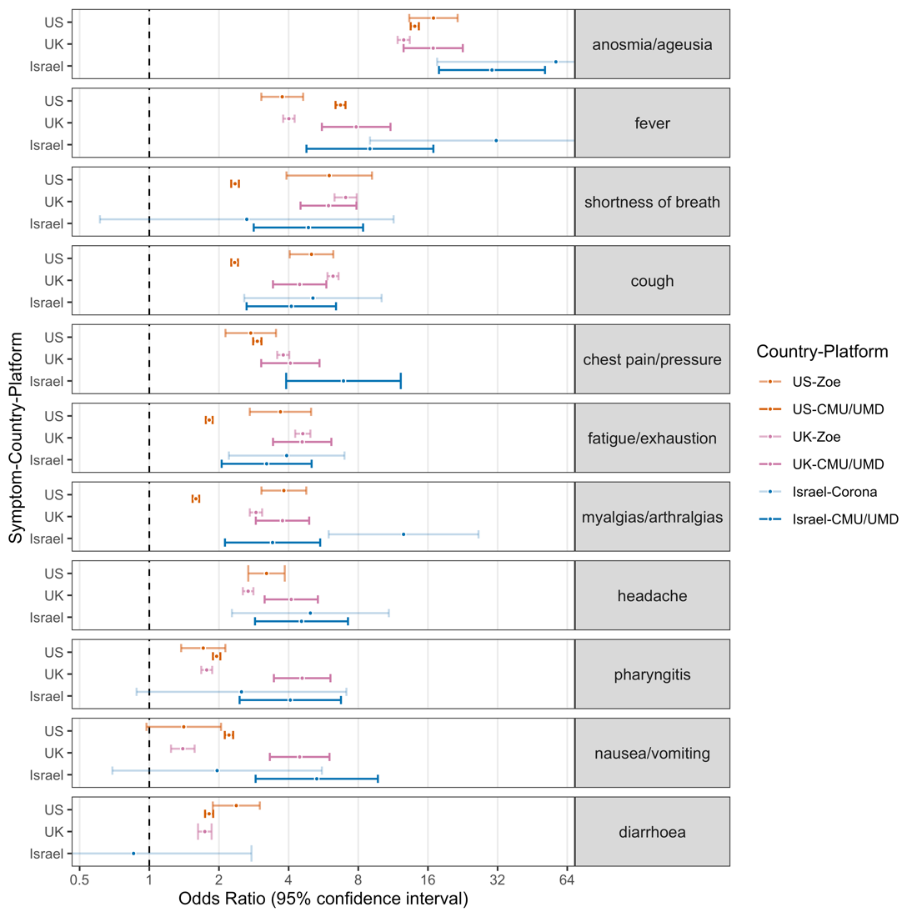

## Figure 3

Longitudinal Zoe data stratified by country (top, UK vs US), time from symptom onset-to-test (middle, UK early ≤ 3 days vs late > 3 days) and testing-qualifying symptom era (bottom, UK narrow vs broad) to show the impact on effect estimates (vertical axis) for the three canonical symptoms of anosmia (left column), fever (middle column) and cough (right column). Horizontal axis gives the effect estimates censoring symptoms 0 to 14 days following the reported COVID-19 test, which may include later-onset symptoms as well as measurement bias as a result of knowledge of the test result. 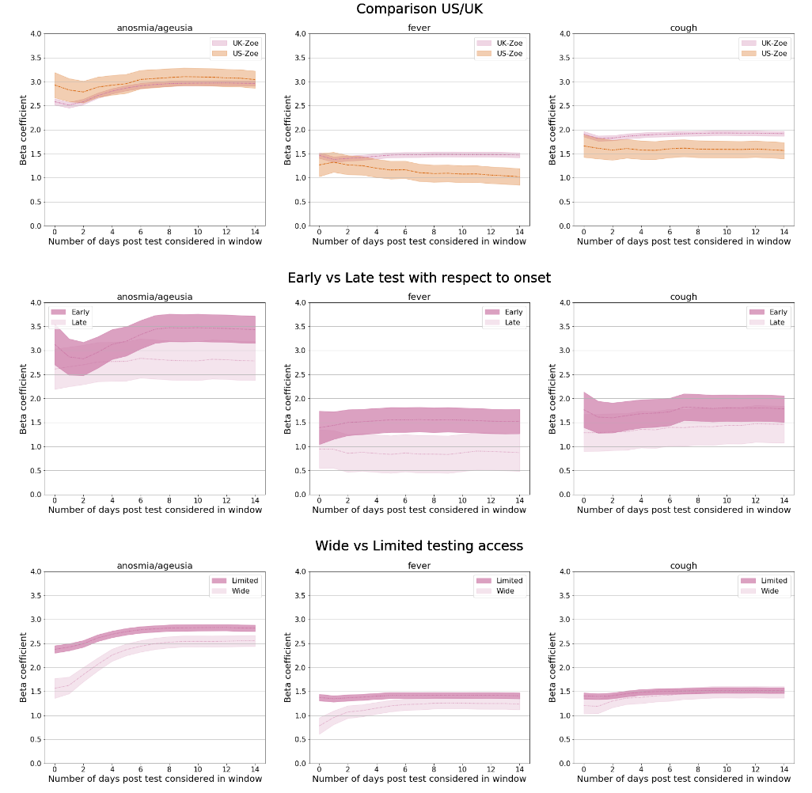

# **Acknowledgments**

Zoe Global provided in-kind support for all aspects of building, running and supporting the Zoe app and service to all users worldwide. Support for this study was provided by the National Institute for Health Research (NIHR)-funded Biomedical Research Centre based at Guy’s and St Thomas’ (GSTT) NHS Foundation Trust. This work was supported by the UK Research and Innovation London Medical Imaging & Artificial Intelligence Centre for Value-Based Healthcare. Investigators also received support from the Wellcome Trust, Medical Research Council (MRC), British Heart Foundation (BHF), Alzheimer’s Society, European Union, NIHR, COVID-19 Driver Relief Fund (CDRF), Innovate UK and the NIHR-funded BioResource, Clinical Research Facility and Biomedical Research Centre (BRC) based at GSTT NHS Foundation Trust in partnership with KCL. S.O. was supported by the French government, through the 3IA Côte d’Azur Investments in the Future project managed by the National Research Agency (ANR) with the reference number ANR-19-P3IA-0002. A.T.C. was supported by a Stuart and Suzanne Steele MGH Research Scholar Award. L.H.N., D.A.D., A.D.J. and A.T.C. were supported by the Massachusetts Consortium on Pathogen Readiness (MassCPR) and M. Schwartz and L. Schwartz. CMA acknowledges funding from National Institutes of Health K23 DK120899, Boston Children’s Hospital Office of Faculty Development Career Development Award. CHS was supported by Alzheimer’s Society Junior Fellowship - AS-JF-17-011, ADJ from NIH K01 DK 110267, EM from ‘Skills Development Scheme’ of the Medical Research Council UK. Support for the Covid Symptom Study (UK data) was provided by the NIHR-funded Biomedical Research Centre based at GSTT NHS Foundation Trust.

### **Competing interests**

Zoe Global codeveloped the app pro bono for noncommercial purposes. J.W., J.C.P. and S.G. work for Zoe Global, and T.S. and is consultants to Zoe Global. L.H.N., D.A.D and A.T.C. previously participated as investigators on a diet study unrelated to this work that was supported by Zoe Global. C.H.S., M.S.G., E.M., K.K., M.A., L.S.C., M.M., C.J.S, E.S., A.K., S.S, J.B., T.M, C.M.A, H.R., B.M and S.O. declare no competing interests.

# **Data sharing statement**

## Israel-Corona Platform

Tables of de-identified, aggregated data are available at <https://github.com/hrossman/Covid19-Survey>.

## Zoe Platform

Data used in this study is available to bona fide researchers through UK Health Data Research using the following link

<https://web.www.healthdatagateway.org/dataset/fddcb382-3051-4394-8436-b92295f14259>

## CMU/UMD Platform:

Requests for access to the US Carnegie Mellon University/University of Maryland Facebook COVID-19 Symptom Survey available via <https://dataforgood.fb.com/docs/covid-19-symptom-survey-request-for-data-access/>.

**Authors contribution:**

CHS, AK, MSG, ADJ, HR, SS, JSB, CMA designed and conceived the study. CHS, AK, CMA, MSG HR, SS, ADJ analysed and interpreted the data. BM, MG, TM, AK, HR, CMA, CHS contributed analysis tools. SG, JCP, CHS, MSG, DAD, LHN, ATC, ES, HR, JW, CJS, TDS, and SO contributed to the acquisition of data. All authors critically revised the manuscript.