**Supplementary material: Methods for the systematic review on clinical trials in dementia with Lewy bodies**

### **Eligibility criteria**

We included study protocols from pharmacological randomized clinical trials (RCTs) of adults (age ≥18 years) with dementia with Lewy bodies (DLB) diagnosis according to consensus criteria1-3, on phases 1-3 and funded by NIH, the industry, other U.S Federal agencies or any other (individual, university, organizations). Study protocols from pharmacological RCTs who recruited DLB patients with other dementias or synucleinopathies in parallel were also considered. The index date for this review was September 27th, 2022.

|  |  |  |
| --- | --- | --- |
| **Scoping Review** | ***Inclusion*** | ***Exclusion*** |
| **Population** | Patients aged ≥18 years diagnosed with DLB according to consensus criteria1-3; with or without other dementias or synucleinopathies. | Includes Parkinson’s disease or Parkinson’s disease dementia but not DLB. |
| **Concept** | Study protocols from RCTs on phases 1-3 and funded by NIH, industry other U.S Federal agencies or any other (individual, university, organizations). | Non-pharmacological trials, observational studies, phase 4, or phase 1 trials in healthy subjects. |
| **Study Design (context)** | Study protocols from RCTs completed, active or ongoing (recruiting, active/not recruiting), withdrawn, not recruiting, not yet recruiting, terminated, or pending status. | RTCs with stem cells.  RTCs without a defined phase. |

### **Information sources**

Two known relevant scoping reviews on different neurodegenerative diseases published in the last two years were used as a starting point to identify the most extensive clinical trials databases and records within databases4,5.

We used study protocols of pharmacological RCTs registered on ClinicalTrials.gov, EudraCT and ICTRP. ClinicalTrials.gov is a registry of clinical trials operated by the United States National Library of Medicine (NLM) at the National Institutes of Health. It is the most extensive clinical trials database, holding registrations from over 329,000 trials from 209 countries and available online since February, 29th 20006. Likewise, EudraCT is the European Clinical Trials Database of all clinical trials of investigational medicinal products with at least one site in the European Union7. This database has collected data commencing May, 1st 2004. Finally, the International Clinical Trials Registry Platform (ICTRP) is a platform for the registration of clinical trials operated by the World Health Organization (WHO)8. The WHO ICTRP was established in August 2005. The ICTRP combines data from multiple cooperating clinical trials registries to generate a global view of clinical trials worldwide.

### **Search strategy**

The search strategy was adapted for each of the search engines used as information sources. The search engines selected for this scoping review do not use Boolean operators or MESH terms, but pre-defined search fields. For the condition or disease search fields, we used the terms “dementia with Lewy bodies” (on ClinicalTrials.gov), “dementia” AND “Lewy” (on EudraCT and ICTPR).

### **Selection process**

We downloaded references from the search engines and created a customized workbook in Google Spreadsheets to manage the screening and data collection processes. We used the complete entry from the search strategy to confirm that the study protocols downloaded have indeed our targeted condition, study type, phase and parameters. Finally, and based on the aims of this scoping review, we excluded all non-pharmacological trials, observational studies, and phase 4, or phase 1 trials in healthy subjects.

### **Data collection process**

Once a RCT was identified in the trial registry, we extracted key trial characteristics: clinical trial title, source registry, trial number, classification into symptomatic or disease modifying therapy (DMT), primary outcome measure, use of biomarkers as inclusion criteria and/or outcome measures (excluding safety biomarkers), start date, study completion date, actual end date, if completed, active or ongoing (recruiting, active/not recruiting), withdrawn, not recruiting, not yet recruiting, terminated or pending status; cause of termination, duration of treatment exposure in weeks, number of subjects planned for enrollment, number of subjects enrolled if completed or terminated; additional diagnostic groups, stage of the disease, global distribution, sponsorship, whether the agent was repurposed, or used an adaptive design. Two review authors (C.A. and M.C.G.) conducted this process, where one would do the initial data extraction, and the second would confirm that the data is in accordance with the original study protocols.

## **Synthesis of data**

We used a PRISMA flow diagram to present the numbers of sources of evidence screened, assessed for eligibility, and included in the review, with the reasons for exclusions in numbers (supplementary figure 1).

Table 1 describes in numbers and percentages the general characteristics of clinicals trials with regards to trial phase, status, main purpose of treatment (symptomatic vs DMT), and whether the agent is repurposed. Similarly, tables 2, 4 and 5 present information for each trial in phase 3, 2 and 1 respectively. These tables describe: agent, common Alzheimer's Disease Research Ontology (CADRO), mechanism of action, therapeutic purpose, status, registry source, registry number, start date and end date. Additionally, we provided a timeline to display terminated vs ongoing RCTs in figure 2.

## **References**

1. McKeith IG, Galasko D, Kosaka K, et al. Consensus guidelines for the clinical and pathologic diagnosis of dementia with Lewy bodies (DLB): report of the consortium on DLB international workshop. *Neurology*. Nov 1996;47(5):1113-24. doi:10.1212/wnl.47.5.1113

2. McKeith IG, Dickson DW, Lowe J, et al. Diagnosis and management of dementia with Lewy bodies: third report of the DLB Consortium. *Neurology*. Dec 27 2005;65(12):1863-72. doi:10.1212/01.wnl.0000187889.17253.b1

3. McKeith IG, Boeve BF, Dickson DW, et al. Diagnosis and managament of dementia with Lewy bodies. *Neurology*. 2017;89(1):88-100. doi:10.1212/WNL.0000000000004058

4. Cummings J, Lee G, Nahed P, et al. Alzheimer's disease drug development pipeline: 2022. *Alzheimers Dement (N Y)*. 2022;8(1):e12295. doi:10.1002/trc2.12295

5. McFarthing K, Buff S, Rafaloff G, Dominey T, Wyse RK, Stott SRW. Parkinson’s Disease Drug Therapies in the Clinical Trial Pipeline: 2020. *Journal of Parkinson's Disease*. 2020;10:757-774. doi:10.3233/JPD-202128

6. (US) NLoM. ClinicalTrials.gov: History, Policies, and Laws. Updated February 2023. Accessed February 18, 2023. <https://clinicaltrials.gov/ct2/about-site/history#WorldHealthOrganization>

7. Database EUDRACT. European Union Drug Regulating Authorities Clinical Trials Database. Updated February 14, 2023. Accessed February 18, 2023. <https://eudract.ema.europa.eu/>

8. Gulmezoglu AM, Pang T, Horton R, Dickersin K. WHO facilitates international collaboration in setting standards for clinical trial registration. *Lancet*. May 28-Jun 3 2005;365(9474):1829-31. doi:10.1016/S0140-6736(05)66589-0

**Supplementary Figure 1**

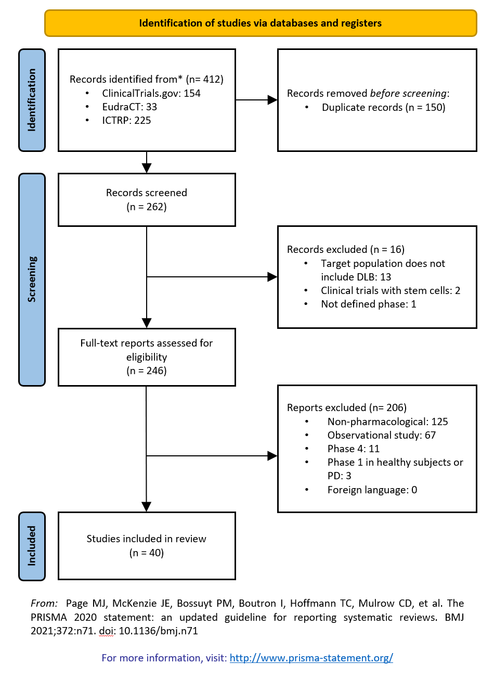

**Supplementary table 1: Treatment exposure, number of subjects, and their contribution in person weeks**

|  |  |  |  |  |  |  |  |  |  |  |
| --- | --- | --- | --- | --- | --- | --- | --- | --- | --- | --- |
| Phases | Therapeutic purpose | Completed | | | Active | | | Other* | | |
| Mean (range) duration of treatment exposure in weeks | Number of subjects enrolled | Total participants weeks | Mean (range) duration of treatment exposure in weeks | Number of subjects planned for enrollment | Total participants weeks | Mean (range) duration of treatment exposure in weeks | Number of subjects planned for enrollment | Total participants weeks |
| Phase 3 | Symptomatic | 22 (4-52) | 970a | 21,340 | 52 | 372 | 19,344 | 0 | 0 | 0 |
| DMT | 0 | 0 | 0 | 0 | 0 |  | 0 | 0 | 0 |
| Phase 2 | Symptomatic | 13 (4-24) | 1,780b | 23,140 | 9 (4-12) | 446 | 4,014 | 13 (4-24)c | 436 | 5,668 |
| DMT | 14 (12-16) | 117 | 1,638 | 33 (12-78) | 472 | 15,576 | 92 | 30 | 2,760 |
| Phase 1 | Symptomatic | 0 | 0 | 0 | 0 | 0 |  | 0 | 0 | 0 |
| DMT | 0 | 0 | 0 | 0 | 0 |  | 24 (15-52) | 55 | 1,320 |
| Total | | 16 (4-52) | 2,867 | 46,118 | 27 (4-78) | 1290 | 38,934 | 26 (4-92) | 521 | 9,748 |

*Other: Withdrawn: 3 phase 2, Not yet recruiting: 2 phase 1, Not recruiting: 2 phase 2, Missing data: 2 phase 2, Terminated 1 phase 2.

a1 missing value: number of subjects planned for enrollment 60 participants (not included in the total).

b1 missing value: number of subjects planned for enrollment 50 participants (not included in the total).

c1 missing value.

**Supplementary table 2: Disease stage of clinical trials participants**

|  |  |  |  |  |  |  |
| --- | --- | --- | --- | --- | --- | --- |
| Disease stage | Total  N (%) | Recruitment status | | | Therapeutic purpose | |
| Active  N (%) | Completed  N (%) | Other*  N (%) | Symptomatic  N (%) | DMTs  N (%) |
| Prodromal | 1 (2.5%) | 0 | 0 | 1 (10%) | 0 | 1 (10%) |
| Prodromal and mild dementia | 2 (5%) | 2 (22.2%) | 0 | 0 | 1 (3.3%) | 1 (10%) |
| Mild to moderate dementia | 24 (60%) | 5 (55.6%) | 16 (76.2%) | 3 (30%) | 16 (53.3%) | 8 (80%) |
| All dementia stages | 10 (25%) | 2 (22.2) | 4 (19%) | 4 (40%) | 10 (33.3%) | 0 |
| Missing data | 3 (7.5%) | 0 | 1 (4.8%) | 2 (20%) | 3 (10%) | 0 |
| Total | 40 | 9 | 21 | 10 | 30 | 10 |

*Other: Withdrawn: 3 (phase 2), Not yet recruiting: 2 (phase 1), Not recruiting: 2 (phase 2), Missing data: 2 (phase 2), Terminated 1 (phase 2).

**Supplementary table 3: Diagnostic groups of clinical trial participants**

|  |  |  |  |  |  |  |
| --- | --- | --- | --- | --- | --- | --- |
| Diagnostic groups | Total  N (%) | Recruitment status | | | Therapeutic purpose | |
| Active  N (%) | Completed  N (%) | Other*  N (%) | Symptomatic  N (%) | DMTs  N (%) |
| DLB only | 21 (52.5%) | 4 (44.4%) | 12 (57.1%) | 5 (50%) | 13 (43.3%) | 8 (80%) |
| DLB + PDD | 12 (30%) | 3 (33.3%) | 6 (28.6%) | 3 (30%) | 10 (33.3%) | 2 (20) |
| DLB+PDD+AD | 1 (2.5%) | 0 | 1 (4.8%) | 0 | 1 (3.3%) | 0 |
| DLB+PD+HD | 1 (2.5%) | 0 | 0 | 1 (10%) | 1 (3.3%) | 0 |
| DLB+PD | 1 (2.5%) | 1 (11.1%) | 0 | 0 | 1 (3.3%) | 0 |
| RBD+PD/MCI/DLB or PDD | 1 (2.5%) | 1 (11.1%) | 0 | 0 | 1 (3.3%) | 0 |
| Parkinsonism (PD, MSA, LBD)+RBD | 1 (2.5%) | 0 | 0 | 1 (10%) | 1 (3.3%) | 0 |
| AD/DLB/Vascular Dementia/FTD | 1 (2.5%) | 0 | 1 (4.8%) | 0 | 1 (3.3%) | 0 |
| All causes of dementia | 1 (2.5%) | 0 | 1 (4.8%) | 0 | 1 (3.3%) | 0 |

HD: Huntington’s disease, RBD: REM sleep behavior disorder, MCI: mild cognitive impairment, MSA: multiple system atrophy, FTD: frontotemporal dementia.