ASSGCN Model Based Vibration Signal Reconstruction in Motor Vibration Testing Wangjie Lang, Yihua Hu, Senior Member, IEEE, Quanfeng Li, Alexander Wireko-Brobby, and Mohammed Alkahtani
Abstract— For modern electric powertrain applications (wind, electric vehicles/ships/aircrafts,…), the vibration analysis of the electric motor is one of the most important tasks. Normally, a large number of vibration sensors are placed evenly around the stator of the prototype to sample the acceleration and vibration signals. To decrease the vibration testing cost and time, in this paper, an attention-based spatial-spectral graph convolutional network (ASSGCN) model is proposed to reduce the number of sensors to reconstruct the vibration signal of the motor. Three spectral features of the vibration signal are modeled separately, and the correlation of the operating condition force (OCF), acceleration and vibro-impedance matrices are investigated and analyzed in the spatial dimension. Via dynamic correlation analysis of spatial configuration and spectral response, the proposed ASSGCN model predicts vibration signals at different sensor sampling points. A 21kw IPMSM testing rig with Brüel & Kjær's vibration sensing equipment is employed to test the proposed ASSGCN model;, and the proposed method successfully reconstructs the vibration source signal and achieves well performance.

Index Terms—Vibration signal， Operating condition force (OCF)， Signal reconstruction.

ASSGCN: Attention-based spatial-spectral graph convolutional network
OCF: Operating condition force
IPMSM: Interior Permanent Magnet Synchronous Motor
PMSM: Permanent Magnet Synchronous Motor
FEM: Finite Element Method
GNN: Graph Neural Networks
T: Kinetic energy
U: Potential energy
φ: Energy consumed by damping
K: Stiffness matrix
C: Damping matrix
M: Mass matrix
$F_{1}$: Excitation force
Y: Displacement
θ: Angle
n: Number of stator slots
$m_{c}$: Mass of a slot
$p_{m}$: Electromagnetic force
$f_{1}$ , $f_{1}$: Shear forces
$ρ_{1}$, $ρ_{1}$ : Densities
$R_{1}$, $R_{2}$: Radius
a, b: Lengths
$ζ_{1}$, $ζ_{2}$, $ζ_{3}$: Damping ratios
$dm_{1}$: Mass of shell micro-element segment

INTRODUCTION

w
ith the popularity of permanent magnet motors (PMSMs) in the industry, the monitoring and analysis of the vibration characteristics of the PMSMs stator system in electric vehicles can effectively evaluate the operating state of the motor to ensure the reliability and continuity of the powertrain system. In general, the motor vibration signal is used to detect machine faults and noise caused by excessive vibration levels. The main operating condition force sources of excitation for motor vibration and noise include electromagnetic and mechanical forces. Mechanical deformation and vibration of the stator are caused directly by electromagnetic and mechanical forces. Simultaneously, several electromagnetic sources affect the vibration of the PMSM including cogging torque, radial and tangential forces, torque pulsation, etc. These sources have a specific number of harmonics related to the intrinsic frequency of the PMSM stator [1]- [2]. The effect of radial force harmonics on vibration with low modulus is investigated [3]- [4]. Radial force harmonics with the lowest modal number can produce large low frequency vibration. Optimizing the low-noise design of electrical machines based on the analysis of electromagnetic forces has been proposed [5]- [6]. Therefore, to further meet the low noise requirement, it is significant to evaluate and predict vibration and noise during the quantification stage of motor design [7]- [8].
Methods to calculate vibrational force from air-gap magnetic flux density include the Maxwell stress tensor, virtual work principle, energy method, imaginary magnetic flow, and finite element analysis [9]. Most studies utilize the finite element method (FEM) to analyze the flux density of the air gap to calculate electromagnetic vibrations [10]. By using equations to calculate the waveform of the air gap flux density, vibrations can be predicted. Various approaches have been used to predict the vibrations in the IPMSM during operation. Analytical calculations based on equations for the waveform of the air gap flux density have shown promise in accurately predicting the vibrational behaviour of the motor. Furthermore, Finite Element Method (FEM) simulations have been widely utilized to model the motor's electromagnetic and mechanical interactions, providing valuable insights into the structural dynamics. Additionally, combining experimental modal analysis with numerical simulations has proven effective in validating the accuracy of the predicted vibration patterns. By leveraging the analytical and FEM-based techniques together, a comprehensive understanding of the motor's vibrational characteristics can be achieved, enabling better design optimization and reliability in various operating conditions. Expected vibration and noise predictions can be made using FEM [11] [12] based on the proper material attributes and boundary conditions acquired by modal testing. However, the process of using finite element models is time-consuming. The analytical methods are attracting interest in machine design and optimization as an alternative to the noise and vibration prediction [13]. A novel air-gap relative permeability formula to offset the rotor outer diameter is proposed to predict electromagnetic vibrations in the motor design process [14]. Detailed normal forces based on finite element calculations with phase currents and rotor position look-up tables to predict vibrations have been proposed in [15]. The effect of air gap deformation on the electromagnetic performance and characteristics of radial vibration on integrated permanent magnet synchronous motor (IPMSM) at rated power peak speed is investigated in [16]. The vibration characteristics of a motor are defined by the electromagnetically originated air-gap force and the structural response of the stator assembly, [17] proposed a Multiphysics-based sensitivity analysis for vibration prediction that can be freed from analytical derivation for the evaluation of the electromagnetic and structural performance of the motor. [18] proposed a combined model based on the airgap permeance model (APM) and a unique adaptive reluctance network model (ARNM) to qualitatively analyze the air-gap excitation force to evaluate motor vibration.
Effective analysis of vibration signals is significant for vibration monitoring. Vibration data contains a wealth of analytical information about the operating state of the machine [19]. The changes in the magnetic flux distribution in the motor lead to changes in the vibration characteristics. Therefore, faulty air gap eccentricity, stator winding or rotor faults, bearing damage and power supply asymmetries can be monitored by vibration signal. The vibration signal is measured by the vibration sensors mounted on the cap of the machine bearing or stator. To monitor the health status of a motor based on vibration, the most suitable vibration sensors and the number of high precision sensors need to be selected to be evenly distributed on the outside of the motor to ensure that faults can be detected, diagnosed and predicted. Due to the high installation and maintenance costs of the sensors and the complex operating conditions of the motors. The high monitoring costs can therefore prevent the effective detection of motor faults and cause more serious hazards.

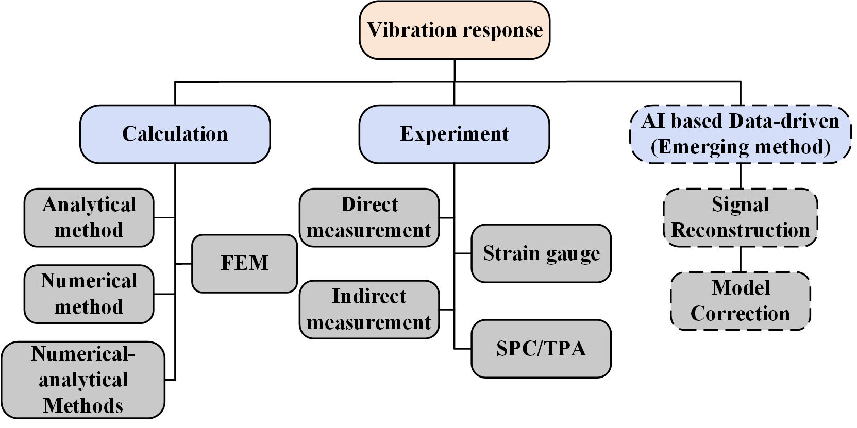
Fig. 1. Classification of vibration analysis methods [22].
To decrease the vibration testing cost and time, this paper investigates a data-driven machine learning-based approach to reconstruct vibration signals in combination with the position distribution relationships of vibration sensors to reconstruct the vibration signal to reduce the number of sensors, obtaining an accurate vibration response. In addition, data-driven machine learning methods in prediction and regression tasks have been widely developed in the field of electric vehicle powertrain [20]- [21],[25]-[28]. And graph neural networks (GNN) are suitable for mining graph data for signal features [22]. The effective use of data-driven methods combined with sensor signals to predict vibration signals instead of sensor-dependent solutions is attractive in industrial applications. Unlike the time-domain signal, the proposed model uses the spatial structure relationship of the sensors and the linkage of the vibration spectrum for the extraction of vibration features through an attention mechanism and uses graph convolution for information updating of the target nodes. The contribution of this paper was summarized as below:
- The paper proposes an innovative solution called the Attention-based Spatial-Spectral Graph Convolutional Network (ASSGCN) model to reduce the number of sensors required for vibration signal reconstruction, thereby decreasing the overall testing cost and time.
- Three spectral features of the vibration signal are modeled separately, and the correlation of the operating condition force (OCF), acceleration, and vibro-impedance matrices are investigated and analyzed in the spatial dimension.
- The proposed ASSGCN model leverages dynamic correlation analysis of spatial configuration and spectral response to predict vibration signals at different sensor sampling points.
- The experimental verification is performed on a 21kw IPMSM testing rig with Brüel & Kjær's vibration sensing equipment, demonstrating that the proposed method successfully reconstructs the vibration source signal and achieves excellent performance.
The motor vibration analysis is presented in Section II, and the proposed method is introduced in Section III. Then, the experimental verification is presented in Section VI, and the conclusion is summarized in Section V.

Motor Vibration analysis
A．Stator Structure Vibration Model
The inner surfaces of the stator core and windings are subjected to periodic radial electromagnetic forces during the operation of the motor and generate vibrations. The stator of the intercepted micro-element section motor is shown in the Fig. 2. The number of stator slots is n, and each slot contains a full mass of $m_{c}$. The electromagnetic force acting on the inner surface of the stator is $p_{m}(θ,t)$. At the same time the stator section surface received respectively from the adjacent micro-element section of the shear force $f_{1}{(θ,t)}_{θ}$, shell section surface also received from the adjacent micro-element section of the shear force $f_{2}{(θ,t)}_{θ}$ [23].
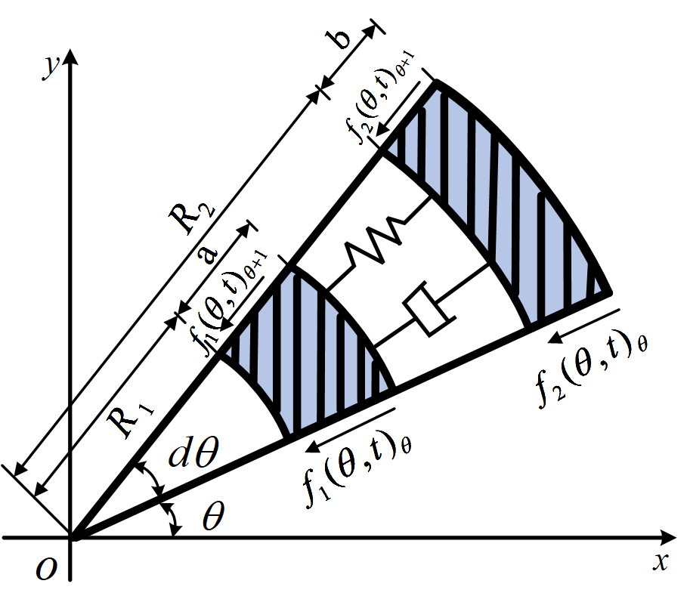
Fig. 2. Shell micro-element segment.
The expression for the mass of the shell micro-element segment is shown as follows:
$dm_{1}=(ρ_{1}R_{1}a+\frac{m_{f}n}{2π}ldθ)$ (1)
The periodic deformation n of the inner surface of the stator caused by electromagnetic forces is used as the base displacement excitation and loaded onto the stator structure to calculate the forced vibration response of the stator housing. Using Lagrange's equation with dissipation, the response is solved as follows:
$\frac{d}{dt}\left(\frac{∂L\left(θ,t\right)}{∂\dot{y_{i}}{\left(θ,t\right)}_{l}}\right)-\frac{∂L\left(θ,t\right)}{∂\dot{y_{i}}{\left(θ,t\right)}_{l}}+\frac{∂φ\left(θ,t\right)}{∂\dot{y_{i}}{\left(θ,t\right)}_{l}}=F_{i}$ (2)
where $\dot{y_{i}}{\left(θ,t\right)}_{l}$ represents the first-order derivatives of the electromagnetic force and the base displacement concerning time, respectively. Lagrange's equation: $L(θ,t$)=T ($θ,t$)-U ($θ,t$), T ($θ,t$) and U ($θ,t$) are the kinetic and potential energies. $φ\left(θ,t\right)$ is the energy consumed by the damping of the system. The equivalent stiffness $K_{i}=A_{i}E_{i}/l$ of the stator structure, the equivalent damping $C_{i}=2\sqrt{m_{i}K_{i}}ζ_{i}$, where $ζ_{i}$ is the damping ratio of the system.
$\left[M\right]\left\{\ddot{y_{l}}\right\}dθ$+$\left[C\right]\left\{\dot{y_{l}}\right\}dθ+\left[K\right]\left\{y_{l}\right\}dθ=\left\{F_{1}\right\}$ (3)
Where M, C, K, $F_{1}$ is the mass matrix, the damping matrix, the stiffness matrix and the excitation force, respectively, with the following values：
$\left[M\right]=\left[\begin{matrix}ρ_{1}R_{1}a+\frac{m_{0}n}{2πl} & 0 \\ 0 & ρ_{2}R_{2}b\end{matrix}\right]$; $\left\{y_{l}\right\}=\left\{\begin{matrix}y_{1}(θ,t) \\ y_{2}(θ,t)\end{matrix}\right\}$;
$\left[C\right]= \left[\begin{matrix}\sqrt{ρ_{1}E_{1}}{R_{1}ζ}_{1}+\sqrt{ρ_{3}3}{R_{2}ζ}_{3} & -\sqrt{ρ_{3}3}{R_{2}ζ}_{3} \\ -\sqrt{ρ_{3}3}{R_{2}ζ}_{3} & \sqrt{ρ_{2}E_{2}}{R_{2}ζ}_{2}+\sqrt{ρ_{3}E_{3}}{R_{2}ζ}_{3}\end{matrix}\right]$;
$\left[K\right]=\left[\begin{matrix}\frac{R_{1}E_{1}}{a}+\frac{R_{2}E_{3}}{R_{2}-R_{1}-a} & -\frac{R_{2}E_{3}}{R_{2}-R_{1}-a} \\ -\frac{R_{2}E_{3}}{R_{2}-R_{1}-a} & \frac{R_{2}E_{2}}{b}+\frac{R_{2}E_{3}}{R_{2}-R_{1}-a}\end{matrix}\right]$;
$\left\{F_{1}\right\}=\left\{R_{1}p_{n}\left(θ,t\right)+2R_{1}aζ_{1}\sqrt{\frac{ρ_{1}}{E_{1}}}\dot{p_{n}}{(θ,t)}_{l}\right\}+ \frac{1}{l}\left\{\begin{matrix}{-f}_{1}{(θ,t)}_{θ}-{-f}_{1}{(θ,t)}_{θ+1} \\ {-f}_{2}{(θ,t)}_{θ}-{-f}_{2}{(θ,t)}_{θ+1}\end{matrix}\right\}$; (4)

Equation (3) represents the vibration characteristics of the $dθ$ segment stator by superimposing all the micro-element segments in the range of $0\sim θ$ to give the vibration characteristics in the d-angle range. When superimposed, the internal forces in adjacent segments cancel each other, leaving only the internal forces f and f to the left of the starting segment to cancel. The excitation force is simplified as follows:
$\left\{F\right\}=\left\{\begin{matrix}R_{1}P_{n}\left(θ,t\right)+2R_{1}aζ_{1}\sqrt{\frac{ρ_{1}}{E_{1}}}\dot{P_{n}}{(θ,t)}_{l} \\ 0\end{matrix}\right\}$ (5)

Assume $Y\left(θ,t\right)=\int_{0}^{θ}{y\left(θ,t\right)dθ, }$ $P_{n}\left(θ,t\right)=\int_{0}^{θ}{p_{n}\left(θ,t\right)dθ,}$ then the vibration equation of the stator structure on the whole circumference is equation (11) By solving for 3 then the vibration response characteristics of the stator structure can be obtained.
$\left[M\right]\left\{\ddot{Y_{l}}\right\}dθ$+$\left[C\right]\left\{\dot{Y_{l}}\right\}dθ+\left[K\right]\left\{Y_{l}\right\}=\left\{F\right\}$ (6)
B．Stator vibration modal analysis
To obtain the modal parameters of the stator vibration, experiments are usually carried out using multi-point excitation measurements and modal analysis techniques. The motor stator mode is influenced by the order of the electromagnetic force in the motor. Moreover, to correspond to the order of the electromagnetic force, the modal order of the motor is defined as the same order when the displacement pattern of the vibration coincides with the force pattern of the electromagnetic force. The order of the electromagnetic force represents the spatial characteristics of the force, the $n^{th}$order radial electromagnetic force produces n force peaks on the motor stator. As the stator vibrates at its intrinsic frequency, electromagnetic forces in the radial, axial, or tangential directions are applied, and the response is generated in each direction when the frequency of the electromagnetic excitation is equal to the intrinsic frequency. Axial vibration is relatively weak due to the high axial stiffness of the stator. The focus in motor vibration analysis is on radial vibration.
The study of vibration characteristics is the key to reducing vibration and noise in electric motors. Experimental modal analysis based on the motor stator is the basic method for obtaining the modal structural parameters. The full modal parameters of the structure can be found by measuring the value of the frequency response function matrix. A single point measurement of the multi-point excitation is made by distributing the excitation points uniformly in a cross section perpendicular to the stator axis and measuring its radial response.
The experimental modal analysis not only provides accurate parameters of the stator system for each order of vibration but also visualizes the shape of the stator system vibration. The obtained modes can be used to build up a vibration calculation model for the stator system and provide the basis for structural optimization.

Spectral-Spatial Graph Model for vibration signal reconstruction

The sensor clusters around the motor stator housing can be considered as different node locations distributed on the motor surface. Each vibration sensor unit is treated as a node and due to the structural features of motor vibration, there are interdependencies between each sensor data. The sensors and their monitoring data are therefore taken as nodes with characteristic properties and the interdependencies between each sensor are treated as edges connecting the nodes. As the Fig. 4 shows, the resulting data type is the graph structure. By aggregating information from neighboring nodes of the current node and by analogy to the current node, a representation of the state of the target node under the influence of the surrounding nodes can be obtained. The proposed method is based on the attention-based spatial-temporal graph convolutional network (ATSGCN) model presented in [24] for traffic flow forecasting with an improved application for mining vibration spectrum signals.
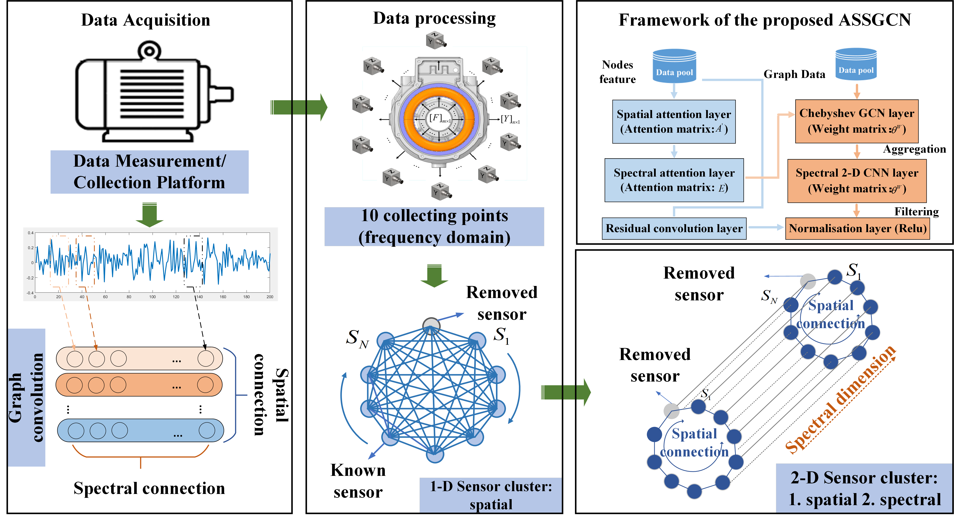
Fig. 3. The basic frame of the proposed algorithm.

The processed graph data is noted as $ζ$=$\left\{V,ε\right\}$, where $V$=$\left\{v_{1},…v_{N}\right\}$ is the set of nodes with the number N =$\left|V\right|$, $ε$ =$\left\{e_{1},…e_{M}\right\}$ is the set of edges with the number M. For a given 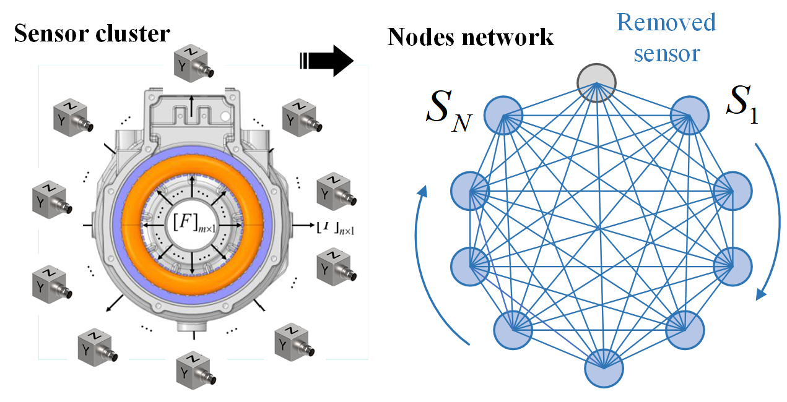
Fig. 4. Graph data for sensor cluster distribution.
graph $ζ$=$\left\{V,ε\right\}$, The corresponding adjacency matrix is denoted A∈$\left\{0,1\right\}$ with a size of $N×N$, $A_{i,j}$denotes the existence of an edge from $v_{i}$ to $v_{j}$, Conversely, it means not present.
Laplace matrices are used to study the structural properties of graphs, The symmetrically normalized Laplacian expressions are as follows：
$L^{sym}=D^{-1/2}L$ (7)
where $D$ represents the degree matrix of the nodes. The L is defined as $D-A$. Laplace matrix whose spectrum decomposes as $L^{sym}=UΛU^{T}$, and $Λ=diag({ λ}_{1}, { λ}_{2},..., { λ}_{n})$ represents the diagonal matrix of eigenvalues. The corresponding graph convolution formula is derived from the ordinary convolution formula:
$g*x=TGF\left\{GF\left\{g\right\}∙GF\left\{x\right\}\right\}=U(U^{T}g∙U^{T}x)$ (8)
Where $GF\left\{∙\right\}$and $TGF\left\{∙\right\}$ represent the Fourier transform and its inverse transform. $g$ is a Laplacian propagation function $g(L)$ and $x$ denotes the graph input feature. Regard $U^{T}g$ as the function of the Laplacian eigenvalues $g_{θ}(Λ)=diag(θ)$, with the parameters $θ$. Due to the large number of matrix operations involved, Chebyshev polynomials were used as a basis for approximation.
$g_{θ}*x= Ug_{θ}U^{T}x≈U\sum_{k=0}^{K}{θ_{k}T_{k}(\tilde{Λ})U^{T}x}$ (9)
Where k depends on the nearest neighbor node of the central node's order. To prevent overfitting and to simplify calculations, (14) can be expressed as follow:
${ g}_{θ}*x=θ(I_{N}+D^{-1/2}AD^{-1/2})x$ (10)
Thus, the layer-to-layer propagation expression of the GCN is shown as follows:
$f\left(x,A\right)=σ({\tilde{D}}^{-1/2}\tilde{A}{\tilde{D}}^{-1/2}xW)$ (11)
Where $σ\left(∙\right)$ represents the activation function and $W$represents the weighting parameter.

- Spectral-Spatial Attention Module
In the spatial dimension of the stator structure, the vibrational states of the different sampled points are interacting with each other, and the influence of different spatial points is highly dynamic. The

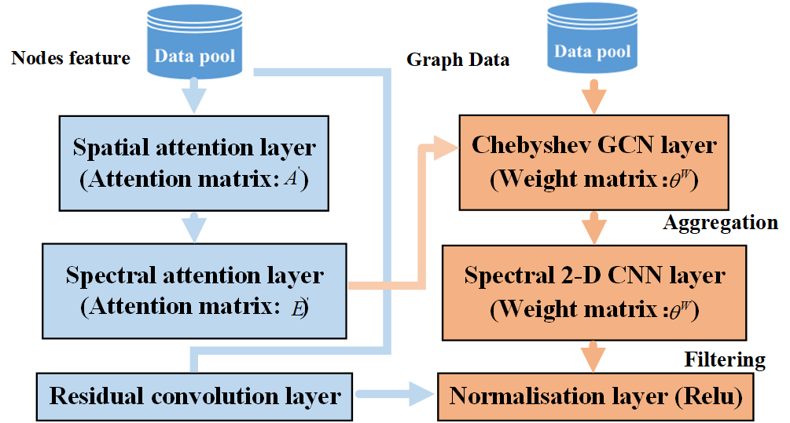
Fig. 5. The framework of the proposed ASSGCN.

dynamic correlation between nodes in the spatial dimension is captured adaptively by using an attention mechanism.
${Att}_{spa}={h_{s}∙σ((X_{f}^{\left(r-1\right)}W_{1})W_{2}(W_{3}X_{f}^{\left(r-1\right)})}^{T}+b_{s}$ (12)
${{Att}_{spa}}_{i,j}^{'}=\frac{exp⁡({{Att}_{spa}}_{i,j})}{\sum_{j=1}^{N}{exp⁡({{Att}_{spa}}_{i,j}^{'})}}$ (13)
The sample input signal for the sensor cluster is constructed as $X_{f}^{\left(r-1\right)}=\left(X_{1},X_{2},..,X_{r-1}\right).$ The training parameters including weights and bias are set to $W_{1},W_{2},W_{3}$ and $b_{s}$, where $W_{1}∈ R^{T_{r-1}}$, $W_{2}∈ R^{{C_{r-1}×T}_{r-1}}$, $W_{2}∈ R^{C_{r-1}}$. $C_{r-1}$ denotes the number of channels of input data on layer $r$. $T$ is the length of the $r^{th}$ level time dimension. Furthermore, in the frequency domain dimension, the vibration characteristics in different frequency bands are correlated as they are collected by a cluster of sensors distributed in different locations. The correlation of the input data is captured by using an attention mechanism.
${ Att}_{spe}={V_{e}∙σ(({{{(X}_{f}^{\left(r-1\right)})}^{T}U}_{1})U_{2}(U_{3}X_{f}^{\left(r-1\right)})}^{T}+b_{e}$ (14)
${{ Att}_{spe}}_{i,j}^{'}=\frac{exp⁡({{Att}_{spe}}_{i,j})}{\sum_{j=1}^{N}{exp⁡({{Att}_{spe}}_{i,j}^{'})}}$ (15)
Where the learnable parameters also include $V_{e}$, $b_{e}∈$ $R^{T_{r-1}×T_{r-1}}$, $U_{1}∈ R^{N}$, $U_{2}∈ R^{C_{r-1}×N}$, $U_{3}∈ R^{C_{r-1}}$.
- Spectral-Spatial Convolution Module
To take full advantage of the topological nature of the sensor clusters, graph convolution based on spectral graph theory is used at frequency domain points to directly process the signal in the spatial dimension using the signal correlation on the sensor network. In spectral graph analysis, the graph is represented by its corresponding Laplacian matrix. The nature of the graph structure can be obtained by analyzing the Laplace matrix and its eigenvalues. The full graph signal in the frequency domain dimension is $x=x_{t}^{f}∈R^{N}$, the graph Fourier transform of the signal is defined as $\hat{x}=U^{T}x$, and the inverse graph Fourier transform is $x=U\hat{x}$. A graph convolution is a convolution operation implemented by replacing the classical convolution operator with a linear operator diagonalized in the Fourier domain. Therefore, a signal $G$ on a graph $x$ is filtered by a kernel $g_{θ}$. $*G$ represents the graph convolution operation. Then use the Chebyshev polynomial approximation:
${ g}_{θ}*G_{x}=g_{θ}\left(L\right)x=\sum_{k=0}^{K-1}{θ_{k}T_{k}(\tilde{L})x}$ (16)
The parameter $θ∈R^{K}$ is the polynomial coefficient vector, $\tilde{L}=\frac{2}{λ_{max}}L-I_{N}$, $λ_{max}$ is the largest eigenvalue of the Laplace matrix, the recursive definition of the Chebyshev polynomial is $T_{k}\left(x\right)=2T_{k-1}\left(x\right)-T_{k-2}\left(x\right), T_{0}\left(x\right)=1,T_{1}\left(x\right)=x.$ To adjust the correlation between nodes dynamically, for each term of the Chebyshev polynomial, combining $S^{'}∈ R^{N×N}$ with the spatial attention matrix $T_{k}(\tilde{L})$ to get $T_{k}(\tilde{L) }ʘS^{'}$. Therefore, the graph convolution formula above is changed as shown below:
${ g}_{θ}*G_{x}=g_{θ}\left(L\right)x=\sum_{k=0}^{K-1}{θ_{k}T_{k}(\tilde{L})x}$ (17)
Furthermore, the definition can be extended to multi-channel graph signals. Supposing the input is $X_{f}^{\left(r-1\right)}=\left({\hat{X}}_{1},{\hat{X}}_{2},…{\hat{X}}_{T_{r-1}}\right)∈R^{N×C_{r-1}×T_{r-1}}$, where each node's feature has $C_{r-1}$ channels. At each frequency point $f$, perform $C_{r}$convolutions on the graph ${\hat{X}}_{f}$ to obtain $g_{θ}*G_{{\hat{X}}_{f} }$ where $θ=(θ_{1}, θ_{2},…θ_{C_{r}})$ is the convolution kernel parameter. After the graph convolution operation has captured the adjacency information of each node on the graph in the spatial dimension, the standard convolution layers in the frequency domain dimension are further stacked to signal more unknown nodes by merging the information of known nodes.
$X_{h}^{\left(r\right)}=ReLU(Ф*(ReLU(g_{θ}*X_{f}^{\left(r-1\right)})))∈R^{C_{r}×N×T_{r}}$ (18)

Where $*$ is the standard convolution operation and $Ф$ represents the parameters of the time-dimensional convolution kernel. The Spectral-Spatial attention module and the Spectral-Spatial convolution module form a spatial-temporal block. Multiple Spectral-Spatial blocks are stacked to further extract a larger range of dynamic Spectral-Spatial correlations. Finally, a fully connected layer is added to ensure that the output of each component has the same dimension and shape as the predicted target. The final fully connected layer uses ReLU as the activation function.

- Sensor Cluster Adjacency Matrix Construction

As input to the construction of the proposed module, the adjacency matrix can reflect the structural association between nodes by whether two nodes are connected or not. Similarly, in sensor clusters, the construction of adjacency matrices for sensor clusters is also essential to reflect the correlation of vibration responses at different locations. By setting $A_{i,j}$ to determine whether nodes are connected, 1 means connected and 0 means the opposite.
$A_{i,j}=\left\{\begin{aligned}1, if e_{i,j}=ε \\ 0, otherwise\end{aligned}\right. i,j=1,2,….,N$ (19)
Where $N$ represents the input nodes number, $ε$ denotes the connection states. The fact that vibrations propagate through the medium and decay in intensity with distance indicates that each node in the graph is constantly changing its state due to the influence of its neighboring nodes and more distant points until the final equilibrium, the closer the neighboring nodes the greater the influence. Information on the nodes containing structural relationships and vibration characteristics will be used as input to the model for parameter training.

- Overall structure and training strategy

The detailed steps of the entire algorithm are shown in the Fig. 5. The data pool is first constructed to include three physical quantities that describe the characteristics of the vibration signal $\left\{x_{i}\left(n\right),x_{j}\left(n\right), x_{h}\left(n\right)\right\}, n∈\left[0,N-1\right],$ which $N$ is the number of signals sampled in the time domain. Transformation of vibration signals in the time domain to the frequency domain by applying the Fourier transform calculation as shown below:
$Y\left(w\right)=\sum_{n=0}^{N-1}{x(n)e^{-j2πwn/N}}$ (20)
where $N$ is the number of samples of the time domain discrete signal and n is the input of the time domain discrete signal.

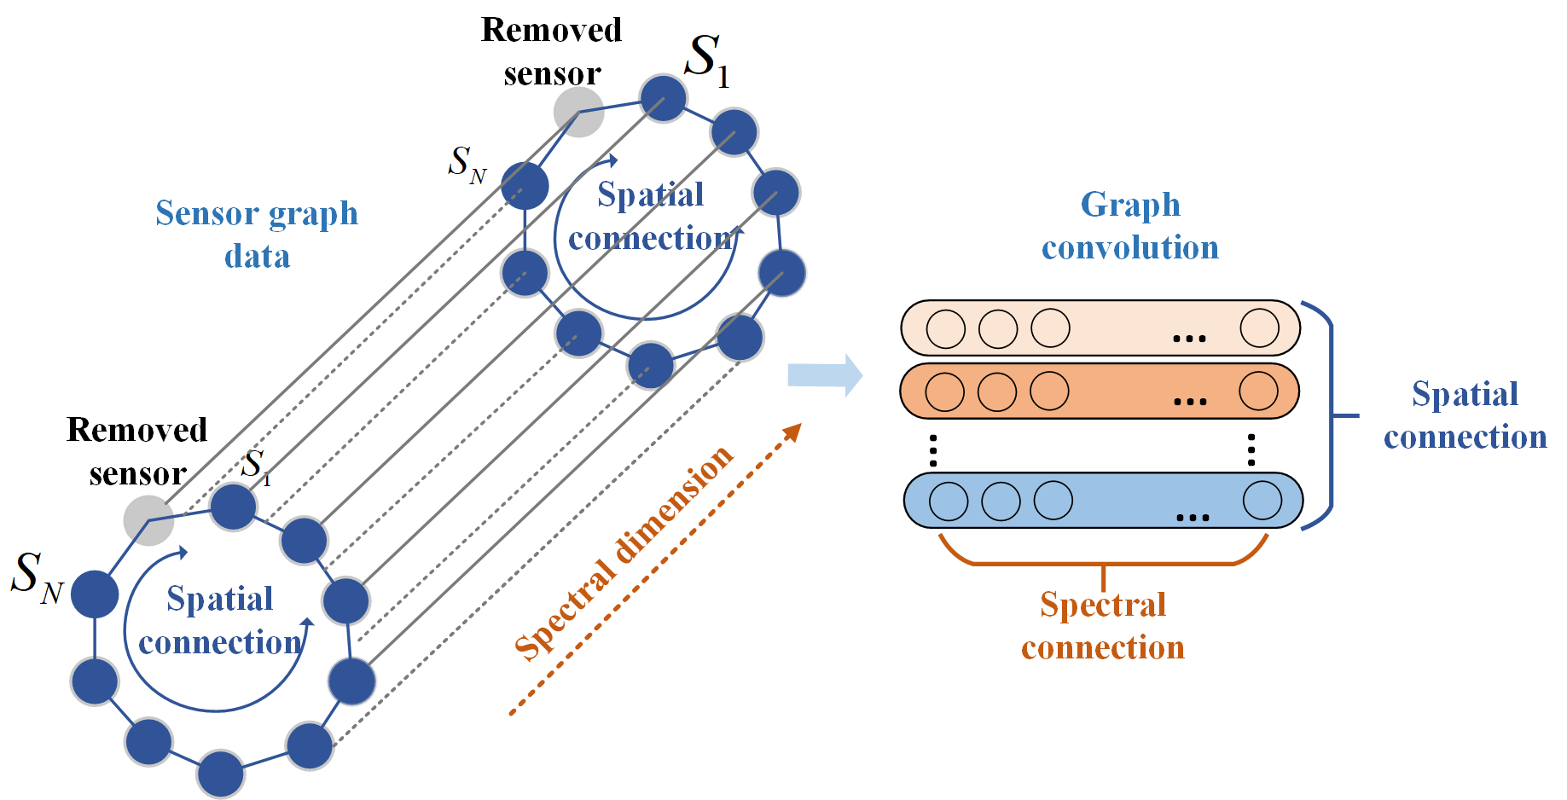
Fig. 6. The spectral-spatial correlation diagram of the vibration signal.
To achieve the prediction of the vibration response, the spectral attention matrix ${{Att}_{spe}}_{i,j}^{'}$is calculated by the spectral attention layer after the data pool has been obtained. The spectral attention matrix is then dot-multiplied with the input data and used as input to the spatial attention layer to obtain the spatial attention matrix ${{Att}_{spa}}_{i,j}^{'}$. Furthermore, the values obtained by multiplying the resulting attention matrix with the previous layer of dot products are used as input to the graph convolution network. Approximate Laplace matrix eigenvalue decomposition by using Chebyshev polynomials. Position information is obtained by entering the adjacency matrix of the sensor cluster. Further convolution is then performed in the spectral dimension. At the same time, the whole process described above is used as a SS module and then the residual network is used to avoid the issue of gradient disappearance or gradient explosion when the number of layers of the model increases. Finally, through a fully connected layer， the calculated feature space maps the sample marker space and then outputs the predicted frequency response of the vibration signal.

IV. Experimental setup and validation

A 48-slots, 8-poles IPMSM was chosen as the experimental prototype. The modal experiments of the prototype were carried out by the hammering method. The basic parameters of the prototype are shown in Table I. In the experiments, the prototype was subjected to static and dynamic experiments using Brüel & Kjær's equipment. The stator system of the prototype was taken out separately and the inertia matrix and natural frequencies of the stator system were tested in the static experiments. In the vibration data acquisition experiment, 10 points are taken as hammer excitation points on the stator tooth surface and 20 points are taken as sensor acquisition points on the outer surface of the frame. The average of the two points in the same group is taken as the final response value. The prototype was installed in the same way for both dynamic and static experiments to ensure that the external physical environment was the same. As the structure and external conditions of the motor remain the same, the inertia matrix of the motor also remains the same. Under dynamic conditions, the prototype was set up with multiple variations of load and speed. Brüel & Kjær's 4520 three-dimension acceleration sensor was used for the experiments. The experimental setup is shown in Fig. 7.
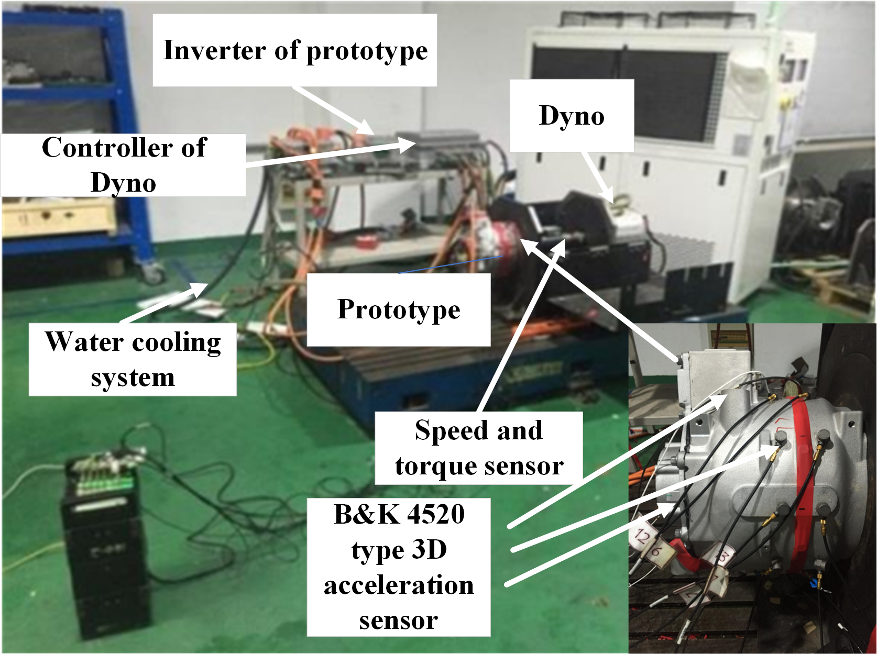
Fig. 7. Experimental setup.
TABLE I
Experimental setup parameters
Parameters | Value
Number of poles and slots | 8/48
Rated power/kW | 21
Out radius of stator/mm | 200
Out radius of rotor/mm | 123.4
Internal radius of rotor/mm | 43
Length of core/mm | 110

- Data Preprocessing and Description

The vibration signals collected in this paper are based on vibration response predictions over a wide motor frequency band (1-6400Hz). To verify the robustness of the algorithm, the acquired motor operating conditions include different speeds under on-load and no-load. The purpose of this article on vibration prediction is to investigate the characteristics of the internal operating condition force (OCF) of a motor under a variety of operating conditions. Therefore, the characteristics and acceleration of the internal OCF under a variety of operating conditions are used as reference indicators.
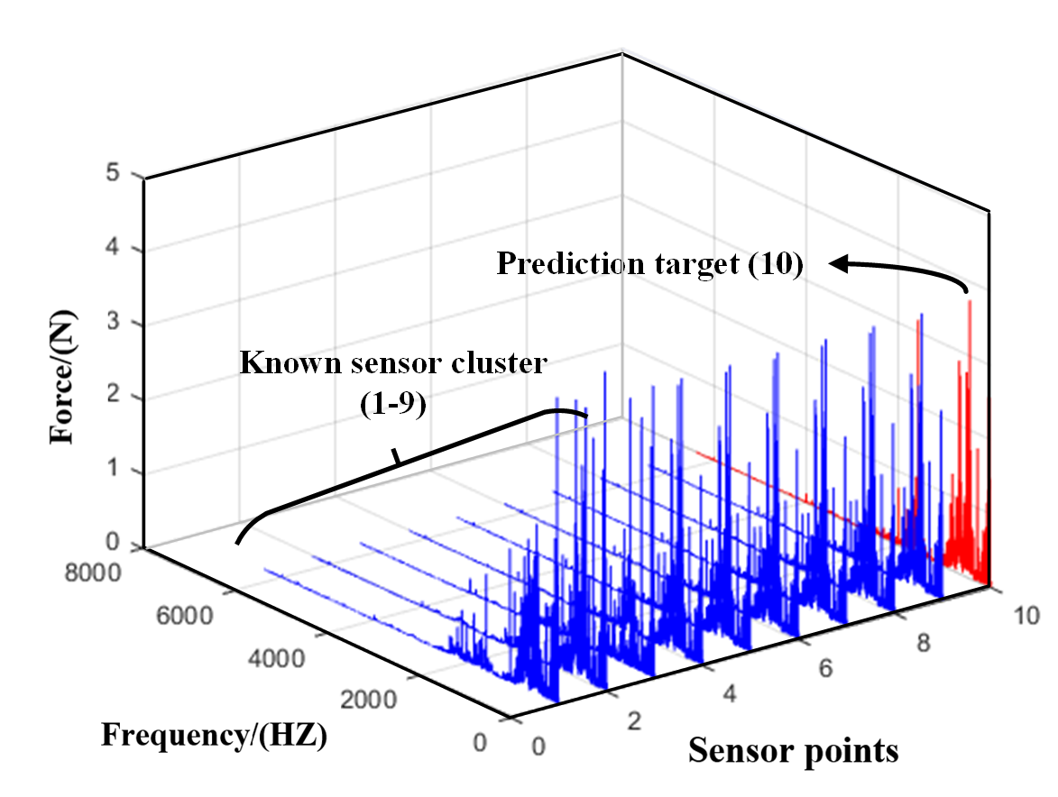
Fig. 8. Sampling dataset of 10 sensor distribution points in the frequency domain.
In addition, [25] proposed vibration impedance matrix theory is necessary for the development of a mathematical analysis model of the OCF. The data set used for the experiments was therefore divided into eight groups based on different operating conditions. Each operating condition includes three indicators for assessing the vibration characteristics. Furthermore, the dataset is divided into a training and a test set in the ratio of 7:3. The proposed algorithm is constructed based on the Pytorch framework. The mean absolute error (MAE) of the loss function used for training in the experiments is a commonly used regression loss function, which is the mean value of the absolute sum of the difference between the target and predicted values and represents the mean magnitude of the error in the predicted values, without regard to the direction of the error. The equations are shown below:
$MAE=\frac{\sum_{i=1}^{n}{\left|f\left(x\right)-y\right|}}{n}$ (21)
compared to MSE, MAE is less sensitive to outliers in the training process. It has a stable gradient regardless of the input value, which does not lead to gradient explosion problems and has a more robust prediction performance.
There are some significant parameters to consider in lifting the ASSGCN model. The step size represents the length of the specified sequence. Longer spectral steps may capture wide spectral-spatial relationships but may also increase the computational burden. Meanwhile, the input feature dimensions depend on the feature dimensions in the specific problem, which in this article include the amount of vibration signal description, operating condition force, acceleration, and vibro-impedance matrices. In addition, the adjacency matrix describes the connectivity between nodes in the graph data and contains information on the spatial location of the sensors. In ASSGCN, a one-dimensional convolution operation is typically used, so the convolution kernel size specifies the size of the convolution window in the time dimension. The number of convolution layers determines the depth of the model, and the graph convolution kernel size specifies the range of local neighbors between nodes when graph convolution operations are performed in space. The learning rate is used to control the update step of the model parameters, and for optimal model stability, the batch size specifies the number of samples used to update the model parameters in each training iteration. The choice of these hyperparameters depends on factors such as the complexity of the input signal, the size of the data and the computational resources. The optimal combination of parameters is usually chosen through experimentation and tuning.

- Prediction performance with multiple operation conditions

To verify the robustness of the prediction model, vibration signals were collected under both no-load and on-load conditions in the multiple operations. In addition to acceleration and force in the frequency domain, the impedance matrix is used as input to the model as the three components describing the vibration characteristics. Table II and Table III illustrate the predictive performance of the model at different loads and speeds according to three indicators including mean absolute error (MAE), mean square error (MSE), and root mean square error (RMSE). From Table II, the prediction accuracy of the vibration signal OCF (F) at a low speed of 3000rpm is higher than that at a higher speed of 6000rpm under the same load at 66N. However, the prediction performance of the frequency response function (FRF) is the opposite of the prediction performance of F. At the same load of 66N, the prediction accuracy is higher in terms of the higher speed of 6000rpm than at a lower speed.
TABLE II
Comparison of results
Operating Conditions | MAE | MSE | RMSE
3000-66-OCF | 0.1378 | 0.2608 | 0.5107
6000-66-OCF | 0.3734 | 1.7489 | 1.3225
8200-48-OCF | 0.37 | 0.451 | 0.6716
3000-66-FRF | 0.8032 | 1.1564 | 1.0753
6000-66-FRF | 0.694 | 0.9218 | 0.9601
8200-48-FRF | 0.8201 | 1.398 | 1.1824
3000-66-PAS | 0.1973 | 0.2165 | 0.4653
6000-66-PAS | 0.9156 | 1.3965 | 1.1817
8200-48-PAS | 0.4032 | 0.5114 | 0.7151

With the same predictive performance of OCF, the predictive performance of PAS which means vibration acceleration response at low speed is higher than the predictive accuracy at high speed for the same load. Furthermore, under the same load and speed conditions, OCF has the best prediction performance among the three vibration parameters. Table III illustrates the investigation of the predicted performance of the three vibration signal parameters at different speeds under no-load conditions. The data set was collected at four speeds including 2000rpm, 3000rpm, 6000rpm and 8200rpm. The prediction accuracy of OCF at 8200 rpm was the highest for the different speed conditions compared to the other speed conditions. And the predicted performance of FRF is best at 6000rpm. In addition, PAS has the lowest prediction accuracy at 3000 rpm and has the lowest average prediction error compared to the component models with the best learning for PAS signal features. It presents an intuitive indication of the trend in the predictive performance of the proposed model for the vibration signal under changes in torque and speed conditions. For MAE values, the trend in the prediction error rate of the model varies with
TABLE III
Comparison of results
Operating Conditions | MAE | MSE | RMSE
2000-no-OCF  3000-no-OCF | 0.3578  0.395 | 0.2608  0.2686 | 0.5107  0.5182
6000-no-OCF | 0.3137 | 1.1709 | 1.0821
8200-no-OCF | 0.2757 | 0.0764 | 0.2764
2000-no-FRF  3000-no-FRF | 0.659  0.474 | 0.8313  0.4252 | 0.9117  0.6521
6000-no-FRF | 0.7604 | 0.9975 | 0.9988
8200-no-FRF | 0.3964 | 0.2705 | 0.5201
2000-no-PAS  3000-no-PAS | 0.3529  0.1956 | 0.3523  0.0666 | 0.5935  0.2581
6000-no-PAS | 0.2057 | 0.0621 | 0.2492
8200-no-PAS | 0.4476 | 0.9634 | 0.9764

increasing torque for the three vibration signal components at the same speed. The prediction of OCF performs significantly better than the other two vibration components, and the prediction accuracy is stable within a fixed range. This is because the proposed model is more effective in extracting the Force signal characteristics than the other two signals, which show strong robustness. Among the other three evaluation metrics, the predictions of FRF and PAS fluctuate more radically under variable load and variable speed conditions. For the MSE value, the prediction accuracy of the FRF decreases and then increases as the torque increases from 0nm to 66nm at a speed of 8000rpm, representing a wide range of errors. Differences in the learning performance of models for different vibration signals indicate that the adaptability of the proposed model for different signals remains to be improved.
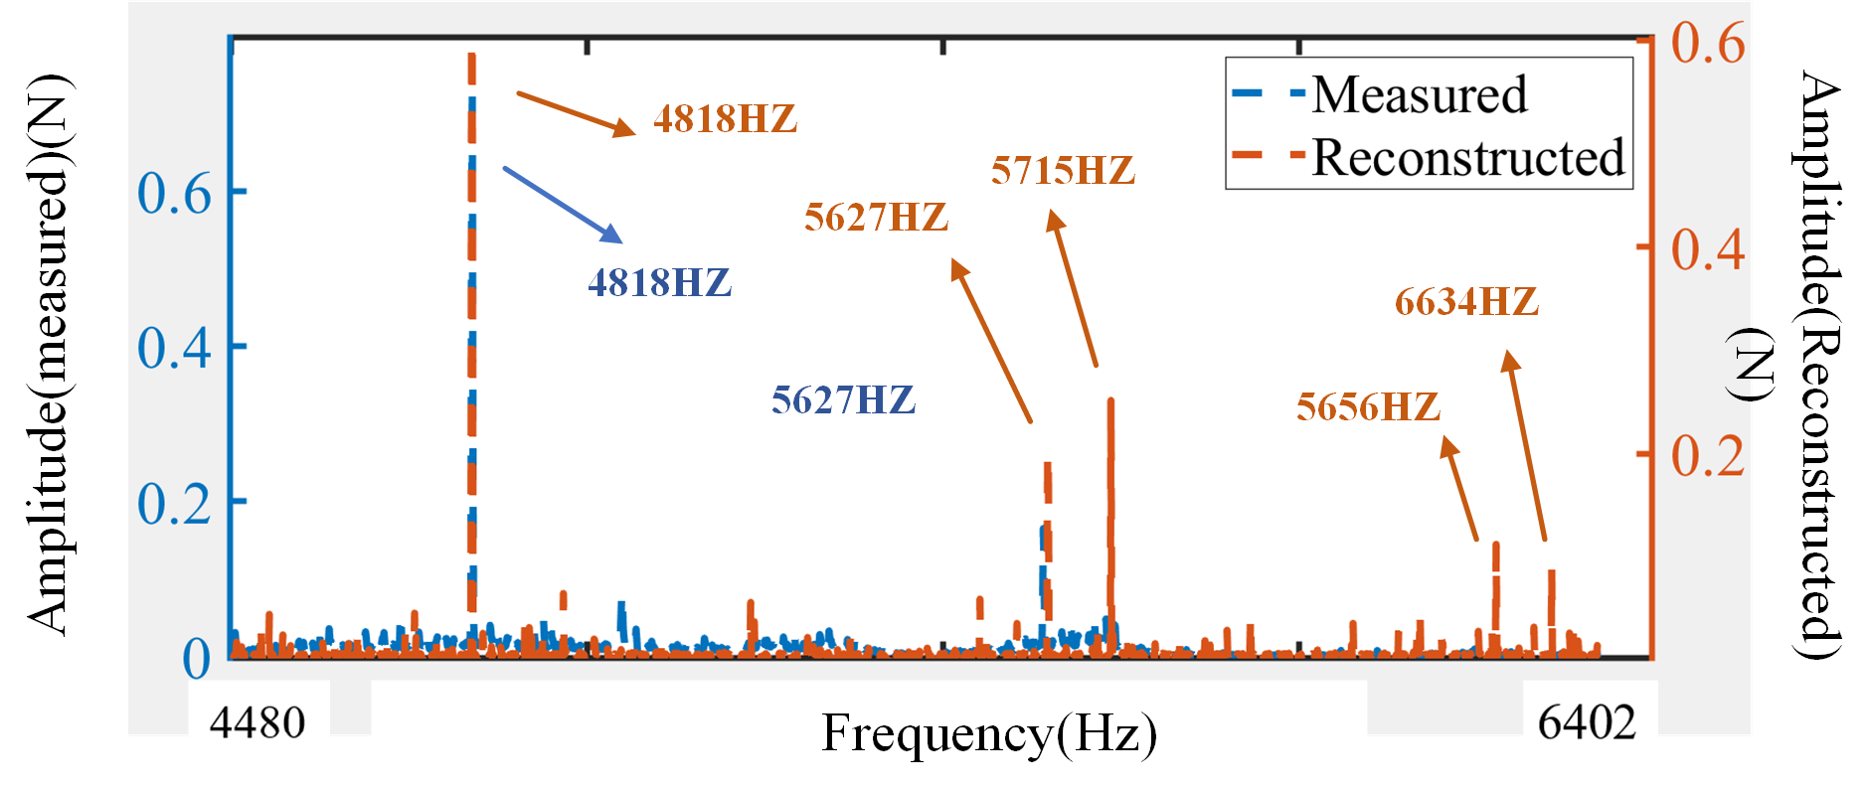
Fig. 9. Measured and reconstructed value of OCF under the condition of 6000rpm without load.

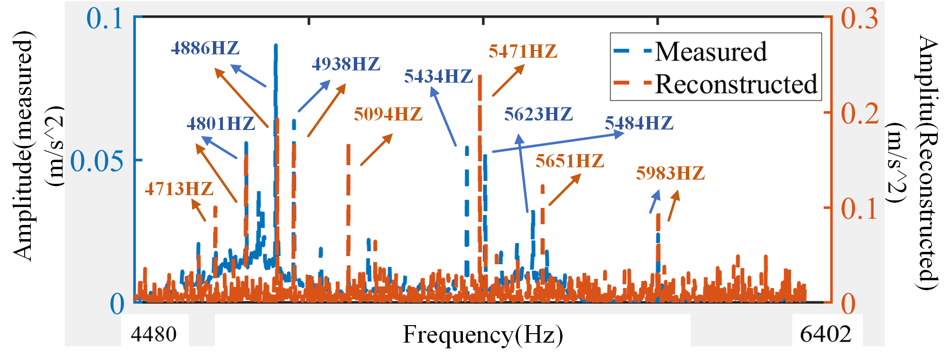
Fig. 10. Measured and reconstructed value of acceleration response under the condition of 6000rpm without load.

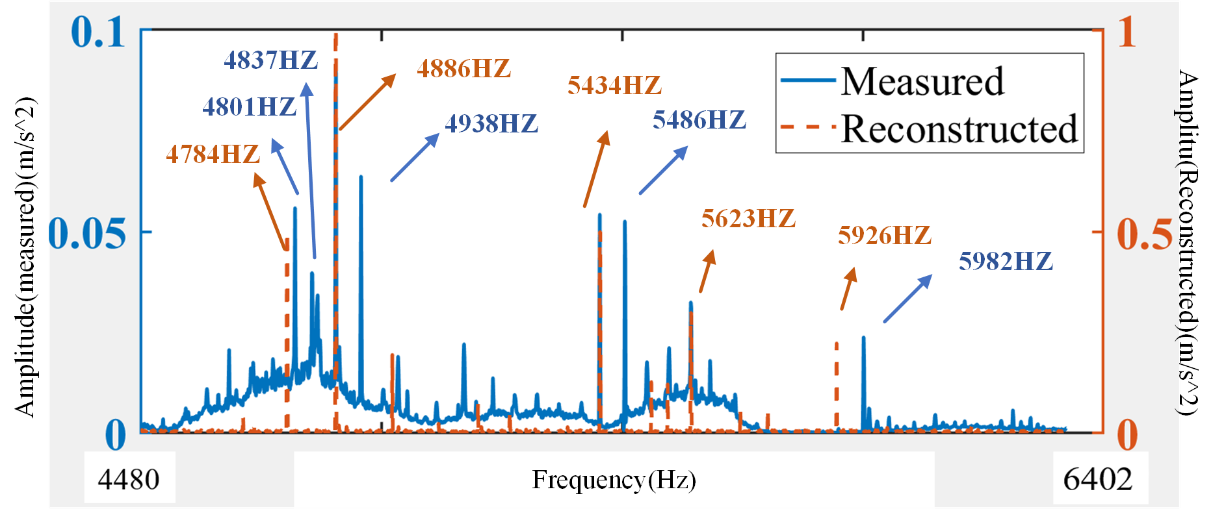
Fig. 11. Measured and reconstructed value of acceleration response under the condition of 8200rpm with a load of 48N.
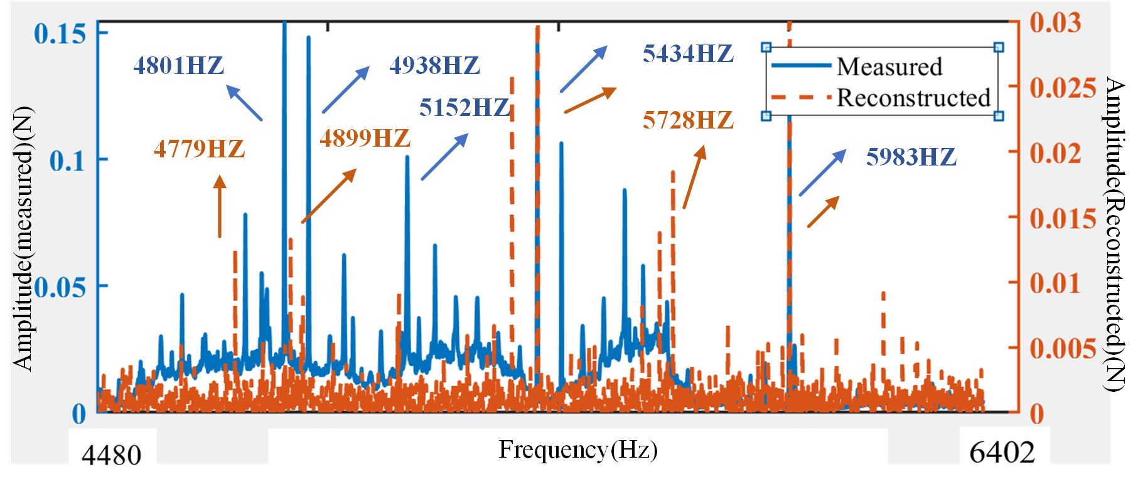 Fig. 12. Measured and reconstructed value of OCF under the condition of 8200rpm with a load of 48N.

- Error analysis and performance discussion

It is worth noting that the paper focuses on the reconstructed performance of the vibration response in the high-frequency range. The experiment is for the prediction of the frequency response of a high-frequency vibration signal from 4480-6402hz. Fig. 9 to Fig. 10 show a comparison of the reconstructed signal and the actual response at 6000rpm without load. Fig. 11 to Fig. 12 indicate the results of the signal reconstruction under the condition of 8200rpm with a load of 48N. Fig. 8 illustrates that the frequency response of the OCF at 4818hz and 5627hz is relatively large and that the proposed algorithm can accurately reconstruct the response at this frequency. The reconstruction values of 48186Hz and 5627Hz frequency points are consistent with the experimental values which indicate the effectiveness of the proposed model. The measured acceleration response amplitudes were in the range of 4801-4938 and 5801-4938hz, with relatively large responses. The model predicts the corresponding frequency bands between 5094-5671hz and 5623-5983hz and the corresponding results deviate from the measured results by approximately 3.8%. Due to the underfitting or overfitting of the vibration signal training samples, the generalization error brought by the model is reflected in the frequency of 5094hz, and the reconstructed value has a large error from the real value. It is required to be reduced by increasing the training samples or further optimizing the model. It suggests that the learning capability of the model decreases as the complexity of the operating characteristics increases due to the change in speed accompanied by multiple changes in vibration amplitude. At the same time, the prediction performance under load conditions is similar to that under no-load conditions. The number of noticeable acceleration responses and high OCF amplitudes was slightly less at the operating condition of 6000 rpm without a load than at 8200 rpm. Fig. 13 to Fig. 14 show the vibration response of adjacent points to the reconstructed points to investigate their spatial connection under different operating conditions. Point 10 represents the reconstruction point, point 1 and point 9 are two vibration points adjacent to the reconstruction point. The amplitude curves of the reconstructed points are similar to those of the adjacent points as can be seen from the graph. It indicates that the vibration characteristics of the adjacent points of the motor are similar with high response amplitude at several frequency points.
The predictive performance of regression models in general is related to the size of the training data, with limited data set causing overfitting problems in regression models. As shown in Fig. 15 the
MAE training error in the various operation states 25 epochs to a lower range and stabilizes in a certain interval. It means that the proposed model has generalization capability to the input vibration
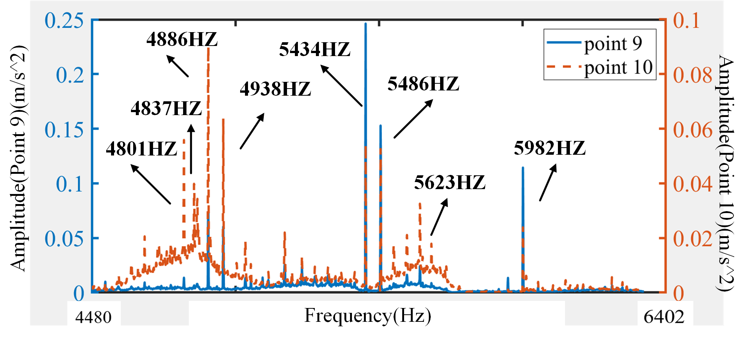
Fig. 13. Spectrum of OCF under the condition of 6000rpm without load for sensor point 1 and point 10.
TABLE IV
Experimental Accuracy and computational burden
Operating Conditions | Experimental Accuracy | Training time (s) | Testing time (s)
OCF without load | 0.8542 | 45.63 | 31.45
FRF without load | 0.9136 | 54.34 | 37.54
PAS without load | 0.9521 | 44.54 | 45.45
OCF with load | 0.9124 | 48.43 | 46.34
FRF with load | 0.9432 | 47.64 | 45.65
PAS with load | 0.9620 | 38.54 | 43.54

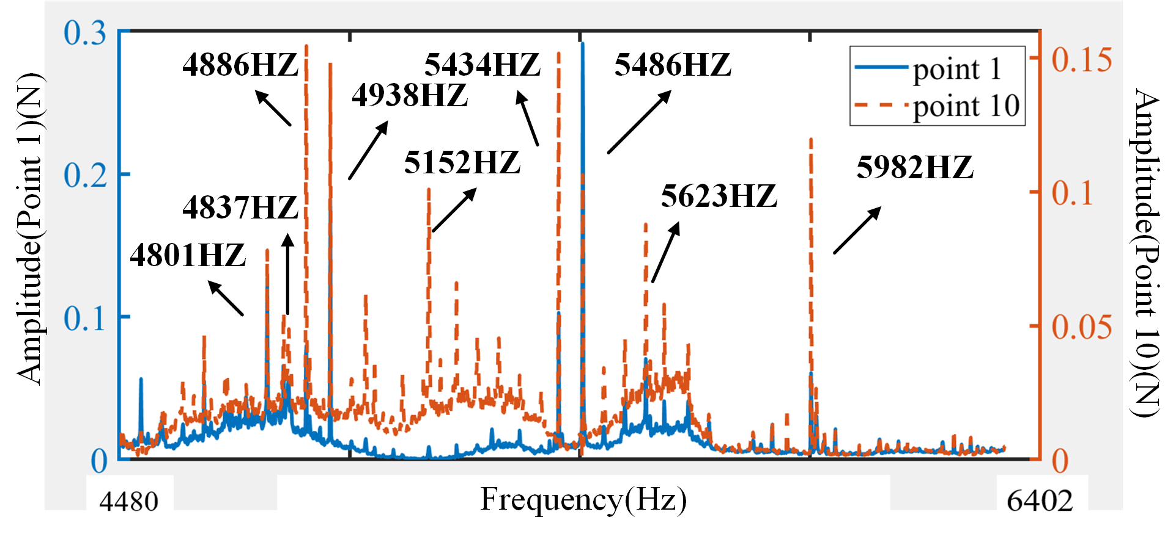
Fig. 14. Spectrum of OCF under the condition of 8200rpm without load for sensor point 9 and point 10.
TABLE V
Comparison Results
Methods | Training sample  (%) | Condition | Experimental Accuracy
Standard GCN | 60 | Conditions 1-7 | 84.32%
Standard CNN | 60 | Conditions 1-7 | 79.64%
KCN | 60 | Conditions 1-7 | 92.34%
IGNNK | 40 | Conditions 1-7 | 95.67%
SVR | 40 | Conditions 1-7 | 72.34%
ASSGCN | 60 | Conditions 1-7 | 96.20%

data set. However, after 100 epochs of training, basically decreases from the initial high training loss of around there is some fluctuation in the training loss of the training set for the different operation states, which indicates a slight overfitting of the model. Therefore, the effect of balancing the training performance of training datasets in different operation states on the ultimate prediction behaviour deserves further investigation in subsequent work.
Table V compares a number of advanced reconstruction models, and the ASSGCN method also performs particularly well, with the highest experimental accuracy of 96.20%. This demonstrates the effectiveness of the method in achieving high accuracy. the IGNNK method achieves a good experimental accuracy of 95.67% with a training sample of 40%. the KCN method achieves an accuracy of 92.34%, demonstrating its reliability in conditional prediction. The standard GCN and standard CNN methods achieved accuracies of 84.32% and 79.64% respectively. Although not as high as IGNNK and ASSGCN, they still provided reasonably good performance. On the other hand, the SVR method had the lowest experimental accuracy of 72.34%, suggesting that it may not be as effective as the other methods in predicting conditions.
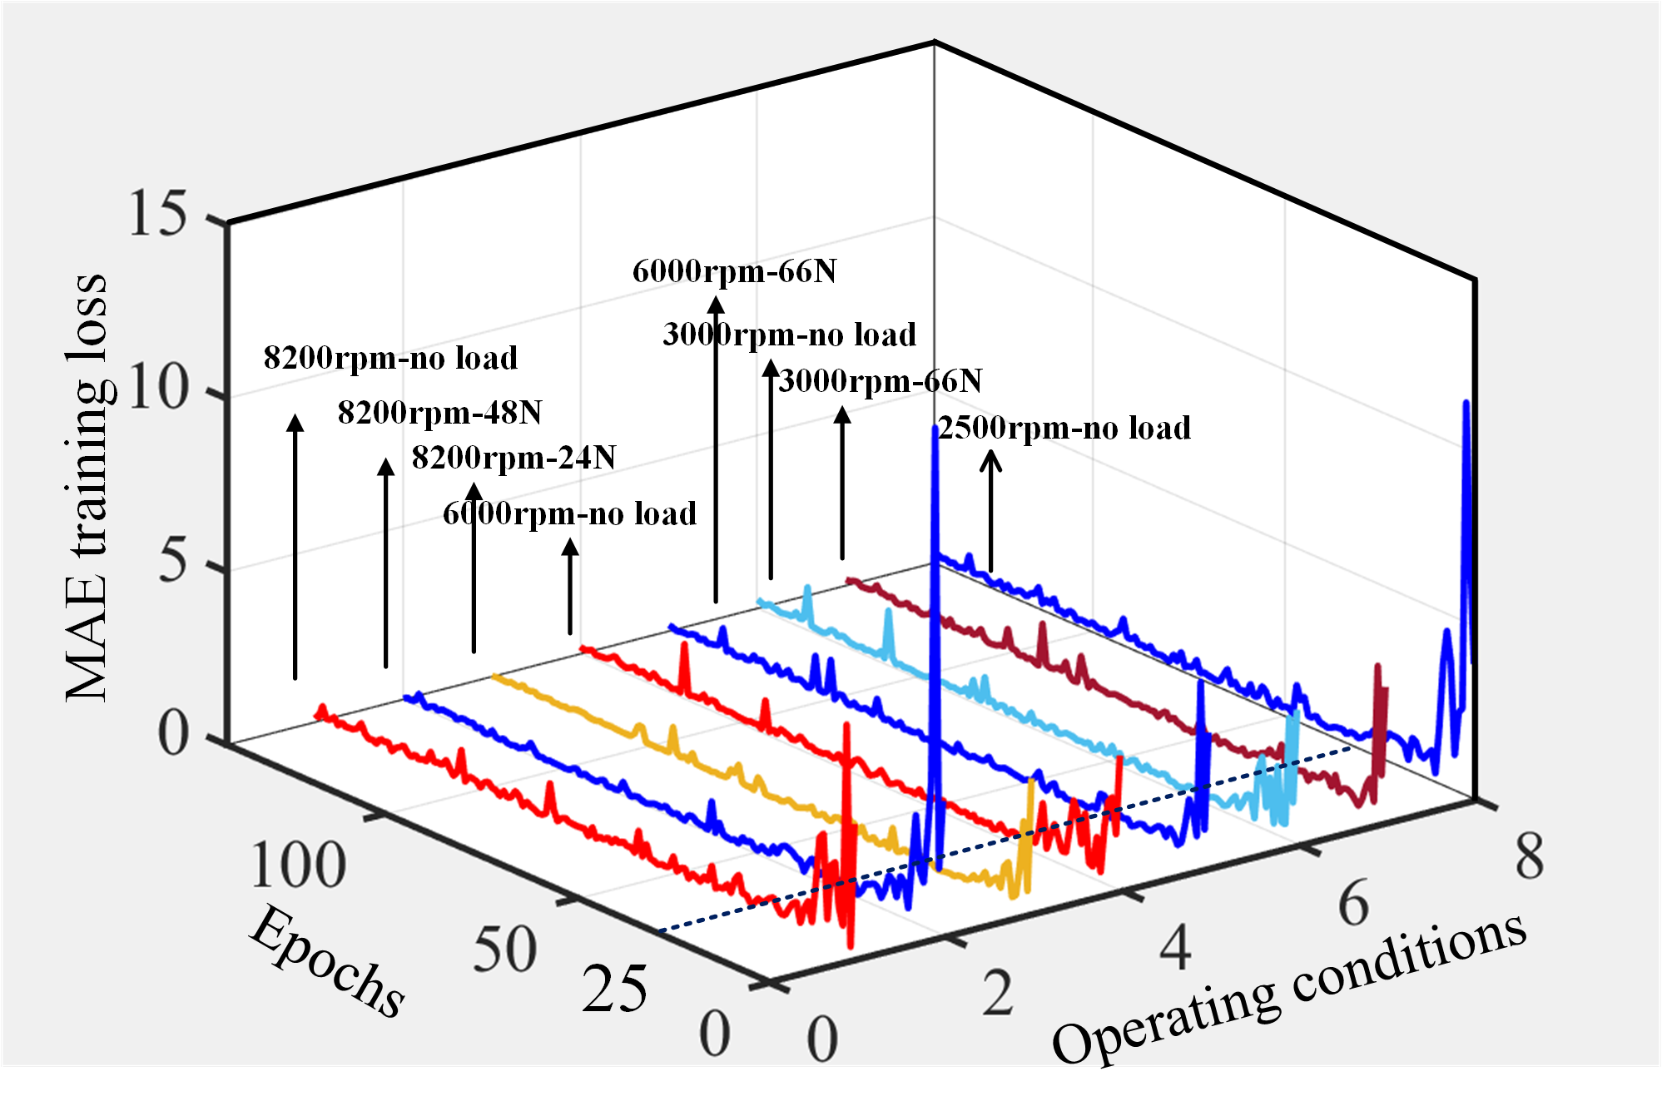
Fig. 15. Curve of MAE training loss with different epochs.

As shown in Table IV, the Vibration acceleration response had the highest experimental accuracy of 0.9521 without load, followed by FRF (frequency response function) and OCF (operating The accuracy of the FRF and OCF was 0.9432 and 0.9124 respectively. The training and testing times were within reasonable limits for all operating conditions. were within reasonable limits. The training times ranged from 38.54 to 54.34 seconds and the test times ranged from 31.45 to 46.34 seconds. By comparing the experimental accuracies, it can be seen that the proposed algorithm exhibits relatively high prediction accuracies under all operating conditions. This indicates that the algorithm has good performance in vibration signal prediction. In addition, the algorithm shows good accuracy with and without load, which indicates that it has good generalization capability for different operating conditions. The relatively short training and testing times imply that the algorithm is highly efficient and can complete the training and testing processes in a short period. In summary, the proposed algorithm has high accuracy and high efficiency in vibration signal prediction, which is potentially valuable in practical applications. However, further research and experiments may be required to validate and evaluate the adaptability and robustness of the algorithm more fully.

IV. Conclusion

The proposed Attention-based Spatial-Spectral Graph Convolutional Network (ASSGCN) model successfully reduces the number of sensors required for vibration signal reconstruction in electric motors. Experimental results on a 21kw IPMSM testing rig with Brüel & Kjær's vibration sensing equipment validate the effectiveness of the proposed method. The following conclusions can be drawn:
- The ASSGCN model utilizes the correlation analysis of the operating state force, acceleration, and vibration impedance matrices in the spatial dimension. The model predicts the vibration signals of different sensor sampling points by modeling the frequency spectrum features of vibration signals separately and using dynamic correlation analysis.
- The reconstructed vibration signal is in good agreement with the actual response at a specific frequency point, demonstrating the validity of the proposed model. The lowest MAE is 0.1378 and 0.1956 under no-load and load conditions respectively.
- The model exhibits high predictive accuracy for OCF at 91.24%, FRF at 94.32% and PAS at 96.2%. And the training loss of 0.67 can be achieved in 25 epochs within a short period indicates the expected performance.
The proposed method offers significant cost and time savings for vibration testing of electric powertrain applications. By reducing the number of sensors required, the overall monitoring cost can be reduced without compromising the effectiveness of fault detection and prediction. the ASSGCN model has the potential to have wider applications beyond specific IPMSM configurations. In summary, the proposed ASSGCN model offers a promising solution for reducing vibration testing costs, increasing efficiency, and improving the overall understanding of motor vibration characteristics. Its adaptability to different motor configurations and wider application in electric powertrain systems make it a valuable tool in the field of vibration analysis and monitoring. The model exhibits robustness in extracting force signal features, making it suitable for applications requiring vibration analysis in electric powertrain systems. In addition, the adaptability of the model to different signals and operating conditions can be further improved.

References

[1] | H. -J. Shin, J. -Y. Choi, H. -I. Park and S. -M. Jang, "Vibration Analysis and Measurements Through Prediction of Electromagnetic Vibration Sources of Permanent Magnet Synchronous Motor Based on Analytical Magnetic Field Calculations," in IEEE Transactions on Magnetics, vol. 48, no. 11, pp. 4216-4219, Nov. 2012.
[2] | E. K. Kim et al., "Vibration-Generation Mechanism and Reduction Method in Linear Iron-Cored Permanent-Magnet Synchronous Motors at Stationary State," in IEEE/ASME Transactions on Mechatronics, vol. 27, no. 5, pp. 3397-3406, Oct. 2022.
[3] | H. Yang and Y. Chen, "Influence of Radial Force Harmonics With Low Mode Number on Electromagnetic Vibration of PMSM," in IEEE Transactions on Energy Conversion, vol. 29, no. 1, pp. 38-45, March 2014.
[4] | J. Du, Y. Li, Z. Yu and Z. Wang, "Research On Radial Electromagnetic Force and Vibration Response Characteristics of Squirrel-Cage Induction Motor Fed By PWM Inverter," in IEEE Transactions on Applied Superconductivity, vol. 31, no. 8, pp. 1-4, Nov. 2021.
[5] | J. Le Besnerais, V. Lanfranchi, M. Hecquet and P. Brochet, "Optimal Slot Numbers for Magnetic Noise Reduction in Variable-Speed Induction Motors," in IEEE Transactions on Magnetics, vol. 45, no. 8, pp. 3131-3136, Aug. 2009.
[6] | S. -H. Lee, J. -P. Hong, S. -M. Hwang, W. -T. Lee, J. -Y. Lee and Y. -K. Kim, "Optimal Design for Noise Reduction in Interior Permanent-Magnet Motor," in IEEE Transactions on Industry Applications, vol. 45, no. 6, pp. 1954-1960, Nov.-dec. 2009.
[7] | Z. Zhao, H. Taghavifar, H. Du, Y. Qin, M. Dong and L. Gu, "In-Wheel Motor Vibration Control for Distributed-Driven Electric Vehicles: A Review," in IEEE Transactions on Transportation Electrification, vol. 7, no. 4, pp. 2864-2880, Dec. 2021.
[8] | W. Zhang, Y. Xu, H. Huang and J. Zou, "Vibration Reduction for Dual-Branch Three-Phase Permanent Magnet Synchronous Motor With Carrier Phase-Shift Technique," in IEEE Transactions on Power Electronics, vol. 35, no. 1, pp. 607-618, Jan. 2020.
[9] | R. Pile, E. devillers and J. Le Besnerais, "Comparison of Main Magnetic Force Computation Methods for Noise and Vibration Assessment in Electrical Machines," in IEEE Transactions on Magnetics, vol. 54, no. 7, pp. 1-13, July 2018.
[10] | S. Zuo, F. Lin and X. Wu, "Noise Analysis, Calculation, and Reduction of External Rotor Permanent-Magnet Synchronous Motor," in IEEE Transactions on Industrial Electronics, vol. 62, no. 10, pp. 6204-6212, Oct. 2015.
[11] | Z. Wu, Y. Fan, H. Chen, X. Wang and C. H. T. Lee, "Electromagnetic Force and Vibration Study of Dual-Stator Consequent-Pole Hybrid Excitation Motor for Electric Vehicles," in IEEE Transactions on Vehicular Technology, vol. 70, no. 5, pp. 4377-4388, May 2021.
[12] | J. Hong, S. Wang, Y. Sun and H. Cao, "A High-Precision Analytical Method for Vibration Calculation of Slotted Motor Based on Tooth Modeling," in IEEE Transactions on Industry Applications, vol. 57, no. 4, pp. 3678-3686, July-Aug. 2021.
[13] | J. Le Besnerais, V. Lanfranchi, M. Hecquet, P. Brochet and G. Friedrich, "Prediction of Audible Magnetic Noise Radiated by Adjustable-Speed Drive Induction Machines," in IEEE Transactions on Industry Applications, vol. 46, no. 4, pp. 1367-1373, July-Aug. 2010.
[14] | S. -H. Lee, I. -J. Yang, W. -H. Kim and I. -S. Jang, "Electromagnetic Vibration-Prediction Process in Interior Permanent Magnet Synchronous Motors Using an Air Gap Relative Permeance Formula," in IEEE Access, vol. 9, pp. 29270-29278, 2021.
[15] | Zhangjun Tang, P. Pillay, Yicheng Chen and A. M. Omekanda, "Prediction of electromagnetic forces and vibrations in SRMs operating at steady-state and transient speeds," in IEEE Transactions on Industry Applications, vol. 41, no. 4, pp. 927-934, July-Aug. 2005.
[16] | F. Chai, Y. Li, Y. Pei and Y. Yu, "Analysis of Radial Vibration Caused by Magnetic Force and Torque Pulsation in Interior Permanent Magnet Synchronous Motors Considering Air-Gap Deformations," in IEEE Transactions on Industrial Electronics, vol. 66, no. 9, pp. 6703-6714, Sept. 2019.
[17] | S. Das et al., "Sensitivity Analysis Based NVH Optimization in Permanent Magnet Synchronous Machines Using Lumped Unit Force Response," in IEEE Transactions on Industry Applications, vol. 58, no. 3, pp. 3533-3544, May-June 2022.
[18] | Z. Song, C. Liu, Y. Chen and R. Huang, "Air-Gap Permeance and Reluctance Network Models for Analyzing Vibrational Exciting Force of In-Wheel PMSM," in IEEE Transactions on Vehicular Technology, vol. 71, no. 7, pp. 7122-7133, July 2022.
[19] | M. Tsypkin, "The Origin of the Electromagnetic Vibration of Induction Motors Operating in Modern Industry: Practical Experience—Analysis and Diagnostics," in IEEE Transactions on Industry Applications, vol. 53, no. 2, pp. 1669-1676, March-April 2017.
[20] | W. Lang, Y. Hu, C. Gong, X. Zhang, H. Xu and J. Deng, "Artificial Intelligence-Based Technique for Fault Detection and Diagnosis of EV Motors: A Review," in IEEE Transactions on Transportation Electrification, vol. 8, no. 1, pp. 384-406, March 2022.
[21] | M. S. Rafaq et al., "A Simple Method for Identifying Mass Unbalance Using Vibration Measurement in Permanent Magnet Synchronous Motors," in IEEE Transactions on Industrial Electronics, vol. 69, no. 6, pp. 6441-6444, June 2022.
[22] | B. Zhao, X. Zhang, Z. Zhan, Q. Wu and H. Zhang, "Multiscale Graph-Guided Convolutional Network With Node Attention for Intelligent Health State Diagnosis of a 3-PRR Planar Parallel Manipulator," in IEEE Transactions on Industrial Electronics, vol. 69, no. 11, pp. 11733-11743, Nov. 2022.
[23] | M. Ni, X. Zhang, Y. Zuo, L. Liao and Z. Yang, "Electromegnatic Vibration Analysis for Permanent Magnet Synchronous Motor," in Micormotors, vol. 48, no. 1, Jan. 2015.
[24] | Guo, S., Lin, Y., Feng, N., Song, C., & Wan, H. (2019). Attention Based Spatial-Temporal Graph Convolutional Networks for Traffic Flow Forecasting. Proceedings of the AAAI Conference on Artificial Intelligence, 33(01), 922-929.”.
[25] | Q. Li, S. Liu and Y. Hu, "Vibration Characteristics of Permanent Magnet Motor Stator System Based on Vibro-Inertance Matrix Method," in IEEE Transactions on Energy Conversion, vol. 37, no. 3, pp. 1777-1788, Sept. 2022.
[26] | D. Chen, Y. Qin, J. Luo and S. Xiang, "Gated Adaptive Hierarchical Attention Unit Neural Networks for the Life Prediction of Servo Motors," in IEEE Transactions on Industrial Electronics, vol. 69, no. 9, pp. 9451-9461, Sept. 2022.
[27] | J. Song, F. Dong, J. Zhao, H. Wang, Z. He and L. Wang, "An Efficient Multiobjective Design Optimization Method for a PMSLM Based on an Extreme Learning Machine," in IEEE Transactions on Industrial Electronics, vol. 66, no. 2, pp. 1001-1011, Feb. 2019.
[28] | “Z. Zhang et al., "Faster Multiscale Dictionary Learning Method With Adaptive Parameter Estimation for Fault Diagnosis of Traction Motor Bearings," in IEEE Transactions on Instrumentation and Measurement, vol. 70, pp. 1-13, 2021”.


Wangjie Lang was born in Zhejiang province in P.R. China, on December 11, 1998. He received the B.Eng. degree in electrical engineering from the University of Strathclyde and Lanzhou University of Technology. Currently, he is a Ph.D student with the major of Electrical Engineering in the Department of Electronic Engineering of University of York, Heslington, York, the UK. His research interests include electrical machine fault detection and diagnosis and machine learning.

Yihua Hu received the B.S. degree in electrical engineering in 2003, and the Ph.D. degree in power electronics and drives in 2011, both at China University of Mining and Technology. Between 2011 and 2013, he was with the College of Electrical Engineering, Zhejiang University as a Postdoctoral Fellow. Between 2013 and 2015, he worked as a Research Associate at the power electronics and motor drive group, the University of Strathclyde. Between 2016 and 2019, he was a Lecturer at the Department of Electrical Engineering and Electronics, University of Liverpool (UoL). Currently, he is a Reader at Electronics Engineering Department at The University of York (UoY). He has published over 120 papers in IEEE Transactions journals. His research interests include renewable generation, power electronics converters & control, electric vehicle, more electric ship/aircraft, smart energy system and non-destructive test technology. He is the associate editor of IEEE Transactions on Industrial Electronics, IET Renewable Power Generation, IET Intelligent Transport Systems and Power Electronics and Drives. He is a fellow of Institution of Engineering and Technology (FIET). He was awarded Royal Society Industry Fellowship.

Quanfeng Li (M’22) received the B.E. degree from Liaoning Technical University, Fuxin, China, in 2005, the M.E degree from Shenyang University of Technology, Shenyang, China, in 2009, and the Ph.D. degrees from the Shanghai University, Shanghai, China, in 2018, all in electrical engineering. He is a senior lecturer of electrical engineering with the Shanghai Dianji University from 2009, and he is head of New Energy Motor R&D Lab. He was a post-doctor associate researcher in the department of electronic engineering of University of York, UK. He works on novel motor design, electromagnetic field computation, analysis of NVH for Electric Vehicle, wireless power transport and medical robotics.


Alex Wireko-Brobby received the MSc degree in Electrical Power and Energy Systems from the University of Strathclyde, Glasgow, U.K in 2020. He is currently pursuing the Ph.D degree with a major in Electrical Engineering with the Department of Electronic Engineering, University of York, York, U.K. His research interests include electric vehicle powertrain errors, PMSM motor drives, Sensorless control and Model Predictive Control.
Mohammed Alkahtani (Graduate Student Member, IEEE) received the B.Eng. degree (Hons.) in electrical and electronics engineering and the M.Sc. degree in electrical power and control engineering from Liverpool John Moores University, Liverpool, U.K., in 2014 and 2016, respectively. He is currently pursuing the Ph.D. degree with the University of Liverpool. His research interests include the management of photovoltaic and a PV array efficiency improvement.

