Top 10 Replicated Findings from Behavioral Genetics

Robert Plomin

King’s College London

John C. DeFries

University of Colorado

Valerie S. Knopik

Rhode Island Hospital and Brown University

Jenae M. Neiderhiser

The Pennsylvania State University

**Abstract**

In the context of current concerns about replication in psychological science, we describe 10 findings from behavioral genetic research that have robustly replicated. These are ‘big’ findings, both in terms of effect size and potential impact on psychological science, such as linearly increasing heritability of intelligence from infancy (20%) through adulthood (60%). Four of our top-10 findings involve the environment, discoveries that could only have been found using genetically sensitive research designs. We also consider reasons specific to behavioral genetics that might explain why these findings replicate.

**Introduction**

A recent concern in psychological science is that many statistically significant findings, including some classic findings, do not replicate (Pashler & Wagenmakers, 2012). This problem is not unique to psychological science. A landmark paper with the title ‘Why most published research findings are false’ (Ioannidis, 2005b) was relevant to all scientific research. It was accompanied by a paper that focused on medical research, showing that, of 49 most highly cited medical papers, only 34 had been tested for replication and, of these, 14 (41%) had been convincingly shown to be wrong; 5 of 6 studies (83%) with nonrandomized designs failed to replicate (Ioannidis, 2005a). Subsequent studies of attempts to replicate medical findings yielded similarly gloomy results (Begley & Ellis, 2012; Prinz, Schlange, & Asadullah, 2011). Such research led to claims that 85% of research resources are wasted (Macleod et al., 2014). In psychological science, a systematic attempt to replicate 100 studies found that only 36% yielded significant replication (Open Science Collaboration, 2015). Another attempt to replicate 17 structural brain-behavior findings concluded that “we were unable to successfully replicate any” (Boekel et al., 2015). Although much has been written about the diagnosis, cause and prescription for fixing these cracks in the bedrock of psychological science (Ledgerwood, 2014a, 2014b), there is consensus throughout science that the final arbiter is replication (Jasny, Chin, Chong, & Vignieri, 2011; Schmidt, 2009).

In this context, the purpose of this paper is to highlight 10 findings about the genetic and environmental origins of individual differences in behavior that have consistently replicated. On the basis of our decades of experience in the field of behavioral genetics and our experience in writing the major textbook in the field (Plomin, DeFries, Knopik, & Neiderhiser, 2013), we selected these 10 findings because in our opinion they are ‘big’ findings both in terms of effect size and their potential impact on psychological science. These findings are not novel precisely because we have selected results that have been repeatedly verified. For this reason, each of the findings in our top-10 list has been reviewed elsewhere and a few have been highlighted previously as ‘laws’ of behavioral genetics, as noted below. Although not all of these findings are supported by formal meta-analyses, we expect that most behavioral geneticists will agree with the 10 findings on our list, although we also suspect they would wish to add to the list. What is novel about our paper is that we bring together 10 reproducible findings from behavioral genetics and consider reasons specific to behavioral genetics that might explain why these results replicate and why others do not.

Before we turn to our list, we mention five other preliminary issues. First, we should explain our use of the more modest word *finding* rather than the word *law*, which has been used previously in the context of describing replicable results from behavioral genetics (Chabris, Lee, Cesarini, Benjamin, & Laibson, in press; Plomin & Deary, 2015; Turkheimer, 2000; Turkheimer, Pettersson, & Horn, 2014). One reason to use the word *finding* is that *law* -- like the law of gravity --connotes rules responsible for invariable results, and there are exceptions to our findings. We mention these exceptions, not to make the specious suggestion that exceptions prove the rule, but to point out that these exceptions are important because they stand out from the rest of the results. Another reason for avoiding the word *law* is that behavioral genetic statistics such as *heritability* ascribe variance in traits and covariance between traits to genetic and environmental sources; its results, like other descriptive statistics such as means, variances and correlations, may be limited by the samples, measures and methods employed. In terms of samples, for example, most of this research comes from developed countries and results could differ in less developed countries. Heritability describes ‘what is’ in a population – it does not predict what could be or prescribe what should be in that population or any other. It should also be emphasized that heritability does not refer to a single individual but rather to individual differences in a particular population at a particular time with its particular mix of genetic and environmental effects. Most importantly, heritability does not imply immutability (Plomin et al., 2013).

A second preliminary issue concerns background and documentation. Although we provide references that describe the methods and research that underlie these findings, we cannot include details about the methods, their limitations, or the research because it would require a book-length treatment. Indeed, most of these details can be found in our textbook from which these findings were abstracted (Plomin et al., 2013).

Third, many of these findings are not limited to psychological traits. Most extend to physical, physiological and medical traits as well. However, we focus on psychological traits to avoid having the paper become even more unwieldy.

Fourth, we use a broad definition of the word *replication* in the sense of reproducing results. In our use of the word we include conceptual as well as direct replication (Schmidt, 2009).

Fifth, our goal is to describe big behavioral genetic findings that replicate, rather than describing results that have not shown sufficient replication to be included in our list. Examples, which may become more convincing with more research, include differential heritability (attempts to show that certain personality traits are more heritable than others), sex differences in heritability, and genotype-environment interaction (attempts to show that heritability differs as a function of environment).

Finally, we note that four of the top-10 findings (2, 7, 8 and 9) are about environmental influences rather than genetic influences. By using genetically sensitive designs such as twin studies, behavioral genetics has revealed almost as much about the environment as about genetics.

***1. All psychological traits show significant and substantial genetic influence***

Psychological domains that have traditionally focused on individual differences are those that have been studied most using genetically sensitive designs, primarily the twin method that compares resemblance in pairs of identical and fraternal twins: cognitive abilities and disabilities, psychopathology, personality, substance use and abuse, and health psychology. Traits in these domains have consistently shown significant genetic influence in adequately powered studies (Plomin et al., 2013), which has led this to be described as the first ‘law’ of behavioral genetics (Turkheimer, 2000). (As discussed later, model-fitting analyses emphasize estimation of effect sizes and confidence intervals, which also provides evidence for statistical significance.) Although ubiquitous genetic influence is now widely accepted, this finding should not be taken for granted because it was a battleground in psychology even a few decades ago (Pinker, 2002) and remains controversial in some areas such as education (Check Hayden, 2013; Haworth & Plomin, 2011).

As an example, a review of the world’s literature on intelligence, which included 10,000 pairs of twins, showed that identical twins are significantly more similar than fraternal twins, with twin correlations of about 0.85 and 0.60, respectively, with corroborating results from family and adoption studies, implying significant genetic influence (Bouchard & McGue, 1981, as modified by Loehlin, 1989). Although most of this research was conducted in the United States and western European countries, significant genetic influence has been found in countries such as Russia, the former East Germany, Japan, and rural and urban India (Plomin et al., 2013). Recent studies continue to report similar results, as seen for example in a report of 11,000 pairs of twins from six twin studies in four countries (Haworth et al., 2010). We are not aware of a single adequately powered study reporting nonsignificant heritability.

As an example in the domain of psychopathology, a meta-analysis of 14 twin studies of schizophrenia found MZ concordances of about 50% and DZ concordances of about 15%, suggesting significant genetic influence (Sullivan, Kendler, & Neale, 2003), which has been corroborated in more recent studies (Cardno et al., 2012), as well as in adoption studies (Plomin et al., 2013). Other cognitive and psychopathological traits have not been studied as much as general intelligence and schizophrenia, but as these other traits are investigated they too repeatedly yield significant genetic influence, such as specific cognitive abilities and other aspects of psychopathology, such as autism and hyperactivity (Plomin et al., 2013). For personality, scores of twin studies have over the decades yielded evidence for significant genetic influence for dozens of traits studied using self-report questionnaires (Turkheimer et al., 2014), results confirmed in meta-analyses with adoption and family data as well as twin data on 24,000 pairs of twins (Loehlin, 1992). Many other traits have also have been reported to show significant genetic influence such as political beliefs, religiosity, altruism and food preferences (Plomin et al., 2013). A recent meta-analysis of nearly 18,000 traits from 3000 publications including 15 million twin pairs shows that this finding is not limited to psychological traits (Polderman et al., 2015).

As discussed later, a strength of behavioral genetics is its focus on estimating effect size, heritability. Rather than just concluding that genetic influence is statistically significant, another consistent finding is that heritabilities are substantial, often accounting for half of the variance of psychological traits. For example, for general intelligence, heritability estimates are typically about 50% in meta-analyses of older family, twin and adoption studies (Chipuer, Rovine, & Plomin, 1990; Devlin, Daniels, & Roeder, 1997; Loehlin, 1989) as well as newer twin studies (Haworth et al., 2010), with 95% confidence intervals on the order of 45% - 55%. For personality, heritabilities are usually 30% -50%. For example, wellbeing is a relative newcomer in relation to genetic analyses of personality; a meta-analytic review of 10 studies based on 56,000 individuals yielded a heritability estimate of 36% (34%-38%) (Bartels, 2015). It is sometimes said that the estimation of the effect size of heritability does not matter. However, surely it matters if heritabilities were just 5% rather than 50% or perhaps 95%. For example, if heritability were near 100% this implies that environmental differences that exist in the population do not have an effect on a particular phenotype assessed at a particular stage in development. However, this does not imply that new environmental factors would also have no effect.

This research has primarily relied on the twin design that compares resemblance of identical and fraternal twins and the adoption design that compares resemblance of relatives separated by adoption. Although the twin and adoption designs have separately been criticized (Plomin et al., 2013), these two designs generally converge on the same conclusion, despite making very different assumptions, which adds strength to these conclusions. An exciting development is the first completely new genetic design in a century, *Genome-wide Complex Trait Analysis* (GCTA; Yang, Lee, Goddard, & Visscher, 2011). GCTA uses hundreds of thousands of DNA differences (single-nucleotide polymorphisms, SNPs, which involve a difference in a single nucleotide) across the genome to estimate chance genetic similarity for each pair of individuals in a large sample of conventionally unrelated individuals and to relate this chance genetic similarity to phenotypic similarity. GCTA underestimates genetic influence for several reasons and requires samples of several thousand individuals in order to pick up the tiny signal of chance genetic similarity from the noise of DNA differences across the genome (Vinkhuyzen, Wray, Yang, Goddard, & Visscher, 2013). Nonetheless, GCTA has consistently yielded evidence for significant genetic influence for cognitive abilities (Benyamin et al., 2014; Davies et al., 2015; St Pourcain et al., 2014), psychopathology (Davis et al., 2013; Gaugler et al., 2014; Klei et al., 2012; Lubke et al., 2012; Lubke et al., 2014; McGue et al., 2013; Ripke et al., 2013; Wray et al., 2014), personality (Rietveld, Cesarini, et al., 2013; Verweij et al., 2012; Vinkhuyzen et al., 2012), and substance use/drug dependence (Palmer et al., 2015; Vrieze, McGue, Miller, Hicks, & Iacono, 2013), thus supporting the results of twin and adoption studies.

Significant and substantial genetic influence on individual differences in psychological traits is so widespread that we are unable to name an exception. The challenge now is to find any reliably measured behavioral trait for which genetic influence is *not* significantly different from zero in more than one adequately powered study.

***2. No traits are 100% heritable***

Although heritability estimates are significantly greater than 0%, they are also significantly less than 100%. As noted above, heritabilities are substantial, typically 30% - 50%, but this is a long way from 100%. Again, we are unable to find any exception in which the heritability of a behavioral trait is near 100%. This is not a limitation of the methods because some traits, such as individual differences in height, yield heritabilities as high as 90%. However, it should be noted that behavioral traits are less reliably measured than physical traits such as height and error of measurement contributes to nonheritable variance. Many others have noted that no traits are 100% heritable (e.g., Plomin, 1989; Turkheimer, 2000).

Although this finding might seem obvious and unsurprising, it is crucial because it provides the strongest available evidence for the importance of environmental influence after controlling for genetic influence. Because genetic influence is significant and substantial, it is necessary to control for genetic influence when investigating environmental influence. Environmental research using genetically sensitive designs has led to three of the most important discoveries about the way the environment affects behavioral development, presented as findings 7, 8 and 9.

***3. Heritability is caused by many genes of small effect***

The two previous findings come from family-based genetic designs, primarily twin and adoption studies. Although the quantitative genetic model underlying these methods (Fisher, 1918) assumes that many genes affect complex traits and common disorders, these methods cannot estimate how many genes are involved in heritability or the distribution of their effect sizes.

Powerful but overlooked evidence that many genes affect complex traits including behavior comes from selection studies in nonhuman animal research. If only a few genes were responsible for the heritability of a trait, selected lines would separate after a few generations and would not diverge any further in later generations. In contrast, selection studies of complex traits show a linear response to selection even after dozens of generations of selection, as seen for example (Figure 1) in one of the largest and longest selection studies of behavior that included replicate selected and control lines (DeFries, Gervais, & Thomas, 1978). Another overlooked point from selection studies is that genetic effects transmitted from parents to offspring can only be due to additive genetic effects (the independent effects of alleles and loci that ‘add up’), in contrast to nonadditive genetic effects in which the effects of alleles and loci that interact. This is important information because it would be difficult to identify specific DNA differences responsible for heritability if genetic effects on behaviour were caused by interactions between many loci (epistasis).

-------------------------------------

Figure 1 about here

-------------------------------------

GCTA also provides evidence for the highly polygenic nature of quantitative traits and qualitative disorders because it shows that SNPs on each chromosome contribute cumulatively to the heritability estimated by GCTA (Yang et al., 2013). The strongest evidence comes from a method called *genome-wide association* (GWA), which has been widely used in attempts to identify specific DNA associations with quantitative traits and qualitative disorders (Manolio et al., 2009). An association is a correlation between a trait or disorder and the frequency of one of the two alleles (forms) of a SNP; for example, the frequency of a particular allele of the gene that encodes apolipoprotein E is about 40 percent for individuals with Alzheimer disease and 15 percent for control individuals who do not have the disorder.

Earlier attempts to identify gene associations with behavior investigated a few genes thought to be ‘candidates’ on the basis of their function; however, such candidate gene studies have not generally replicated, for example, for schizophrenia (Farrell et al., 2015) or intelligence (Chabris et al., 2012). GWA is an atheoretical approach that uses hundreds of thousands or millions of SNPs covering most of the genome to detect population associations between a SNP and a trait.

GWA has been successful in detecting SNP associations for many traits and disorders (Visscher, Brown, McCarthy, & Yang, 2012), but it was a shock to discover that the largest effect sizes are extremely small (Gratten, Wray, Keller, & Visscher, 2014). For example, the largest associations in a GWA meta-analysis of over 36,000 diagnosed schizophrenic cases and 113,000 controls accounted for less than 1.1-fold increase in the odds of a schizophrenia diagnosis (Schizophrenia Working Group of the Psychiatric Genomics Consortium, 2014). In a GWA study of years of schooling, the three largest replicated SNP associations in a sample of 120,000 individuals each accounted for only 0.0002 of the variance of years of schooling in independent samples (Rietveld et al., 2014; Rietveld, Medland, et al., 2013). In other words, the largest effect sizes detected by GWA are extremely small for both disorders and traits. This finding has been noted by many others, and specifically in relation to psychological traits (e.g., Chabris et al., 2015; Plomin & Deary, 2015). These results are based on common SNPs, which have been used in GWA studies. Exciting results are emerging from other types of DNA variants, such as rare duplications and deletions of long stretches of DNA, called copy number variants (Farrell et al., 2015).

Our purpose here is not to discuss issues involved in using GWA to detect and replicate such small effects but rather to turn the results of GWA studies around. Although the power of GWA is limited to detect such minuscule effects even with samples in the tens or hundreds of thousands, these studies have tremendous power to detect larger effects (Robinson, Wray, & Visscher, 2014). For example, a GWA study of 20,000 individuals has 99.9% power to detect an association with an effect size that accounts for 1% of the variance (i.e., a correlation of 0.10). This suggests that no such associations exist with effect sizes larger than 1% in the population. Some extremely rare mutations have large effects on individuals, but because they are rare their effect on the population is small. If the largest effects are so small, the smallest effects are likely to be infinitesimal, which implies that heritability is caused by many genes of small effect (Chabris et al., in press; Plomin & Simpson, 2013).

***4. Phenotypic correlations between psychological traits show significant and substantial genetic mediation***

Much psychological research is about the relationship between traits. For example, a recent issue in this journal included reports on associations between creativity and mental health, stress reactivity and neuroticism, empathy and moral behavior, and personality and job performance. Few of the thousands of reported correlations between traits such as these have been studied using genetically sensitive designs. However, when genetically informed designs are used, research consistently points to a finding with far-reaching implications: Phenotypic covariance between traits is significantly and substantially caused by genetic covariance, not just environmentally driven covariance.

Multivariate genetic analysis estimates the extent to which genetic and environmental influences contribute to the phenotypic covariance between traits by comparing for example the cross-trait cross-twin correlations for MZ and same-sex DZ twins (i.e., correlating one twin’s X with the co-twin’s Y) (Plomin et al., 2013). If the MZ cross-correlation is greater than the DZ cross-correlation, it suggests that genetic factors contribute to the phenotypic correlation between the traits, which is what we mean by the phrase *genetic mediation*.

Cognitive abilities have been studied most systematically from a multivariate genetic perspective. This research consistently shows that the phenotypic correlations among cognitive abilities are mediated significantly and substantially by genetic factors, called *generalist genes* (Plomin & Kovas, 2005). For example, as shown in Figure 2, a multivariate genetic analysis of intelligence, reading, mathematics and language in nearly 5000 12-year-old twins found that genetic factors consistently accounted for over half of the phenotypic correlations, ranging from 53% to 65%, with a mean of 61% and a mean 95% confidence interval of 53% - 67% (Davis, Haworth, & Plomin, 2009). These findings have received support from multivariate GCTA (Trzaskowski et al., 2013). One implication of this finding is that the phenotypic structure of domains is similar to their genetic structure, as has been shown, for example, for cognitive abilities (Petrill, 1997) and personality (Turkheimer et al., 2014).

-------------------------------------

Figure 2 about here

-------------------------------------

More than one hundred twin studies have addressed the key question of comorbidity in psychopathology and this body of research also consistently finds substantial genetic overlap between common disorders (Cerda, Sagdeo, Johnson, & Galea, 2010; Kendler, Prescott, Myers, & Neale, 2003) in children (Rhee, Lahey, & Waldman, 2015) and in adults (Kendler et al., 2011). For example, a review of 23 twin studies and 12 family studies confirms that anxiety and depression are correlated entirely for genetic reasons (Middeldorp, Cath, Van Dyck, & Boomsma, 2005). In other words, the same genes affect both disorders, which means that from a genetic perspective they are the same disorder. Even the comorbidity between schizophrenia and bipolar depression, the first fork in the diagnosis of psychosis, is mainly due to genetic factors (Lichtenstein et al., 2009). Again, this implies that many of the same genes affect both disorders. These twin study findings of genetic overlap among disorders have received support from multivariate GCTA studies (Cross-Disorder Group of the Psychiatric Genomics Consortium, 2013a) and from GWA studies (Cross-Disorder Group of the Psychiatric Genomics Consortium, 2013c). For example, a recent review of molecular genetic studies of schizophrenia concluded: “There is evidence for shared genetic risk between schizophrenia, bipolar disorder, autism spectrum disorders, intellectual disability and attention-deficit and hyperactivity disorder” (Kavanagh, Tansey, O'Donovan, & Owen, 2015, p. 76). These results convey an important implication: the genetic structure of psychopathology does not map neatly on current diagnostic classifications (Doherty & Owen, 2014). Moreover, correlations between personality dimensions and psychopathological diagnoses are also mediated genetically, most notably between neuroticism and depression (Kendler, Gatz, Gardner, & Pedersen, 2006).

This finding goes far beyond these well-known examples of genetic contributions to correlations in the domains of cognitive abilities and psychopathology. Whenever a phenotypic correlation is found between two behavioral traits, the genetic contribution to the phenotypic correlation is significant and substantial, with the usual caveat of adequate power, which is especially severe for low phenotypic correlations. As one of many such examples of new but as yet unreplicated findings of this type, genes accounted for more than 70% of the phenotypic correlations of about 0.30 between attitudes toward exercise and exercise behavior, meaning that many of the same genes affect the two traits (Huppertz et al., 2014).

This finding extends even further, to the phenotypic correlations between behavior and other variables that are not ostensibly measures of behavior. One of our other findings is of this type: phenotypic correlations between behavioral measures and environmental measures (*Finding 8*).

***5. The heritability of intelligence increases throughout development***

Unlike the other findings, this one is limited to a specific domain, general cognitive ability (intelligence), but it is one of the most surprising and counterintuitive findings from behavioral genetics. Although it would be reasonable to expect that experiences accumulate in their effect as time goes by, which some developmental theories propose (e.g., Baltes, Reese, & Lipsitt, 1980), the heritability of intelligence has consistently over three decades’ research been found to increase linearly throughout the life course in longitudinal as well as cross-sectional analyses and in adoption as well as twin studies (McGue, Bouchard, Iacono, & Lykken, 1993; Plomin, 1986; Plomin & Deary, 2015). For example, as summarized in Figure 3, an analysis of cross-sectional data for 11,000 pairs of twins – larger than all previous twin studies combined – showed that the heritability of intelligence increases significantly from 41% in childhood (age 9) to 55% in adolescence (age 12) and to 66% in young adulthood (age 17) (Haworth et al., 2010). The non-overlapping standard errors in Figure 3 suggest that the increases in heritability across the three ages are significant and model-fitting confirmed that the increases are significant. A meta-analysis of results from longitudinal twin and adoption studies also found increases in heritability from infancy through adolescence (Briley & Tucker-Drob, 2013). Some evidence suggests that heritability might increase to as much as 80% in later adulthood independent of dementia (Panizzon et al., 2014); other results suggest a decline to about 60% after age 80 (Lee, Henry, Trollor, & Sachdev, 2010) but another study suggests no change in later life (McGue & Christensen, 2013).

-------------------------------------

Figure 3 about here

-------------------------------------

Increasing heritability for intelligence is interesting because other domains such as personality do not show systematic changes in heritability during development (Turkheimer et al., 2014); reasons for this difference in results are not known. However, a meta-analysis of seven behavioral domains other than intelligence found significant increases in heritability for externalizing and internalizing behavior problems and social attitudes during adolescence and young adulthood (Bergen, Gardner, & Kendler, 2007). There was no evidence for significant decreases in heritability, suggesting that when heritability changes in development, it increases, although the evidence is not as compelling as it is for intelligence.

Why does heritability of intelligence increase throughout development? Increasing heritability could be due to new genetic influences coming on line, a process called *innovation*, which would seem reasonable given the changes in brain structure and function that occur during development. However, the next finding, about age-to-age genetic stability, suggests a less obvious reason for the developmental increase in heritability.

***6. Age-to-age stability is mainly due to genetics***

Longitudinal genetic studies consistently show that phenotypic correlations from age to age are largely due to genetic stability. In other words, genetic effects contribute to continuity (the same genes affect the trait across age), whereas age-to-age change is primarily the provenance of environmental factors (Plomin, 1986). Longitudinal genetic analysis is a variant on multivariate genetic analysis (see *Finding 4*) of the phenotypic covariance across time for the ‘same’ trait. Such research has shown that phenotypic stability from age to age is mainly due to genetics for personality, psychopathology and intelligence, domains for which the most longitudinal genetic data are available.

For personality, the first report of a longitudinal genetic analysis over an age span of a decade concluded that 80% of the phenotypic stability was mediated genetically (McGue, Bacon, & Lykken, 1993), which has been confirmed in recent meta-analyses (Briley & Tucker-Drob, 2014; Turkheimer et al., 2014). For psychopathology, fewer longitudinal genetic studies are available but results are similar for diverse traits related to psychopathology such as borderline personality disorder (Bornovalova, Hicks, Iacono, & McGue, 2009); antisocial personality disorder (Burt, McGue, Carter, & Iacono, 2007); aggression (van Beijsterveldt, Bartels, Hudziak, & Boomsma, 2003); attention problems (Rietveld, Hudziak, Bartels, Van Beijsterveldt, & Boomsma, 2004); withdrawn behavior (Hoekstra, Bartels, Hudziak, Van Beijsterveldt, & Boomsma, 2008); anxiety and depression after childhood (Kendler, Gardner, & Lichtenstein, 2008); and general internalizing and externalizing problems (Bartels et al., 2004).

For intelligence, similar results have been reported, for example, in a meta-analysis of 15 longitudinal studies (Tucker-Drob & Briley, 2014). This finding creates an apparent paradox: How can the heritability of intelligence increase so substantially throughout development if genetic effects are stable? That is, how can the same genes largely affect intelligence across the life course and yet genes account for more variance as time goes by? Increasing heritability despite genetic stability implies some contribution from what has been called *genetic amplification* (Plomin & DeFries, 1985). In other words, genetic nudges early in development are magnified as time goes by, increasing heritability, but the same genetic propensities continue to affect behavior throughout the life course. This amplification model has recently been supported in a meta-analysis of 11,500 twin and sibling pairs with longitudinal data on intelligence, which found that a genetic amplification model fit the data better than a model in which new genetic influences arise across time (Briley & Tucker-Drob, 2013). Genotype-environment correlation seems the most likely explanation in which small genetic differences are amplified as children select, modify and create environments correlated with their genetic propensities (Scarr & McCartney, 1983). As mentioned earlier, all behavioral genetic results are limited by the samples, measures and methods employed, which means that such results could differ for example in different cultures.

This active model of selected environments—in contrast to the traditional model of imposed environments—offers a general paradigm for thinking about how genotypes become phenotypes (Plomin, 1994). Genotype-environment correlation also predicts the next finding about genetic influence on ostensible measures of the environment.

***7. Most measures of the ‘environment’ show significant genetic influence***

Although it might seem a peculiar thing to do, measures of the environment widely used in psychological science – such as parenting, social support, and life events – can be treated as dependent measures in genetic analyses. If they are truly measures of the environment they should not show genetic influence. To the contrary, in 1991 a review of the first 18 studies using environmental measures as dependent measures in genetically sensitive designs showed evidence for genetic influence for these measures of the environment (Plomin & Bergeman, 1991). Significant genetic influence was found for objective measures such as videotape observations of parenting as well as self-report measures of parenting, social support, and life events. How can measures of the environment show genetic influence? The reason is that such measures do not assess the environment ‘out there’ independent of the person. As noted above, we select, modify and create environments correlated with our genetic behavioral propensities such as personality and psychopathology (McAdams, Gregory, & Eley, 2013). For example, in studies in which children are twins, parenting can reflect genetic differences in children’s characteristics such as their personality and psychopathology (Avinun & Knafo, 2014; Klahr & Burt, 2014; Plomin, 1994).

In the 25 years since 1991, more than 150 papers using environmental measures in genetically sensitive designs have been published, consistently showing significant genetic influence on environmental measures, extending the findings from family environments to neighborhood, school, and work environments. A review of 55 independent genetic studies found an average heritability of 0.27 across 35 diverse environmental measures (Kendler & Baker, 2007; confidence intervals not available). Meta-analyses of parenting, the most frequently studied domain, show genetic influence that is driven by child characteristics (Avinun & Knafo, 2014) as well as by parent characteristics (Klahr & Burt, 2014). Some exceptions have emerged. Not surprisingly, when life events are separated into uncontrollable events (e.g., death of a spouse) and controllable life events (e.g., financial problems), the former show nonsignificant genetic influence. As a reminder that all behavioral genetic results can differ in different cultures, a comparison of parenting in Japan and Sweden found that parenting in Japan showed more genetic influence than in Sweden, which is consistent with the view that parenting is more child centered in Japan than in the West (Shikishima, Hiraishi, Yamagata, Neiderhiser, & Ando, 2012).

GCTA has begun to replicate these findings from twin studies. For example, GCTA has shown significant genetic influence on stressful life events (Power et al., 2013) and on variables often used as environmental measures in epdemiological studies such as years of schooling (Rietveld, Medland, et al., 2013). GCTA can also circumvent a limitation of twin studies when the twins are children. Such twin studies are limited to investigating within-family (twin-specific) experiences, whereas many important environmental factors such as SES are the same for two children in a family. However, GCTA can assess genetic influence on family environments such as SES that differ between families not within families. GCTA has shown genetic influence on family SES (Trzaskowski et al., 2014) and an index of social deprivation (Marioni et al., 2014).

***8. Most associations between environmental measures and psychological traits are significantly mediated genetically***

If genetic factors affect environmental measures as well as behavioral measures, it is reasonable to ask the extent to which associations between environmental measures and behavioral measures are mediated genetically. For example, rather than assuming that correlations between parenting and children’s behavior are caused by the environmental effect of parenting on children’s behavior, it is important to consider the possibility that the correlation is in part due to genetic factors that influence both parenting and children’s behavior. Individual differences in parenting might reflect genetically driven differences in children’s behavior or differences in parenting might be due to genetically driven propensities of parents that are inherited directly by their children.

In 1985, using a parent-offspring adoption design, evidence emerged for genetic mediation that accounted on average for about half of the correlations between measures of home environment and infants’ development (Plomin, Loehlin, & DeFries, 1985). For example, at age 2, the correlation between the Home Observation for Measurement of the Environment (HOME) and Bayley Mental Development Index was 0.44 in nonadoptive families, in which parents share nature as well as nurture with their offspring, as compared to 0.29 in adoptive families in which parents and offspring are genetically unrelated (Plomin & DeFries, 1985). Similar results were available but not noticed in earlier adoption studies (Burks, 1928; Leahy, 1935).

In twin studies, multivariate genetic analysis (see *Finding 4*) can be used to disentangle genetic and environmental effects from correlations between environmental measures and behavioral measures. As shown in Figure 4, the first study of this type found that two-thirds of the correlation between maternal negativity and adolescent children’s antisocial behavior could be attributed to genetic factors (Pike, McGuire, Hetherington, Reiss, & Plomin, 1996). More than a hundred studies have reported similar results, extending the findings to cross-lagged longitudinal analyses (Burt, McGue, Krueger, & Iacono, 2005; Neiderhiser, Reiss, Hetherington, & Plomin, 1999) and to new designs such as the children-of-twins design (Knopik et al., 2006; McAdams et al., 2014) and the combined parents-of-twins and extended children-of-twins design (Narusyte et al., 2008).

-------------------------------------

Figure 4 about here

-------------------------------------

GCTA is beginning to provide additional support for this finding. For example, bivariate GCTA has shown significant genetic mediation between family SES and children’s intelligence (Trzaskowski et al., 2014) and educational performance (Krapohl & Plomin, 2015). Showing genetic influence on family SES and its association with children’s intelligence and educational performance is less surprising than it might at first seem because family SES indexes parental education which also correlates substantially with parental intelligence.

It is important to disentangle genetic and environmental influences on correlations between environmental and behavioral measures for three reasons. First, if these correlations are mediated genetically, interpretations that assume environmental causation are wrong, which has important implications for intervention. Second, genetically sensitive designs can identify causal effects of the environment free of genetic confound (Marceau et al., 2015). Third, genetic mediation of the association between environmental measures and behavioral traits is not just a nuisance that needs to be controlled. It suggests a general way of thinking about how genotypes develop into phenotypes, from a passive model of imposed environments to an active model of shaped experiences in which we select, modify and create experiences in part based on our genetic propensities.

***9. Most environmental effects are not shared by children growing up in the same family***

It is reasonable to think that growing up in the same family makes brothers and sisters similar psychologically, which is what developmental theorists from Freud onwards assumed. However, for most behavioral dimensions and disorders, it is genetics that accounts for similarity among siblings. Although environmental effects have a major impact (see *Finding 2*), the salient environmental influences do not make siblings growing up in the same family similar. The message is not that family experiences are unimportant but rather that the relevant experiences are specific to each child in the family. This finding was ignored when it was first noted (Loehlin & Nichols, 1976) and controversial when it was first highlighted (Plomin & Daniels, 1987a, 1987b), but it is now widely accepted because it has consistently replicated (Plomin, 2011; Turkheimer, 2000). The acceptance is so complete that the focus now is on finding *any* shared environmental influence (Buchanan, McGue, Keyes, & Iacono, 2009), for example, for personality (e.g., Matteson, McGue, & Iacono, 2013) and some aspects of childhood psychopathology (Burt, 2009, 2014). For instance, for antisocial behavior in adolescence, shared environment accounts for about 15% of the total phenotypic variance; however, even here nonshared environment accounts for more of the variance, about 40% in meta-analyses, although these estimates include variance due to error of measurement (Rhee & Waldman, 2002). Academic achievement consistently shows some shared environmental influence, presumably due to the effect of schools, although the effect is surprisingly modest in its magnitude (about 15% for English and 10% for Mathematics) given that this result is based on siblings growing up in the same family and being taught in the same school (Kovas, Haworth, Dale, & Plomin, 2007). An interesting developmental exception is that shared environmental influence is found for intelligence up until adolescence and then diminishes as adolescents begin to make their own way in the world, as shown in meta-analyses (Briley & Tucker-Drob, 2013; Haworth et al., 2010).

Progress in identifying specific sources of nonshared environmental effects has been slow (Turkheimer & Waldron, 2000), although the MZ differences design is proving useful in detecting some nonshared effects controlling for genetic confounding (Plomin, 2011). It seems likely that nonshared environmental effects are due to many experiences of small effect, analogous to *Finding 3* (‘heritability is caused by many genes of small effect’). That is, rather than asking whether a monolithic factor like parental control is primarily responsible for nonshared effects, it might be necessary to consider many seemingly inconsequential experiences that are tipping points in children’s lives. The ‘gloomy prospect’ is that these could be idiosyncratic stochastic experiences – chance (Plomin & Daniels, 1987a). However, the basic finding that most environmental effects are not shared by children growing up in the same family remains one of the most far-reaching findings from behavioral genetics. It is important to reiterate that the message is not that family experiences are unimportant but rather that the salient experiences that affect children’s development are specific to each child in the family, not general to all children in the family.

***10. Abnormal is normal***

A fundamental question about common psychological disorders is the extent to which genetic and environmental effects on disorders are merely the quantitative extremes of the same genetic and environmental factors that affect the rest of the distribution. Or are common disorders qualitatively different from the normal range of behavior? There are thousands of rare single-gene disorders such as phenylketonuria (PKU), which causes intellectual disability and has a frequency of about 1 in 10,000. This is the way we often think about disorders – as qualitatively different from the normal range of behavior. However, disorders studied by psychologists are much more common, including learning disabilities and psychopathology such as schizophrenia, autism, and hyperactivity.

Quantitative genetic methods suggest that common disorders are the extremes of the same genetic factors responsible for heritability throughout the distribution, although the evidence is indirect and the methods are somewhat abstruse. After describing two quantitative genetic methods (DeFries-Fulker extremes analysis and liability-threshold model-fitting) that provide support for this conclusion, we consider DNA research that addresses this issue directly. The first quantitative genetic method is DeFries-Fulker (DF) extremes analysis, which assesses genetic links between the extremes and the normal range of variation by bringing together disorders and dimensions (DeFries & Fulker, 1985, 1988). Rather than assessing the genetic etiology of a disorder dichotomously using identical and fraternal twin concordance rates, DF extremes analysis assesses the extent to which the quantitative scores of identical and fraternal twin partners (cotwins) of selected index cases (probands) regress differentially to the population mean. In other words, to the extent that genetic influences are responsible for the difference between the probands and the rest of the population, cotwins should be more similar to the probands for identical twins than for fraternal twins. This comparison of identical and fraternal cotwin means yields an estimate of *group* *heritability,* anindex of the extent to which the extreme scores of probands is due to genetic influences, and thereby provides a test of the hypothesis that the etiology of extreme scores differs from that of variation within the normal range. Consequently, finding significant group heritability implies that there are genetic links between the disorder, however assessed, and the quantitative trait. That is, if the measure of extremes (or a diagnosis) were not linked genetically to the quantitative trait, group heritability would be zero.

DF extremes analysis was developed to assess reading disability in the context of reading ability (DeFries, Fulker, & LaBuda, 1987). Research using the method has consistently shown that group heritabilities are substantial for cognitive disability such as language, mathematical and general learning disability, as well as reading disability (Plomin & Kovas, 2005). An interesting exception involves severe intellectual disability (IQ < 70), which DF extremes analysis suggests is etiologically distinct from the normal distribution of intelligence (Reichenberg et al., in press).

Another quantitative genetic technique, called *liability-threshold model-fitting,* relies on dichotomous data such as diagnoses. It assumes that liability is distributed normally but that the disorder occurs only when a certain threshold of liability is exceeded. Liability-threshold model-fitting estimates heritability of liability but this is not the heritability of the disorder as assessed quantitatively – it is the heritability of a hypothetical construct of continuous liability derived from dichotomous data. Nonetheless, if all the assumptions of the liability-threshold model are correct for a particular disorder, it will yield results similar to the DF extremes analysis to the extent that the quantitative dimension assessed underlies the qualitative disorder. For cognitive disabilities and abilities, liability-threshold analyses yield estimates of heritability similar to DF extremes analysis (Plomin & Kovas, 2005). Similar results from DF extremes analysis and liability-threshold model-fitting have been found for psychopathology (Robinson, Neale, & Daly, 2015; for recent examples, see Zavos et al., 2014). In this way, these two quantitative genetic methods – DeFries-Fulker extremes analysis and liability-threshold model-fitting – lead to the conclusion that common disorders represent the extremes of the same genetic influences responsible for heritability throughout the distribution.

DNA research can address this issue directly: Genes associated with disorders are expected to be associated with dimensions and vice versa. Although evidence for replicable genetic associations is just emerging for complex traits, the data are consistent with this prediction (Plomin, Haworth, & Davis, 2009). For example, a polygenic score derived from a GWA of ADHD cases and control significantly predicted an ADHD trait measure in the general population (Groen-Blokhuis et al., 2014; Martin, Hamshere, Stergiakouli, O’Donovan, & Thapar, 2014) and vice versa (Stergiakouli et al., 2015).

As mentioned earlier, most DNA research to date relies on common SNPs, which yield small effects, but it is possible that other types of DNA variants yield larger effects. Nonetheless, based on what we know now relying on common SNPs, it seems safe to hypothesize that most common disorders are at the genetic extreme of the spectrum of normal trait variation. This seems a safe hypothesis because heritability of complex traits and common disorders is caused by many genes of small effect (*Finding 3*), which implies that together these genetic effects will contribute to a quantitative distribution, as Fisher (1918) assumed, even though each gene is inherited in the discrete manner hypothesized by Mendel (1866). Empirical support for Fisher’s prediction is emerging from genome-wide association studies that detect many associations of small effect (see *Finding 3*). Although the individual effects of these associations are tiny, their effects can be aggregated in ‘polygenic’ scores, like summing items on a test (Wray et al., 2014). These polygenic scores are distributed normally, as Fisher anticipated (Plomin et al., 2009). The normal distribution of polygenic scores suggests that what we call disorders are the quantitative extreme of the same genetic factors that affect the rest of the distribution. Stated more provocatively, there are no common disorders, just quantitative traits – the abnormal is normal. This finding supports the recently adopted NIMH Research Domain Criteria strategy that focuses on dimensional models of psychopathology rather than diagnostic categories (Insel et al., 2010).

There is also a less obvious implication. Polygenic scores are typically referred to as polygenic *risk* scores because their constituent associations were derived from case-control studies comparing a group of individuals diagnosed with a disorder and controls. However, this ‘risk’ label misses the point that because these polygenic scores are distributed normally their distribution has a positive end as well as a negative end. This opens up opportunities for considering *positive* *genetics* -- how children flourish rather than flounder and about resilience rather than vulnerability (Plomin et al., 2009).

**Why do behavioral genetic results replicate?**

Dozens of papers have considered general reasons for false positive publications in science (Ioannidis, 2005b, 2014) including psychological science (Pashler & Wagenmakers, 2012). Much of the discussion has concentrated on problems related to null-hypothesis significance testing and ‘chasing p values’ (Cumming, 2014). The prescribed remedy is the ‘new statistics’: estimating effect sizes, power, and meta-analysis. These new statistics are relevant to replication in behavioral genetics, as mentioned below.

Other issues proposed as risk factors for false positive findings include questionable research practices such as flexibility in analytic procedures (Simmons, Nelson, & Simonsohn, 2011), academic issues such as a hypercompetitive culture for publishing, and publication issues such as bias towards novel and positive results (Ioannidis, Munafo, Fusar-Poli, Nosek, & David, 2014). Although it is possible that behavioral genetic studies are less subject to publication bias because finding low heritability is as interesting as finding high heritability, these risk factors also affect studies in behavioral genetics. Thus, they cannot explain why the top-10 behavioral genetic findings replicate.

Here we go beyond these general risk factors, which have been widely discussed, to suggest five reasons for replication that appear to be specific to behavioral genetics. Because these reasons are specific to behavioral genetics, they are not a panacea for replicating results in other fields, although we suggest ways in which these issues might be relevant.

**Controversy**

The modern origins of genetic research in psychology began 150 years ago with the work of Francis Galton, who coined the phrase ‘nature and nurture’ (Galton, 1869), which launched psychology’s major conflict of the twentieth century (Pinker, 2002). We suggest that the controversy and conflict surrounding behavioral genetics had the positive effect of motivating bigger and better studies that met the high standard of evidence needed to convince sceptical psychological scientists of the importance of genetics in the development of individual differences in behavior. A single study was not enough –- it was the convergence of evidence across studies using different methods that tipped the balance of opinion.

The relevance for other embattled fields is the comfort of knowing that the extra effort required to address scepticism and criticism can pay off in building a stronger foundation for a field.

**The new statistics are not new to behavioral genetics**

Most of the concern about failures to replicate relates to experiments that test for significant mean differences between experimental and control groups. Null-hypothesis significance testing (NHST) and p values have been central to the experimental approach rather than estimation of effect sizes, confidence intervals, and power (Cumming, 2014). As a result, experimental research has often relied on sample sizes that are underpowered to detect reasonable effect sizes, and thus published results are at increased risk of being false positives (Marszalek, Barber, Kohlhart, & Holmes, 2011), especially in cognitive science (Ioannidis, 2014) and neuroscience (Button et al., 2013), where most research is experimental and sample sizes tend to be small.

In contrast, human behavioral genetic research does not experimentally manipulate genes or environments or randomly assign participants to groups (although nonhuman animal research can do both). Its purview is naturally occurring differences between individuals, a perspective shared with research on psychopathology, personality and cognitive abilities and disabilities. What is unique in behavioral genetics is its attempt to estimate the extent to which observed variance can be attributed to genetic and environmental components of variance.

Focusing on naturally occurring variability does not insure replicable results; indeed, the demands for power are far greater for individual differences research than for detecting mean differences between groups. However, the essential statistics of individual differences, variance and covariance, are effect size indicators and forced behavioral geneticists to face issues about estimating effect size, confidence intervals, and power.

Other fields are likely to profit from considering individual differences as well as group differences.

**Focusing on the net effect of genetic and environmental influences**

Another important factor that contributes to the replicability of behavioral genetic results is that it partitions total phenotypic variance into genetic and environmental components of variance rather than identifying specific genes or specific environmental factors. That is, heritability indexes the net effect of all inherited DNA differences on phenotypic variance, regardless of the number or effect size of individual DNA variants or the complexity of mechanisms by which they affect the trait. Point estimates of heritability vary but reliability is found within the confidence intervals of these estimates.

In contrast, attempts to identify specific genes associated with complex traits have been much more difficult to replicate because the number of genes responsible for heritability is so large and their individual effects are so small (Chabris et al., 2012; Chabris et al., in press). Rather than trying to identify individual SNPs of small effect size that need to reach statistical significance in the face of massive multiple testing of millions of SNPs (typically p < 5*10-8), greater success is beginning to be achieved with *polygenic scores* that aggregate small effects across the genome for thousands of SNPs even though the individual SNPs are not significantly associated with the trait (Plomin & Simpson, 2013). For example, Figure 5 shows the association between polygenic scores for educational attainment (college yes or no) and scores on a test of mathematics achievement in 16-year-olds (Krapohl et al., 2015). Polygenic scores were calculated for 3000 16-year-olds based on results from a GWAS of educational attainment with 120,000 adults (Rietveld et al., 2013). Although the polygenic scores accounted for only 2% of the variance in math scores (*r* = 0.15, s.e., 0.02), the top and bottom septiles differed by half a standard deviation. This suggests that, even with modest effect sizes, polygenic scores can be used to select low and high genotypic extremes for intensive and expensive research, such as clinical or neuroscience research.

-------------------------------------

Figure 5 about here

-------------------------------------

Similarly, it has been difficult to pin down specific environmental factors responsible for the large nonshared environmental component of variance for behavioral traits (Plomin, 2011; Turkheimer et al., 2014). However, in the case of nonshared environment there is nothing analogous to polygenic scores that make it possible to aggregate small effects.

Other fields might also profit from considering approaches analogous to components of variance or polygenic scores.

**Incentives for replication and meta-analysis**

Replication is key to a progressive science that produces a steady accumulation of knowledge. Lack of incentives for publishing replication studies is a major culprit in the perseverance of false positive findings (Bakker, van Dijk, & Wicherts, 2012). Behavioral genetic research has been conducive to replication, not so much in pursuit of lofty ideals of a progressive science as for more mundane reasons. One reason is that behavioral genetic research often involves large representative samples of difficult-to-obtain individuals such as twins and adoptees. This creates opportunities for replication and meta-analysis across studies and across countries because, once such expensive long-term studies are created, they often collect data on a wide range of psychological traits, which means that many studies have data on similar traits (Hur & Craig, 2013).

A different reason prevails for replication in behavioral genetic studies that select individuals on the basis of a diagnosis such as schizophrenia. Here the importance of the basic question of nature and nurture drives researchers in different countries to conduct separate studies of these disorders, which also sets the stage for replication and meta-analysis.

The DNA revolution has greatly accelerated this trend toward replication and meta-analysis in behavioral genetics research. DNA analysis can be applied to unrelated individuals -- that is, it does not require special samples of twins and adoptees -- which means that many studies with overlapping assessments are available for meta-analysis. It is widely accepted that heritability is caused by many genes of small effect (*Finding 3*) and that one way to increase power to detect such small effects is to increase sample size by creating consortia for purposes of meta-analysis of summary statistics and, increasingly, mega-analysis of raw data (Gelernter, 2015).

In relation to other fields, the recent turmoil concerning false positive findings has led to top-down recommendations for changing the incentives for replication and meta-analysis (Nosek, Spies, & Motyl, 2012; Stanley & Spence, 2014). Although these top-down recommendations are important, bottom-up approaches to collaboration and meta-analysis that coincide with researchers’ own needs – in this case, the need to achieve greater power to detect smaller effects – are likely to be practical and powerful incentives.

**Genetic effect sizes are large**

The most important reason for the reproducibility of behavioral genetic results is that genetic effect sizes are large. Heritabilities for behavioral traits, typically 30% - 50%, are by far the largest effect sizes in psychological science. What other findings in psychological science account for 5% of the variance, let alone 50%? Consider sex differences as one of countless examples. Although thousands of papers report significant sex differences in psychological traits, a general rule is that sex differences account for less than 1% of the variance (Hyde, 2014).

In retrospect, it is amazing that inherited DNA differences can work their way through the complexities of pathways from genes to brain to behavior and end up accounting for so much of the variance of complex psychological traits. These large heritabilities were lucky for behavioral genetics because earlier studies would have been underpowered to detect more modest heritabilities. As an extreme example, heritabilities of 5% would require twin samples in the tens of thousands to reach 80% power to detect them (Visscher, 2004; http://genepi.qimr.edu.au/general/TwinPowerCalculator/).

**Conclusions**

Discovering such big and often counterintuitive findings is a cause for celebration in psychology, especially coming from behavioral genetics, which has been so controversial during the past century. These findings have begun to change the received psychological perspective about the origins of individual differences in behavior. During the past century, the pendulum of opinion has swung from nature to nurture and is now swinging back towards nature. We hope that this research has stopped the pendulum at a point between nature and nurture because the most basic message (*Findings 1 and 2*) is that both genetics and environment contribute substantially to individual differences in psychological traits. It is worth noting again that four of these findings are primarily about the environment rather than genetics, which emphasizes the value of studying environmental influences in genetically sensitive designs.

What we like best about some of these findings is that they are counterintuitive. For example, who would have thought that the heritability of intelligence increases throughout development (*Finding 5*) or that environmental measures show genetic influence (*Finding 7*) or that the abnormal is normal (*Finding 10*)? Another feature of these findings is that each is falsifiable. For example, if major-gene effects on complex traits and common disorders are found, they would falsify the hypothesis that heritability is caused by many genes of small effect (*Finding 3*).

We also speculated why behavioral genetic results replicate, suggesting possible reasons that are specific to behavioral genetics. For example, the controversies that permeated the field during the past century raised the bar for the quality and quantity of research needed to convince people of the importance of genetics throughout psychology. Another reason we described is that behavioral genetic research is conducive to replication for several practical reasons rather than for lofty ideals of a progressive science. However, as researchers in the field for several decades, it has been our experience that the field is imbued with an ethos of building a progressive science based on replicable findings. It is crucial to build from this firm foundation of replicable findings, and the most difficult tasks lie ahead, understanding the actual processes that mediate these replicable findings. What we have learned about the genetic and environmental architecture hints at just how difficult this will be because heritability is caused by many genes of small effect (Finding 3) and most environmental effects are not shared by children growing up in the same family (Finding 9).

**Funding Acknowledgment**

RP is a UK Medical Research Council Research Professor [G19/2] and European Research Council Advanced Investigator Award holder [295366].

**REFERENCE LIST**

Avinun, R., & Knafo, A. (2014). Parenting as a reaction evoked by children's genotype: A meta-analysis of children-as-twins studies. *Personality and Social Psychology Review, 18*, 87-102. doi: 10.1177/1088868313498308

Bakker, M., van Dijk, A., & Wicherts, J. M. (2012). The rules of the game called psychological science. *Perspectives on Psychological Science, 7*, 543-554. doi: 10.1177/1745691612459060

Baltes, P. B., Reese, H. W., & Lipsitt, L. P. (1980). Life-span developmental psychology. *Annual Review of Psychology, 31*, 65-110. doi: 10.1146/annurev.ps.31.020180.000433

Bartels, M. (2015). Genetics of wellbeing and its components satisfaction with life, happiness, and quality of life: A review and meta-analysis of heritability studies. *Behavior Genetics, 45*, 137-156. doi: 10.1007/s10519-015-9713-y

Bartels, M., van den Oord, E. J., Hudziak, J. J., Rietveld, M. J., Van Beijsterveldt, C. E., & Boomsma, D. I. (2004). Genetic and environmental mechanisms underlying stability and change in problem behaviors at ages 3, 7, 10, and 12. *Developmental Psychology, 40*, 852-867. doi: 10.1037/0012-1649.40.5.852

Begley, C. G., & Ellis, L. M. (2012). Drug development: Raise standards for preclinical cancer research. *Nature, 483*(7391), 531-533. doi: 10.1038/483531a

Benyamin, B., Pourcain, B., Davis, O. S., Davies, G., Hansell, N. K., Brion, M. J., . . . Visscher, P. M. (2014). Childhood intelligence is heritable, highly polygenic and associated with FNBP1L. *Molecular Psychiatry, 19*, 253-258. doi: 10.1038/mp.2012.184

Bergen, S. E., Gardner, C. O., & Kendler, K. S. (2007). Age-related changes in heritability of behavioral phenotypes over adolescence and young adulthood: A meta-analysis. *Twin Research and Human Genetics, 10*, 423-433. doi: 10.1375/twin.10.3.423

Boekel, W., Wagenmakers, E. J., Belay, L., Verhagen, J., Brown, S., & Forstmann, B. U. (2015). A purely confirmatory replication study of structural brain-behavior correlations. *Cortex, 66*, 115-133. doi: 10.1016/j.cortex.2014.11.019

Bornovalova, M. A., Hicks, B. M., Iacono, W. G., & McGue, M. (2009). Stability, change, and heritability of borderline personality disorder traits from adolescence to adulthood: A longitudinal twin study. *Development and Psychopathology, 21*, 1335-1353. doi: 10.1017/s0954579409990186

Bouchard, T. J., Jr., & McGue, M. (1981). Familial studies of intelligence: A review. *Science, 212*(4498), 1055-1059. doi: 10.1126/science.7195071

Briley, D. A., & Tucker-Drob, E. M. (2013). Explaining the increasing heritability of cognitive ability across development: A meta-analysis of longitudinal twin and adoption studies. *Psychological Science, 24*, 1704-1713. doi: 10.1177/0956797613478618

Briley, D. A., & Tucker-Drob, E. M. (2014). Genetic and environmental continuity in personality development: A meta-analysis. *Psychological Bulletin, 140*, 1303-1331. doi: 10.1037/a0037091

Buchanan, J. P., McGue, M., Keyes, M., & Iacono, W. G. (2009). Are there shared environmental influences on adolescent behavior? Evidence from a study of adoptive siblings. *Behavior Genetics, 39*, 532-540. doi: 10.1007/s10519-009-9283-y

Burks, B. (1928). The relative influence of nature and nurture upon mental development: A comparative study on foster parent-foster child resemblance. *Yearbook of the National Society for the Study of Education, Part 1, 27*, 219-316.

Burt, S. A. (2009). Rethinking environmental contributions to child and adolescent psychopathology: A meta-analysis of shared environmental influences. *Psychological Bulletin, 135*, 608-637. doi: 10.1037/a001570

Burt, S. A. (2014). Research review: The shared environment as a key source of variability in child and adolescent psychopathology. *Journal of Child Psychology and Psychiatry, 55*, 304-312. doi: 10.1111/jcpp.12173

Burt, S. A., McGue, M., Carter, L. A., & Iacono, W. G. (2007). The different origins of stability and change in antisocial personality disorder symptoms. *Psychological Medicine, 37*, 27-38. doi: 10.1017/S0033291706009020

Burt, S. A., McGue, M., Krueger, R. F., & Iacono, W. G. (2005). How are parent-child conflict and childhood externalizing symptoms related over time? Results from a genetically informative cross-lagged study. *Development and Psychopathology, 17*, 145-165. doi: 10.1017/S095457940505008X

Button, K. S., Ioannidis, J. P. A., Mokrysz, C., Nosek, B. A., Flint, J., Robinson, E. S. J., & Munafo, M. R. (2013). Power failure: Why small sample size undermines the reliability of neuroscience. *Nature Reviews Neuroscience, 14*, 365-376. doi: 10.1038/nrn3475

Cardno, A. G., Rijsdijk, F. V., West, R. M., Gottesman, I. I., Craddock, N., Murray, R. M., & McGuffin, P. (2012). A twin study of schizoaffective-mania, schizoaffective-depression, and other psychotic syndromes. *American Journal of Medical Genetics. B: Neuropsychiatric Genetics, 159*, 172-182. doi: 10.1002/ajmg.b.32011

Cerda, M., Sagdeo, A., Johnson, J., & Galea, S. (2010). Genetic and environmental influences on psychiatric comorbidity: A systematic review. *Journal of Affective Disorders, 126*, 14-38. doi: 10.1016/j.jad.2009.11.006

Chabris, C. F., Hebert, B. M., Benjamin, D. J., Beauchamp, J., Cesarini, D., van der Loos, M., . . . Laibson, D. (2012). Most reported genetic associations with general intelligence are probably false positives. *Psychological Science, 23*, 1314-1323. doi: 10.1177/0956797611435528

Chabris, C., Lee, J., Cesarini, D., Benjamin, D., & Laibson, D. (2015). The fourth law of behavior genetics. *Current Directions in Psychological Science*, *24*, 304-312. doi: 10.1177/0963721415580430

Check Hayden, E. (2013). Ethics: Taboo genetics. *Nature, 502*, 26-28. doi: 10.1038/502026a

Chipuer, H. M., Rovine, M. J., & Plomin, R. (1990). LISREL modeling: Genetic and environmental influences on IQ revisited. *Intelligence, 14*, 11-29. doi: 10.1016/0160-2896(90)90011-H

Cross-Disorder Group of the Psychiatric Genomics Consortium. (2013a). Genetic relationship between five psychiatric disorders estimated from genome-wide SNPs. *Nature Genetics, 45*, 984-994. doi: 10.1038/ng.2711

Cross-Disorder Group of the Psychiatric Genomics Consortium. (2013b). Identification of risk loci with shared effects on five major psychiatric disorders: A genome-wide analysis. *Lancet, 381*(9875), 1371-1379. doi: 10.1016/s0140-6736(12)62129-1

Cumming, G. (2014). The new statistics: Why and how. *Psychological Science, 25*, 7-29. doi: 10.1177/0956797613504966

Davies, G., Armstrong, N., Bis, J. C., Bressler, J., Chouraki, V., Giddaluru, S., . . . Deary, I. J. (2015). Genetic contributions to variation in general cognitive function: A meta-analysis of genome-wide association studies in the CHARGE consortium (N=53 949). *Molecular Psychiatry, 20*, 183-192. doi: 10.1038/mp.2014.188

Davis, L. K., Yu, D., Keenan, C. L., Gamazon, E. R., Konkashbaev, A. I., Derks, E. M., . . . Scharf, J. M. (2013). Partitioning the heritability of Tourette syndrome and obsessive compulsive disorder reveals differences in genetic architecture. *PLoS Genetics, 9*: e1003864. doi: 10.1371/journal.pgen.1003864

Davis, O. S. P., Haworth, C. M. A., & Plomin, R. (2009). Learning abilities and disabilities: Generalist genes in early adolescence. *Cognitive Neuropsychiatry, 14*, 312-331. doi: 10.1080/13546800902797106

DeFries, J. C., & Fulker, D. W. (1985). Multiple regression analysis of twin data. *Behavior Genetics, 15*, 467-473. doi: 10.1007/BF01066239

DeFries, J. C., & Fulker, D. W. (1988). Multiple regression analysis of twin data: Etiology of deviant scores versus individual differences. *Acta Geneticae Medicae et Gemellologiae, 37*, 205-216. doi: 10.1017/S0001566000003810

DeFries, J. C., Fulker, D. W., & LaBuda, M. C. (1987). Evidence for a genetic aetiology in reading disability of twins. *Nature, 329*(6139), 537-539. doi: 10.1038/329537a0

DeFries, J. C., Gervais, M. C., & Thomas, E. A. (1978). Response to 30 generations of selection for open-field activity in laboratory mice. *Behavior Genetics, 8*, 3-13. doi: 10.1007/BF01067700

Devlin, B., Daniels, M., & Roeder, K. (1997). The heritability of IQ. *Nature, 388*(6641), 468-471. doi: 10.1038/41319

Doherty, J. L., & Owen, M. J. (2014). Genomic insights into the overlap between psychiatric disorders: implications for research and clinical practice. *Genome Medicine, 6*: 29. doi: 10.1186/gm546

Farrell, M. S., Werge, T., Sklar, P., Owen, M. J., Ophoff, R. A., O'Donovan, M. C., . . . Sullivan, P. F. (2015). Evaluating historical candidate genes for schizophrenia. *Molecular Psychiatry, 20*, 555-562. doi: 10.1038/mp.2015.16

Fisher, R. A. (1918). The correlation between relatives on the supposition of Mendelian inheritance. *Transactions of the Royal Society of Edinburgh, 52*, 399-433. doi: 10.1017/S0080456800012163

Galton, F. (1869). *Hereditary genius: An enquiry into its laws and consequences*. Cleveland, OH: World.

Gaugler, T., Klei, L., Sanders, S. J., Bodea, C. A., Goldberg, A. P., Lee, A. B., . . . Buxbaum, J. D. (2014). Most genetic risk for autism resides with common variation. *Nature Genetics, 46*, 881-885. doi: 10.1038/ng.3039

Gelernter, J. (2015). Genetics of complex traits in psychiatry. *Biological Psychiatry, 77*, 36-42. doi: 10.1016/j.biopsych.2014.08.005

Gratten, J., Wray, N. R., Keller, M. C., & Visscher, P. M. (2014). Large-scale genomics unveils the genetic architecture of psychiatric disorders. *Nature Neuroscience, 17*, 782-790. doi: 10.1038/nn.3708

Groen-Blokhuis, M. M., Middeldorp, C. M., Kan, K.-J., Abdellaoui, A., van Beijsterveldt, C. E. M., Ehli, E. A., . . . Boomsma, D. I. (2014). Attention-deficit/hyperactivity disorder polygenic risk scores predict attention problems in a population-based sample of children. *Journal of the American Academy of Child and Adolescent Psychiatry, 53*, 1123-1129. doi: 10.1016/j.jaac.2014.06.014

Haworth, C. M. A., & Plomin, R. (2011). Genetics and education: Towards a genetically sensitive classroom. In K. R. Harris, S. Graham & T. Urdan (Eds.), *The American Psychological Association Handbook of Educational Psychology.* (pp. 529-559). Washington, DC: APA.

Haworth, C. M. A., Wright, M. J., Luciano, M., Martin, N. G., de Geus, E. J. C., van Beijsterveldt, C. E. M., . . . Plomin, R. (2010). The heritability of general cognitive ability increases linearly from childhood to young adulthood. *Molecular Psychiatry, 15*, 1112-1120. doi: 10.1038/mp.2009.55

Hoekstra, R. A., Bartels, M., Hudziak, J. J., Van Beijsterveldt, T. C., & Boomsma, D. I. (2008). Genetic and environmental influences on the stability of withdrawn behavior in children: A longitudinal, multi-informant twin study. *Behavior Genetics, 38*, 447-461. doi: 10.1007/s10519-008-9213-4

Huppertz, C., Bartels, M., Jansen, I. E, Boomsma, D. I, Willemsen, G., de Moor, M. H M., & de Geus, E. J. C. (2014). A twin-sibling study on the relationship between exercise attitudes and exercise behavior. *Behavior Genetics, 44*, 45-55. doi: 10.1007/s10519-013-9617-7

Hur, Y. M., & Craig, J. M. (2013). Twin registries worldwide: An important resource for scientific research. *Twin Research and Human Genetics, 16*, 1-12. doi: 10.1017/thg.2012.147

Hyde, J. S. (2014). Gender similarities and differences. *Annual Review of Psychology, 65*, 373-398. doi: 10.1146/annurev-psych-010213-115057

Insel, T., Cuthbert, B., Garvey, M., Heinssen, R., Pine, D. S., Quinn, K., . . . Wang, P. (2010). Research domain criteria (RDoC): Toward a new classification framework for research on mental disorders. *American Journal of Psychiatry, 167*, 748-751. doi: 10.1176/appi.ajp.2010.09091379

Ioannidis, J. P. A. (2005a). Contradicted and initially stronger effects in highly cited clinical research. *JAMA, 294*, 218-228. doi: 10.1001/jama.294.2.218

Ioannidis, J. P. A. (2005b). Why most published research findings are false. *PLoS Medicine, 2*: e124. doi: 10.1371/journal.pmed.0020124

Ioannidis, J. P. A. (2014). How to make more published research true. *PLoS Medicine, 11*: e1001747. doi: 10.1371/journal.pmed.1001747

Ioannidis, J. P., Munafo, M. R., Fusar-Poli, P., Nosek, B. A., & David, S. P. (2014). Publication and other reporting biases in cognitive sciences: Detection, prevalence, and prevention. *Trends in Cognitive Science, 18*, 235-241. doi: 10.1016/j.tics.2014.02.010

Jasny, B. R., Chin, G., Chong, L., & Vignieri, S. (2011). Data replication & reproducibility. Again, and again, and again ... Introduction. *Science, 334*(6060), 1225. doi: 10.1126/science.334.6060.1225

Kavanagh, D. H., Tansey, K. E., O'Donovan, M. C., & Owen, M. J. (2015). Schizophrenia genetics: Emerging themes for a complex disorder. *Molecular Psychiatry, 20*, 72-76. doi: 10.1038/mp.2014.148

Kendler, K. S., Aggen, S. H., Knudsen, G. P., Røysamb, E., Neale, M. C., & Reichborn-Kjennerud, T. (2011). The structure of genetic and environmental risk factors for syndromal and subsyndromal common DSM-IV Axis I and all Axis II disorders. *American Journal of Psychiatry, 168*, 29-39. doi: doi:10.1176/appi.ajp.2010.10030340

Kendler, K. S., & Baker, J. H. (2007). Genetic influences on measures of the environment: A systematic review. *Psychological Medicine, 37*, 615-626. doi: 10.1017/S0033291706009524

Kendler, K. S., Gardner, C. O., & Lichtenstein, P. (2008). A developmental twin study of symptoms of anxiety and depression: Evidence for genetic innovation and attenuation. *Psychological Medicine, 38*, 1567-1575. doi: 10.1017/s003329170800384x

Kendler, K. S., Gatz, M., Gardner, C. O., & Pedersen, N. L. (2006). Personality and major depression: A Swedish longitudinal, population-based twin study. *Archives of General Psychiatry, 63*, 1113-1120.

Kendler, K. S., Prescott, C. A., Myers, J., & Neale, M. C. (2003). The structure of genetic and environmental risk factors for common psychiatric and substance use disorders in men and women. *Archives of General Psychiatry, 60*, 929-937. doi: 10.1001/archpsyc.60.9.929

Klahr, A. M., & Burt, S. A. (2014). Elucidating the etiology of individual differences in parenting: A meta-analysis of behavioral genetic research. *Psychological Bulletin, 140*, 544-586. doi: 10.1037/a0034205

Klei, L., Sanders, S. J., Murtha, M. T., Hus, V., Lowe, J. K., Willsey, A. J., . . . Devlin, B. (2012). Common genetic variants, acting additively, are a major source of risk for autism. *Molecular Autism, 3*: 9. doi: 10.1186/2040-2392-3-9

Knopik, V. S., Heath, A. C., Jacob, T., Slutske, W. S., Bucholz, K. K., Madden, P. A. F., . . . Martin, N. G. (2006). Maternal alcohol use disorder and offspring ADHD: Disentangling genetic and environmental effects using a children-of-twins design. *Psychological Medicine, 36*, 1461-1471. doi: 10.1017/s0033291706007884

Kovas, Y., Haworth, C. M. A., Dale, P. S., & Plomin, R. (2007). The genetic and environmental origins of learning abilities and disabilities in the early school years. *Monographs of the Society for Research in Child Development, 72*, 1-144. doi: 10.1111/j.1540-5834.2007.00453.x

Krapohl, E., Euesden, J., Zababneh, D., Pingault, J-B., Rimfeld, K., von Stumm, S., Dale, P.S., Breen, G, O’Reilly, P.F., & Plomin, R. (2015). Phenome-wide analysis of genome-wide polygenic scores. *Molecular Psychiatry.* Advance online publication. Doi: 10.1038/mp2015.126

Krapohl, E., & Plomin, R. (2015). Genetic link between family socioeconomic status and children's educational achievement estimated from genome-wide SNPs. *Molecular Psychiatry*. Advance online publication. doi: 10.1038/mp.2015.2

Leahy, A. M. (1935). Nature-nurture and intelligence. *Genetic Psychology Monographs, 17*, 236-308.

Ledgerwood, A. (2014a). Introduction to the special section on advancing our methods and practices. *Perspectives on Psychological Science, 9*, 275-277. doi: 10.1177/1745691614529448

Ledgerwood, A. (2014b). Introduction to the special section on moving toward a cumulative science: Maximizing what our research can tell us. *Perspectives on Psychological Science, 9*, 610-611. doi: 10.1177/1745691614553989

Lee, T., Henry, J. D., Trollor, J. N., & Sachdev, P. S. (2010). Genetic influences on cognitive functions in the elderly: A selective review of twin studies. *Brain Research Reviews, 64*, 1-13. doi: 10.1016/j.brainresrev.2010.02.001

Lichtenstein, P., Yip, B. H., Bjork, C., Pawitan, Y., Cannon, T. D., Sullivan, P. F., & Hultman, C. M. (2009). Common genetic determinants of schizophrenia and bipolar disorder in Swedish families: A population-based study. *Lancet, 373*(9659), 234-239. doi: 10.1016/s0140-6736(09)60072-6

Loehlin, J. C. (1989). Partitioning environmental and genetic contributions to behavioral development. *American Psychologist, 44*, 1285-1292. doi: 10.1037/0003-066X.44.10.1285

Loehlin, J. C. (1992). *Genes and environment in personality development*. Newbury Park, CA: Sage Publications Inc.

Loehlin, J. C., & Nichols, J. (1976). *Heredity, environment and personality: A study of 850 sets of twins*. Austin, TX: University of Texas.

Lubke, G. H., Hottenga, J. J., Walters, R., Laurin, C., de Geus, E. J., Willemsen, G., . . . Boomsma, D. I. (2012). Estimating the genetic variance of major depressive disorder due to all single nucleotide polymorphisms. *Biological Psychiatry, 72*, 707-709. doi: 10.1016/j.biopsych.2012.03.011

Lubke, G. H., Laurin, C., Amin, N., Hottenga, J. J., Willemsen, G., van Grootheest, G., . . . Boomsma, D. I. (2014). Genome-wide analyses of borderline personality features. *Molecular Psychiatry, 19*, 923-929. doi: 10.1038/mp.2013.109

Macleod, M. R., Michie, S., Roberts, I., Dirnagl, U., Chalmers, I., Ioannidis, J. P. A., . . . Glasziou, P. (2014). Biomedical research: Increasing value, reducing waste. *The Lancet, 383*(9912), 101-104. doi: 10.1016/S0140-6736(13)62329-6

Manolio, T. A., Collins, F. S., Cox, N. J., Goldstein, D. B., Hindorff, L. A., Hunter, D. J., . . . Visscher, P. M. (2009). Finding the missing heritability of complex diseases. *Nature, 461*(7265), 747-753. doi: 10.1038/nature08494

Marceau, K., Narusyte, J., Lichtenstein, P., Ganiban, J. M., Spotts, E. L., Reiss, D., & Neiderhiser, J. M. (2015). Parental knowledge is an environmental influence on adolescent externalizing. *Journal of Child Psychology and Psychiatry, 56*, 130-137. doi: 10.1111/jcpp.12288

Marioni, R. E., Davies, G., Hayward, C., Liewald, D., Kerr, S. M., Campbell, A., . . . Deary, I. J. (2014). Molecular genetic contributions to socioeconomic status and intelligence. *Behavior Genetics, 44*, 26-32. doi: 10.1016/j.intell.2014.02.006

Marszalek, J. M., Barber, C., Kohlhart, J., & Holmes, C. B. (2011). Sample size in psychological research over the past 30 years. *Perceptual and Motor Skills, 112*, 331-348. doi: 10.2466/03.11.pms.112.2.331-348

Martin, J., Hamshere, M. L., Stergiakouli, E., O’Donovan, M. C., & Thapar, A. (2014). Genetic risk for attention-deficit/hyperactivity disorder contributes to neurodevelopmental traits in the general population. *Biological Psychiatry, 76*, 664-671. doi: 10.1016/j.biopsych.2014.02.013

Matteson, L. K., McGue, M., & Iacono, W. G. (2013). Shared environmental influences on personality: A combined twin and adoption approach. *Behavior Genetics, 43*, 491-504. doi: 10.1007/s10519-013-9616-8

McAdams, T. A., Gregory, A. M., & Eley, T. C. (2013). Genes of experience: Explaining the heritability of putative environmental variables through their association with behavioural and emotional traits. *Behavior Genetics, 43*, 314-328. doi: 10.1007/s10519-013-9591-0

McAdams, T. A., Neiderhiser, J. M., Rijsdijk, F. V., Narusyte, J., Lichtenstein, P., & Eley, T. C. (2014). Accounting for genetic and environmental confounds in associations between parent and child characteristics: A systematic review of children-of-twins studies. *Psychological Bulletin, 140*, 1138-1173. doi: 10.1037/a0036416

McGue, M., Bacon, S., & Lykken, D. T. (1993). Personality stability and change in early adulthood: A behavioral genetic analysis. *Developmental Psychology, 29*, 96-109. doi: 10.1037/0012-1649.29.1.96

McGue, M., Bouchard, T. J., Jr., Iacono, W. G., & Lykken, D. T. (1993). Behavioral genetics of cognitive ability: A life-span perspective In R. Plomin & G. E. McClearn (Eds.), *Nature, nurture, and psychology* (pp. 59-76). Washington, DC: American Psychological Association.

McGue, M., & Christensen, K. (2013). Growing old but not growing apart: Twin similarity in the latter half of the lifespan. *Behavior Genetics, 43*, 1-12. doi: 10.1007/s10519-012-9559-5

McGue, M., Zhang, Y., Miller, M. B., Basu, S., Vrieze, S., Hicks, B., . . . Iacono, W. G. (2013). A genome-wide association study of behavioral disinhibition. *Behavior Genetics, 43*, 363-373. doi: 10.1007/s10519-013-9606-x

Mendel, G. J. (1866). Versuche ueber Pflanzenhybriden. *Verhandlungen des Naturforschunden Vereines in Bruenn, 4*, 3-47.

Middeldorp, C. M., Cath, D. C., Van Dyck, R., & Boomsma, D. I. (2005). The co-morbidity of anxiety and depression in the perspective of genetic epidemiology. A review of twin and family studies. *Psychological Medicine, 35*, 611-624. doi: 10.1017/S003329170400412

Narusyte, J., Neiderhiser, J. M., D'Onofrio, B. M., Reiss, D., Spotts, E. L., Ganiban, J., & Lichtenstein, P. (2008). Testing different types of genotype-environment correlation: An extended children-of-twins model. *Developmental Psychology, 44*, 1591-1603. doi: 10.1037/a0013911

Neiderhiser, J. M., Reiss, D., Hetherington, E. M., & Plomin, R. (1999). Relationships between parenting and adolescent adjustment over time: Genetic and environmental contributions. *Developmental Psychology, 35*, 680-692. doi: 10.1037/0012-1649.35.3.680

Nosek, B. A., Spies, J. R., & Motyl, M. (2012). Scientific utopia: II. Restructuring incentives and practices to promote truth over publishability. *Perspectives on Psychological Science, 7*, 615-631. doi: 10.1177/1745691612459058

Open Science Collaboration. (2015). Estimating the reproducibility of psychological science. *Science, 349,* aac4716. doi: 10.1126/science.aac4716

Palmer, R. H. C., Brick, L., Nugent, N. R., Bidwell, L. C., McGeary, J. E., Knopik, V. S., & Keller, M. C. (2015). Examining the role of common genetic variants on alcohol, tobacco, cannabis and illicit drug dependence: Genetics of vulnerability to drug dependence. *Addiction, 110*, 530-537. doi: 10.1111/add.12815

Panizzon, M. S., Vuoksimaa, E., Spoon, K. M., Jacobson, K. C., Lyons, M. J., Franz, C. E., . . . Kremen, W. S. (2014). Genetic and environmental influences on general cognitive ability: Is g a valid latent construct? *Intelligence, 43*, 65-76. doi: 10.1016/j.intell.2014.01.008

Pashler, H., & Wagenmakers, E.–J. (2012). Editors’ introduction to the special section on replicability in psychological science: A crisis of confidence? *Perspectives on Psychological Science, 7*, 528-530. doi: 10.1177/1745691612465253

Petrill, S. A. (1997). Molarity versus modularity of cognitive functioning? A behavioral genetic perspective. *Current Directions in Psychological Science, 6*, 96-99. doi: 10.1111/1467-8721.ep11512833

Pike, A., McGuire, S., Hetherington, E. M., Reiss, D., & Plomin, R. (1996). Family environment and adolescent depressive symptoms and antisocial behavior: A multivariate genetic analysis. *Developmental Psychology, 32*, 590-603. doi: 10.1037/0012-1649.32.4.590

Pinker, S. (2002). *The blank slate: The modern denial of human nature*. New York: Penguin.

Plomin, R. (1986). *Development, genetics, and psychology*. Hillsdale, NJ: Erlbaum.

Plomin, R. (1989). Environment and genes. Determinants of behavior. *American Psychologist, 44*, 105-111. doi: 10.1037/0003-066X.44.2.105

Plomin, R. (1994). *Genetics and experience: The interplay between nature and nurture*. Thousand Oaks, CA: Sage Publications Inc.

Plomin, R. (2011). Commentary: Why are children in the same family so different? Non-shared environment three decades later. *International Journal of Epidemiology, 40*, 582-592. doi: 10.1093/ije/dyq144

Plomin, R., & Bergeman, C. S. (1991). The nature of nurture: Genetic influence on "environmental" measures. (With open peer commentary). *Behavioral and Brain Sciences, 14*, 373-414. doi: 10.1017/S0140525X00070278

Plomin, R., & Daniels, D. (1987a). Children in the same family are very different, but why? *Behavioral and Brain Sciences, 10*, 44-55. doi: 10.1017/S0140525X00056272

Plomin, R., & Daniels, D. (1987b). Why are children in the same family so different from each other? *Behavioral and Brain Sciences, 10*, 1-16. doi: 10.1017/S0140525X00055941

Plomin, R., & Deary, I. J. (2015). Genetics and intelligence differences: Five special findings. *Molecular Psychiatry, 20*, 98-108. doi: 10.1038/mp.2014.105

Plomin, R., & DeFries, J. C. (1985). *Origins of individual differences in infancy: The Colorado Adoption Project*. Orlando, FL: Academic Press, Inc.

Plomin, R., DeFries, J. C., Knopik, V. S., & Neiderhiser, J. M. (2013). *Behavioral genetics* (6th ed.). New York: Worth Publishers.

Plomin, R., Haworth, C. M. A., & Davis, O. S. P. (2009). Common disorders are quantitative traits. *Nature Reviews Genetics, 10*, 872-878. doi: 10.1038/nrg2670

Plomin, R., & Kovas, Y. (2005). Generalist genes and learning disabilities. *Psychological Bulletin, 131*, 592-617. doi: 10.1037/0033-2909.131.4.592

Plomin, R., Loehlin, J. C., & DeFries, J. C. (1985). Genetic and environmental components of "environmental" influences. *Developmental Psychology, 21*, 391-402. doi: 10.1037/0012-1649.21.3.391

Plomin, R., & Simpson, M. A. (2013). The future of genomics for developmentalists. *Development and Psychopathology, 25*, 1263-1278. doi: 10.1017/S0954579413000606

Polderman, T. J. C., Benyamin, B., de Leeuw, C. A., Sullivan, P. F., van Bochoven, A., Visscher, P. M., & Posthuma, D. (2015). *Nature Genetics*. Advance online publication. doi: 10.1038/ng.3285

Power, R. A., Wingenbach, T., Cohen-Woods, S., Uher, R., Ng, M. Y., Butler, A. W., . . . McGuffin, P. (2013). Estimating the heritability of reporting stressful life events captured by common genetic variants. *Psychological Medicine, 43*, 1965-1971. doi: 10.1017/S0033291712002589

Prinz, F., Schlange, T., & Asadullah, K. (2011). Believe it or not: How much can we rely on published data on potential drug targets? *Nature Reviews Drug Discovery, 10*: 712.

Reichenberg, A., Cederlöf, M., McMillan, A., Trzaskowski, M., Davidson, M., Weiser, M. , . . . Lichtenstein, P. (in press). Discontinuity in the genetic and environmental causes of the intellectual disability spectrum. *Proceedings of the National Academy of Sciences USA*.

Rhee, S. H., Lahey, B. B., & Waldman, I. D. (2015). Comorbidity among dimensions of childhood psychopathology: Converging evidence from behavior genetics. *Child Development Perspectives, 9*, 26-31. doi: 10.1111/cdep.12102

Rhee, S. H., & Waldman, I. D. (2002). Genetic and environmental influences on antisocial behavior: A meta-analysis of twin and adoption studies. *Psychological Bulletin, 128*, 490-529. doi: 10.1037/0033-2909.128.3.490

Rietveld, C. A., Cesarini, D., Benjamin, D. J., Koellinger, P. D., De Neve, J. E., Tiemeier, H., . . . Bartels, M. (2013). Molecular genetics and subjective well-being. *Proceedings of the National Academy of Sciences (USA), 110*, 9692-9697. doi: 10.1073/pnas.1222171110

Rietveld, C. A., Conley, D., Eriksson, N., Esko, T., Medland, S. E., Vinkhuyzen, A. A. E., . . . The Social Science Genetics Association Consortium. (2014). Replicability and robustness of genome-wide-association studies for behavioral traits. *Psychological Science, 25*, 1975-1986. doi: 10.1177/0956797614545132

Rietveld, C. A., Medland, S. E., Derringer, J., Yang, J., Esko, T., Martin, N. W., . . . Koellinger, P. D. (2013). GWAS of 126,559 individuals identifies genetic variants associated with educational attainment. *Science, 340*(6139)*,* 1467-1471. doi: 10.1126/science.1235488

Rietveld, M. J., Hudziak, J. J., Bartels, M., Van Beijsterveldt, C. E., & Boomsma, D. I. (2004). Heritability of attention problems in children: Longitudinal results from a study of twins, age 3 to 12. *Journal of Child Psychology and Psychiatry, 45*, 577-588. doi: 10.1111/j.1469-7610.2004.00247.x

Ripke, S., O'Dushlaine, C., Chambert, K., Moran, J. L., Kahler, A. K., Akterin, S., . . . Sullivan, P. F. (2013). Genome-wide association analysis identifies 13 new risk loci for schizophrenia. *Nature Genetics, 45*, 1150-1159. doi: 10.1038/ng.2742

Robinson, E. B. , Neale, B. M., & Daly, M. J. (2015). Epidemiology of neuropsychiatric and developmental disorders of childhood. In D. S. Charney (Ed.), *Neurobiology of mental illness* (pp. 993-943). New York: Oxford University Press.

Robinson, M. R., Wray, N. R., & Visscher, P. M. (2014). Explaining additional genetic variation in complex traits. *Trends in Genetics, 30*, 124-132. doi: 10.1016/j.tig.2014.02.003

Scarr, S., & McCartney, K. (1983). How people make their own environments: A theory of genotype greater than environmental effects. *Child Development, 54*, 424-435. doi: 10.2307/1129703

Schizophrenia Working Group of the Psychiatric Genomics Consortium. (2014). Biological insights from 108 schizophrenia-associated genetic loci. *Nature, 511*(7510)*,* 421-427. doi: 10.1038/nature13595

Schmidt, S. (2009). Shall we really do it again? The powerful concept of replication is neglected in the social sciences. *Review of General Psychology, 13*, 90-100. doi: 10.1037/a0015108

Shikishima, C., Hiraishi, K., Yamagata, S., Neiderhiser, J. M., & Ando, J. (2012). Culture moderates the genetic and environmental etiologies of parenting: A cultural behavior genetic approach. *Social Psychological and Personality Science, 4*, 434-444. doi: 10.1177/1948550612460058

Simmons, J. P., Nelson, L. D., & Simonsohn, U. (2011). False-positive psychology: Undisclosed flexibility in data collection and analysis allows presenting anything as significant. *Psychological Science, 22*, 1359-1366. doi: 10.1177/0956797611417632

Speliotes, E. K., Willer, C. J., Berndt, S. I., Monda, K. L., Thorleifsson, G., Jackson, A. U., . . . Loos, R. J. (2010). Association analyses of 249,796 individuals reveal 18 new loci associated with body mass index. *Nature Genetics, 42*, 937-948. doi: 10.1038/ng.686

St Pourcain, B., Cents, R. A., Whitehouse, A. J., Haworth, C. M., Davis, O. S., O'Reilly, P. F., . . . Davey Smith, G. (2014). Common variation near ROBO2 is associated with expressive vocabulary in infancy. *Nature Communications, 5*: 4831. doi: 10.1038/ncomms5831

Stanley, D. J., & Spence, J. R. (2014). Expectations for replications: Are yours realistic? *Perspectives on Psychological Science, 9*, 305-318. doi: 10.1177/1745691614528518

Stergiakouli, E., Martin, J., Hamshere, M. L., Langley, K., Evans, D. M., St Pourcain, B., . . . Davey Smith, G. (2015). Shared genetic influences between attention-deficit/hyperactivity disorder (ADHD) traits in children and clinical ADHD. *Journal of the American Academy of Child and Adolescent Psychiatry, 54*, 322-327. doi: 10.1016/j.jaac.2015.01.010

Sullivan, P. F., Kendler, K. S., & Neale, M. C. (2003). Schizophrenia as a complex trait: Evidence from a meta-analysis of twin studies. *Archives of General Psychiatry, 60*, 1187-1192. doi: 10.1001/archpsyc.60.12.1187

Trzaskowski, M., Davis, O. S., Defries, J. C., Yang, J., Visscher, P. M., & Plomin, R. (2013). DNA evidence for strong genome-wide pleiotropy of cognitive and learning abilities. *Behavior Genetics, 43*, 267-273. doi: 10.1007/s10519-013-9594-x

Trzaskowski, M., Harlaar, N., Arden, R., Krapohl, E., Rimfeld, K., McMillan, A., . . . Plomin, R. (2014). Genetic influence on family socioeconomic status and children's intelligence. *Intelligence, 42*, 83-88. doi: 10.1016/j.intell.2013.11.002

Tucker-Drob, E. M., & Briley, D. A. (2014). Continuity of genetic and environmental influences on cognition across the life span: A meta-analysis of longitudinal twin and adoption studies. *Psychological Bulletin, 140*, 949-979. doi: 10.1037/a0035893

Turkheimer, E. (2000). Three laws of behavior genetics and what they mean. *Current Directions in Psychological Science, 9*, 160-164. doi: 10.1111/1467-8721.00084

Turkheimer, E., Pettersson, E., & Horn, E. E. (2014). A phenotypic null hypothesis for the genetics of personality. *Annual Review of Psychology, 65*, 515-540. doi: 10.1146/annurev-psych-113011-143752

Turkheimer, E., & Waldron, M. (2000). Nonshared environment: A theoretical, methodological, and quantitative review. *Psychological Bulletin, 126*, 78-108. doi: 10.1037/0033-2909.126.1.78

van Beijsterveldt, C. E., Bartels, M., Hudziak, J. J., & Boomsma, D. I. (2003). Causes of stability of aggression from early childhood to adolescence: A longitudinal genetic analysis in Dutch twins. *Behavior Genetics, 33*, 591-605. doi: 10.1023/A:1025735002864

Verweij, K. J. H., Yang, J., Lahti, J., Veijola, J., Hintsanen, M., Pulkki-Råback, L., . . . Zietsch, B. P. (2012). Maintenance of genetic variation in human personality: Testing evolutionary models by estimating heritability due to common causal variants and investigating the effect of distant inbreeding. *Evolution, 66*, 3238-3251. doi: 10.1111/j.1558-5646.2012.01679.x

Vinkhuyzen, A. A. E., Pedersen, N. L., Yang, J., Lee, S. H., Magnusson, P. K. E., Iacono, W. G., . . . Wray, N. R. (2012). Common SNPs explain some of the variation in the personality dimensions of neuroticism and extraversion. *Translational Psychiatry, 2*: e102. doi: 10.1038/tp.2012.27

Vinkhuyzen, A. A., Wray, N. R., Yang, J., Goddard, M. E., & Visscher, P. M. (2013). Estimation and partition of heritability in human populations using whole-genome analysis methods. *Annual Review of Genetics, 47*, 75-95. doi: 10.1146/annurev-genet-111212-133258

Visscher, P. M. (2004). Power of the classical twin design revisited. *Twin Research, 7*, 505-512. doi: 10.1375/1369052042335250

Visscher, P. M., Brown, M. A., McCarthy, M. I., & Yang, J. (2012). Five years of GWAS discovery. *American Journal of Human Genetics, 90*, 7-24. doi: 10.1016/j.ajhg.2011.11.029

Vrieze, S. I., McGue, M., Miller, M. B., Hicks, B. M., & Iacono, W. G. (2013). Three mutually informative ways to understand the genetic relationships among behavioral disinhibition, alcohol use, drug use, nicotine use/dependence, and their co-occurrence: Twin biometry, GCTA, and genome-wide scoring. *Behavior Genetics, 43*, 97-107. doi: 10.1007/s10519-013-9584-z

Wray, N. R., Lee, S. H., Mehta, D., Vinkhuyzen, A. A., Dudbridge, F., & Middeldorp, C. M. (2014). Research review: Polygenic methods and their application to psychiatric traits. *Journal of Child Psychology and Psychiatry, 55*, 1068-1087. doi: 10.1111/jcpp.12295

Yang, J. A., Lee, S. H., Goddard, M. E., & Visscher, P. M. (2011). GCTA: A tool for genome-wide complex trait analysis. *American Journal of Human Genetics, 88*, 76-82. doi: 10.1016/j.ajhg.2010.11.011

Yang, J., Lee, T., Kim, J., Cho, M.-C., Han, B.-G., Lee, J.-Y., . . . Kim, H. (2013). Ubiquitous polygenicity of human complex traits: Genome-wide analysis of 49 traits in Koreans. *PLoS Genetics, 9*: e1003355. doi: 10.1371/journal.pgen.1003355

Zavos, H. M., Freeman, D., Haworth, C. M., McGuire, P., Plomin, R., Cardno, A. G., & Ronald, A. (2014). Consistent etiology of severe, frequent psychotic experiences and milder, less frequent manifestations: A twin study of specific psychotic experiences in adolescence. *JAMA Psychiatry, 71*, 1049-1057. doi: 10.1001/jamapsychiatry.2014.994

**Figure Legends**

**Figure 1**. Results of a selection study of open-field activity in mice. Replication was built into the design: two lines were selected for high open-field activity (H1 and H2), two lines were selected for low open-field activity (L1 and L2), and two lines were randomly mated within each line to serve as controls (C1 and C2). After 30 generations of such selective breeding, a 30-fold average difference in activity had been achieved, with no overlap between the activity of the low and high lines. (From DeFries, Gervais & Thomas, 1978.)

**Figure 2**. Results of multivariate genetic latent variable analysis of general cognitive ability (*g*), reading, mathematics, and language of more than 5000 pairs of 12-year-old twins assessed on a web-based battery of measures. A = additive genetic effects; C = shared (common) environmental effects; E = nonshared environmental effects. Squares represent measured traits; circles represent latent factors. Multiple tests are used to index latent factors of *g*, reading, mathematics, and language. The lower tier of path coefficients represents factor loadings of the tests on the latent factor. The second tier of coefficients represents the genetic and environmental components of the variance of the latent variables – the path coefficients in this path diagram are the square roots of these coefficients. The curved arrows at the top represent genetic correlations, the extent to which genetic effects on one trait are correlated with genetic effects on another. The genetic contribution to the phenotypic correlation between two traits can be calculated as the product of the paths that connect them. For example, the genetic contribution to the phenotypic correlation between reading and math is √ .70 x .75 x √ .61 = 0.49. The phenotypic correlation is 0.76, which means that genetic factors account for 64% of the phenotypic correlation (i.e., .49 / .76 = .64). (From Davis, Haworth & Plomin, 2009.)

**Figure 3.** A meta-analysis of 11,000 pairs of twins showed that heritability (A) of intelligence increases significantly from childhood (age 9) to adolescence (age 12) and to young adulthood (age 17). Estimates of shared environmental influence (C) decreased significantly from childhood to adolescence. Nonshared environment (E) showed no change. (From Haworth et al., 2010.)

**Figure 4.** Results of bivariate model-fitting analysis between mothers’ negativity and adolescents’ antisocial behavior. The paths are standardized partial regressions (all significant at *p* < .05) from the latent variables representing genetic (A) and shared (C) and nonshared (E) environmental effects on the measured variables. The genetic contribution to the phenotypic correlation is the product of the standardized paths 0.77 x 0.52 = 0.40. Calculated in the same way, the environmental contributions to the phenotypic correlation are 0.16 for C and 0.05 for E. The phenotypic correlation, 0.61, is the sum of these three contributions. The sample consisted of 719 families with same-sex adolescent sibling pairs including twins, full siblings, half siblings and unrelated siblings. (Adapted from Pike, McGuire, Hetherington, Reiss & Plomin, 1996.)

**Figure 5.** A polygenic score based on a GWAS of educational attainment in adults correlates 0.15 with mathematics scores at age 16. (Adapted from Krapohl et al., 2015.)

**Figure 1**

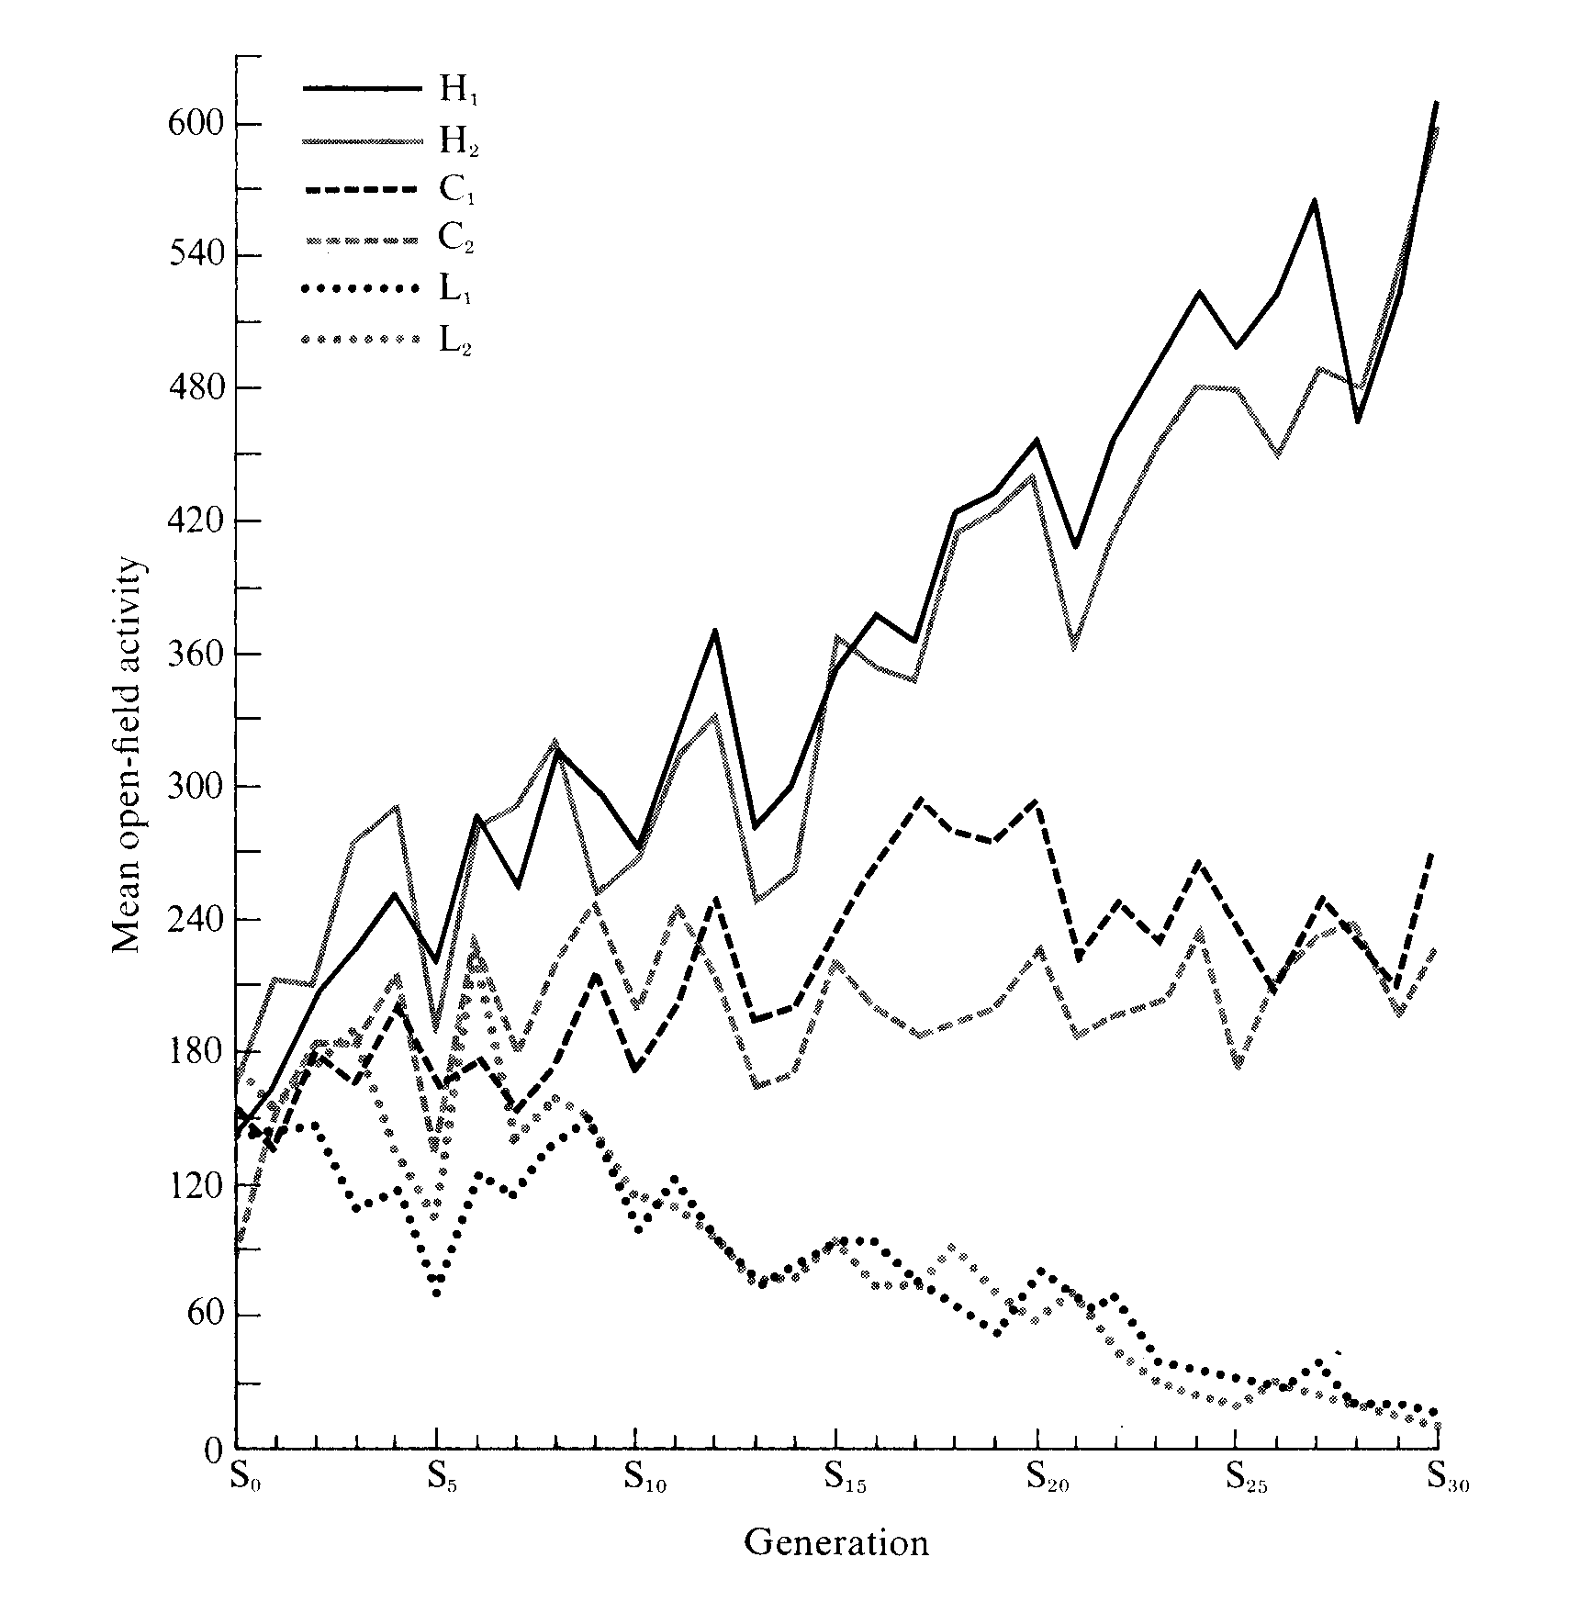

**Figure 2**

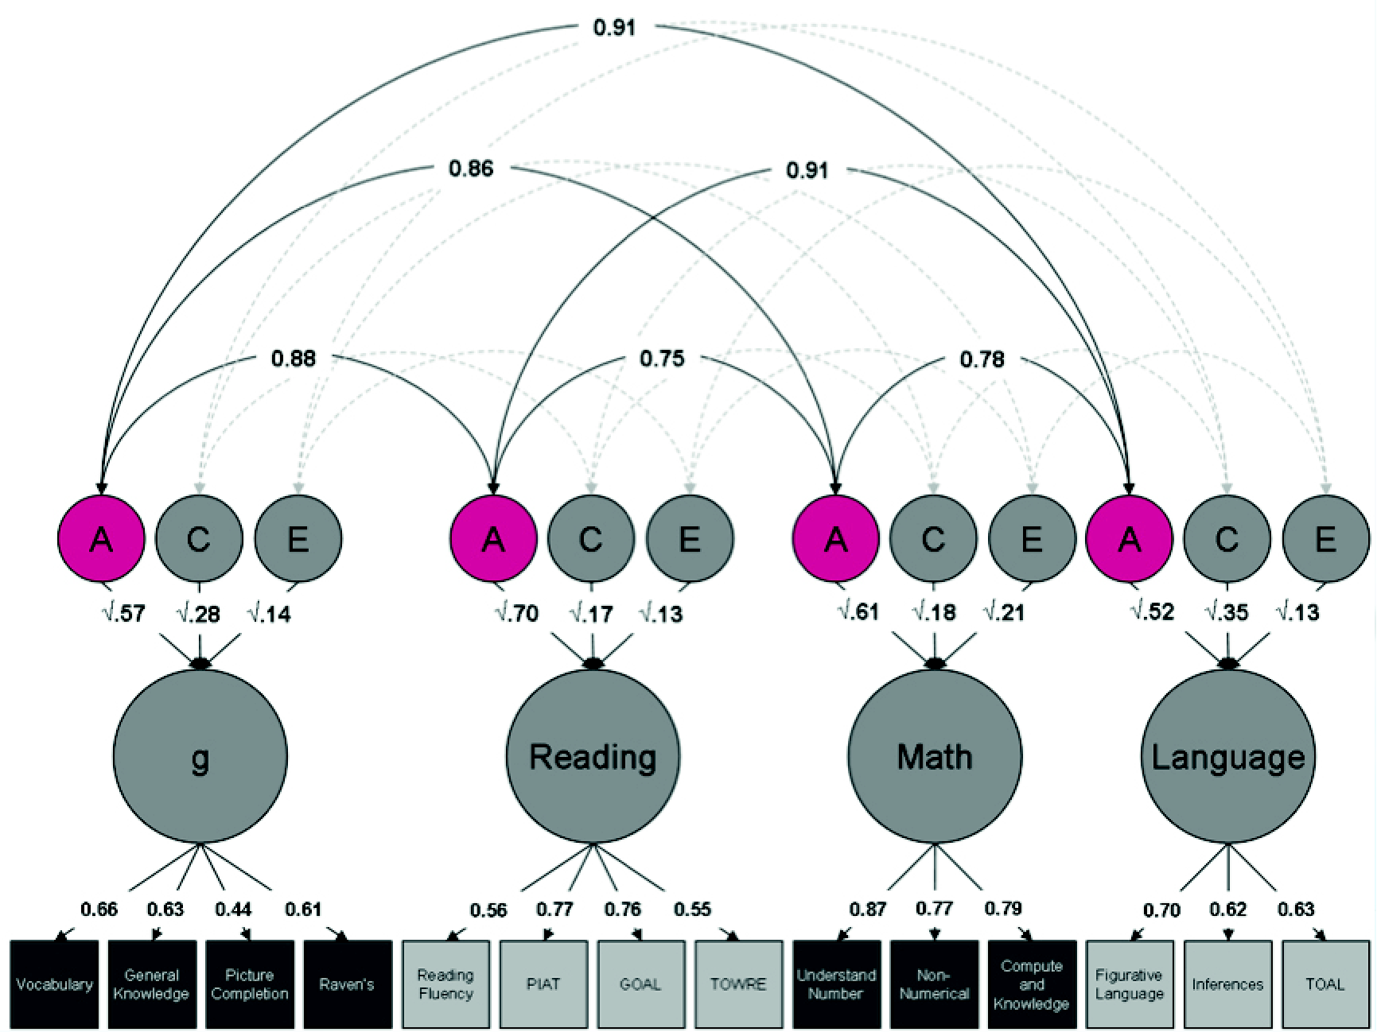

**Figure 3**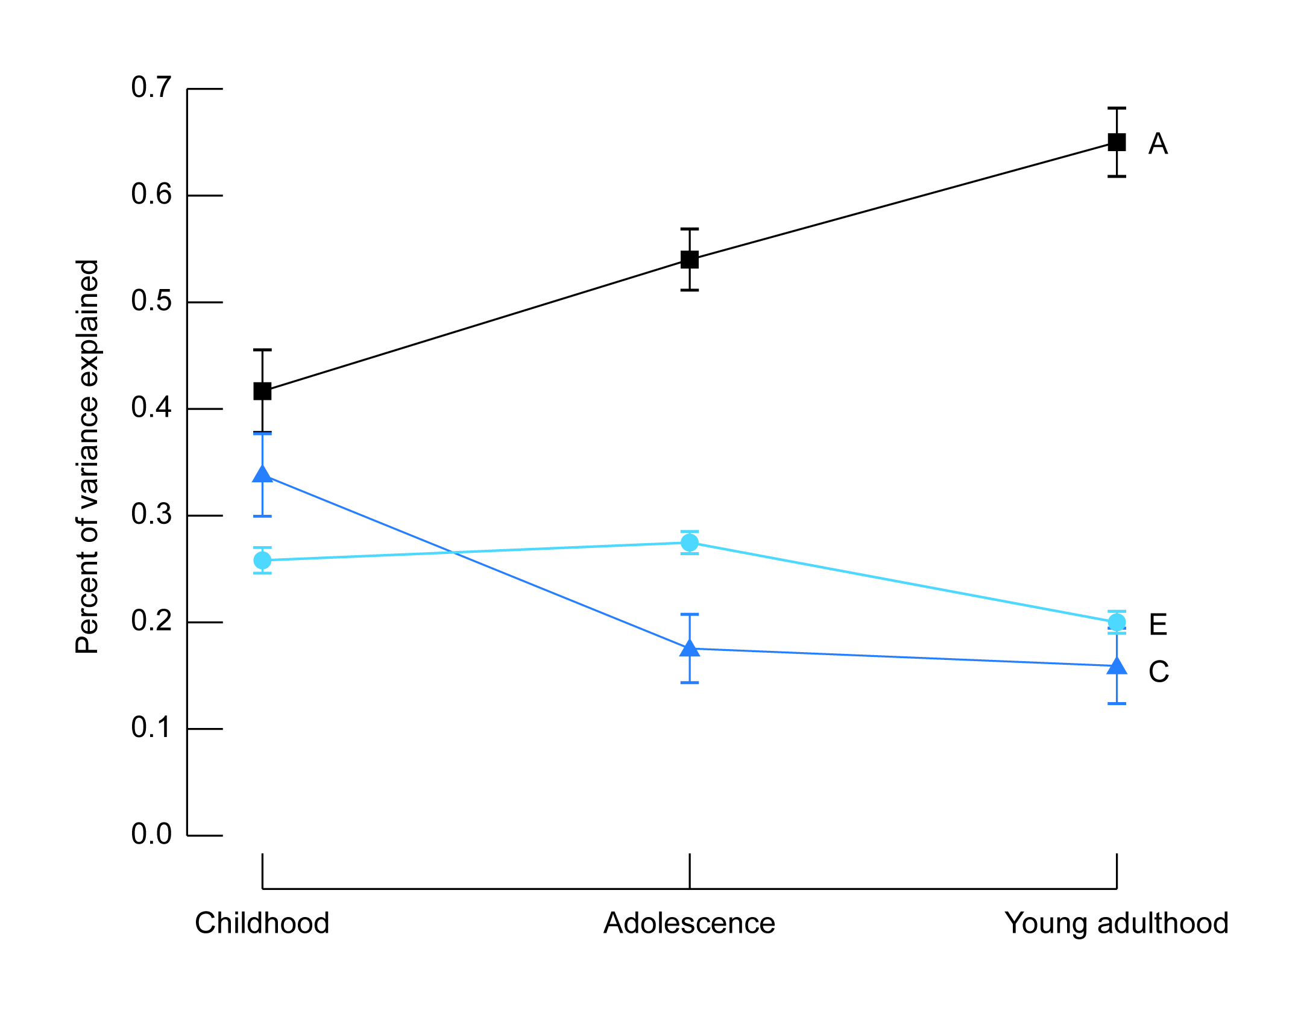

**Figure 4**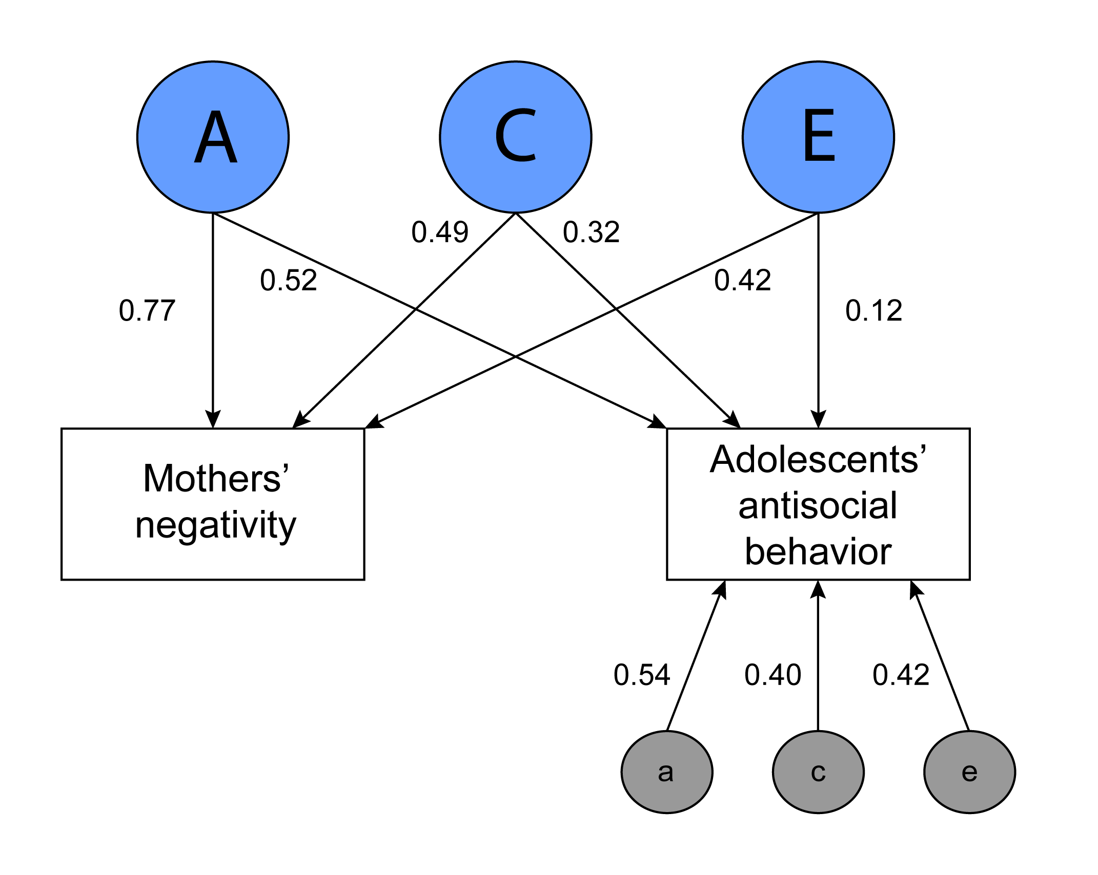

**Figure 5**

Macintosh HD:private:var:folders:l3:2z40vfqx0pv3gbz75gyt2lfr0000gp:T:TemporaryItems:Plomin et al. new Figure 5.pdf