# What can universities do to support all their students to progress successfully throughout their time at university?

## Abstract

This article reviews the findings from a UK nationwide project on the causes of differences in student outcomes in higher education. The project was commissioned by the Higher Education Funding Council for England and reported in July 2015. We found that universities with an embedded, institution-wide approach that engaged senior managers, academic staff, professional service staff and students as stakeholders and agents in the differential outcomes agenda were most promising in decreasing progression gaps. Universities use targeted and universal interventions to affect change. Initiatives that tackle assessment and the content and meaning of curricula are a promising steam of interventions. Overall, more evaluations on what works and sharing of practice will further enable the sector to support all higher education students in reaching their academic potential.

## Introduction

‘Access without support is not an opportunity’ (Tinto 2008). For a long time, institutions’ outreach and widening participation activities have been the focus of access work and spending of access funding in the UK. A key aim of this work was to raise aspirations and make more young people think that universities are for people ‘like them’. While access work is likely to have contributed to some increases of disadvantaged students in higher education and in the often more selective Russell Group universities overall, stakeholders have recognised the need for extending and developing an access-focused model as key to social mobility and more inclusive higher education.

On the one hand, the deficit model of less advantaged students having lower aspirations is not usually empirically validated. Instead of aspirations being a barrier to access, the elephant in the room especially with regards to accessing academically selective courses is the continued relationship between social background and attainment. The second impetus for re-focusing the agenda has been growing awareness that merely succeeding in getting ‘bumps on seats’ at the beginning of an academic university term does not always translate into successful completion of a university degree, a successful university experience, attaining a degree grade that makes labour market entry easier or graduate-level employment or further study. In other words, with the maturity of the access agenda with regards to undergraduate study in the UK, there has been greater awareness of the whole student lifecycle – or, as some prefer to call it, the journey of student progression in higher education. The 2014 national strategy for access and student success in higher education presented by HEFCE and the Office for Fair Access (OFFA) emphasises the full student life cycle and connects student success with employability attributes. It articulates the key notion that higher education access *starts* rather than ends at the door to a university, involves student engagement with a curriculum and includes progress onto further study or into employment.

In this present article we draw on the findings from the report “Causes of differences in student outcomes”. Commissioned by HEFCE and published in July 2015, this report investigated the causes of why some student groups have better progression outcomes in higher education than others. We will briefly review the empirical pattern of differences in student progression in UK higher education. We will then propose a causal model of how these differences in outcomes are generated. In the penultimate section, we will describe some practical initiatives that universities have introduced to support more equal progression for their students before offering some concluding thoughts and ideas for progressing the agenda in the final section.

## Pattern of differences in student progression in UK higher education

This section sets out the patterns of differential outcomes for different student groups, drawing on the most recent statistical reports relating to UK-domiciled students.[1] The key student groups we look at are different ethnic groups and students from different socio-economic groups[2]. A limitation to the analysis presented here is that it does not capture interaction effects although these are likely to influence higher education outcomes (HEFCE, 2003). For example, social class may play out differently in different ethnic groups’ performance in higher education. Also, we do not have information on very detailed factors that are known to affect how students perform in higher education (Powdthavee and Vignoles, 2008) such as social and cultural capital in the home or more nuanced socio-demographic variables. However, the data takes into account some key factors known to affect higher education performance such as the students’ grades at entry, their subject of study and their sex. The differences of e.g. performance by ethnicity are thus ‘net differences’ that are not explained by attainment, whether men or women study a certain subject and compare students studying the same subject.

In terms of the outcomes we draw on the key outcomes used as dimensions for comparing group outcomes in higher education in recent HEFCE reports, namely: a) achieving a degree and b) achieving a First or upper second class degree, c) achieving a degree and continue to employment of further study, and d) achieving a degree and continue to graduate employment (as opposed to any employment) or further study.

#### Students from lower socio-economic groups

Analysis of higher education outcomes for different student groups shows some consistent patterns, with the least-advantaged students (those from lower socio-economic groups) having consistently lower attainment and progression outcomes even after controlling for other factors such as type of institution. HEFCE has shown these differences to be statistically significant with regard to attainment and employment outcomes (HEFCE, 2013/15, HEFCE, 2014/03).

POLAR (Participation of Local Areas) data is used as a proxy for socio-economic background since data on students’ socio-economic class is self-reported and suffers from reliability issues. Figure 1 shows the difference between the higher education outcomes for students from different POLAR3 quintiles, compared to a ‘sector-adjusted average’ (ie. the expected performance outcome, in a statistical sense, for the student profile within each group). The bottom two HE participation quintiles (with lowest historical progression to higher education) have consistently much lower outcomes than might be expected across all four outcome measures. The greater the share of former HE graduates in a student’s local community, the more likely they are to have better HE outcomes. There are particularly big gaps in the graduate progression outcomes for the most disadvantaged groups such as attainment of ‘top’ degrees with only 45% of the least advantaged gaining a first or upper second class degree, while 59% of those from the most advantaged quintile did so (HEFCE 2013/15).

Figure 1: HE outcomes by category of POLAR3 neighbourhood: difference between the actual and sector-adjusted average the 2006-07 cohort

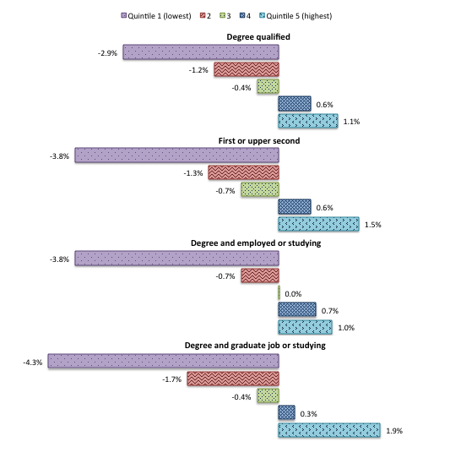Sources and groups description: Young, UK-domiciled students starting a full-time first degree course at a UK higher education institution: (2006-7) cohort by POLAR3 quintile (HEFCE 2013/15).

We also found differences in progression by school type. Those who had been educated in private ‘independent schools’ achieve better graduate-level employment outcomes than those from state graduate level outcomes: 60% independent school graduates got degrees and went into a graduate job or further study compared to 47% of state school students. There has also been work through the FutureTrack project showing the effect of living at home on attainment (Purcell *et al.* 2012) and the under-representation of those from lower socio-economic groups in progression to research graduate degrees (Wakeling and Hampden-Thompson, 2013).

We also found that students from more advantaged POLAR 3 groups reported higher satisfaction with their university experience, assessment, course, and ability to contact academic staff in the National Student Survey, the NSS, compared with less advantaged groups.

#### Students from black and minority ethnic groups

Between 2010-11 and 2012-13 the numbers of BME (black and minority ethnic backgrounds) students starting full-time first degree courses increased by 7% (those from White ethnic groups fell by 6%) (HEFCE 2014/08).

Figure 2 shows the differences between the observed and ‘expected’ outcomes for students from different ethnic backgrounds, taking account of the higher education provider attended but not the subjects studied. White students perform above or on sector-adjusted average for all the outcomes we measured in this project. However, there are some significant trends that deviate from the frequent generalised references to ‘gaps’ in attainment between BME and White students. For example, Black African students are more likely to progress to research degrees; and Indian and Chinese students are more likely to progress to postgraduate study or employment. White students are most likely to be employed or studying after graduation, however Chinese students and Indian students are most likely to be in graduate employment or study. ‘Other Asian’ students have relatively low employment outcomes.

Figure 2: HE outcomes by ethnicity: difference between the actual and sector-adjusted average the 2006-07 cohort

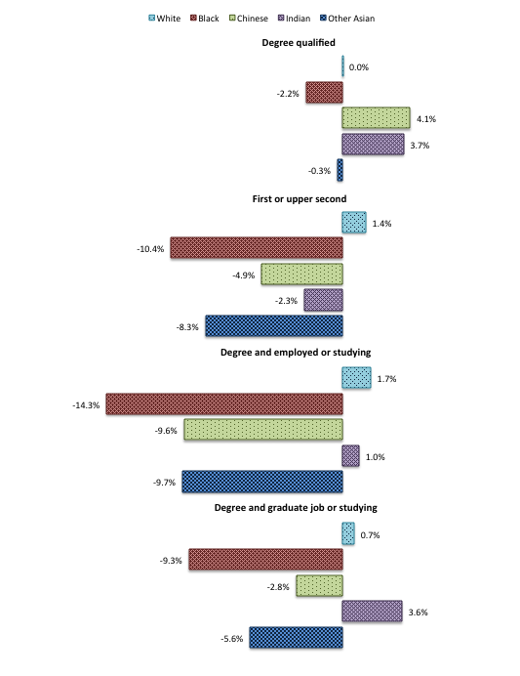

Source and groups description: Young, UK-domiciled students starting a full-time first degree course at a UK higher education institution (HEFCE 2013/15).

Graduates from most ethnic minority groups have a higher chance of unemployment than white graduates or go into non-graduate jobs (Purcell *et al.* 2012). Bangladeshi and Pakistani groups (and Chinese men), for example, are the most likely to be unemployed once education is taken into account. In terms of earnings, some BME group graduates - Indian and Black African - do better than their White peers (especially male graduates). However, the higher rates of unemployment among ethnic minority Russell Group graduates causes concern (Runnymede Trust, 2014).

Results from the NSS suggest that differences in ethnic groups’ experience of higher education and their levels of satisfaction underpin the patterns of student outcomes. For 2013, black and minority ethnic students are less likely than white students to be satisfied with their HE courses with Black-Caribbean, Black-African and mixed ethnic origin students have the lowest levels of satisfaction with HE courses. Although the ethnicity gap is closing further each year, gaps remain persistent across many individual NSS questions.

## Understanding differences in progression: a causal model

Our aim was to develop a causal model that institutions would be able to use as a tool for addressing the differential outcomes in progressions laid out above. While the analysis in the previous section has focused on ethnicity and POLAR3 groups, it is thought that understanding disadvantages for these groups will help increasing progression from other groups such as mature learners, disabled students who do not declare a disability and generally make higher education a more inclusive and welcoming place.

In developing the causal model, it is worth stating which explanatory models we considered but rejected. We have generally rejected accounts that base their explanation around ‘student deficits’ (academic weaknesses, lack of ability or other individual factors or circumstances) or ‘wrong’ choices in subject. Such explanations have been largely superseded (Richardson, 2008; Singh, 2011; Richardson, 2015[3]). Equally unhelpful in developing points for meaningful interventions are explanations that assume overall institutional racism (Turney *et al.*, 2002; Back, 2004) or ethnic bias as the core explanation for differences (Broeke and Nicholls, 2007).

Instead, we take causation to be not only contained in individuals but also in the social relations and structures that they form (Sayer, 1992) and we see causation as a multiplicity of issues (Stevenson 2012). We base our model on the premise that causation can be understood as operating on three main levels as illustrated in Figure 3:

* A **macro-level**, socio-historical and cultural structures such as those of race, ethnicity, culture, gender, social background are embedded in the global environment in which universities employers and students operate.
* At a **meso-level** of individual institutions (higher education institutions, employers and other agencies) which form the social contexts within which student outcomes occur.
* At the **micro-level** where individual students and staff interact on a daily basis.

There is an inter-play between these levels; each is implicated in the other: micro-interactions reproduce patterns that are visible at meso and macro levels; and macro phenomena structure those at micro and meso levels.

**Figure 3: Conceptual model of causes of differential outcomes**

|  |  |  |  |  |  |  |  |  |
| --- | --- | --- | --- | --- | --- | --- | --- | --- |
| **Group Characteristics** |  | | | **Differential outcomes** | | | Macro-level | |
| Institutional context  Other contexts (family, locality) | |  | | |  | | Meso-level |
| **Interactions at the individual level** | | |  | | |  | Micro-level | | |

In addition to these three levels, we also draw on four categories of causal explanation derived from the Disparities in Student Attainment (DiSA) project (Cousin and Cureton, 2012). Broadly, these categories are:

1. **Students’ experience** of their higher education learning, teaching and assessment; the ‘curriculum’ in the broadest sense.
2. The **relationships** that underpin students’ experience of HE; that is, relationships amongst students and between students and staff and their institutional environment
3. **Psycho-social and identity factors**, such as the expectations which academics have about individual students or student groups (Bruner, 1996), and students have about themselves.
4. **Cultural and social capital**: The curricular and extra-curricular student experience and their engagement in learning are related to their access to social and cultural capital including their familial contexts and material resources

These four causal categories can overlap with each other and they intersect with the macro-meso-micro framework: Each causal category has implications for each of the three different levels. For example, social and cultural capital can be relevant at the macro-level (e.g. how does the stratification and reputational hierarchy of HE impact upon students’ conceptions of their study opportunities in HE?), as well as on the meso-level (e.g. to what extent do different students have a sense of entitlement to access academic support sessions?) and the micro-level (e.g. what enables a student to feel comfortable approaching a tutor with a question after class?).

For illustration Figure 4 gives some brief ideas to illustrate how factors in each of these areas might manifest themselves to impact on the student journey through higher education.

**Figure 4: Illustration of factors impacting on the student journey**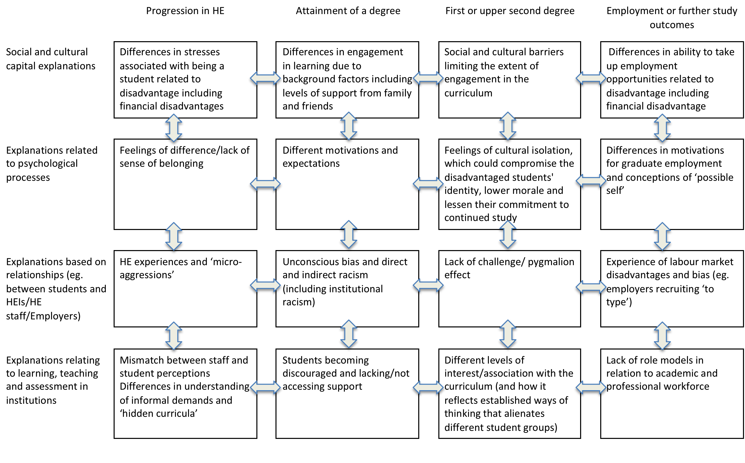

## What can universities do to support more equal progression?

Many institutions with successful practices in supporting student progression have found it helpful to enhance their support of students by understanding their learners better and more holistically. Often, institutions are surprised when they learn how many of their students combine study with work, caring or family responsibilities, the increase of students living at home and learn how students access information and support (Leese, 2010; NASES/NUS, 2012; Pennington et al., 2013; Jackson, 2012).

The literature then suggest key areas where universities can make a difference through interventions, for example, by focusing curricula and learning, extracurricular engagement and building supportive social relationships.

Curricula, learning and assessment and academic literacies matter. Ethnic differences in academic attainment, for example, vary from one institution to another and from subject area to another, suggesting they result at least in part from teaching and assessment practices (Richardson, 2015, see also Singh 2011). Non-traditional students may have different expectations and needs from ‘traditional’ higher education learners (Roberts’ 2011) or are not familiar with certain pedagogical practices (Burke et al., 2013) or may not understand ‘exactly what is expected of them – in relation to academic behaviours, participation and production of work’ (Stevenson 2012a, p.18, see also Rodgers and Thandi, 2010; Leese 2010). Especially non-traditional learners may lack awareness of, or sense of entitlement to, additional support, struggle to learn the rules of HE and a lack of feeling that they belong (see also Meeuwisse et al.’s 2010, p.543). Finally, curricula may affect differential outcomes by being historically, socially and culturally situated in a particular tradition and advantaging students from this tradition. This argument has been central to recent grass-roots activism among students exemplified by the UCL students’ video ‘Why is my curriculum White?’ and the associated NUS campaign.

The lack of ethnic diversity among UK academics (Singh 2011, Leathwood et al., 2009) is also thought to link to differentials in progression and attainment and might affect how students can imagine their ‘future selves’ to be, although the effects are not well studied empirically (Stevenson and Whelan, 2013). There can also be ‘a disjuncture between the pedagogic intentions of academic staff and how students experience these pedagogies’ (Burke et al., 2013, p.4). Biases by staff and examiners are more likely to be unconscious or implicit than conscious and overt (e.g. Woolf et al., 2011; Beattie et al.’s 2013).

Finally, outside the curriculum, extracurricular involvement also matters and here research has shown that less advantaged students are less likely to be involved in clubs/societies, councils/committees, volunteering and other hobbies (Stuart et al. 2008b; Purcell et al., 2012; Pennington et al., 2013) which disadvantages them in showing leadership and communication skills that employers value (Holdsworth and Quinn’s 2010).

Promising institutional responses to enhancing curricula, learning and assessment include:

* Projects to map the student journey through higher education, identifying points at which students are at risk of dropping out, and making key transition points explicit to all students (for example, New College Durham)
* Send disadvantaged students targeted messages to encourage them to participate in e.g. extra-curricular activities as an example of successful engagement at university (for example, King’s College London’s partnership with the Behavioural Insights Unit)
* Initiatives that deconstruct assessment. In other words, learners have an opportunity to explore in detail what assessment criteria require and obtain feedback from academics on the ‘hidden rules’ of assessment. A benefit of such an initiative is that it is ‘universal’ and benefits all students but is expected to disproportionately help less advantaged student groups (for example, University of Derby)
* Initiatives that broaden outreach to a discipline (for example, Classics at Kingston University)
* Initiatives that mainstream previously marginalised literatures into the curriculum and thus make the curriculum meaningful to a wider range of students (for example, University College London)
* BME mentoring schemes are an example of targeted initiatives that are intended to benefit a particular group of students in progressing successfully through higher education by providing role-models and peer-support (Birmingham University)
* Staff training in unconscious bias can challenge implicit assumptions about student groups (unconscious bias training is increasingly compulsory at many universities)

In addition to understanding curricula and learning contexts, understanding differences in social, cultural and economic capital can also help universities in developing interventions to support their students. At its core, capitals allow people who have them to do things they would not be able to do if they did not possess them.

In terms of economic resources, financial support or the lack thereof does make a difference to the make-up of the overall student body in higher education with a marked drop in student numbers for part-time and mature students following increases to fees (Davies et al, 2010). There is some evidence linking financial support explanations to better student retention and success amongst non-traditional groups due to reduced anxiety and less need to combine work and study (West et al., 2008, Moreau and Kerner, 2012; NUS, 20011). ). Psychological benefits of financial support might be particulary important for students with no HE background in their family (Sumner et al., 2006).

In terms of cultural capital, Tomlinson (2008) found first generation students need both tacit and explicit know-how of how to ‘package’ their experiences, opportunities, and attributes into valuable ‘personal capital’. Greenbank (2009) highlighted the disadvantages that students from a working-class background faced in career decision-making because of their lack of social capital. Furthermore, parental attitudes or cultural capital are crucial for understanding educational attainment (Feinstein 2000) highlighting the importance of family support. Aspirations and attitudes can be culturally embedded in ‘ethnic capital’ thus linking to differences in attainment by different groups (Bok 2010; Modood 2011)

Students with a family history of higher education find it easier to unpack the informal demands and often unspoken assumptions of HE of ‘the hidden curricula’ of many universities (Gibney et al., 2011) or the ‘set of taken-for-granted practices’ (Stuart et al. 2011a. p.493) or the ‘social mores of the institution…’ (Stevenson 2012, p.14). Non-traditional students may not have the cultural habits associated with success such as a confidence and a sense of entitlement in accessing services (Crozier and Reay 2008)

Social capital in the form of informal support from friends, family and peers also aids retention and success in higher education (McCary et al., 2011, Harding and Thompson 2011, Field and Morgan-Klein’s 2012). This finding ties in what we know about the importance of families and friends for progression in schools (Carter-Wall et al., 2012).

Promising institutional responses to addressing differentials in capitals include:

* Offering financial support for students from lower income families to access study abroad programmes (for example, King’s College London)
* Offering targeted career guidance or internships to widening participation students to compensate for them having fewer professional networks (for example, Bar Council mini-pupillage scheme)
* Offering help with transitions into university through taster days (for example, the Realising Opportunities partnership)

Overall, work with institutions highlighted that initiatives work best when they are embedded rather than bolted on, when the combine bottom up and top-down approaches and partnerships between senior managers, students, and academics and professional service staff. Generally, we found a great hunger for more data and evaluations of what works that are shared with colleagues across the sector – indeed, the overall lack of evaluation of many initiatives was surprising to the research team with the initiative at Derby University to deconstruct assessment being the only evaluation we found that was an integral part of the project and could thus demonstrate the improvement in student performance as a result. Especially high on the wish-list of evaluations was evidence from longitudinal evaluations, evaluations that combined qualitative and quantitative work thus providing a holistic understanding of what makes interventions successful (or not), and evaluations that break down analyses by institution and subject studied rather than working with sector-level progression data.

## Conclusion

Some issues that influence differential access to and progression in higher education are outside the direct reach of individual universities and the senior managers, students, academics and staff wishing to make a difference to the agenda. Among these issues is the stratification of higher education institutions, the fact that some qualifications carry less currency in the labour market than others (Raffe and Croxford 2013, Bol 2015; Gorrard 2009, Modood and Shiner 1994).

However, universities can have a genuine impact on the space that they do have influence over: university students’ experiences. Student progression outcomes can be enhanced for all learners with an aim to particularly benefit those who might not currently reach their full potential.

In order to work further towards enhancing progression outcomes, universities might want to consider:

1. Expand ways resources and good practice can be shared. There are useful already sector-wide initiatives for sharing experiences and practice (for example, April 2015 saw the launch of the WP evaluation network list on JISC as well as an ECU /HEA conference on developing diversity competency for higher education staff). Support creating a well-advertised one-stop website linking the range of resources available in this field. This would greatly help institutions and individuals looking for further information and resources and create new opportunities for sharing and support and encourage staff in HE institutions to participate in national knowledge exchange and networking opportunities in this field (e.g. through the HEA, SRHE, ECU, JISC lists).
2. Raise awareness of and promote use of exiting national resources (e.g. National mentoring consortium for BME students, ECU unconscious bias training, HEA inclusion guides). Raise awareness among senior strategic staff, academics, professional staff and students to facilitate an embedded ‘whole institution’ approach to impacting the differential progression agenda
3. Undertake interventions which are contextualised and rooted in institutions’ own evidence of the issues facing their student groups.
4. Actively encourage applications and outreach to increase the representation of those from under-represented groups to all professional and academic jobs and, in particular senior positions.
5. Review the ease with which students can access support, the inclusiveness and transparency of the curriculum in general and of assessment in particular.
6. Consider how staff are rewarded and recognised for making contributions to the differential outcome agenda and celebrate success and disseminate good practice through e.g. Learning and Teaching conferences and awards.
7. HEA accredited early academic programmes could be used as an opportunity to promote diversity thinking as a central aspect of curricular, learning, teaching and assessment practices.
8. CPD activities can be used to support diversity competencies among more established staff.
9. Discussion of curriculum needs to be a broad discussion, taking in not just what is taught but how and for what purpose. The notion of an inclusive curriculum should include learning, teaching and assessment practices.
10. Support and encourage engagements of students in initiatives to make curricula relevant to their contexts and experiences
11. Consider how diversity training can be promoted across the institution and how diversity training for academics can embedded in disciplinary practices.
12. Encourage approaches that view staff, students, and managers as partners learning from each other to enhance outcomes for students.
13. Embed support for addressing and reducing differentials in progression and attainment in the strategic policy frameworks of institutions as to generate better outcomes than isolated, small initiatives. For example, the differential progression agenda can be strategically tied to widening participation and institutions could consider investing some of their OFFA ring-fenced funding for supporting students within higher education and not only before entry.
14. Having a key strategic position spanning responsibility for widening access into university and the first year experience could facilitate and underpin such strategic change.
15. Funded ‘mini-projects’ that are partnerships between students, academics staff and professional service staff can bid for to impact on differential outcomes can increase awareness of and interest in the agenda
16. Support peer-support between students and student networks and groups.
17. Making ‘micro-adjustments’ (lots of little things collectively), tied together in a strategic manner to facilitate embedded culture change. Consideration should be given to universal as well as targeted interventions depending on the aim of initiatives.
18. Ask employers to advertise internship opportunities for students openly with transparent recruitment and selection procedures. Universities might consider targeted careers’ support for students less likely to have the networks for entering professional careers

To conclude, differentials in outcome can risk undoing some of the good work that goes into widening access to higher education. Successful access and progression to higher education for a wider range of learners can be achieved by having welcoming and inclusive atmospheres on campuses and a range of often universal, and sometimes targeted activities that genuinely support students in achieving their potential. It can thus be a reality for ever more learners to realise the promise of a stimulating, interesting, and useful higher education experience that offers a genuine opportunity for social mobility and for widening horizons.

## Reference:

Back, L. (2004) Introduction. in Law, I., Philips, D. and Turney, L . (eds.) *Institutional Racism in Higher Education.* Stoke on Trent: Trentham Books.

Beattie, G., Cohen, D. and McGuire, L. (2013) An exploration of possible unconscious ethnic biases in higher education: the role of implicit attitudes on selection for university posts. *Semiotica*, 197, 171-201.

Bol, T. (2015) Has education become more positional? Educational expansion and labour market outcomes, 1985–2007. *Acta Sociologica,* 58(2), 105–120.

Bok, D. (2010) *The Politics of Happiness: What Government can learn from the new research on well-being.*Princeton, NJ: Princeton University Press.

Broecke, S. and Nicholls, T. (2007) *Ethnicity and Degree Attainment.* DfES Research Report RW92. London: DfES.

Bruner, J. (1996) *The Culture of Education.* Harvard: Harvard University Press.

Burke, P.J, Crozier, G., Read, B., Hall, J., Peat, J. and Francis, B. (2013) *Formations of gender and Higher Education Pedagogies*. NTFS Final Report.

Carter-Wall C. and Whitﬁeld, G. (2012) *The role of aspirations, attitudes and behaviour in closing the educational attainment gap.* York: JRF.

Cousin, G. and Cureton, D. (2012) *Disparities in Student Attainment (DISA).* York: HEA

Crozier, G. and Reay, D. (2008) *The Socio-Cultural and Learning Experiences of Working Class Students in HE: ESRC Full Research Report*. Swindon: Economic and Social Research Council. Available at: <http://www.esrc.ac.uk/my-esrc/grants/RES-139-25-0208/outputs/Read/652b5c30-d2c5-4051-9298-e593b2a3d519>

Davies, P., Hughes, A., Slack, K., Mangan J. and Oakleigh Consulting Limited (2010) *Understanding the information needs of users of public information about higher education*, Report to HEFCE.

Field, J. and Morgan-Klein, N. (2012) ‘The Importance of Social Support Structures for Retention and Success’ in Hinton-Smith, T. (ed.), *Widening Participation in Higher Education: Casting the net wide?* London: Palgrave, 178-192.

Gibney, A., Moore, N., Murphy, F. and O’Sullivan, S. (2011) The first semester of university life; ‘will I be able to manage it all?’ *Higher Education*, 62(3), 351-366.

Gorard, S. (2009). Does the index of segregation matter? The composition of secondary schools in England since 1996. *British Educational Research Journal,* 35(4), 639–652.

Greenbank, P. (2009) An examination of the role of values in working-class students' career decision-making. *Journal of Further and Higher Education*, 33 (1). 33-44.

Harding, J. and Thompson, J. (2011) *Dispositions to stay and to succeed. final report.* Bedford: University of Bedfordshire. Available from: <http://www.heacademy.ac.uk/resources/detail/what-works-student-retention/Northumbria-Final_Report-Dec_11>

HEFCE (2013/15) Higher education and beyond: Outcomes from full-time first degree study. Bristol: HEFCE.

Holdsworth, C. and Quinn, J. (2010) Student volunteering in English higher education. *Studies in Higher Education*, 35(1), 113-127.

Jackson, V. (2012) The use of a social networking site with pre-enrolled Business School students to enhance their first year experience at university, and in doing so, improve retention*.* *Widening Participation and Lifelong Learning*, 14, 25-41.

Leathwood, C., Maylor, U. and Moreau, M. (2009) *The experience of Black and minority ethnic staff working in higher education. Literature review*. London: Equality Challenge Unit.

Leese, M. (2010) Bridging the gap: Supporting student transitions into higher education. *Journal of Further and Higher Education,* 29(2), 103-110.

McCary, J., Pankhurst, S., Valentine, H. and Berry, A. (2011) *A comparative evaluation of the roles of*

*student adviser and personal tutor in relation to undergraduate student retention: Final report.* Cambridge: Anglia Ruskin University.

Meeuwisse, M., Severiens, S. and Born, M. (2010) Learning Environment, Interaction, Sense of Belonging and Study Success in Ethnically Diverse Student Groups. *Research in Higher Education*, 51(6), 528-545.

Modood, T. (2011) ‘Capitals, Ethnic Identity and Educational Qualifications’ in Alba, R. and Waters M. (eds) *The Next Generation: Immigrant Youth in a Comparative Perspective*. New York: New York University Press, 185-206.

Moreau, M.P. and Kerner, C. (2012) *Supporting student parents in higher education: A policy perspective*. London: Nuffield Foundation, available online: <http://www.nuffieldfoundation.org/sites/default/files/files/Moreau%20Student%20Parent%20report%20-%20Full%20report%20October%202012.pdf>

Mountford-Zimdars, A, Sabri, D, Moore, J, Sanders, J, Jones, S, Higham, L (2015) [Causes of Differences in Student Outcomes](http://www.hefce.ac.uk/media/HEFCE,2014/Content/Pubs/Independentresearch/2015/Causes,of,differences,in,student,outcomes/HEFCE2015_diffout.pdf), Higher Education Funding Council for England, HEFCE, July 23rd 2015, available at: <http://www.hefce.ac.uk/pubs/rereports/Year/2015/diffout/Title,104725,en.html>

NUS (2011) *Race for equality: A report on the experiences of Black students in further and higher education*. London: National Union of Students. Available from: <http://www.nus.org.uk/PageFiles/12350/NUS_Race_for_Equality_web.pdf>

Pennington, M., Mosley, E. and Sinclair, R. (2013) *AGCAS/AGR Graduate Success Project: an investigation of graduate transitions, social mobility and the HEAR*. Sheffield: AGCAS. Available at: <http://www.agcas.org.uk/assets/download?file=3960&parent=1519>

Powdthavee, N., and Vignoles, A. (2008). The socio-economic gap in University Drop Out. Available at: http://www.tlrp.org/dspace/handle/123456789/1280.

Purcell, K., Elias P., Atfield, G., Behle, H. and Ellison R. (2012) *Futuretrack Stage 4: transitions into employment, further study and other outcomes*. Manchester: Higher Education Careers Services Unit.

Raffe, D. and Croxford, L. (2013) How stable is the stratification of higher education in England and Scotland? *British Journal of Sociology of Education,* 36(2), 313-335.

Richardson, J.T.E. (2008c) Degree attainment, ethnicity and gender: a literature review. York: Equality Challenge Unit/Higher Education Academy.

Richardson, J.T.E. (2015) The under-attainment of ethnic minority students in UK higher education: what we know and what we don’t know. *Journal of Further & Higher Education*, 39(2), 278-291.

Roberts, S. (2011) Traditional practice for non-traditional students? Examining the role of pedagogy in higher education retention. *Journal of Further and Higher Education*, 35(2), 183-199.

Rodgers, T. and Thandi, S. (2010) *The impact on BME attainment and progression of student engagement: A study of level 1 economics, ﬁnance and accounting students.* Coventry University Research Report.

The Runnymede Trust (2015) *Aiming Higher: Race, Inequality and Diversity in the Academy*. London: Runnymede Trust.

Sayer, A. (1992) *Method in Social Science.* London and New York: Routledge.

Singh, G. (2011) *Black and minority ethnic (BME) students’ participation in higher education: improving retention and success. A synthesis of research evidence*. York: Higher Education Academy.

Stevenson, J. (2012a) *Black and Minority Ethnic Student Degree Retention and Attainment*. York: Higher Education Academy.

Stuart, M., Lido, C., Morgan, M., Solomon, L. and Akroyd, K. (2008b) *What do students do outside the HE classroom? Extracurricular activities and different student groups*. Available at: <http://www.heacademy.ac.uk/resources/detail/events/annualconference/2008/Ann_conf_2008_Mary_Stuart>

Stuart, M., Lido, C. and Morgan, J. (2011) Personal stories: how students’ social and cultural life histories interact with the field of higher education. *International Journal of Lifelong Education*, 30(4), 489-508.

Sumner, L., Ralley, R., Grime, K. and McCulloch, A. (2006) The experience of young people in higher education: factors influencing withdrawal. Ormskirk: Edge Hill University. Available at: http://www.heacademy.ac.uk/resources/detail/LLN/GMWL_The_experience_of_young_people_in_ higher_education_Factors_influencing_withdrawal

Tomlinson, M. (2008) ‘The degree is not enough': students' perceptions of the role of higher education credentials for graduate work and employability. *British Journal of Sociology of Education*, 29, (1), 49-61.

Tinto, (2008) Access Without Support Is Not Opportunity, Inside Higher Ed, June 9, 2008

Turney, L., Law, I. and Phillips, D. (2002) *Institutional Racism in Higher Education Toolkit Project: Building the Anti-Racist HEI*. Available from: http://www.s and ociology.leeds.ac.uk/assets/files/research/cers/the-anti-racism-toolkit.pdf

Wakeling, P. and Hampden-Thompson, G. (2013) *Transition to higher degrees across the UK: An analysis of national, international and individual differences*. York: Higher Education Academy. Available at: <http://www.heacademy.ac.uk/assets/documents/research/Transition_to_higher_degree_across_the_UK.pdf>

West, A., Emmerson, C., Frayne, C. and Hind, A. (2008) Examining the Impact of Opportunity Bursaries on the Financial Circumstances and Attitudes of Undergraduate Students in England. *Higher Education Quarterly,* 63(2), 112-140.

Why is my curriculum white? (2014) YouTube video, added by UCLTV. Available at: [www.youtube.com/watch?v=Dscx4h2l-Pk](http://www.youtube.com/watch?v=Dscx4h2l-Pk)​

Woolf, K., Potts, H.W.W. and McManus, I.C. (2011) Ethnicity and academic performance in UK trained doctors and medical students: a systematic review and meta-analysis. *British Medical Journal,* 342, d901.

1. The extent to which those issues are covered in our subsequent reports will depend on the data, available evidence from the grey literature search and meta-analysis of the literature.
2. The full HEFCE report also explores the pattern of differences for students with disabilities.
3. For example, while differences in prior educational attainment are part of explaining differences in higher education progression, but this is only a partial explanation (Broecke and Nicholls 2007; Richardson 2008b).