**Three Cases of Hereditary Tyrosinaemia Type 1; Neuropsychiatric Outcomes and Brain Imaging Following Treatment with NTBC**

**ABSTRACT**

*Aim:* To examine neuropsychiatric outcomes in adults with hereditary tyrosinaemia type I (HT-1), treated with 2-(2-nitro-4-trifluoromethylbenzoyl)-1,3-cyclohexanedione (NTBC) and correlate these with functional imaging as well as with tyrosine and phenylalanine-tyrosine (Phe:Tyr) ratios.

*Design:* We retrospectively reviewed the medical records of three adult HT-1 patients with a particular focus on their FDG PET/CT brain scans, neuropsychiatric assessment (including neurocognitive assessment and mood and anxiety ratings) as well as mean tyrosine and phenylalanine levels and Phe:Tyr ratios for three month period. The patients had been referred to a specialist joint inherited metabolic disorder and neuropsychiatry clinic. They were all on NTBC; two since 6 weeks of age, and one since 9 years of age.

*Results:* All patientsperformed below the expectation on the formal neurocognitive testing and had raised plasma tyrosine levels and reduced plasma Phe:Tyr ratios. FDG PET/CT-brain scans were normal in two patients and the third patient (treated with NTBC from 6 weeks) had reduced metabolism in temporal and medial frontal areas bilaterally which correlated with the neurocognitive performance.

*Conclusions:* All three HT-1 patients treated with NTBC had high tyrosine levels, reduced Phe:Tyr ratios and underperformed in neurocognitive testing regardless of the point when the NTBC was first started. One had imaging abnormalities which also correlated with neurocognitive performance. The patient who struggled the most in neurocognitive testing had the highest average plasma tyrosine levels and the lowest Phe:Tyr ratio. Overall, these cases appear to support the previous hypothesis that either the high tyrosine levels or abnormal phenylalanine hydroxylase (PAH) function may well be the causative factor for poor neurocognitive performance. Further systematic, multi-centre studies with a longer follow-up are required to further clarify the relationship between HT-1, NTBC treatment, tyrosine and phenylalanine levels and neurocognitive outcomes.

**Introduction**

HT-1 is a rare genetic disease caused by mutations in the gene for the enzyme fumarylacetoacetase, and typically present in early infancy with acute liver failure. It can also manifest as chronic liver dysfunction, cirrhosis, neurological crisis and occasional renal tubular dysfunction with hypophosphataemic rickets. Without treatment, patients with HT-1 have a high lifetime risk of developing hepatocellular carcinoma (HCC), resulting from the cytotoxicity of tyrosine metabolites accumulating proximal to the metabolic defect. NTBC was first used in the early 1990’s for the treatment of HT-1 and has transformed the natural history of tyrosinaemia. NTBC acts on tyrosine metabolism upstream of the defect and is used in combination with a tyrosine- and phenylalanine-restricted diet.

However, recent studies have hypothesised that along with improving the overall survival, the treatment with NTBC may increase the likelihood of neurocognitive impairment (Bendadi et al., 2014; De Laet et al., 2011, Masurel-Paulet et al., 2008; Thimm et al.,2011, 2012, Van Ginkel, 2016). Some suggest that this neurocognitive decline may be mediated by increased plasma and CSF tyrosine but clear association between IQ and tyrosine levels have not yet been demonstrated.

Previous studies which include brain imaging are inconclusive. A small case series demonstrated normal MRI brain scans in HT-1 patients treated with NTBC (Thimm et al., 2011, 2012), yet another study confirmed brain abnormalities on the MRI (high signal changes in the globus pallidus and high signal changes in the posterior limbs of the internal capsules) in two young HT-1 children treated with NTBC (Sener, 2005; a,b). An animal study (Sgaravatti et al., 2008) supported a potential aetiological role of hypertyrosinaemia in cognitive decline caused by NTBC treatment, reporting that the elevated tyrosine levels resulted in DNA damage in the cerebral cortex of young rats attributable to a decrease in enzymatic and non- enzymatic antioxidant defences.

Interestingly, the majority of HT-1 studies have focused on neurocognition in children and generally have limited their investigations to IQ testing. Although, it has been proposed that hypertyrosinaemia is a potential aetiological factor in neurocognitive decline, studies of HT-1 patients treated with NTBC are small and literature on adult outcomes is still sparse. Hence, there is a pressing clinical need to further understand the long term neurocognitive implications of treatment with NTBC. This study was designed to further investigate the neurocognitive outcomes in HT-1 adult patients, as opposed to children, by employing more extensive neuropsychiatric investigations and comparing these with plasma and Phe:Tyr ratios as well as with FDG PET/CT brain imaging.

**Methods**

Three patients with HT-1, treated with NTBC, and seen in a specialist neuropsychiatry clinic for patients with inherited metabolic disorders between August 2011 and October 2011 were examined; neuropsychiatric assessment, blood testing and FDG PET/CT brain scans were conducted for each patient. Blood tests were based on averaged results for a period of three months prior to the brain scans.

**Functional Neuroimaging**

PET scans were performed in the PET Imaging Centre at St Thomas’s Hospital, using a GE Discovery ST PET/CT scanner (GE Medical Systems, Milwaukee, WI, USA) with a 15.7cm axial field of view. Participants were instructed to refrain from eating or drinking anything except plain water for three hours prior to the scan. On arrival each participant was injected with 250MBq [18F]-FDG. After a 30-minute uptake period during which they rested in a dimly lit quiet room, the participants were positioned on the PET scanner, with their head secured by a head rest. A planar CT scout was acquired to localise the participant’s brain in the PET field of view then a single low dose CT was acquired for attenuation correction of the PET scan. The PET scan was acquired as a single frame for 15 minutes. Images were reconstructed using OSEM iterative reconstruction. The images were displayed in three orthogonal planes scaled to the maximum activity concentration and visually interpreted by two experienced PET readers and later re-reviewed for the purposes of this report to confirm the accuracy of the findings.

**Neuropsychiatric assessment**

Participants were assessed on a subset of the following standardised neuropsychological measures: estimated optimal adult intellectual functioning (National Adult Reading Test, NART, Wechsler Test of Adult Reading, WTAR or Test of Premorbid Functioning, TOPF); current intellectual functioning (Wechsler Abbreviated Scale of Intelligence, WASI, or Wechsler Adult Intelligence Scales, WAIS); memory (Doors and People, Camden Memory Test or Wechsler Memory Scales, WMS); naming (Graded Naming Test), visual perception and visuospatial functioning (Visual Object and Space Perception battery, VOSP); arithmetic (Graded Difficulty Arithmetic Test); executive functioning (Behavioural Assessment of Dysexecutive Syndrome, BADS, Hayling and Brixton Tests, Modified Wisconsin Card Sort, Trail-Making, Verbal Fluency); manual dexterity (Purdue Pegboard). Assessments took place in a quiet room in an outpatient clinic as part of routine clinical care.

Subjective cognitive difficulties were assessed by using standardised questionnaires (Prospective and Retrospective Memory Questionnaire, PRMQ, Dysexecutive Questionnaire, DEX) as were mood and anxiety symptoms (Beck Depression Inventory II, BDI-II or Hospital Anxiety and Depression Scale, HADS). Participants were asked to rate their health and quality of life on a 10-point Likert scale (0 worst, 10 best).

**Biochemical Investigation**

Blood tests were carried out to ascertain mean tyrosine and phenylalanine levels and Phe:Tyr ratios over a period of three months.

**Case Descriptions**

Patient 1 was a 16 year old white British male, who complained of memory problems which he thought impacted on his school performance. Two days after birth he had developed septicaemia and meningitis and on his 6th week was diagnosed with HT-1, and NTBC with a low protein diet was commenced. His motor developmental milestones had been normal but his verbal milestones were reported as delayed. At assessment he was on NTBC 30 mg am and 40 mg nocte with a restricted natural protein diet of 23g per day and 3 of TyrCooler 20® supplements per day. He had vitamin B12 deficiency (59ng/L) which was a result of poor compliance with his fortified TyrCooler 20®.

Patient 2 was a 19 year old British Indian male who complained of memory problems. He was diagnosed with HT-1 at infancy and began NTBC treatment at 6 weeks old. His speech and motor developmental milestones were broadly within normal limits. At assessment he was on NTBC 20mg twice a day with a restricted natural protein diet of 15-18g per day, and 3 of TyrCooler 20® supplements per day. He had history of Vitamin D and B12 deficiency (undetectable and 151 ng/L respectively).

Patient 3 was a 24 year old white non-British male who complained of memory problems impacting his learning and work. He had suffered from mild liver dysfunction during the first year of his life.  At the age of four he had presented with rickets hypophosphatasia of his lower limbs and was subsequently diagnosed with HT-1. He was commenced on NTBC at the age of 9 however, due to the limited availability of the drug he was only on a low dose until the age of 13. He continued to suffer from symptoms of rickets due to phosphate loss caused by renal tubolopathy. At assessment he was on NTBC 40mg twice a day with a low natural protein diet. He was diagnosed with clinical depression and was prescribed fluoxetine.

**Results**

**Neuropsychological Testing**

*Neuropsychological testing results are summarised in Figure 1. A detailed summary of neuropsychological testing can be found in Appendix 1.*

Patient 1, performance was impaired on tests of perceptual motor function, mixed on tests of executive functioning and average on tests of memory

Patient 2, performance was largely in the average range in intellectual functioning and in line with his estimated premorbid functioning but borderline impaired (1-2 SDs below the mean) on processing speed, semantic memory and cognitive flexibility. He was not anxious or depressed and he rated his health and quality of life as good (9/10) and rated his subjective memory as good.

Patient 3, performance was impaired in intellectual functioning, working memory, verbal recall, visual recognition, executive function and perceptual motor function but in the borderline range for verbal comprehension, processing speed and visual recall. He rated himself as depressed and anxious with poor health (3/10) and poor quality of life (2/10) but he did not think he had memory problems.

**Neuropsychological Testing (percentile ranks)**

|  |  |  |  |  |  |  |  |  |  |
| --- | --- | --- | --- | --- | --- | --- | --- | --- | --- |
|  | | | Memory | | Frontal | | | | |
| Patient | Premorbid IQ | Full-scale IQ | Visual | Verbal | Trail A | Trail B | Perdue Pegboard | Delis Kaplan Executive Function System | |
| Visual Scanning | Number and Letter Sequencing and Number-Letter Switching |
| 1 | 104 | 83 | 21 | 45 | 10 | 40 | <0.1 | Not completed. | Not completed. |
| 2 | 99 | 86 | 25 | 75 | 25-50 | 10-25 | Not completed. | Not completed. | Not completed. |
| 3 | 92 | Verbal Comprehension Index:76  Perceptual Organisation Index: 86 | <1 | 9 | Not completed. | Not completed. | <0.1 | 37 | <0.1 |

Figure 1. Neuropsychological testing.

**Neuroimaging and Biochemistry**

|  |  |  |  |  |
| --- | --- | --- | --- | --- |
| Patient | FDG PET/CT Scan Result | Tyrosine level (micromol/L) | Phenylalanine Level  (micromol/L) | Phe:Tyr Ratio |
| **1** | Normal | 595.9 | 48.9 | 0.08 |
| **2** | Bilateral temporal and medial frontal hypometabolism. | 611.6 | 58.5 | 0.10 |
| **3** | Normal | 760.1 | 55.1 | 0.07 |

Figure 2. Neuroimaging and haematological results.

**Neuroimaging***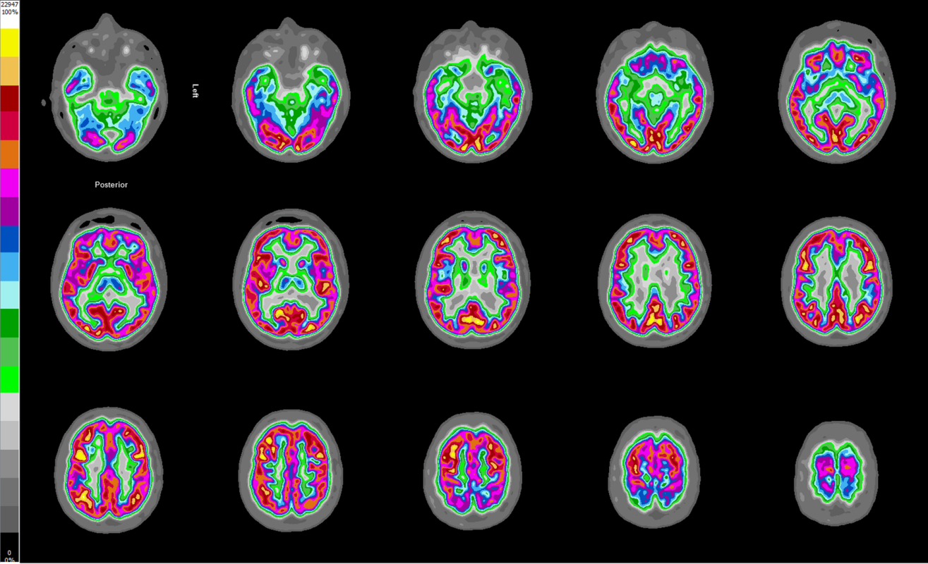*

*Image 1. Patient 1: Normal scan*

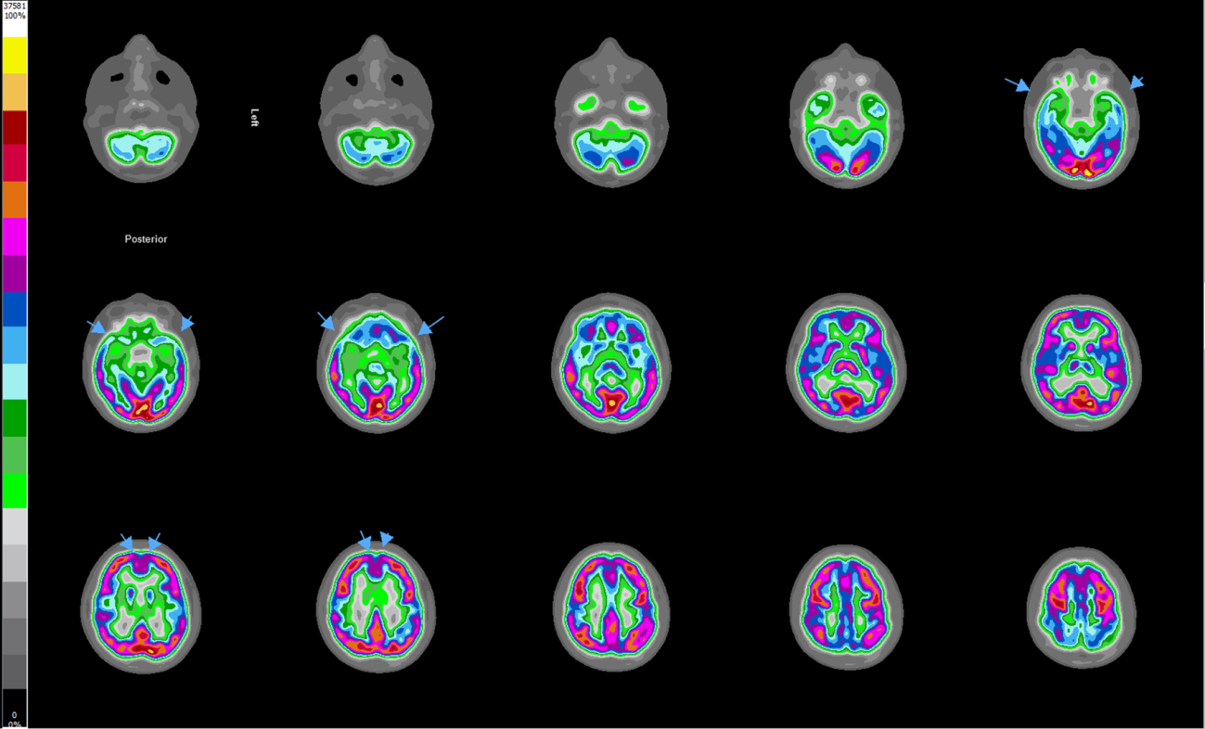

*Image 2. Patient 2: Abnormal scan showing bilateral temporal and medial frontal hypometabolism (arrows).*

**Discussion**

Previous studies have largely focussed on changes in IQ and have been inconclusive with heterogenous results. Our case series employed a detailed neuropsychiatric assessment, reviewed recent plasma tyrosine levels and Phe:Tyr ratios as well as FDG PET/CT brain imaging in order to achieve a more comprehensive understanding of the effects HT-1 and NTBC treatment may have on adult patients.

Neurocognitive testing did not reveal a clear pattern of deficits but confirmed that all three HT-1 patients underperformed in cognitive testing, regardless of the point when the NTBC treatment was first started. The abnormal functional neuroimaging result for one patient demonstrated consistency with his neurocognitive performance but this patient also had severe vitamin D and B12 deficiencies which may well have contributed to his neurocognitive underperformance.

All the patients had raised tyrosine levels, which may support the hypothesis that hypertyrosinaemia is implicated in the declined neurocognitive functions. The oldest patient (patient 3) performed least well, had the highest tyrosine level and the lowest Phe:Tyr ratio. However, when interpreting his cognitive performance on testing one should note that his first language was not English and he was also clinically depressed.

Previous small case series have demonstrated inconsistent MRI brain imaging findings in HT-1 patients. This study, using functional brain imaging, FDG PET/CT scan, demonstrated two normal scans and one with abnormalities.

Although our case series has limitations given the small sample size, it is the first one which compares neurocognitive performance with blood tests (tyrosine and Phe:Tyr ratio) and functional brain imaging and appears to confirm that there is a relationship between HT-1 and neurocognitive compromise. Further systematic, longitudinal, multi-centre studies are necessary in order to understand the relationship between HT-1, NTBC treatment and neurocognitive outcome and the relationship between tyrosine and phenylalanine levels and cognitive decline.

**References**

Bendadi F, de Koning TJ, Visser G, Prinsen HCMT, de Sain MGM, Verhoeven-Duif N, Sinnema G, van Spronsen FJ van Hasselt, PM (2014) Impaired Cognitive Functioning in Patients with Tyrosinaemia Type I Receiving Nitisinone.. J Pediatr 164: 398-401.

De Laet C, Terrones Munoz V, Jaeken J, Francois B, Carton D, Sokals EM, Dan B, Goyens PJ (2011) Neuropsychological outcome of NTBC-treated patients with tyrosinaemia type 1. Dev Med Child Neurol 53: 962-964.

Masurel-Paulet A, Poggi-Bach J, Rolland MO, Bernard O, Guffon N, Dobbelaere D, Sarles J, de Baulny HO, Touati G (2008) NTBC treatment in tyrosinaemia type I: long-term outcome in French patients. J Inherit Metab Dis 31: 81–87.

Sener RN (2005a) Tyrosinaemia: computed tomography, magnetic resonance imaging, diffusion magnetic resonance imaging, and proton spectroscopy findings in the brain. J Comput Assist Tomogr 29: 323–325

Sener RN (2005b) Brain magnetic resonance imaging in tyrosinaemia Acta Radio 46: 618–620

Thimm E, Herebian D, Assmann B, Klee D, Mayatepek E, Spiekerkoetter U (2011) Increase of CSF tyrosine and impaired serotonin turnover in tyrosinaemia type I. Mol Genet Metab 102: 122–125

Thimm E, Richter-Werkle R, Kamp G, Molke B, Herebian D, Klee D, Mayatepek E, Spiekerkoetter, U (2012) Neurocognitive outcome in patients with hypertyrosinaemia type I after long-term treatment with NTBC. J Inherit Metab Dis 35: 263–268.

van Ginkel, Willem G., et al. "Neurocognitive outcome in tyrosinemia type 1 patients compared to healthy controls." Orphanet Journal of Rare Diseases 11.1 (2016): 87.

**APPENDIX 1**

**Patient 1**

**IQ**

Predicted Full scale IQ (National Adult Reading Test): 104

Full scale IQ (WAIS): 83

**Memory**

**Wechsler Memory Scale IV**

|  |  |
| --- | --- |
| **WMS IV Domain** | **Percentile Rank** |
| Auditory Memory | 21 |
| Visual Memory | 45 |
| Visual Working Memory | 58 |
| Immediate Memory | 19 |
| Delayed Memory | 39 |

**Frontal-Executive Function**

**Verbal Fluency:** 37th percentile

**Hayling and Brixton Tests**

|  |  |
| --- | --- |
| **Domain** | **Percentile Rank** |
| Hayling Part A (time) | 25 |
| Hayling Part B (time) | 50 |
| Hayling Part B (errors) | 50 |
| Brixton Test (errors) | 75 |

**Trail making Test**

Part A: 10th percentile

Part B: 40th percentile

**Manual Dexterity**

**Perdue Pegboard**

|  |  |
| --- | --- |
| **Domain** | **Percentile Rank** |
| Dominant Hand | 5 |
| Non-dominant Hand | <0.1 |
| Both Hands | 5 |
| Assemblies, both hands | <0.1 |

**Patient 2**

**IQ**

Predicted Full Scale IQ (National Adult Reading Test): 99

Full Scale IQ (WAIS): 86

**Memory**

**Doors and People**

|  |  |
| --- | --- |
| **Domain** | **Percentile Rank** |
| People (verbal recall) | 25 |
| Doors (visual recognition) | 10-25 |
| Shapes (visual recall) | 75 |
| Names (verbal recognition) | 10-25 |

**Frontal- Executive Function**

**Verbal Fluency:** 63rd percentile

**Hayling and Brixton Tests**

|  |  |
| --- | --- |
| **Domain** | **Percentile Rank** |
| Hayling Part A (time) | 50 |
| Hayling Part B (time) | 50 |
| Hayling Part B (errors) | 50 |
| Brixton Test (errors) | 50 |

**Trail Making Test**

Part A: 25-50th Percentile

Part B: 10-25th Percentile

**Patient 3**

**IQ**

Predicted full scale IQ (National Adult Reading Test): 92

Full scale IQ (WAIS): Could not be measured due to lack of consistency within the Verbal Comprehension Index and clinically significant differences between the Verbal and Performance Indexes.

Verbal Comprehension Index: 5th percentile

Perceptual Organisation Index: 18th percentile

Working Memory Index: <1st percentile

Processing Speed Index: 5th Percentile

**Memory**

**Doors and People Test**

|  |  |
| --- | --- |
| **Domain** | **Percentile Rank** |
| People (verbal recall) | <1st percentile |
| Doors (visual recognition) | <1st percentile |
| Shapes (visual recall) | 9th percentile |
| Names (verbal recognition) | 16th percentile |

**Frontal-Executive Function**

**Delis-Kaplan Executive Function system- Trail Making Test**

|  |  |
| --- | --- |
| **Domain** | **Percentile Rank** |
| Visual Scanning | 37 |
| Number sequencing | <0.1 |
| Letter Sequencing | <0.1 |
| Number -letter switching | <0.1 |
| Motor Speed | 25 |

**Delis-Kaplan Executive Function system- Verbal Fluency Test**

|  |  |
| --- | --- |
| **Domain** | **Percentile rank** |
| Letter Fluency | 9 |
| Category fluency | 5 |
| Category Switching Total | 9 |
| Category Switching Accuracy | 9 |

**Modified Wisconsin Card Sorting task**

|  |  |
| --- | --- |
| **Domain** | **Percentile rank** |
| Total Errors | 60 |
| % perseverative errors | 20 |

**Worrington Graded Calculation test:** <5th Percentile

**Manual Dexterity**

**Perdue Pegboard**

|  |  |
| --- | --- |
| **Domain** | **Percentile Rank** |
| Dominant hand | 38 |
| Non-Dominant hand | 8 |
| Both hands | 4 |
| Assemblies | <0.1 |